AI ACADEMY · WORKBOOK · ai-2/10

Human Classifier Simulation
Project: Transparent Book Recommender

01. Recall and choose your starting point
Try the recall before opening notes. Then use a different colour or a labelled second line to correct your explanation.

Features and Distractors
Without opening the old lesson, explain one key idea from Features and Distractors. Give an example and a mistake that the idea helps you avoid.

My remembered idea, example and correction
________________________________________________________________
________________________________________________________________
________________________________________________________________

Rows Columns and Data Types
Without opening the old lesson, explain one key idea from Rows Columns and Data Types. Give an example and a mistake that the idea helps you avoid.

My remembered idea, example and correction
________________________________________________________________
________________________________________________________________
________________________________________________________________

Trace Tables
Without opening the old lesson, explain one key idea from Trace Tables. Give an example and a mistake that the idea helps you avoid.

My remembered idea, example and correction
________________________________________________________________
________________________________________________________________
________________________________________________________________

02. Practise with fading help
Use W2: Construct both outcome paths for Constructing a classifier. Record the answer once; the lesson and workbook refer to the same attempt.
Given inputs | Procedure I chose | Middle steps | Result and check

The step I completed without help, and the hint I needed
________________________________________________________________
________________________________________________________________
________________________________________________________________

03. Individual reasoning check
Use the worked case for Constructing a classifier. Proposed explanation: “Any numeric input must receive a category”. Decide whether this explanation is supported. Point to the step or supplied fact that decides; explain your repair if needed.

My explanation before partner discussion
________________________________________________________________
________________________________________________________________
________________________________________________________________
________________________________________________________________

04. Independent transfer case

Independent case: Changed independent case
A written rule selects science books with fewer than 140 pages. Trace science/139, science/140, history/90 and missing-genre/90. Policy: missing required information means request it.

My independent explanation, trace and limits
________________________________________________________________
________________________________________________________________
________________________________________________________________
________________________________________________________________
________________________________________________________________
________________________________________________________________
________________________________________________________________
Attempt this case before feedback. Record any help. Earlier examples below are further practice; a case already practised with feedback cannot establish fresh transfer.

05. Your learning target
Recommend a book only if genre is science AND pages<=150. Classify science/150, science/151, mystery/90 and missing-genre/80. State a missing-data policy.

06. Solve the given case
Recommend if adventure AND pages<150; otherwise Other.
Trace A=(adventure,120), B=(adventure,180), C=(science,90).
Show your trace, calculation or evidence

Write or draw your reasoning and evidence.
________________________________________________________________
________________________________________________________________
________________________________________________________________
________________________________________________________________
________________________________________________________________

07. Check a changed case
A human classifier uses sports topic means sports shelf. Classify a sports book and an unreadable cover. State what evidence is missing in the second case.
My independent answer and reason

Write or draw your reasoning and evidence.
________________________________________________________________
________________________________________________________________
________________________________________________________________
________________________________________________________________
________________________________________________________________

Week 10 Test and reflect

08. Design a revealing test
Create a changed input, boundary case or missing-information case. Write the expected answer or safe response before testing.
Test record | My evidence
Changed input or condition
Expected answer or fallback
Observed result
Why the result occurred

09. Project checkpoint
Turn score thresholds into visible boundaries such as recommend / maybe / not now.
The project change and evidence I will keep

Write or draw your reasoning and evidence.
________________________________________________________________
________________________________________________________________
________________________________________________________________
________________________________________________________________
________________________________________________________________

10. Self check
I can explain the mechanism. I can show evidence. I can handle a changed case. I can name a limit. Mark each as not yet, with help or independently, and attach supporting work.
Teacher review ____________________ Next step ____________________

11. Transfer practice from the original programme
Recommend a book only if genre is science AND pages<=150. Classify science/150, science/151, mystery/90 and missing-genre/80. State a missing-data policy.

My independently reasoned answer
________________________________________________________________
________________________________________________________________
________________________________________________________________
________________________________________________________________
________________________________________________________________
________________________________________________________________
________________________________________________________________
Record support used: none, hint or teacher explanation.

12. W1 Write an input contract
Write the complete Tower1 input contract. Give one accepted example and three different rejected examples, each with its reason. Explain why an accepted input does not have to be one of the examples used to fit the threshold.

My reasoning and evidence
________________________________________________________________
________________________________________________________________
________________________________________________________________
________________________________________________________________
________________________________________________________________
________________________________________________________________
________________________________________________________________

13. W2 Construct both outcome paths
Write numbered instructions for Tower1, including input checks, the stopping path after a failed check, the threshold rule and the record to keep. Your partner must be able to use them without supplying an unstated rule.

My reasoning and evidence
________________________________________________________________
________________________________________________________________
________________________________________________________________
________________________________________________________________
________________________________________________________________
________________________________________________________________
________________________________________________________________
________________________________________________________________

14. W3 Trace boundaries and a broken path
Trace 1 cm, 5 cm, 6 cm, 10 cm and 11 cm using Tower1. A faulty procedure records no prediction for a blank, then continues and treats the blank as zero to report short. Identify the missing instruction and the proper final outcome.

My reasoning and evidence
________________________________________________________________
________________________________________________________________
________________________________________________________________
________________________________________________________________
________________________________________________________________
________________________________________________________________

15. W4 Build an independent ribbon classifier
Design Ribbon1 for ribbon lengths recorded as whole centimetres from 1 through 12 inclusive, with unit cm required. Predict long at 8 cm or more and short otherwise. Write complete instructions and trace 7 cm, 8 cm, a blank length and 13 cm. Include reasons for no prediction and the model version in each record.

My reasoning and evidence
________________________________________________________________
________________________________________________________________
________________________________________________________________
________________________________________________________________
________________________________________________________________
________________________________________________________________
________________________________________________________________
________________________________________________________________

16. W5 Explain what your procedure establishes
Ribbon1 accepts 12 cm and predicts long. No comparison label has been supplied for that record. State what has been checked and what remains unknown. Explain why changing a blank to 1 cm just to produce a category would be a mistake.

My reasoning and evidence
________________________________________________________________
________________________________________________________________
________________________________________________________________
________________________________________________________________
________________________________________________________________
________________________________________________________________

17. Feedback, return check and learning record
Evidence | My record
Worked alone / hint / model
First step I repaired and why
New case checked later; date and result
What I can now explain without notes
One remaining question
Revisit this idea with your teacher after a delay. Familiarity is different from explaining and using it on a changed case.

18. Pictorial case practice: Human Classifier Simulation
A fictional librarian wants illustrated mystery books with at most 100 pages.
Written rule: choose only genre mystery AND illustrated True AND pages<=100.
Rows J=(mystery,True,100), K=(mystery,False,90), L=(science,True,80), M=(mystery,True,blank). Missing required fields request review.
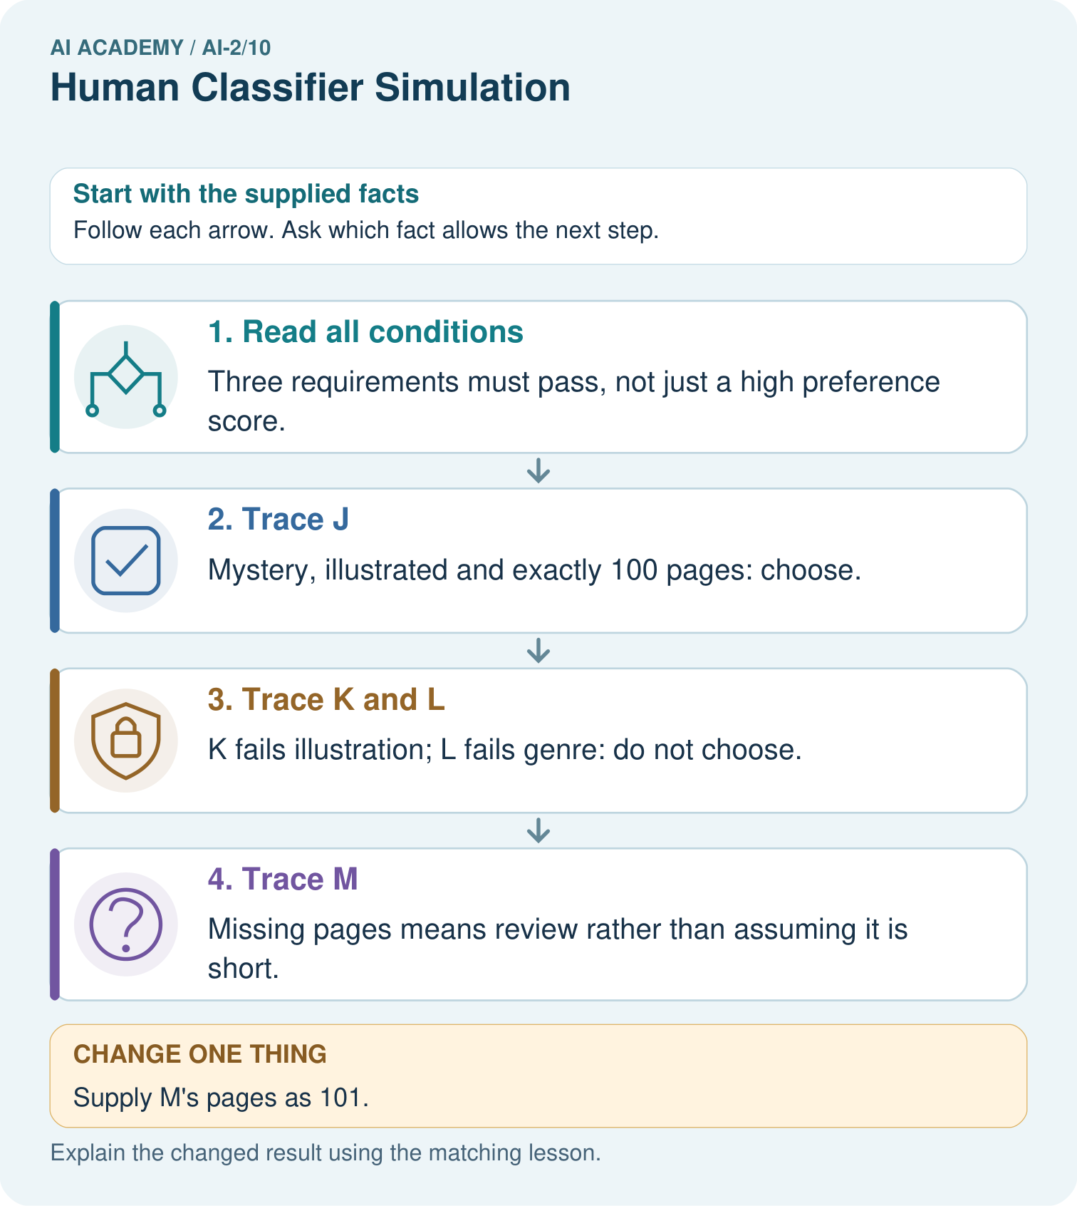
Why are J and M initially treated differently even though both are illustrated mysteries?

My picture-based explanation and changed-case prediction
________________________________________________________________
________________________________________________________________
________________________________________________________________
________________________________________________________________
________________________________________________________________
________________________________________________________________
Support used: alone / hint / worked example. This record is practice evidence.
Project connection: Build a transparent filtering stage for the recommender, storing each failed or unresolved requirement in its explanation.

