AI ACADEMY · WORKBOOK · ai-2/11

Training and Testing
Project: Transparent Book Recommender

01. Recall and choose your starting point
Try the recall before opening notes. Then use a different colour or a labelled second line to correct your explanation.

Human Classifier Simulation
Without opening the old lesson, explain one key idea from Human Classifier Simulation. Give an example and a mistake that the idea helps you avoid.

My remembered idea, example and correction
________________________________________________________________
________________________________________________________________
________________________________________________________________

Operational Labels
Without opening the old lesson, explain one key idea from Operational Labels. Give an example and a mistake that the idea helps you avoid.

My remembered idea, example and correction
________________________________________________________________
________________________________________________________________
________________________________________________________________

Loops and Stopping
Without opening the old lesson, explain one key idea from Loops and Stopping. Give an example and a mistake that the idea helps you avoid.

My remembered idea, example and correction
________________________________________________________________
________________________________________________________________
________________________________________________________________

02. Practise with fading help
Use W2: Distinguish frames from groups for Splits and related examples. Record the answer once; the lesson and workbook refer to the same attempt.
Given inputs | Procedure I chose | Middle steps | Result and check

The step I completed without help, and the hint I needed
________________________________________________________________
________________________________________________________________
________________________________________________________________

03. Individual reasoning check
Use the worked case for Splits and related examples. Proposed explanation: “Different row IDs mean independent examples”. Decide whether this explanation is supported. Point to the step or supplied fact that decides; explain your repair if needed.

My explanation before partner discussion
________________________________________________________________
________________________________________________________________
________________________________________________________________
________________________________________________________________

04. Independent transfer case

Independent case: Audit and repair independently
Eight frames come from trips P (P1 P2 P3), Q (Q1 Q2), R (R1), S (S1 S2). A proposed split is training P1 Q1 R1; validation P2 S1; test Q2 P3 S2. Identify shared groups for each pair of sets. Repair it by assigning P and Q to training, R to validation and S to test. List all frames in each role and give row and group counts. State one limit of the repaired plan.

My independent explanation, trace and limits
________________________________________________________________
________________________________________________________________
________________________________________________________________
________________________________________________________________
________________________________________________________________
________________________________________________________________
________________________________________________________________
Attempt this case before feedback. Record any help. Earlier examples below are further practice; a case already practised with feedback cannot establish fresh transfer.

05. Your learning target
A team tests five rule versions on the same ten books and chooses the highest score. It calls the final score an unbiased unseen test result. Explain the issue and revise the evaluation plan.

06. Solve the given case
A rule is developed and evaluated using the same books A–H.
Why does this not establish unseen performance?
Show your trace, calculation or evidence

Write or draw your reasoning and evidence.
________________________________________________________________
________________________________________________________________
________________________________________________________________
________________________________________________________________
________________________________________________________________

07. Check a changed case
You tune a rule using cards 1 to 8 and test it on cards 9 and 10. After seeing card 9's error you change the rule. Is card 9 still untouched test evidence?
My independent answer and reason

Write or draw your reasoning and evidence.
________________________________________________________________
________________________________________________________________
________________________________________________________________
________________________________________________________________
________________________________________________________________

Week 11 Test and reflect

08. Design a revealing test
Create a changed input, boundary case or missing-information case. Write the expected answer or safe response before testing.
Test record | My evidence
Changed input or condition
Expected answer or fallback
Observed result
Why the result occurred

09. Project checkpoint
Keep final user profiles hidden until weights and thresholds are fixed.
The project change and evidence I will keep

Write or draw your reasoning and evidence.
________________________________________________________________
________________________________________________________________
________________________________________________________________
________________________________________________________________
________________________________________________________________

10. Self check
I can explain the mechanism. I can show evidence. I can handle a changed case. I can name a limit. Mark each as not yet, with help or independently, and attach supporting work.
Teacher review ____________________ Next step ____________________

11. Transfer practice from the original programme
A team tests five rule versions on the same ten books and chooses the highest score. It calls the final score an unbiased unseen test result. Explain the issue and revise the evaluation plan.

My independently reasoned answer
________________________________________________________________
________________________________________________________________
________________________________________________________________
________________________________________________________________
________________________________________________________________
________________________________________________________________
________________________________________________________________
Record support used: none, hint or teacher explanation.

12. W1 Explain the three roles
Explain what training, validation and test sets are used for. What changes if you repeatedly choose a model using its test score?

My reasoning and evidence
________________________________________________________________
________________________________________________________________
________________________________________________________________
________________________________________________________________
________________________________________________________________
________________________________________________________________

13. W2 Distinguish frames from groups
For the worked A through F plan, give training, validation and test counts first in groups and then in rows. Interpret [] from the code and state one problem it cannot detect.

My reasoning and evidence
________________________________________________________________
________________________________________________________________
________________________________________________________________
________________________________________________________________
________________________________________________________________
________________________________________________________________

14. W3 Repair a related example leak
A1 and A2 are in training and A3 is in test. Explain why unique frame IDs and a fixed random seed do not fix this. Propose a repair and what to record.

My reasoning and evidence
________________________________________________________________
________________________________________________________________
________________________________________________________________
________________________________________________________________
________________________________________________________________
________________________________________________________________

15. W4 Audit and repair independently
Eight frames come from trips P (P1 P2 P3), Q (Q1 Q2), R (R1), S (S1 S2). A proposed split is training P1 Q1 R1; validation P2 S1; test Q2 P3 S2. Identify shared groups for each pair of sets. Repair it by assigning P and Q to training, R to validation and S to test. List all frames in each role and give row and group counts. State one limit of the repaired plan.

My reasoning and evidence
________________________________________________________________
________________________________________________________________
________________________________________________________________
________________________________________________________________
________________________________________________________________
________________________________________________________________
________________________________________________________________
________________________________________________________________

16. W5 Match separation to the claim
A model will be evaluated on new routes. Route North has trips A and B; route South has C and D. A proposed split trains on A and C and tests on B and D. Explain the problem and give a route-based alternative. Is this enough for a strong performance claim?

My reasoning and evidence
________________________________________________________________
________________________________________________________________
________________________________________________________________
________________________________________________________________
________________________________________________________________
________________________________________________________________

17. Feedback, return check and learning record
Evidence | My record
Worked alone / hint / model
First step I repaired and why
New case checked later; date and result
What I can now explain without notes
One remaining question
Revisit this idea with your teacher after a delay. Familiarity is different from explaining and using it on a changed case.

18. Pictorial case practice: Training and Testing
A fictional catalogue model learns from scans of book covers and will face previously unseen books.
Book A has scans A1,A2; B has B1,B2; C has C1,C2; D has D1,D2.
Proposed training A1,B1,C1; validation A2,D1; test B2,C2,D2.
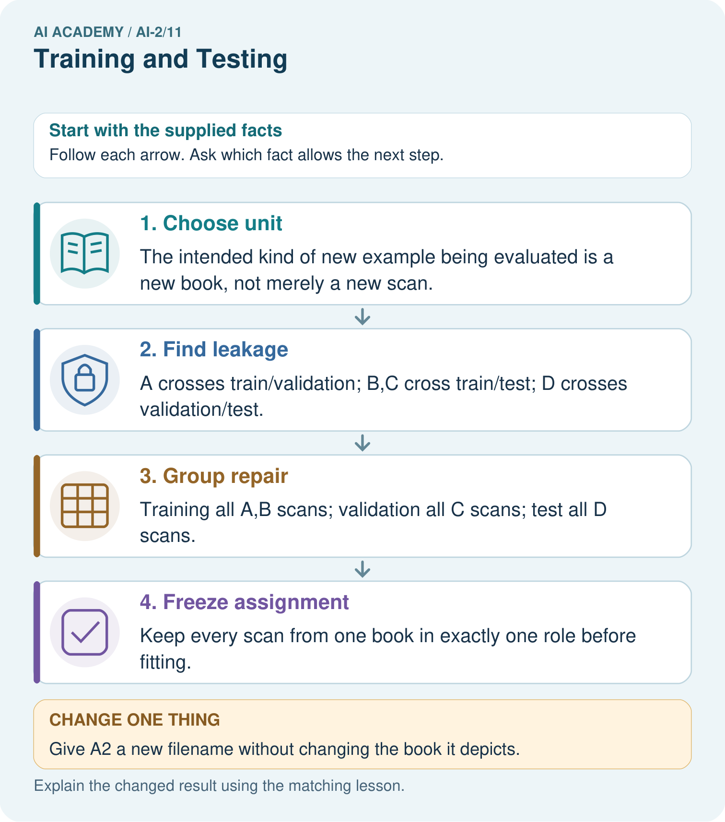
How many distinct books are in each repaired role, and why report that as well as scan counts?

My picture-based explanation and changed-case prediction
________________________________________________________________
________________________________________________________________
________________________________________________________________
________________________________________________________________
________________________________________________________________
________________________________________________________________
Support used: alone / hint / worked example. This record is practice evidence.
Project connection: Group the recommender’s related reviews, editions or repeated-user examples according to its intended evaluation claim.

