AI ACADEMY · WORKBOOK · ai-2/12

Accuracy as a Fraction
Project: Transparent Book Recommender

01. Recall and choose your starting point
Try the recall before opening notes. Then use a different colour or a labelled second line to correct your explanation.

Training and Testing
Without opening the old lesson, explain one key idea from Training and Testing. Give an example and a mistake that the idea helps you avoid.

My remembered idea, example and correction
________________________________________________________________
________________________________________________________________
________________________________________________________________

Features and Distractors
Without opening the old lesson, explain one key idea from Features and Distractors. Give an example and a mistake that the idea helps you avoid.

My remembered idea, example and correction
________________________________________________________________
________________________________________________________________
________________________________________________________________

Debugging Strategies
Without opening the old lesson, explain one key idea from Debugging Strategies. Give an example and a mistake that the idea helps you avoid.

My remembered idea, example and correction
________________________________________________________________
________________________________________________________________
________________________________________________________________

02. Practise with fading help
Use W2: Compare both class fractions for Accuracy and class imbalance. Record the answer once; the lesson and workbook refer to the same attempt.
Given inputs | Procedure I chose | Middle steps | Result and check

The step I completed without help, and the hint I needed
________________________________________________________________
________________________________________________________________
________________________________________________________________

03. Individual reasoning check
Use the worked case for Accuracy and class imbalance. Proposed explanation: “High accuracy means both classes work well”. Decide whether this explanation is supported. Point to the step or supplied fact that decides; explain your repair if needed.

My explanation before partner discussion
________________________________________________________________
________________________________________________________________
________________________________________________________________
________________________________________________________________

04. Independent transfer case

Independent case: Assess a new comparison independently
New training labels have a clear majority. A separate evaluation has 18 clear and 2 blocked records. The always-clear baseline is [[18,0],[2,0]] and candidate is [[15,3],[1,1]], with reference rows and clear then blocked on both axes. Calculate ordinary accuracy, both class fractions and balanced accuracy for each. Give candidate FP and FN, then explain why the metrics do not choose an automatic winner.

My independent explanation, trace and limits
________________________________________________________________
________________________________________________________________
________________________________________________________________
________________________________________________________________
________________________________________________________________
________________________________________________________________
________________________________________________________________
Attempt this case before feedback. Record any help. Earlier examples below are further practice; a case already practised with feedback cannot establish fresh transfer.

05. Your learning target
Class A gets 8/10 cases right and class B gets 18/30 right. Compute each rate and the combined rate. Why is averaging the two percentages misleading here?

06. Solve the given case
Nine of twelve held-out classifications are correct.
Compute accuracy and state the denominator.
Show your trace, calculation or evidence

Write or draw your reasoning and evidence.
________________________________________________________________
________________________________________________________________
________________________________________________________________
________________________________________________________________
________________________________________________________________

07. Check a changed case
A classifier gets 9 of 12 cases right. Another gets 8 of 10 right. Calculate both accuracies and identify the larger fraction.
My independent answer and reason

Write or draw your reasoning and evidence.
________________________________________________________________
________________________________________________________________
________________________________________________________________
________________________________________________________________
________________________________________________________________

Week 12 Test and reflect

08. Design a revealing test
Create a changed input, boundary case or missing-information case. Write the expected answer or safe response before testing.
Test record | My evidence
Changed input or condition
Expected answer or fallback
Observed result
Why the result occurred

09. Project checkpoint
Report correct recommendations / all test users, alongside the raw test count.
The project change and evidence I will keep

Write or draw your reasoning and evidence.
________________________________________________________________
________________________________________________________________
________________________________________________________________
________________________________________________________________
________________________________________________________________

10. Self check
I can explain the mechanism. I can show evidence. I can handle a changed case. I can name a limit. Mark each as not yet, with help or independently, and attach supporting work.
Teacher review ____________________ Next step ____________________

11. Transfer practice from the original programme
Class A gets 8/10 cases right and class B gets 18/30 right. Compute each rate and the combined rate. Why is averaging the two percentages misleading here?

My independently reasoned answer
________________________________________________________________
________________________________________________________________
________________________________________________________________
________________________________________________________________
________________________________________________________________
________________________________________________________________
________________________________________________________________
Record support used: none, hint or teacher explanation.

12. W1 Score the majority baseline
Training has 16 clear and 4 blocked labels. State the majority rule. On the worked evaluation, give its matrix, accuracy, false positives and false negatives with blocked positive. Explain why 80 percent is incomplete.

My reasoning and evidence
________________________________________________________________
________________________________________________________________
________________________________________________________________
________________________________________________________________
________________________________________________________________
________________________________________________________________

13. W2 Compare both class fractions
For the worked candidate [[12,4],[0,4]], give ordinary accuracy, both class-specific correct fractions, balanced accuracy, false positives and false negatives. Compare with the baseline.

My reasoning and evidence
________________________________________________________________
________________________________________________________________
________________________________________________________________
________________________________________________________________
________________________________________________________________
________________________________________________________________

14. W3 Explain a changed class mix
For the illustrative 8-clear 8-blocked set, use baseline [[8,0],[8,0]] and candidate [[6,2],[0,8]]. Calculate ordinary and balanced accuracy for each. Explain what stayed fixed and what this example does not prove.

My reasoning and evidence
________________________________________________________________
________________________________________________________________
________________________________________________________________
________________________________________________________________
________________________________________________________________
________________________________________________________________

15. W4 Assess a new comparison independently
New training labels have a clear majority. A separate evaluation has 18 clear and 2 blocked records. The always-clear baseline is [[18,0],[2,0]] and candidate is [[15,3],[1,1]], with reference rows and clear then blocked on both axes. Calculate ordinary accuracy, both class fractions and balanced accuracy for each. Give candidate FP and FN, then explain why the metrics do not choose an automatic winner.

My reasoning and evidence
________________________________________________________________
________________________________________________________________
________________________________________________________________
________________________________________________________________
________________________________________________________________
________________________________________________________________
________________________________________________________________
________________________________________________________________

16. W5 Limit claims from missing classes
An evaluation contains ten clear cases and no blocked cases. All predictions are clear. State ordinary accuracy, explain why blocked performance is unavailable, and describe how our code handles the missing class.

My reasoning and evidence
________________________________________________________________
________________________________________________________________
________________________________________________________________
________________________________________________________________
________________________________________________________________
________________________________________________________________

17. Summaries with counts and proportions — W1 State the denominator
In the worked poll, why is the known denominator 4 rather than 5?

My reasoning and evidence
________________________________________________________________
________________________________________________________________
________________________________________________________________
________________________________________________________________
________________________________________________________________
________________________________________________________________

18. Summaries with counts and proportions — W2 Compare proportions
Poll A has 2 Yes of 4 known and Poll B has 3 Yes of 6 known. Compare proportions and counts.

My reasoning and evidence
________________________________________________________________
________________________________________________________________
________________________________________________________________
________________________________________________________________
________________________________________________________________
________________________________________________________________

19. Summaries with counts and proportions — W3 Repair zero division
All three responses are Unknown. What should the program report?

My reasoning and evidence
________________________________________________________________
________________________________________________________________
________________________________________________________________
________________________________________________________________
________________________________________________________________
________________________________________________________________

20. Summaries with counts and proportions — W4 Summarize independently
Process Yes, Yes, No, Unknown, No, Yes. Report Yes count, known count, unknown count and Yes proportion among known.

My reasoning and evidence
________________________________________________________________
________________________________________________________________
________________________________________________________________
________________________________________________________________
________________________________________________________________
________________________________________________________________
________________________________________________________________
________________________________________________________________

21. Summaries with counts and proportions — W5 Avoid overclaiming
Three of five known volunteers said Yes. Can you say 60 percent of all students agree?

My reasoning and evidence
________________________________________________________________
________________________________________________________________
________________________________________________________________
________________________________________________________________
________________________________________________________________
________________________________________________________________

22. Feedback, return check and learning record
Evidence | My record
Worked alone / hint / model
First step I repaired and why
New case checked later; date and result
What I can now explain without notes
One remaining question
Revisit this idea with your teacher after a delay. Familiarity is different from explaining and using it on a changed case.

23. Pictorial case practice: Accuracy as a Fraction
A fictional shelf classifier predicts repair needed or not needed.
Evaluation reference labels: 16 not-needed and 4 needed. Positive class is needed.
Always-not-needed baseline is correct on 16. Candidate has TP=3,FN=1,FP=2,TN=14.
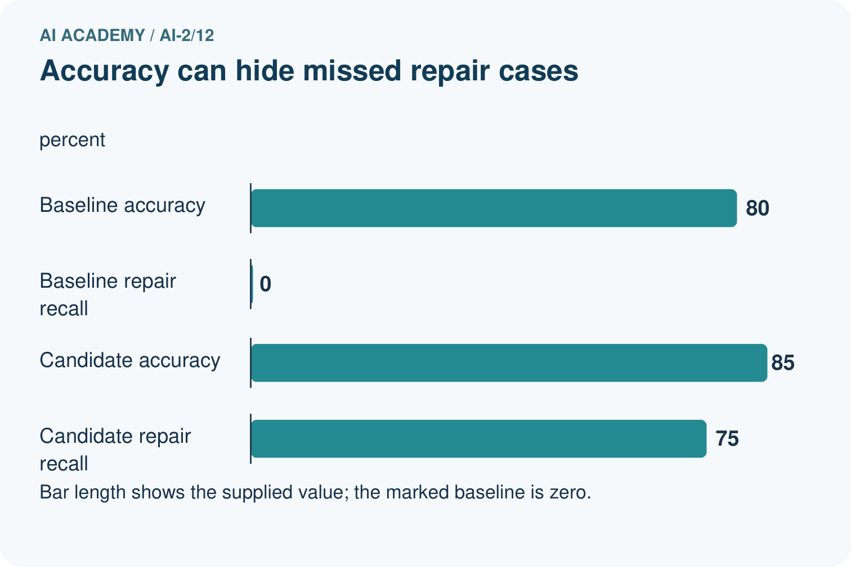
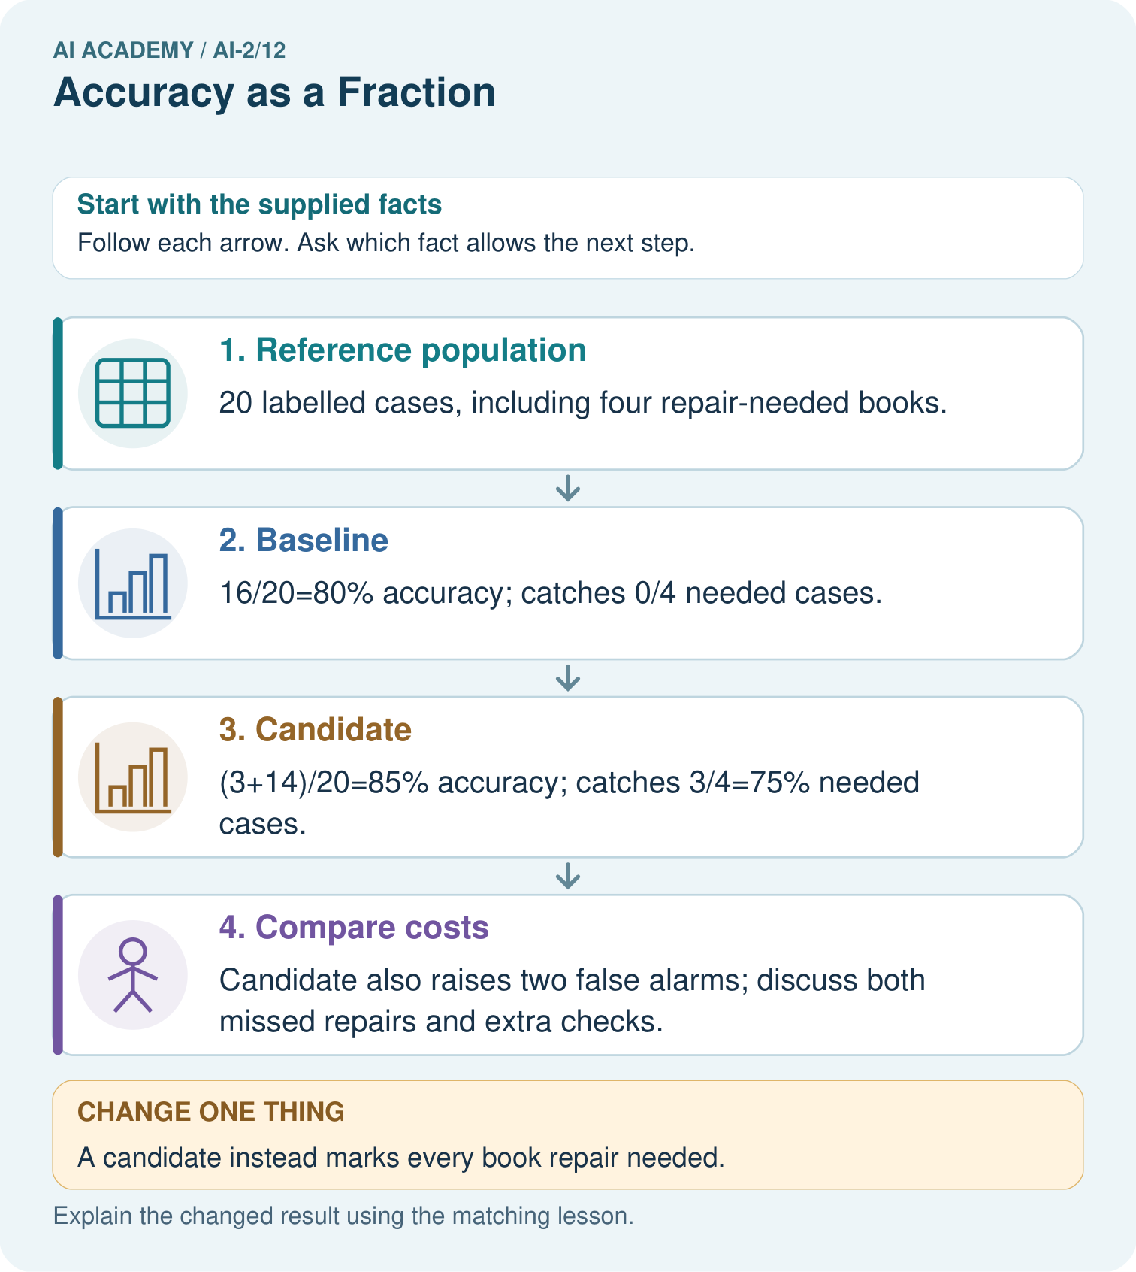
Why is 100% repair detection not sufficient to declare the changed classifier best?

My picture-based explanation and changed-case prediction
________________________________________________________________
________________________________________________________________
________________________________________________________________
________________________________________________________________
________________________________________________________________
________________________________________________________________
Support used: alone / hint / worked example. This record is practice evidence.
Project connection: Compare recommender choices with a simple baseline and report relevant rare-category failures, not only aggregate accuracy.

