AI ACADEMY · WORKBOOK · ai-2/14

Decision Trees
Project: Transparent Book Recommender

01. Recall and choose your starting point
Try the recall before opening notes. Then use a different colour or a labelled second line to correct your explanation.

Types of Classification Error
Without opening the old lesson, explain one key idea from Types of Classification Error. Give an example and a mistake that the idea helps you avoid.

My remembered idea, example and correction
________________________________________________________________
________________________________________________________________
________________________________________________________________

Training and Testing
Without opening the old lesson, explain one key idea from Training and Testing. Give an example and a mistake that the idea helps you avoid.

My remembered idea, example and correction
________________________________________________________________
________________________________________________________________
________________________________________________________________

Operational Labels
Without opening the old lesson, explain one key idea from Operational Labels. Give an example and a mistake that the idea helps you avoid.

My remembered idea, example and correction
________________________________________________________________
________________________________________________________________
________________________________________________________________

02. Practise with fading help
Use W2: Verify the candidate scores for Fitting a decision tree. Record the answer once; the lesson and workbook refer to the same attempt.
Given inputs | Procedure I chose | Middle steps | Result and check

The step I completed without help, and the hint I needed
________________________________________________________________
________________________________________________________________
________________________________________________________________

03. Individual reasoning check
Use the worked case for Fitting a decision tree. Proposed explanation: “A near branch must predict blocked”. Decide whether this explanation is supported. Point to the step or supplied fact that decides; explain your repair if needed.

My explanation before partner discussion
________________________________________________________________
________________________________________________________________
________________________________________________________________
________________________________________________________________

04. Independent transfer case

Independent case: Fit a new tree independently
New training rows (near,tall,label) are (1,0,clear),(1,1,clear),(1,0,clear),(0,1,blocked),(0,0,blocked),(0,1,clear). Use the same candidate order and tie policies. Give both candidates’ leaves and errors, then select the tree. Validation rows are (1,1,clear),(0,0,blocked),(0,1,clear),(1,0,blocked). List tree predictions and compare accuracy with the training-majority baseline.

My independent explanation, trace and limits
________________________________________________________________
________________________________________________________________
________________________________________________________________
________________________________________________________________
________________________________________________________________
________________________________________________________________
________________________________________________________________
Attempt this case before feedback. Record any help. Earlier examples below are further practice; a case already practised with feedback cannot establish fresh transfer.

05. Your learning target
Build a tree for science books: first ask science?; then, for yes, pages<=100? Trace science/100 and history/70. What should happen to science with missing pages?

06. Solve the given case
First ask animal book? If no, Other. If yes, ask pages<100; yes gives Short Animal, no gives Longer Animal.
Trace 90-page animal and science books.
Show your trace, calculation or evidence

Write or draw your reasoning and evidence.
________________________________________________________________
________________________________________________________________
________________________________________________________________
________________________________________________________________
________________________________________________________________

07. Check a changed case
A tree asks topic is space, then pages at most 60. A space book has 70 pages. Trace both answers and explain why you cannot stop at the first question.
My independent answer and reason

Write or draw your reasoning and evidence.
________________________________________________________________
________________________________________________________________
________________________________________________________________
________________________________________________________________
________________________________________________________________

Week 14 Test and reflect

08. Design a revealing test
Create a changed input, boundary case or missing-information case. Write the expected answer or safe response before testing.
Test record | My evidence
Changed input or condition
Expected answer or fallback
Observed result
Why the result occurred

09. Project checkpoint
Create a transparent tree for hard constraints before applying preference scores.
The project change and evidence I will keep

Write or draw your reasoning and evidence.
________________________________________________________________
________________________________________________________________
________________________________________________________________
________________________________________________________________
________________________________________________________________

10. Self check
I can explain the mechanism. I can show evidence. I can handle a changed case. I can name a limit. Mark each as not yet, with help or independently, and attach supporting work.
Teacher review ____________________ Next step ____________________

11. Transfer practice from the original programme
Build a tree for science books: first ask science?; then, for yes, pages<=100? Trace science/100 and history/70. What should happen to science with missing pages?

My independently reasoned answer
________________________________________________________________
________________________________________________________________
________________________________________________________________
________________________________________________________________
________________________________________________________________
________________________________________________________________
________________________________________________________________
Record support used: none, hint or teacher explanation.

12. W1 Name the parts and decisions
Identify the root, its two branches, leaf predictions and depth of the worked fitted tree. Which parts were selected using training labels?

My reasoning and evidence
________________________________________________________________
________________________________________________________________
________________________________________________________________
________________________________________________________________
________________________________________________________________
________________________________________________________________

13. W2 Verify the candidate scores
For each near branch and each tall branch, count blocked and clear labels and choose a leaf. Give the total errors for each candidate question.

My reasoning and evidence
________________________________________________________________
________________________________________________________________
________________________________________________________________
________________________________________________________________
________________________________________________________________
________________________________________________________________

14. W3 Separate fitting from prediction
A learner sees a blocked validation case with near=0 and changes that leaf to blocked before reporting the score. Explain what changed and how to report the original fitted tree fairly.

My reasoning and evidence
________________________________________________________________
________________________________________________________________
________________________________________________________________
________________________________________________________________
________________________________________________________________
________________________________________________________________

15. W4 Fit a new tree independently
New training rows (near,tall,label) are (1,0,clear),(1,1,clear),(1,0,clear),(0,1,blocked),(0,0,blocked),(0,1,clear). Use the same candidate order and tie policies. Give both candidates’ leaves and errors, then select the tree. Validation rows are (1,1,clear),(0,0,blocked),(0,1,clear),(1,0,blocked). List tree predictions and compare accuracy with the training-majority baseline.

My reasoning and evidence
________________________________________________________________
________________________________________________________________
________________________________________________________________
________________________________________________________________
________________________________________________________________
________________________________________________________________
________________________________________________________________
________________________________________________________________

16. W5 Audit a tie and a claim
If near and tall make the same training error count, which question does this code retain and why? Does retaining that question prove it will be better on future trips?

My reasoning and evidence
________________________________________________________________
________________________________________________________________
________________________________________________________________
________________________________________________________________
________________________________________________________________
________________________________________________________________

17. Feedback, return check and learning record
Evidence | My record
Worked alone / hint / model
First step I repaired and why
New case checked later; date and result
What I can now explain without notes
One remaining question
Revisit this idea with your teacher after a delay. Familiarity is different from explaining and using it on a changed case.

18. Pictorial case practice: Decision Trees
A fictional toy classifier predicts whether a book needs an illustration label.
Training rows (colour_cover,diagram_inside,label): (1,1,Yes),(1,0,No),(0,1,Yes),(0,0,No).
Candidates ask colour_cover or diagram_inside; each leaf uses its training majority. A leaf tie chooses No. Select fewer training errors.
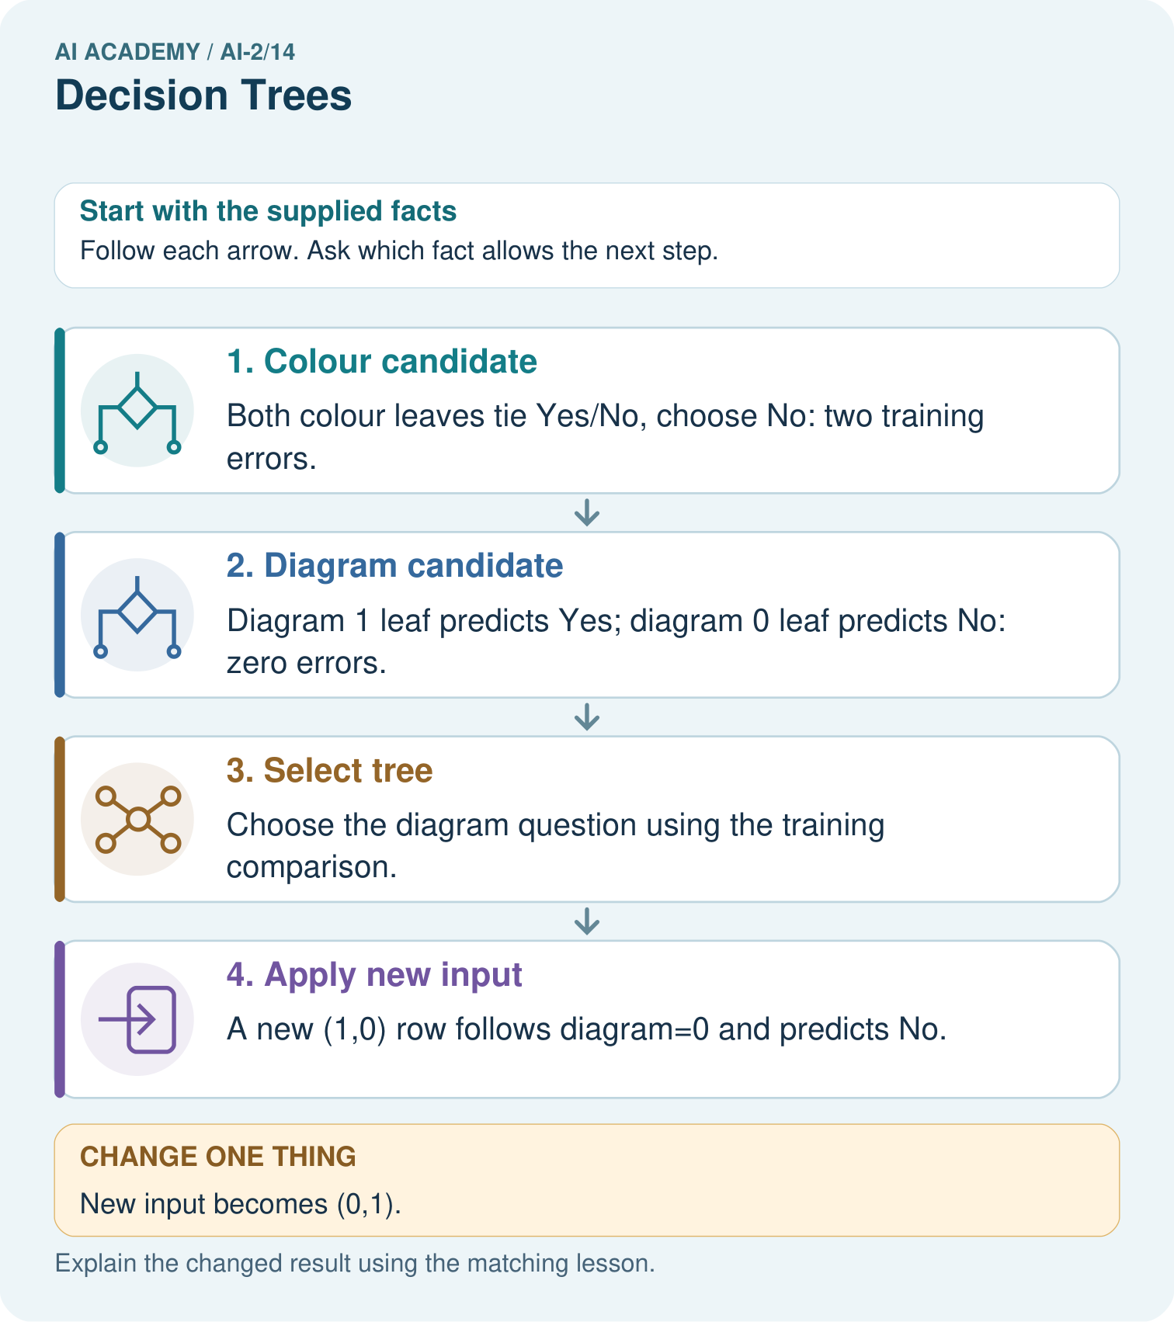
Why does changing colour alone not change this tree’s prediction?

My picture-based explanation and changed-case prediction
________________________________________________________________
________________________________________________________________
________________________________________________________________
________________________________________________________________
________________________________________________________________
________________________________________________________________
Support used: alone / hint / worked example. This record is practice evidence.
Project connection: Fit or hand-specify recommender classification rules transparently, retaining candidate definitions and training-only selection evidence.

