AI ACADEMY · WORKBOOK · ai-2/17

Noise and Outliers
Project: Transparent Book Recommender

01. Recall and choose your starting point
Try the recall before opening notes. Then use a different colour or a labelled second line to correct your explanation.

Overfitting Intuition
Without opening the old lesson, explain one key idea from Overfitting Intuition. Give an example and a mistake that the idea helps you avoid.

My remembered idea, example and correction
________________________________________________________________
________________________________________________________________
________________________________________________________________

Decision Trees
Without opening the old lesson, explain one key idea from Decision Trees. Give an example and a mistake that the idea helps you avoid.

My remembered idea, example and correction
________________________________________________________________
________________________________________________________________
________________________________________________________________

Training and Testing
Without opening the old lesson, explain one key idea from Training and Testing. Give an example and a mistake that the idea helps you avoid.

My remembered idea, example and correction
________________________________________________________________
________________________________________________________________
________________________________________________________________

02. Practise with fading help
Use W2: Compute two medians for Mean median and unusual values. Record the answer once; the lesson and workbook refer to the same attempt.
Given inputs | Procedure I chose | Middle steps | Result and check

The step I completed without help, and the hint I needed
________________________________________________________________
________________________________________________________________
________________________________________________________________

03. Individual reasoning check
Use the worked case for Mean median and unusual values. Proposed explanation: “A successful run proves the conclusion”. Decide whether this explanation is supported. Point to the step or supplied fact that decides; explain your repair if needed.

My explanation before partner discussion
________________________________________________________________
________________________________________________________________
________________________________________________________________
________________________________________________________________

04. Independent transfer case

Independent case: Compare summaries independently
For 1, 2, 2, 3 and 12, calculate mean and median. Then replace 12 with 2 and recalculate. Explain the change.

My independent explanation, trace and limits
________________________________________________________________
________________________________________________________________
________________________________________________________________
________________________________________________________________
________________________________________________________________
________________________________________________________________
________________________________________________________________
Attempt this case before feedback. Record any help. Earlier examples below are further practice; a case already practised with feedback cannot establish fresh transfer.

05. Your learning target
Page counts are 72,80,96,960. The last book may be an anthology. Should a cleaning script delete it automatically? Give a defensible investigation and document the outcome.

06. Solve the given case
Recorded lengths are 90,95,100,105,900 pages.
Is 900 automatically wrong?
Show your trace, calculation or evidence

Write or draw your reasoning and evidence.
________________________________________________________________
________________________________________________________________
________________________________________________________________
________________________________________________________________
________________________________________________________________

07. Check a changed case
Page counts are 40, 42, 43 and 900. Should 900 be deleted immediately? Give two explanations to investigate.
My independent answer and reason

Write or draw your reasoning and evidence.
________________________________________________________________
________________________________________________________________
________________________________________________________________
________________________________________________________________
________________________________________________________________

Week 17 Test and reflect

08. Design a revealing test
Create a changed input, boundary case or missing-information case. Write the expected answer or safe response before testing.
Test record | My evidence
Changed input or condition
Expected answer or fallback
Observed result
Why the result occurred

09. Project checkpoint
Keep legitimate unusual books so the recommender can serve unusual readers.
The project change and evidence I will keep

Write or draw your reasoning and evidence.
________________________________________________________________
________________________________________________________________
________________________________________________________________
________________________________________________________________
________________________________________________________________

10. Self check
I can explain the mechanism. I can show evidence. I can handle a changed case. I can name a limit. Mark each as not yet, with help or independently, and attach supporting work.
Teacher review ____________________ Next step ____________________

11. Transfer practice from the original programme
Page counts are 72,80,96,960. The last book may be an anthology. Should a cleaning script delete it automatically? Give a defensible investigation and document the outcome.

My independently reasoned answer
________________________________________________________________
________________________________________________________________
________________________________________________________________
________________________________________________________________
________________________________________________________________
________________________________________________________________
________________________________________________________________
Record support used: none, hint or teacher explanation.

12. W1 Compute a mean
Find the mean of 4, 4, 6, 6 and 10.

My reasoning and evidence
________________________________________________________________
________________________________________________________________
________________________________________________________________
________________________________________________________________
________________________________________________________________
________________________________________________________________

13. W2 Compute two medians
Find medians of [9, 1, 3] and [8, 2, 4, 6].

My reasoning and evidence
________________________________________________________________
________________________________________________________________
________________________________________________________________
________________________________________________________________
________________________________________________________________
________________________________________________________________

14. W3 Repair an explanation
A learner deletes 18 because it is above the mean. What evidence is needed before correcting or excluding it?

My reasoning and evidence
________________________________________________________________
________________________________________________________________
________________________________________________________________
________________________________________________________________
________________________________________________________________
________________________________________________________________

15. W4 Compare summaries independently
For 1, 2, 2, 3 and 12, calculate mean and median. Then replace 12 with 2 and recalculate. Explain the change.

My reasoning and evidence
________________________________________________________________
________________________________________________________________
________________________________________________________________
________________________________________________________________
________________________________________________________________
________________________________________________________________
________________________________________________________________
________________________________________________________________

16. W5 Report missing evidence
A dataset is empty. Is reporting a mean of 0 justified?

My reasoning and evidence
________________________________________________________________
________________________________________________________________
________________________________________________________________
________________________________________________________________
________________________________________________________________
________________________________________________________________

17. Feedback, return check and learning record
Evidence | My record
Worked alone / hint / model
First step I repaired and why
New case checked later; date and result
What I can now explain without notes
One remaining question
Revisit this idea with your teacher after a delay. Familiarity is different from explaining and using it on a changed case.

18. Pictorial case practice: Noise and Outliers
A fictional library records five book-processing times in minutes.
Sorted times: 2,3,3,4,18.
All are recorded measurements; no evidence yet shows 18 is a mistake.
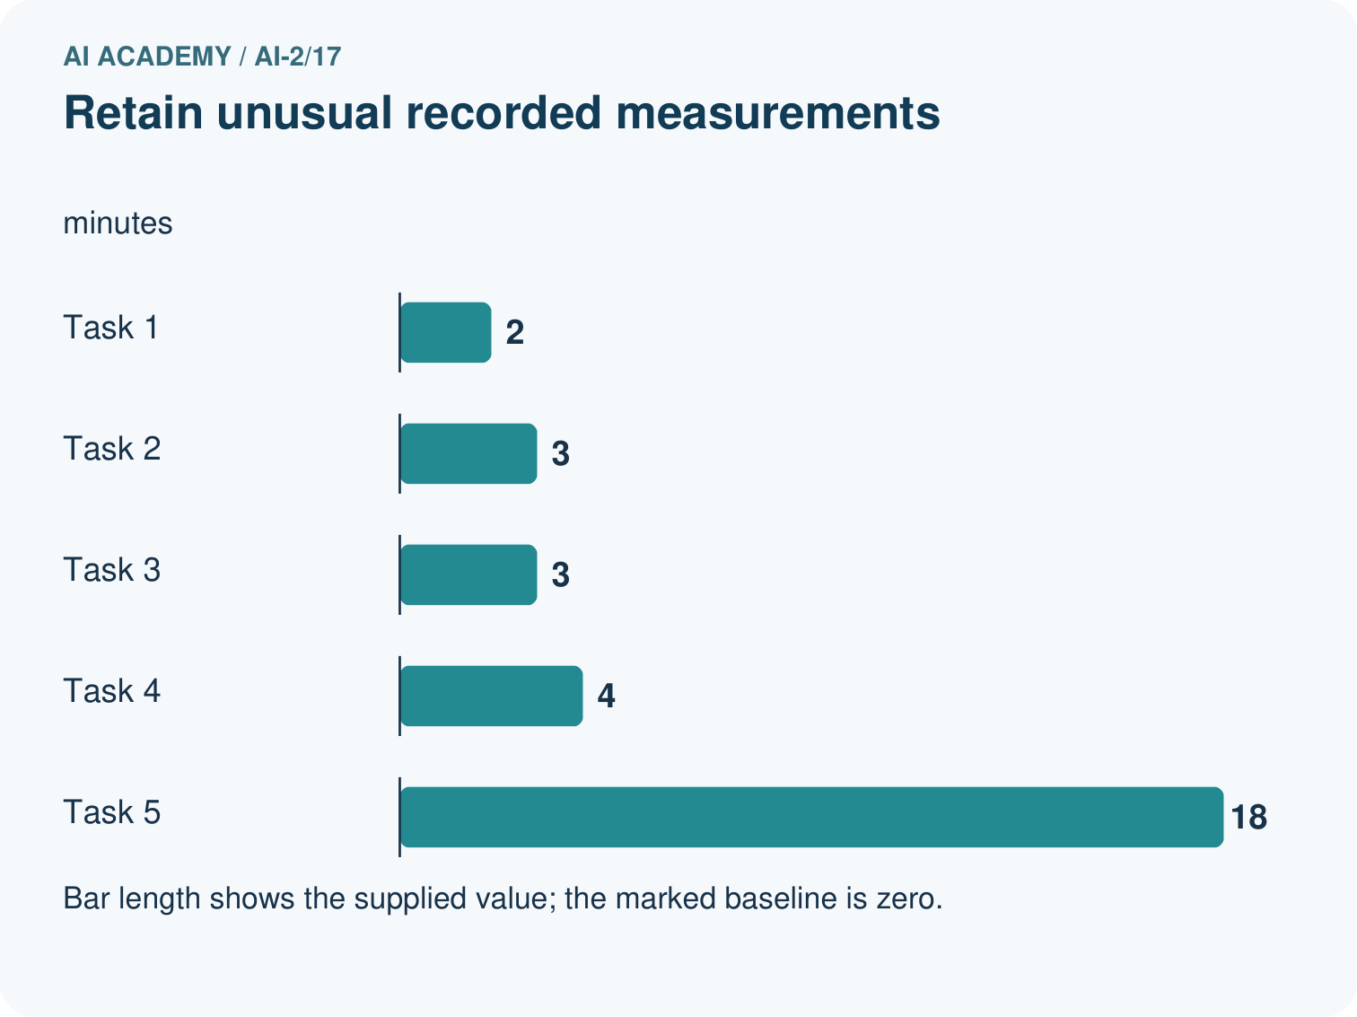
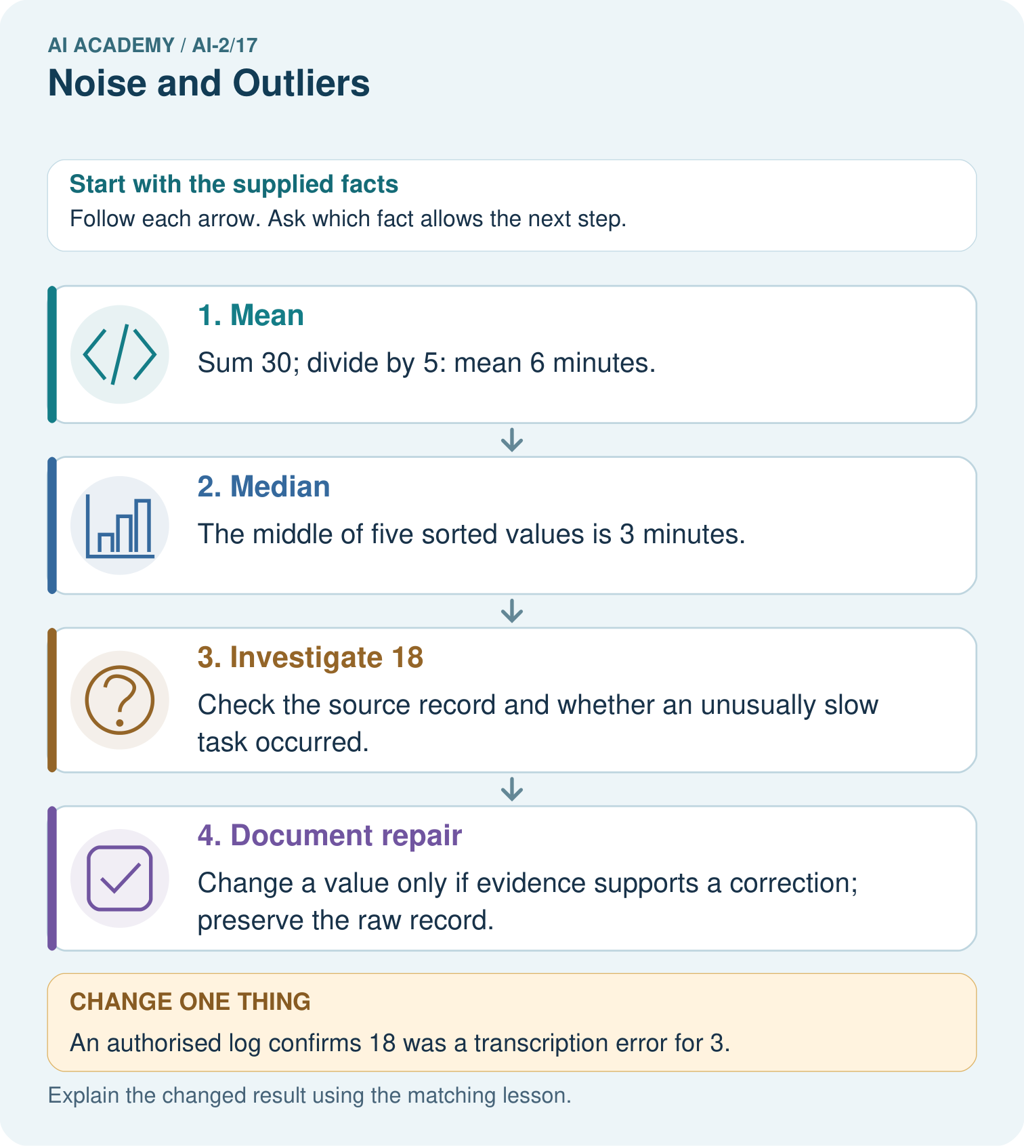
If 18 was genuine, which summary better describes the middle observed task, and what extra fact should be shown?

My picture-based explanation and changed-case prediction
________________________________________________________________
________________________________________________________________
________________________________________________________________
________________________________________________________________
________________________________________________________________
________________________________________________________________
Support used: alone / hint / worked example. This record is practice evidence.
Project connection: Investigate unusual recommender features and show evidence-backed repairs instead of removing inconvenient records.

