AI ACADEMY · WORKBOOK · ai-2/22

Nearest Neighbor Reasoning
Project: Transparent Book Recommender

01. Recall and choose your starting point
Try the recall before opening notes. Then use a different colour or a labelled second line to correct your explanation.

Similarity by Selected Traits
Without opening the old lesson, explain one key idea from Similarity by Selected Traits. Give an example and a mistake that the idea helps you avoid.

My remembered idea, example and correction
________________________________________________________________
________________________________________________________________
________________________________________________________________

Sampling and Representation
Without opening the old lesson, explain one key idea from Sampling and Representation. Give an example and a mistake that the idea helps you avoid.

My remembered idea, example and correction
________________________________________________________________
________________________________________________________________
________________________________________________________________

Overfitting Intuition
Without opening the old lesson, explain one key idea from Overfitting Intuition. Give an example and a mistake that the idea helps you avoid.

My remembered idea, example and correction
________________________________________________________________
________________________________________________________________
________________________________________________________________

02. Practise with fading help
Use W2: Apply neighbour and tie rules for Nearest neighbours and distances. Record the answer once; the lesson and workbook refer to the same attempt.
Given inputs | Procedure I chose | Middle steps | Result and check

The step I completed without help, and the hint I needed
________________________________________________________________
________________________________________________________________
________________________________________________________________

03. Individual reasoning check
Use the worked case for Nearest neighbours and distances. Proposed explanation: “A negative difference is a negative distance”. Decide whether this explanation is supported. Point to the step or supplied fact that decides; explain your repair if needed.

My explanation before partner discussion
________________________________________________________________
________________________________________________________________
________________________________________________________________
________________________________________________________________

04. Independent transfer case

Independent case: Find neighbours independently
New training rows are P at 1 cm clear, Q at 5 blocked, R at 7 blocked, S at 11 clear, T at 13 blocked. For query 6, give all distances, order the IDs by distance then alphabetically, and predict with k=1 and k=3. Using the same training pool and k=3, score validation (6,blocked),(10,clear),(12,blocked). Compare the training-majority baseline.

My independent explanation, trace and limits
________________________________________________________________
________________________________________________________________
________________________________________________________________
________________________________________________________________
________________________________________________________________
________________________________________________________________
________________________________________________________________
Attempt this case before feedback. Record any help. Earlier examples below are further practice; a case already practised with feedback cannot establish fresh transfer.

05. Your learning target
A query has nearest books A and B at distance 1, with conflicting labels; C is distance 2. A program chooses whichever row occurs first. Explain the risk and define a reproducible alternative.

06. Solve the given case
A=[1,1] liked, B=[1,0] disliked, C=[0,0] disliked; query=[0,1].
Find nearest neighbours using differing-trait distance and k=1.
Show your trace, calculation or evidence

Write or draw your reasoning and evidence.
________________________________________________________________
________________________________________________________________
________________________________________________________________
________________________________________________________________
________________________________________________________________

07. Check a changed case
Training items have one numeric feature: A=2 with label short, B=8 with label long. A new item has value 6. Use absolute distance to choose its nearest neighbour.
My independent answer and reason

Write or draw your reasoning and evidence.
________________________________________________________________
________________________________________________________________
________________________________________________________________
________________________________________________________________
________________________________________________________________

Week 22 Test and reflect

08. Design a revealing test
Create a changed input, boundary case or missing-information case. Write the expected answer or safe response before testing.
Test record | My evidence
Changed input or condition
Expected answer or fallback
Observed result
Why the result occurred

09. Project checkpoint
Use neighboring liked books as evidence, while explaining which traits created closeness.
The project change and evidence I will keep

Write or draw your reasoning and evidence.
________________________________________________________________
________________________________________________________________
________________________________________________________________
________________________________________________________________
________________________________________________________________

10. Self check
I can explain the mechanism. I can show evidence. I can handle a changed case. I can name a limit. Mark each as not yet, with help or independently, and attach supporting work.
Teacher review ____________________ Next step ____________________

11. Transfer practice from the original programme
A query has nearest books A and B at distance 1, with conflicting labels; C is distance 2. A program chooses whichever row occurs first. Explain the risk and define a reproducible alternative.

My independently reasoned answer
________________________________________________________________
________________________________________________________________
________________________________________________________________
________________________________________________________________
________________________________________________________________
________________________________________________________________
________________________________________________________________
Record support used: none, hint or teacher explanation.

12. W1 Calculate feature distances
For query 3 cm, calculate distances to all five training rows. Explain why A and B tie even though their labels differ.

My reasoning and evidence
________________________________________________________________
________________________________________________________________
________________________________________________________________
________________________________________________________________
________________________________________________________________
________________________________________________________________

13. W2 Apply neighbour and tie rules
For query 3, list the selected IDs and predictions for k=1 and k=3 using alphabetical ID order on equal distances. Explain what changes and what remains the same.

My reasoning and evidence
________________________________________________________________
________________________________________________________________
________________________________________________________________
________________________________________________________________
________________________________________________________________
________________________________________________________________

14. W3 Keep evaluation examples separate
Why must the three validation reference labels not enter the neighbour pool? Give the fixed k=3 score and baseline score on the worked validation examples.

My reasoning and evidence
________________________________________________________________
________________________________________________________________
________________________________________________________________
________________________________________________________________
________________________________________________________________
________________________________________________________________

15. W4 Find neighbours independently
New training rows are P at 1 cm clear, Q at 5 blocked, R at 7 blocked, S at 11 clear, T at 13 blocked. For query 6, give all distances, order the IDs by distance then alphabetically, and predict with k=1 and k=3. Using the same training pool and k=3, score validation (6,blocked),(10,clear),(12,blocked). Compare the training-majority baseline.

My reasoning and evidence
________________________________________________________________
________________________________________________________________
________________________________________________________________
________________________________________________________________
________________________________________________________________
________________________________________________________________
________________________________________________________________
________________________________________________________________

16. W5 Interpret a vote and a match
Two of three neighbours vote clear. Does that prove a two-thirds chance of a correct prediction? Does an exact feature match guarantee a correct label? Explain both limits.

My reasoning and evidence
________________________________________________________________
________________________________________________________________
________________________________________________________________
________________________________________________________________
________________________________________________________________
________________________________________________________________

17. Feedback, return check and learning record
Evidence | My record
Worked alone / hint / model
First step I repaired and why
New case checked later; date and result
What I can now explain without notes
One remaining question
Revisit this idea with your teacher after a delay. Familiarity is different from explaining and using it on a changed case.

18. Pictorial case practice: Nearest Neighbor Reasoning
A fictional one-feature classifier predicts compact or extended book format.
Stored training rows: A at 2 units compact, B at 6 extended, C at 8 compact, D at 12 extended. Query is 7.
Distance is absolute difference; ties sort by ID; tied category vote chooses compact.
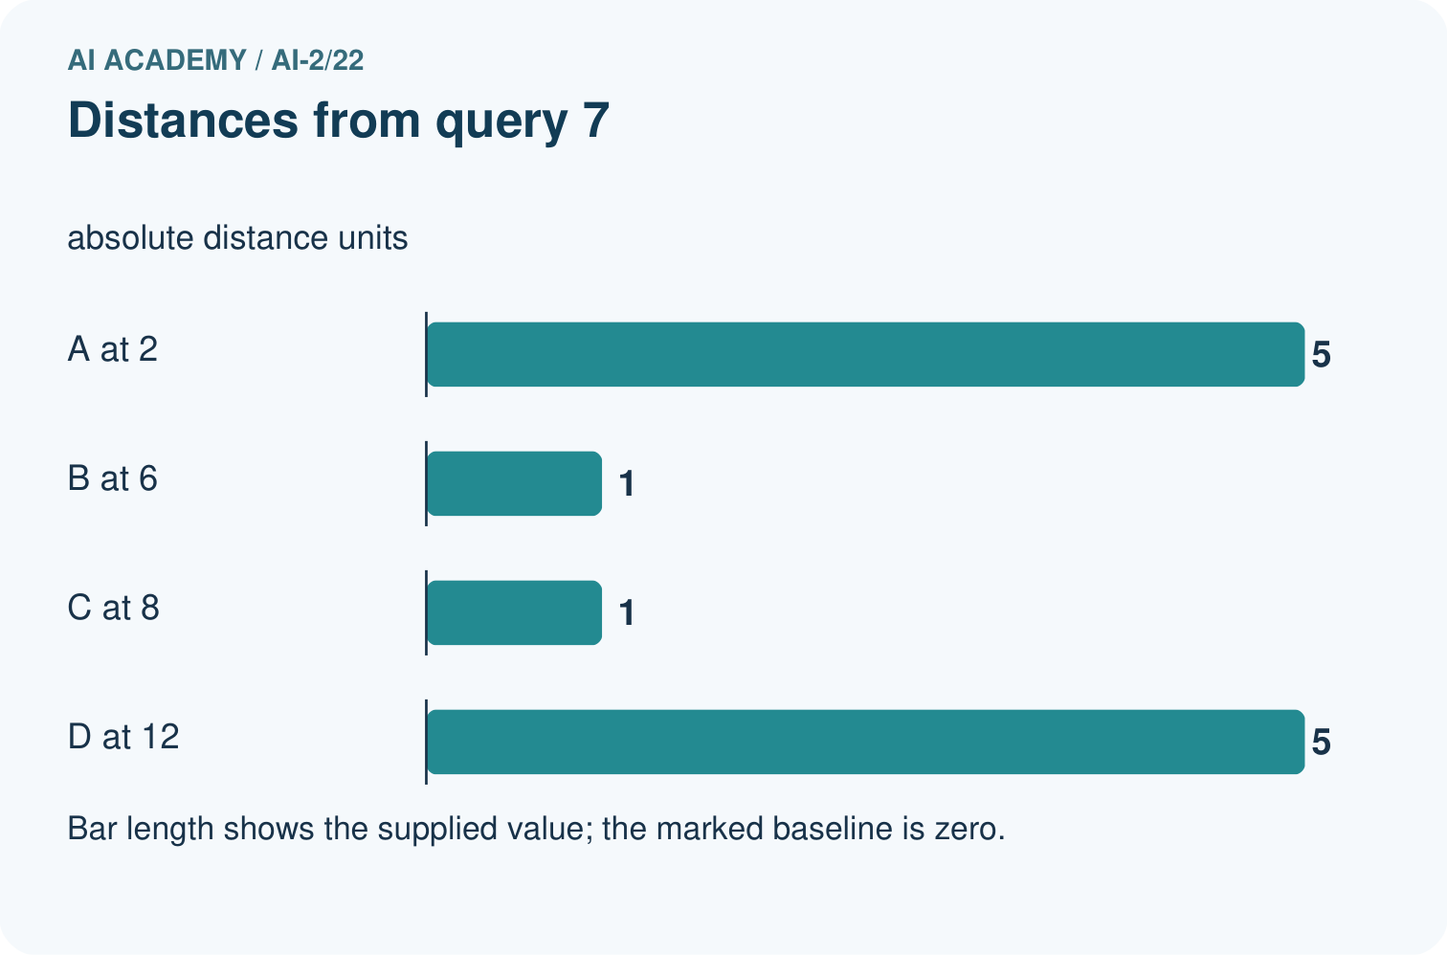
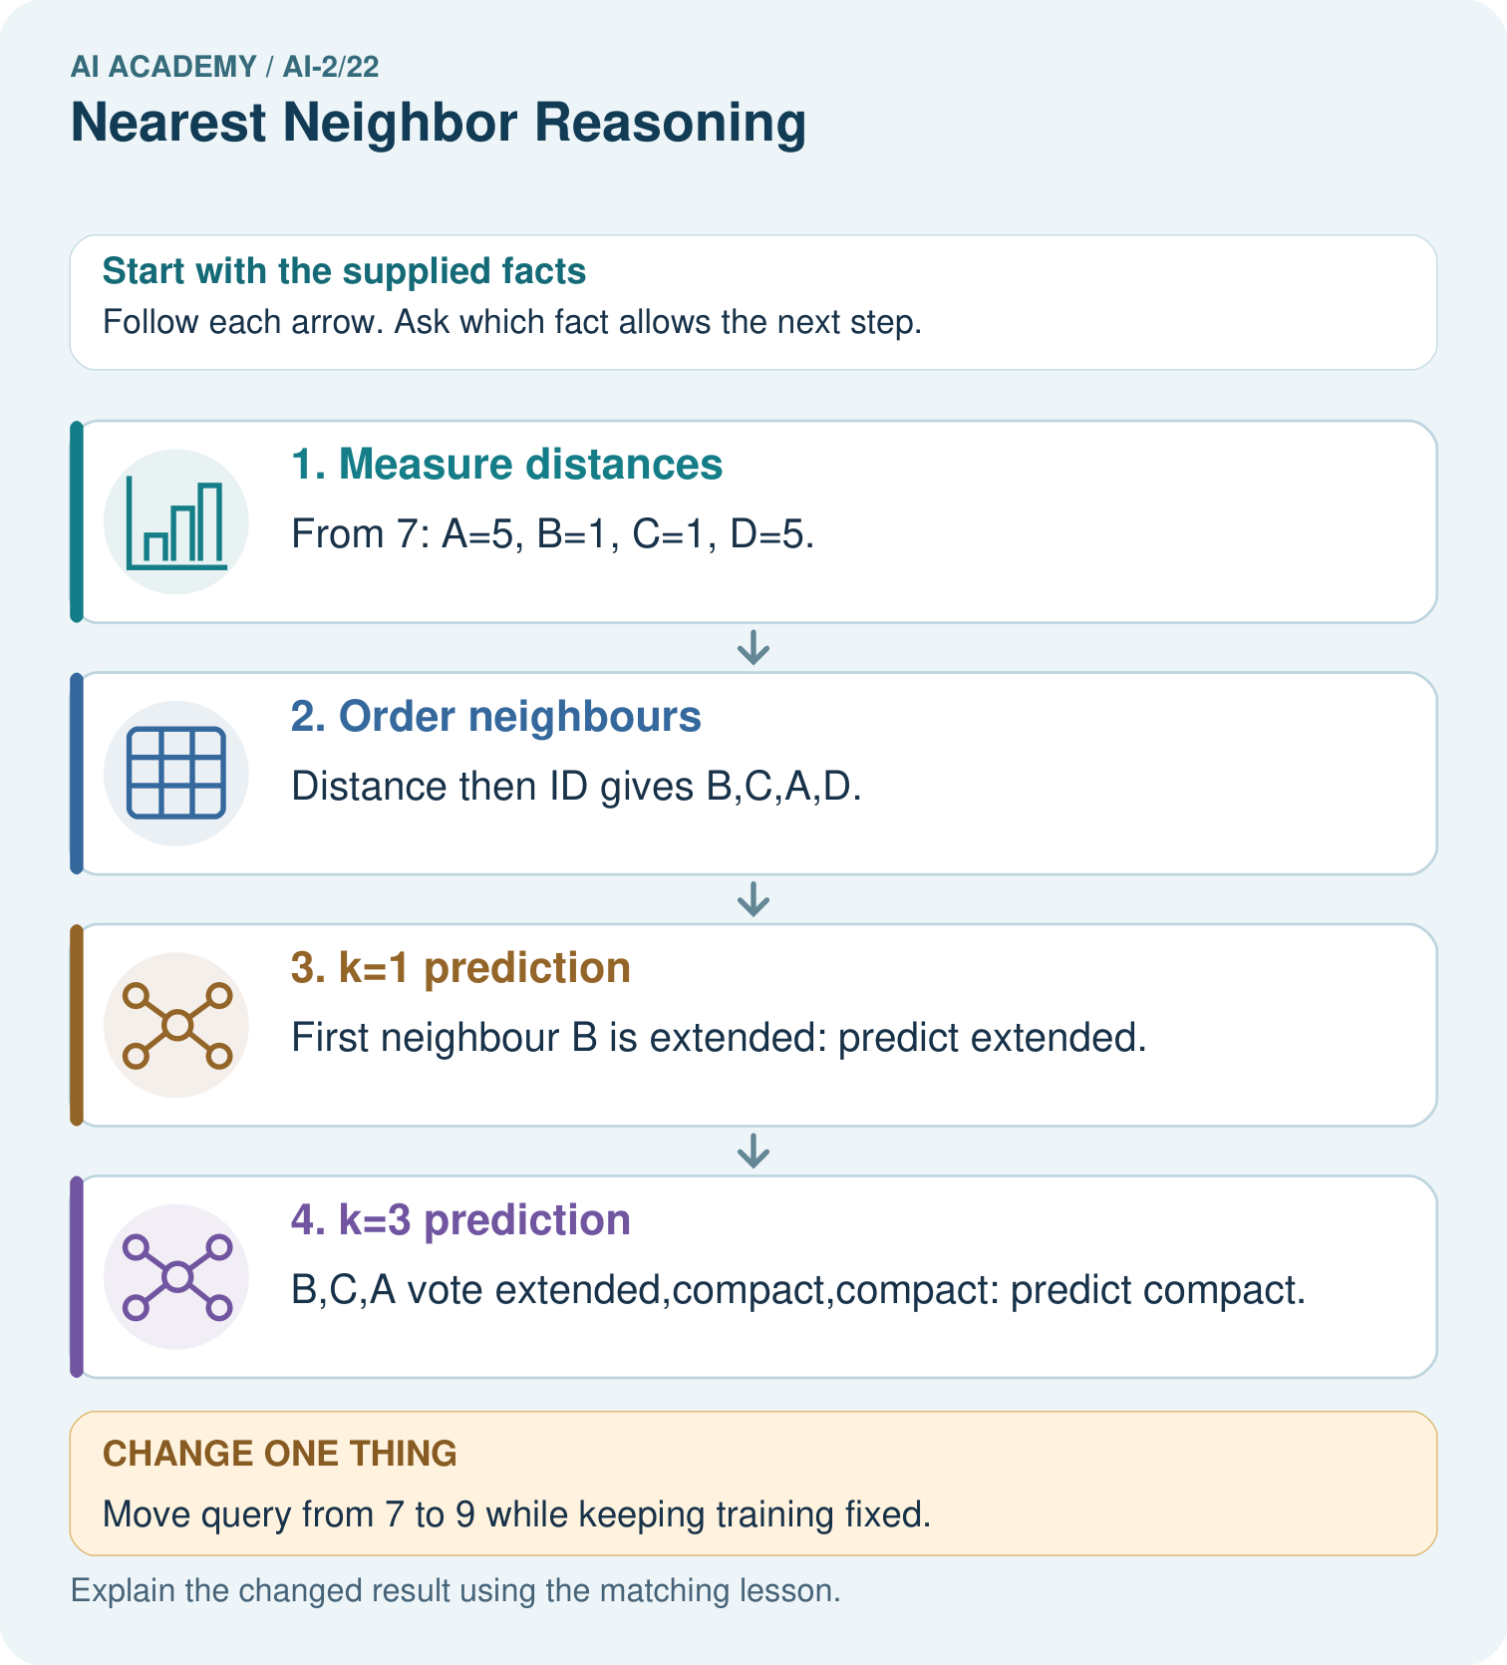
Why do k=1 and k=3 disagree for the original query?

My picture-based explanation and changed-case prediction
________________________________________________________________
________________________________________________________________
________________________________________________________________
________________________________________________________________
________________________________________________________________
________________________________________________________________
Support used: alone / hint / worked example. This record is practice evidence.
Project connection: Retain recommender neighbour IDs, distances, k and tie decisions so similar-book explanations can be audited.

