AI ACADEMY · WORKBOOK · ai-2/26

Image and Voice Pipelines
Project: Transparent Book Recommender

01. Recall and choose your starting point
Try the recall before opening notes. Then use a different colour or a labelled second line to correct your explanation.

Text as Pieces
Without opening the old lesson, explain one key idea from Text as Pieces. Give an example and a mistake that the idea helps you avoid.

My remembered idea, example and correction
________________________________________________________________
________________________________________________________________
________________________________________________________________

Recommendation Scores
Without opening the old lesson, explain one key idea from Recommendation Scores. Give an example and a mistake that the idea helps you avoid.

My remembered idea, example and correction
________________________________________________________________
________________________________________________________________
________________________________________________________________

Repair Bias in Data
Without opening the old lesson, explain one key idea from Repair Bias in Data. Give an example and a mistake that the idea helps you avoid.

My remembered idea, example and correction
________________________________________________________________
________________________________________________________________
________________________________________________________________

02. Practise with fading help
Use W2: Trace the worked case for Speech pipelines and multimodal evidence. Record the answer once; the lesson and workbook refer to the same attempt.
Given inputs | Procedure I chose | Middle steps | Result and check

The step I completed without help, and the hint I needed
________________________________________________________________
________________________________________________________________
________________________________________________________________

03. Individual reasoning check
Use the worked case for Speech pipelines and multimodal evidence. Proposed explanation: “The worked result establishes every future case”. Decide whether this explanation is supported. Point to the step or supplied fact that decides; explain your repair if needed.

My explanation before partner discussion
________________________________________________________________
________________________________________________________________
________________________________________________________________
________________________________________________________________

04. Independent transfer case

Independent case: Apply a new case independently
Transcript says room E; a current written approval says room F. The task requires current approved room. Written approval is declared authoritative; trace the response and the transcription limit.

My independent explanation, trace and limits
________________________________________________________________
________________________________________________________________
________________________________________________________________
________________________________________________________________
________________________________________________________________
________________________________________________________________
________________________________________________________________
Attempt this case before feedback. Record any help. Earlier examples below are further practice; a case already practised with feedback cannot establish fresh transfer.

05. Your learning target
A voice request says 'under 90 pages'. The transcript says 'under 19 pages'; filtering correctly finds no books. Identify the first failing stage and a useful confirmation step.

06. Solve the given case
A voice book helper transcribes speech, extracts preference, then ranks books.
Where can a wrong suggestion begin?
Show your trace, calculation or evidence

Write or draw your reasoning and evidence.
________________________________________________________________
________________________________________________________________
________________________________________________________________
________________________________________________________________
________________________________________________________________

07. Check a changed case
A voice helper hears find a book, converts speech to text, then searches. It writes find a cook. Which stage first failed and what should you inspect?
My independent answer and reason

Write or draw your reasoning and evidence.
________________________________________________________________
________________________________________________________________
________________________________________________________________
________________________________________________________________
________________________________________________________________

Week 26 Test and reflect

08. Design a revealing test
Create a changed input, boundary case or missing-information case. Write the expected answer or safe response before testing.
Test record | My evidence
Changed input or condition
Expected answer or fallback
Observed result
Why the result occurred

09. Project checkpoint
If voice or image input is added, show each transformation and a safe fallback.
The project change and evidence I will keep

Write or draw your reasoning and evidence.
________________________________________________________________
________________________________________________________________
________________________________________________________________
________________________________________________________________
________________________________________________________________

10. Self check
I can explain the mechanism. I can show evidence. I can handle a changed case. I can name a limit. Mark each as not yet, with help or independently, and attach supporting work.
Teacher review ____________________ Next step ____________________

11. Transfer practice from the original programme
A voice request says 'under 90 pages'. The transcript says 'under 19 pages'; filtering correctly finds no books. Identify the first failing stage and a useful confirmation step.

My independently reasoned answer
________________________________________________________________
________________________________________________________________
________________________________________________________________
________________________________________________________________
________________________________________________________________
________________________________________________________________
________________________________________________________________
Record support used: none, hint or teacher explanation.

12. W1 Explain the mechanism
Explain the weekly mechanism in your own words. Use the worked scenario to name its input, decision rule and output.

My reasoning and evidence
________________________________________________________________
________________________________________________________________
________________________________________________________________
________________________________________________________________
________________________________________________________________
________________________________________________________________

13. W2 Trace the worked case
Audio transcript reads fifteen boxes; a clear written inventory says fifty boxes. The original audio is unavailable and the assistant reports fifteen as certain. Show the intermediate steps and give the conclusion with its scope.

My reasoning and evidence
________________________________________________________________
________________________________________________________________
________________________________________________________________
________________________________________________________________
________________________________________________________________
________________________________________________________________
________________________________________________________________

14. W3 Audit the limit
A report omits this qualification: A stage-level accuracy or authority policy does not establish every modality agrees or every downstream claim is supported. Explain how omitting it could change a reader's interpretation, and write an accurate replacement.

My reasoning and evidence
________________________________________________________________
________________________________________________________________
________________________________________________________________
________________________________________________________________
________________________________________________________________
________________________________________________________________

15. W4 Apply a new case independently
Transcript says room E; a current written approval says room F. The task requires current approved room. Written approval is declared authoritative; trace the response and the transcription limit.

My reasoning and evidence
________________________________________________________________
________________________________________________________________
________________________________________________________________
________________________________________________________________
________________________________________________________________
________________________________________________________________
________________________________________________________________
________________________________________________________________

16. W5 Design a revealing follow-up
For the worked scenario, propose one additional case that could reveal a failure, describe its expected outcome before running it, and explain what would need to remain fixed for a fair comparison. Do not reuse W4 as a new final test after receiving feedback.

My reasoning and evidence
________________________________________________________________
________________________________________________________________
________________________________________________________________
________________________________________________________________
________________________________________________________________
________________________________________________________________
________________________________________________________________

17. Feedback, return check and learning record
Evidence | My record
Worked alone / hint / model
First step I repaired and why
New case checked later; date and result
What I can now explain without notes
One remaining question
Revisit this idea with your teacher after a delay. Familiarity is different from explaining and using it on a changed case.

18. Pictorial case practice: Image and Voice Pipelines
A fictional librarian dictates a shelf note that passes through transcription and catalogue lookup.
Teacher-supplied ground truth audio phrase is “shelf fourteen”. Transcript says “shelf forty”.
A current signed inventory is declared authoritative and lists the requested book on shelf 14. The original audio recording remains available.
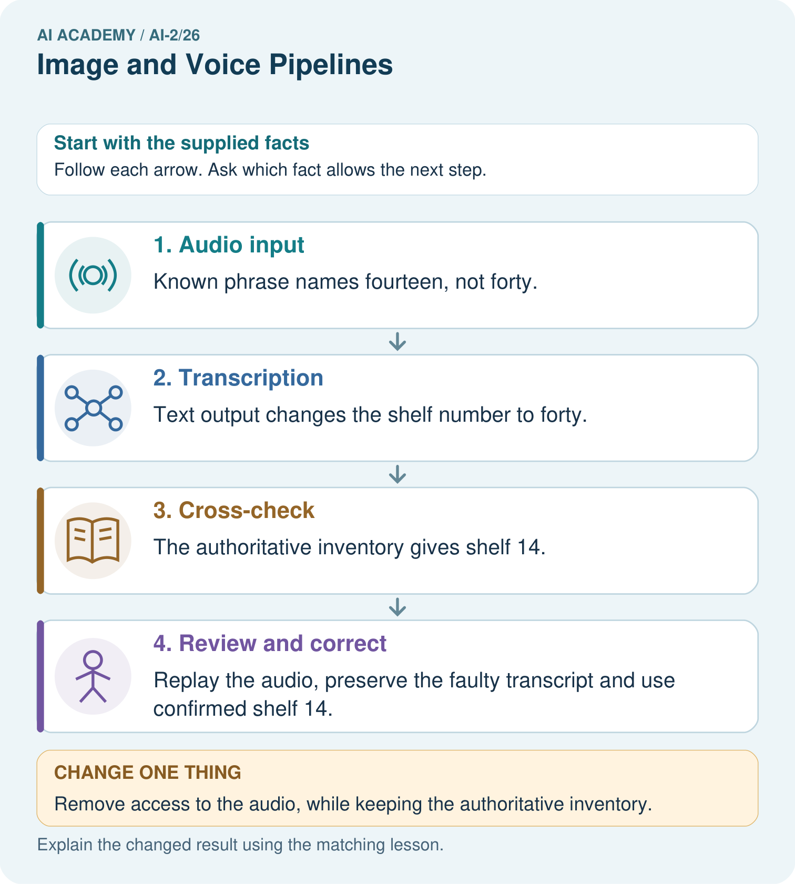
Which stage first fails, and why should the faulty transcript not be silently overwritten?

My picture-based explanation and changed-case prediction
________________________________________________________________
________________________________________________________________
________________________________________________________________
________________________________________________________________
________________________________________________________________
________________________________________________________________
Support used: alone / hint / worked example. This record is practice evidence.
Project connection: For voice-driven recommendations, confirm important recognised fields before searching or acting and retain source provenance.

