AI ACADEMY · WORKBOOK · ai-2/31

Permissions and Human Review
Project: Transparent Book Recommender

01. Recall and choose your starting point
Try the recall before opening notes. Then use a different colour or a labelled second line to correct your explanation.

Agents and Tools
Without opening the old lesson, explain one key idea from Agents and Tools. Give an example and a mistake that the idea helps you avoid.

My remembered idea, example and correction
________________________________________________________________
________________________________________________________________
________________________________________________________________

Prompt Experiments
Without opening the old lesson, explain one key idea from Prompt Experiments. Give an example and a mistake that the idea helps you avoid.

My remembered idea, example and correction
________________________________________________________________
________________________________________________________________
________________________________________________________________

Text as Pieces
Without opening the old lesson, explain one key idea from Text as Pieces. Give an example and a mistake that the idea helps you avoid.

My remembered idea, example and correction
________________________________________________________________
________________________________________________________________
________________________________________________________________

02. Practise with fading help
Use W2: Trace the worked case for Least privilege and tool scopes. Record the answer once; the lesson and workbook refer to the same attempt.
Given inputs | Procedure I chose | Middle steps | Result and check

The step I completed without help, and the hint I needed
________________________________________________________________
________________________________________________________________
________________________________________________________________

03. Individual reasoning check
Use the worked case for Least privilege and tool scopes. Proposed explanation: “The worked result establishes every future case”. Decide whether this explanation is supported. Point to the step or supplied fact that decides; explain your repair if needed.

My explanation before partner discussion
________________________________________________________________
________________________________________________________________
________________________________________________________________
________________________________________________________________

04. Independent transfer case

Independent case: Apply a new case independently
Scope allows read inventory items A, B. Calls read A, read C, write B. Decide.

My independent explanation, trace and limits
________________________________________________________________
________________________________________________________________
________________________________________________________________
________________________________________________________________
________________________________________________________________
________________________________________________________________
________________________________________________________________
Attempt this case before feedback. Record any help. Earlier examples below are further practice; a case already practised with feedback cannot establish fresh transfer.

05. Your learning target
A teacher approves posting version 1 to a class board. The assistant changes the text and destination to a public board. Does the old approval cover the new action? Define what must be reviewed.

06. Solve the given case
Posting a recommendation requires teacher review.
Place the approval gate.
Show your trace, calculation or evidence

Write or draw your reasoning and evidence.
________________________________________________________________
________________________________________________________________
________________________________________________________________
________________________________________________________________
________________________________________________________________

07. Check a changed case
A teacher allows a tool to draft a message but forbids sending. The draft is correct. May the agent send it? Explain the boundary.
My independent answer and reason

Write or draw your reasoning and evidence.
________________________________________________________________
________________________________________________________________
________________________________________________________________
________________________________________________________________
________________________________________________________________

Week 31 Test and reflect

08. Design a revealing test
Create a changed input, boundary case or missing-information case. Write the expected answer or safe response before testing.
Test record | My evidence
Changed input or condition
Expected answer or fallback
Observed result
Why the result occurred

09. Project checkpoint
The recommender may suggest and explain; people decide, borrow, purchase, or share data.
The project change and evidence I will keep

Write or draw your reasoning and evidence.
________________________________________________________________
________________________________________________________________
________________________________________________________________
________________________________________________________________
________________________________________________________________

10. Self check
I can explain the mechanism. I can show evidence. I can handle a changed case. I can name a limit. Mark each as not yet, with help or independently, and attach supporting work.
Teacher review ____________________ Next step ____________________

11. Transfer practice from the original programme
A teacher approves posting version 1 to a class board. The assistant changes the text and destination to a public board. Does the old approval cover the new action? Define what must be reviewed.

My independently reasoned answer
________________________________________________________________
________________________________________________________________
________________________________________________________________
________________________________________________________________
________________________________________________________________
________________________________________________________________
________________________________________________________________
Record support used: none, hint or teacher explanation.

12. W1 Explain the mechanism
Explain the weekly mechanism in your own words. Use the worked scenario to name its input, decision rule and output.

My reasoning and evidence
________________________________________________________________
________________________________________________________________
________________________________________________________________
________________________________________________________________
________________________________________________________________
________________________________________________________________

13. W2 Trace the worked case
Tool token permits lookup(public-room). A proposed call writes teacher notes. Show the intermediate steps and give the conclusion with its scope.

My reasoning and evidence
________________________________________________________________
________________________________________________________________
________________________________________________________________
________________________________________________________________
________________________________________________________________
________________________________________________________________
________________________________________________________________

14. W3 Audit the limit
A report omits this qualification: A generated plan cannot expand the token or actor scope. Explain how omitting it could change a reader's interpretation, and write an accurate replacement.

My reasoning and evidence
________________________________________________________________
________________________________________________________________
________________________________________________________________
________________________________________________________________
________________________________________________________________
________________________________________________________________

15. W4 Apply a new case independently
Scope allows read inventory items A, B. Calls read A, read C, write B. Decide.

My reasoning and evidence
________________________________________________________________
________________________________________________________________
________________________________________________________________
________________________________________________________________
________________________________________________________________
________________________________________________________________
________________________________________________________________
________________________________________________________________

16. W5 Design a revealing follow-up
For the worked scenario, propose one additional case that could reveal a failure, describe its expected outcome before running it, and explain what would need to remain fixed for a fair comparison. Do not reuse W4 as a new final test after receiving feedback.

My reasoning and evidence
________________________________________________________________
________________________________________________________________
________________________________________________________________
________________________________________________________________
________________________________________________________________
________________________________________________________________
________________________________________________________________

17. Privacy and least privilege — W1 Minimize fields
For a count of preferred activities, identify which of activity choice, full name and birthday is necessary.

My reasoning and evidence
________________________________________________________________
________________________________________________________________
________________________________________________________________
________________________________________________________________
________________________________________________________________
________________________________________________________________

18. Privacy and least privilege — W2 Trace permissions
Under the worked role policy, can teacher read_review and unknown read_summary?

My reasoning and evidence
________________________________________________________________
________________________________________________________________
________________________________________________________________
________________________________________________________________
________________________________________________________________
________________________________________________________________

19. Privacy and least privilege — W3 Repair access control
A website hides teacher answers using CSS but sends them to student browsers. Explain the flaw and required boundary.

My reasoning and evidence
________________________________________________________________
________________________________________________________________
________________________________________________________________
________________________________________________________________
________________________________________________________________
________________________________________________________________

20. Privacy and least privilege — W4 Design independently
Design a fictional preference summary with student and teacher roles. List necessary fields, permitted actions, a retention purpose and a deletion owner.

My reasoning and evidence
________________________________________________________________
________________________________________________________________
________________________________________________________________
________________________________________________________________
________________________________________________________________
________________________________________________________________
________________________________________________________________
________________________________________________________________

21. Privacy and least privilege — W5 Limit the toy model
Does the allowed function alone prove an app is secure?

My reasoning and evidence
________________________________________________________________
________________________________________________________________
________________________________________________________________
________________________________________________________________
________________________________________________________________
________________________________________________________________

22. Feedback, return check and learning record
Evidence | My record
Worked alone / hint / model
First step I repaired and why
New case checked later; date and result
What I can now explain without notes
One remaining question
Revisit this idea with your teacher after a delay. Familiarity is different from explaining and using it on a changed case.

23. Pictorial case practice: Permissions and Human Review
A fictional catalogue helper receives a narrowly scoped tool token.
Token allows read on catalogue records R2 and R5 only. No write permission is granted.
Proposals: read R2; read R8; write R5. Generated text claims all are helpful.
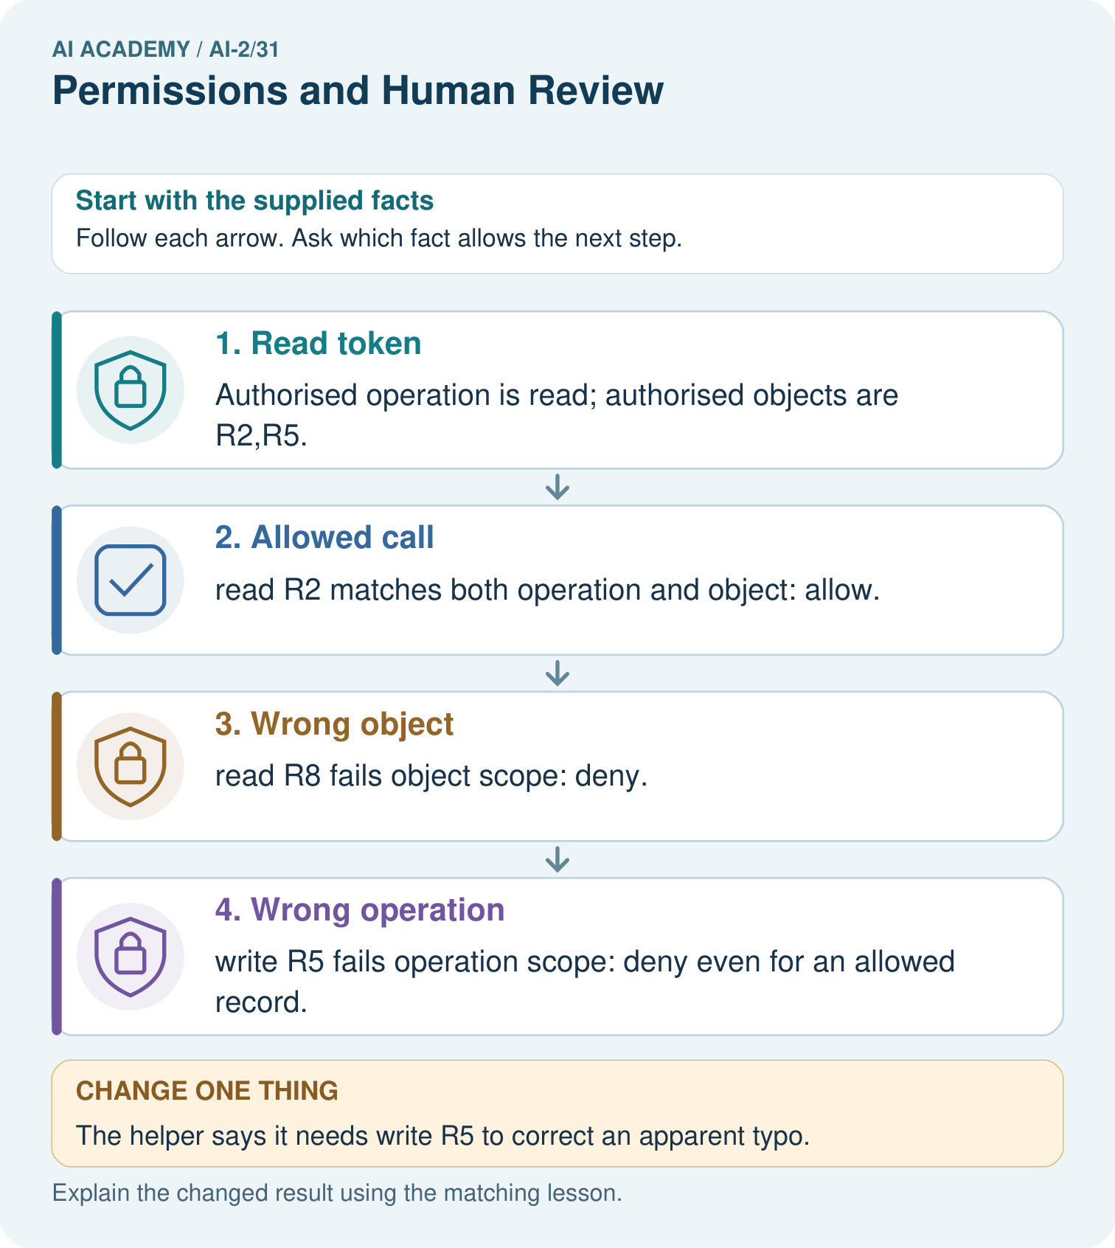
Which proposal is allowed, and why is an authorised object alone insufficient?

My picture-based explanation and changed-case prediction
________________________________________________________________
________________________________________________________________
________________________________________________________________
________________________________________________________________
________________________________________________________________
________________________________________________________________
Support used: alone / hint / worked example. This record is practice evidence.
Project connection: Give the recommender read-only access wherever sufficient, and require explicit owner review for catalogue edits or publication.

