AI ACADEMY · WORKBOOK · ai-2/33

Build the Recommender
Project: Transparent Book Recommender

01. Recall and choose your starting point
Try the recall before opening notes. Then use a different colour or a labelled second line to correct your explanation.

Project Problem and Success Test
Without opening the old lesson, explain one key idea from Project Problem and Success Test. Give an example and a mistake that the idea helps you avoid.

My remembered idea, example and correction
________________________________________________________________
________________________________________________________________
________________________________________________________________

Agents and Tools
Without opening the old lesson, explain one key idea from Agents and Tools. Give an example and a mistake that the idea helps you avoid.

My remembered idea, example and correction
________________________________________________________________
________________________________________________________________
________________________________________________________________

Predictive vs Generative
Without opening the old lesson, explain one key idea from Predictive vs Generative. Give an example and a mistake that the idea helps you avoid.

My remembered idea, example and correction
________________________________________________________________
________________________________________________________________
________________________________________________________________

02. Practise with fading help
Use W2: Handle no match for Implementing a recommender. Record the answer once; the lesson and workbook refer to the same attempt.
Given inputs | Procedure I chose | Middle steps | Result and check

The step I completed without help, and the hint I needed
________________________________________________________________
________________________________________________________________
________________________________________________________________

03. Individual reasoning check
Use the worked case for Implementing a recommender. Proposed explanation: “A successful run proves the conclusion”. Decide whether this explanation is supported. Point to the step or supplied fact that decides; explain your repair if needed.

My explanation before partner discussion
________________________________________________________________
________________________________________________________________
________________________________________________________________
________________________________________________________________

04. Independent transfer case

Independent case: Changed independent case
Request: mystery, at most 100 pages. Catalogue: D mystery110 illustrated; E mystery80 plain; F science80 illustrated; G mystery95 illustrated; H mystery90 illustrated. Filter first; score 3 for mystery plus 2 for illustrations; break ties by fewer pages.

My independent explanation, trace and limits
________________________________________________________________
________________________________________________________________
________________________________________________________________
________________________________________________________________
________________________________________________________________
________________________________________________________________
________________________________________________________________
Attempt this case before feedback. Record any help. Earlier examples below are further practice; a case already practised with feedback cannot establish fresh transfer.

05. Your learning target
Catalogue: A mystery/90/illustrated, B mystery/140/not illustrated, C science/80/illustrated. Request mystery, maximum 100 pages. Rank with 2 genre points and 1 illustration point after filtering. Show why other books are excluded.

06. Solve the given case
A has flags (1,1), B=(1,0), C=(0,1); score=2g+l.
Compute the winner and evidence to display.
Show your trace, calculation or evidence

Write or draw your reasoning and evidence.
________________________________________________________________
________________________________________________________________
________________________________________________________________
________________________________________________________________
________________________________________________________________

07. Check a changed case
A reader requests space and at most 60 pages. Book A is space, 90 pages; B is animals, 40 pages. What should the prototype return if both conditions are required?
My independent answer and reason

Write or draw your reasoning and evidence.
________________________________________________________________
________________________________________________________________
________________________________________________________________
________________________________________________________________
________________________________________________________________

Week 33 Test and reflect

08. Design a revealing test
Create a changed input, boundary case or missing-information case. Write the expected answer or safe response before testing.
Test record | My evidence
Changed input or condition
Expected answer or fallback
Observed result
Why the result occurred

09. Project checkpoint
This is the complete baseline: inputs, scoring, filter, ranking, explanation, and abstain rule.
The project change and evidence I will keep

Write or draw your reasoning and evidence.
________________________________________________________________
________________________________________________________________
________________________________________________________________
________________________________________________________________
________________________________________________________________

10. Self check
I can explain the mechanism. I can show evidence. I can handle a changed case. I can name a limit. Mark each as not yet, with help or independently, and attach supporting work.
Teacher review ____________________ Next step ____________________

11. Transfer practice from the original programme
Catalogue: A mystery/90/illustrated, B mystery/140/not illustrated, C science/80/illustrated. Request mystery, maximum 100 pages. Rank with 2 genre points and 1 illustration point after filtering. Show why other books are excluded.

My independently reasoned answer
________________________________________________________________
________________________________________________________________
________________________________________________________________
________________________________________________________________
________________________________________________________________
________________________________________________________________
________________________________________________________________
Record support used: none, hint or teacher explanation.

12. W1 Trace selection
Why does A win the worked example even though B is processed first?

My reasoning and evidence
________________________________________________________________
________________________________________________________________
________________________________________________________________
________________________________________________________________
________________________________________________________________
________________________________________________________________

13. W2 Handle no match
State recommend([], 10) and the worked items with limit 8.

My reasoning and evidence
________________________________________________________________
________________________________________________________________
________________________________________________________________
________________________________________________________________
________________________________________________________________
________________________________________________________________

14. W3 Repair order dependence
A tied selection changes after reversing input order. Identify the likely missing policy and test.

My reasoning and evidence
________________________________________________________________
________________________________________________________________
________________________________________________________________
________________________________________________________________
________________________________________________________________
________________________________________________________________

15. W4 Implement independently
Use the function with X (fun 4, learning 1, minutes 12), Y (3,3,10), Z (5,5,13), limit 12. Predict the winner, reverse the list and retest. Also test limit 9.

My reasoning and evidence
________________________________________________________________
________________________________________________________________
________________________________________________________________
________________________________________________________________
________________________________________________________________
________________________________________________________________
________________________________________________________________
________________________________________________________________

16. W5 Explain the result
Write a one-sentence explanation of X winning without calling it objectively best.

My reasoning and evidence
________________________________________________________________
________________________________________________________________
________________________________________________________________
________________________________________________________________
________________________________________________________________
________________________________________________________________

17. Building the data pipeline — W1 Trace a validation
Explain why a row with fun "4" fails while fun 4 can pass.

My reasoning and evidence
________________________________________________________________
________________________________________________________________
________________________________________________________________
________________________________________________________________
________________________________________________________________
________________________________________________________________

18. Building the data pipeline — W2 Check missing fields
What does valid_item return if learning is absent?

My reasoning and evidence
________________________________________________________________
________________________________________________________________
________________________________________________________________
________________________________________________________________
________________________________________________________________
________________________________________________________________

19. Building the data pipeline — W3 Repair the connection
A program validates rows but still sends the original raw list to recommend. What should change?

My reasoning and evidence
________________________________________________________________
________________________________________________________________
________________________________________________________________
________________________________________________________________
________________________________________________________________
________________________________________________________________

20. Building the data pipeline — W4 Build independently
Combine validation and the Week 24 selector for A (minutes 10, fun 3, learning 2), B (12,4,1), and C (8,"5",5), limit 10. State accepted rows, rejected row, selection and explanation.

My reasoning and evidence
________________________________________________________________
________________________________________________________________
________________________________________________________________
________________________________________________________________
________________________________________________________________
________________________________________________________________
________________________________________________________________
________________________________________________________________

21. Building the data pipeline — W5 Handle duplicates
Two valid rows have the same name but different ratings. Should individual validation alone permit selection?

My reasoning and evidence
________________________________________________________________
________________________________________________________________
________________________________________________________________
________________________________________________________________
________________________________________________________________
________________________________________________________________

22. Feedback, return check and learning record
Evidence | My record
Worked alone / hint / model
First step I repaired and why
New case checked later; date and result
What I can now explain without notes
One remaining question
Revisit this idea with your teacher after a delay. Familiarity is different from explaining and using it on a changed case.

23. Pictorial case practice: Build the Recommender
A fictional book chooser filters a request before comparing preference scores.
Request: animal subject, at most 90 pages. Score 2 for illustrated and 1 for comic. Tie chooses smaller ID.
A animal90 illustrated prose; B animal70 plain comic; C space60 illustrated comic; D animal80 illustrated comic.
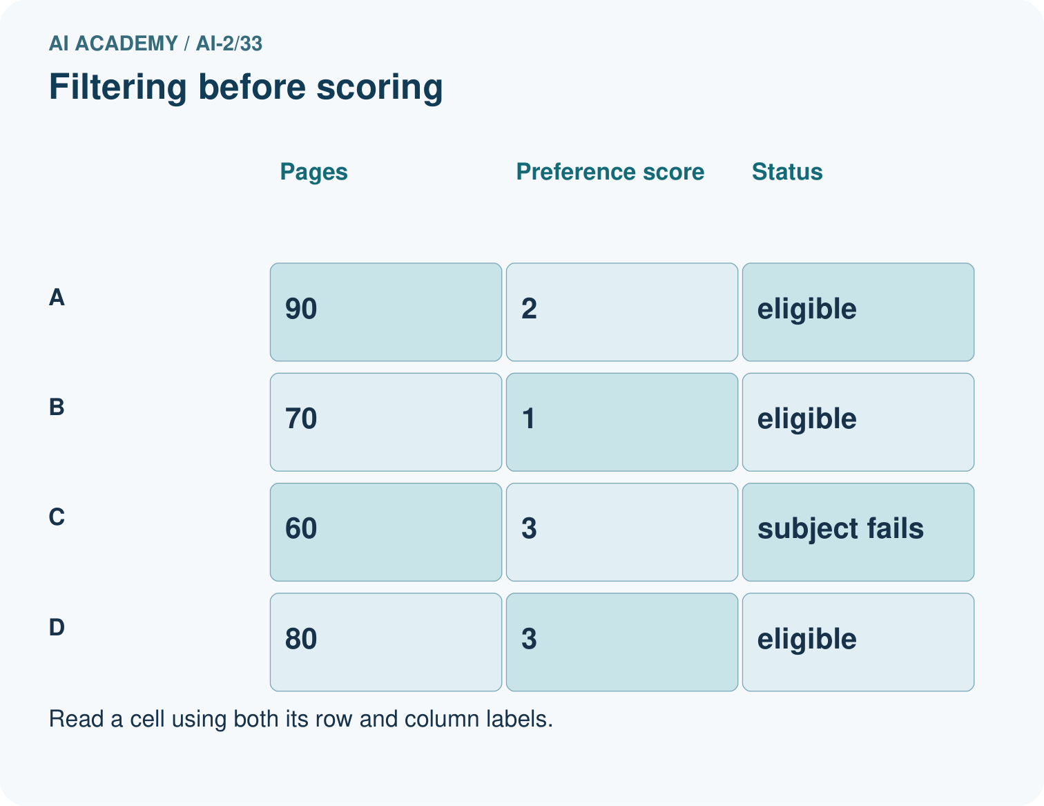
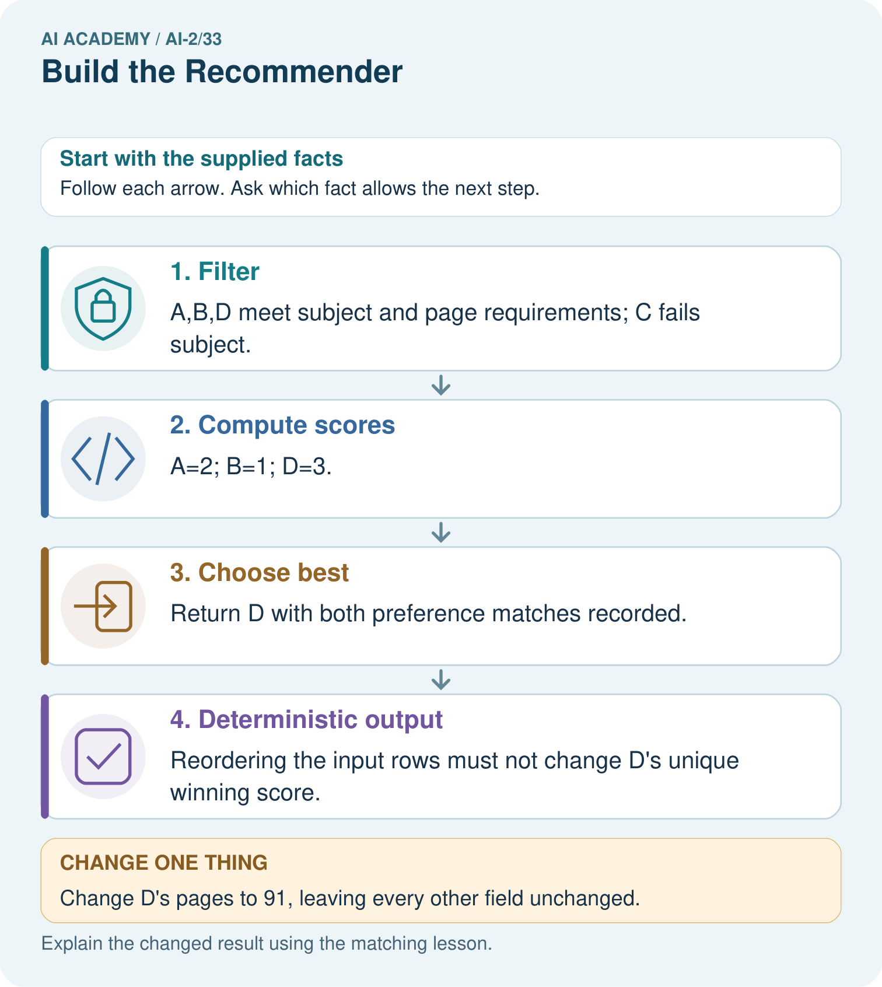
Explain why B does not win after D is excluded even though it has fewer pages.

My picture-based explanation and changed-case prediction
________________________________________________________________
________________________________________________________________
________________________________________________________________
________________________________________________________________
________________________________________________________________
________________________________________________________________
Support used: alone / hint / worked example. This record is practice evidence.
Project connection: Save the recommender code, contract and this full trace; test the same records in different input orders.

