AI ACADEMY · WORKBOOK · ai-2/34

Test Diverse Users
Project: Transparent Book Recommender

01. Recall and choose your starting point
Try the recall before opening notes. Then use a different colour or a labelled second line to correct your explanation.

Build the Recommender
Without opening the old lesson, explain one key idea from Build the Recommender. Give an example and a mistake that the idea helps you avoid.

My remembered idea, example and correction
________________________________________________________________
________________________________________________________________
________________________________________________________________

Permissions and Human Review
Without opening the old lesson, explain one key idea from Permissions and Human Review. Give an example and a mistake that the idea helps you avoid.

My remembered idea, example and correction
________________________________________________________________
________________________________________________________________
________________________________________________________________

Prompt Experiments
Without opening the old lesson, explain one key idea from Prompt Experiments. Give an example and a mistake that the idea helps you avoid.

My remembered idea, example and correction
________________________________________________________________
________________________________________________________________
________________________________________________________________

02. Practise with fading help
Use W2: Plan coverage for Evaluating varied cases. Record the answer once; the lesson and workbook refer to the same attempt.
Given inputs | Procedure I chose | Middle steps | Result and check

The step I completed without help, and the hint I needed
________________________________________________________________
________________________________________________________________
________________________________________________________________

03. Individual reasoning check
Use the worked case for Evaluating varied cases. Proposed explanation: “A successful run proves the conclusion”. Decide whether this explanation is supported. Point to the step or supplied fact that decides; explain your repair if needed.

My explanation before partner discussion
________________________________________________________________
________________________________________________________________
________________________________________________________________
________________________________________________________________

04. Independent transfer case

Independent case: Evaluate independently
Given ordinary 3/3, boundary 1/2, invalid 2/2 and tie 0/1, compute overall results and prioritize issues.

My independent explanation, trace and limits
________________________________________________________________
________________________________________________________________
________________________________________________________________
________________________________________________________________
________________________________________________________________
________________________________________________________________
________________________________________________________________
Attempt this case before feedback. Record any help. Earlier examples below are further practice; a case already practised with feedback cannot establish fresh transfer.

05. Your learning target
The recommender succeeds on 9/10 mystery requests and 2/5 poetry requests. Compute total and separate rates. A team reports only 11/15. Explain what that hides.

06. Solve the given case
A recommender satisfies 5/6 adventure requests and 3/6 poetry requests.
Compare and investigate.
Show your trace, calculation or evidence

Write or draw your reasoning and evidence.
________________________________________________________________
________________________________________________________________
________________________________________________________________
________________________________________________________________
________________________________________________________________

07. Check a changed case
A recommender serves 6 of 6 easy-book requests but 1 of 4 advanced-book requests. Report both results and identify the next test priority.
My independent answer and reason

Write or draw your reasoning and evidence.
________________________________________________________________
________________________________________________________________
________________________________________________________________
________________________________________________________________
________________________________________________________________

Week 34 Test and reflect

08. Design a revealing test
Create a changed input, boundary case or missing-information case. Write the expected answer or safe response before testing.
Test record | My evidence
Changed input or condition
Expected answer or fallback
Observed result
Why the result occurred

09. Project checkpoint
Use the same test record across ordinary, boundary, missing-data, and access-needs cases.
The project change and evidence I will keep

Write or draw your reasoning and evidence.
________________________________________________________________
________________________________________________________________
________________________________________________________________
________________________________________________________________
________________________________________________________________

10. Self check
I can explain the mechanism. I can show evidence. I can handle a changed case. I can name a limit. Mark each as not yet, with help or independently, and attach supporting work.
Teacher review ____________________ Next step ____________________

11. Transfer practice from the original programme
The recommender succeeds on 9/10 mystery requests and 2/5 poetry requests. Compute total and separate rates. A team reports only 11/15. Explain what that hides.

My independently reasoned answer
________________________________________________________________
________________________________________________________________
________________________________________________________________
________________________________________________________________
________________________________________________________________
________________________________________________________________
________________________________________________________________
Record support used: none, hint or teacher explanation.

12. W1 Read denominators
A report says 8 of 10 tests pass, including 0 of 2 invalid-input cases. What is the important weakness?

My reasoning and evidence
________________________________________________________________
________________________________________________________________
________________________________________________________________
________________________________________________________________
________________________________________________________________
________________________________________________________________

13. W2 Plan coverage
Name five distinct categories for the chooser evaluation.

My reasoning and evidence
________________________________________________________________
________________________________________________________________
________________________________________________________________
________________________________________________________________
________________________________________________________________
________________________________________________________________

14. W3 Repair reporting
A learner drops two failed cases and reports 8/8. What should be restored?

My reasoning and evidence
________________________________________________________________
________________________________________________________________
________________________________________________________________
________________________________________________________________
________________________________________________________________
________________________________________________________________

15. W4 Evaluate independently
Given ordinary 3/3, boundary 1/2, invalid 2/2 and tie 0/1, compute overall results and prioritize issues.

My reasoning and evidence
________________________________________________________________
________________________________________________________________
________________________________________________________________
________________________________________________________________
________________________________________________________________
________________________________________________________________
________________________________________________________________
________________________________________________________________

16. W5 Protect final evidence
You fix the tie bug using the final tie case. What should the next evaluation report say?

My reasoning and evidence
________________________________________________________________
________________________________________________________________
________________________________________________________________
________________________________________________________________
________________________________________________________________
________________________________________________________________

17. Feedback, return check and learning record
Evidence | My record
Worked alone / hint / model
First step I repaired and why
New case checked later; date and result
What I can now explain without notes
One remaining question
Revisit this idea with your teacher after a delay. Familiarity is different from explaining and using it on a changed case.

18. Pictorial case practice: Test Diverse Users
A fictional recommender is tested on distinct ordinary, equality, invalid-input and tie cases.
Recorded full passes: ordinary 4/4; equality 1/3; invalid 2/3; ties 1/2.
Categories are disjoint and every case was run on the same frozen version with the same contract.
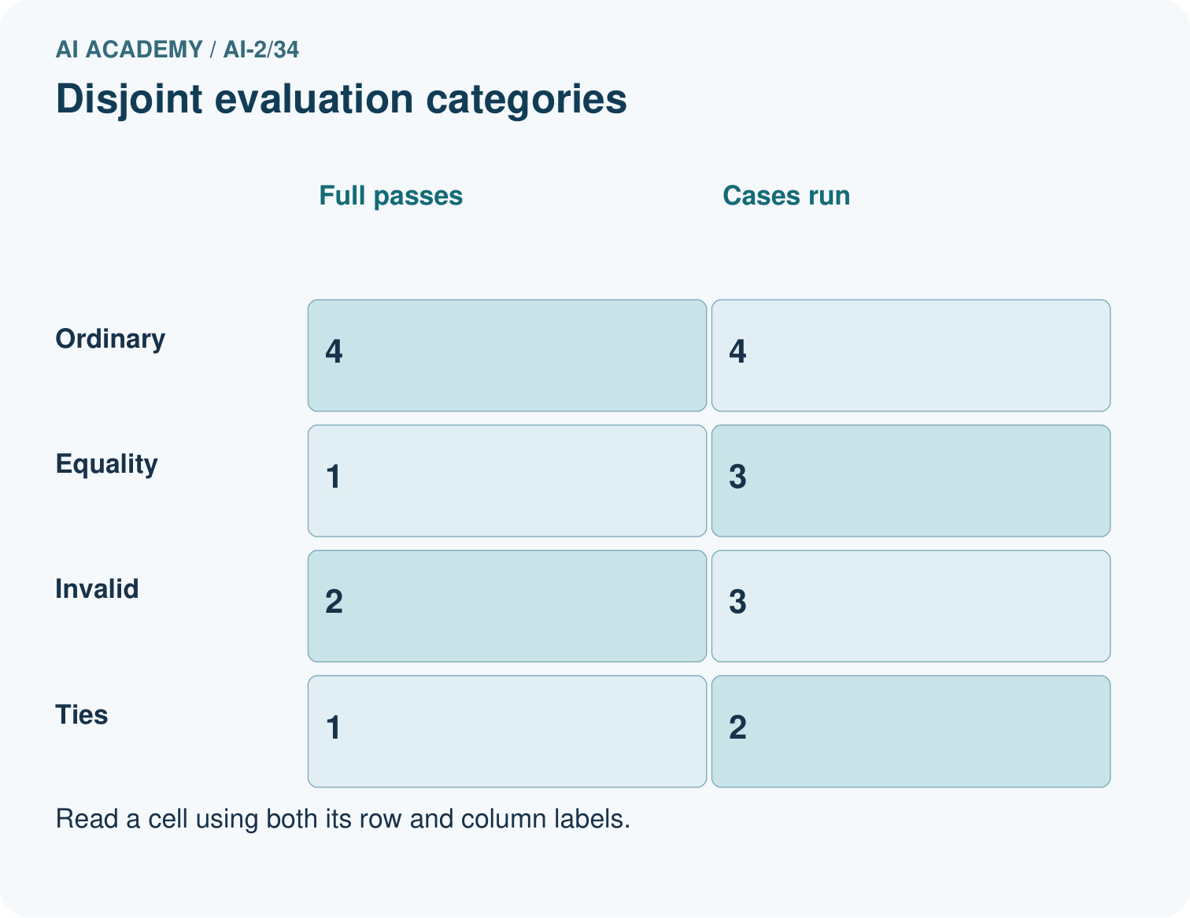
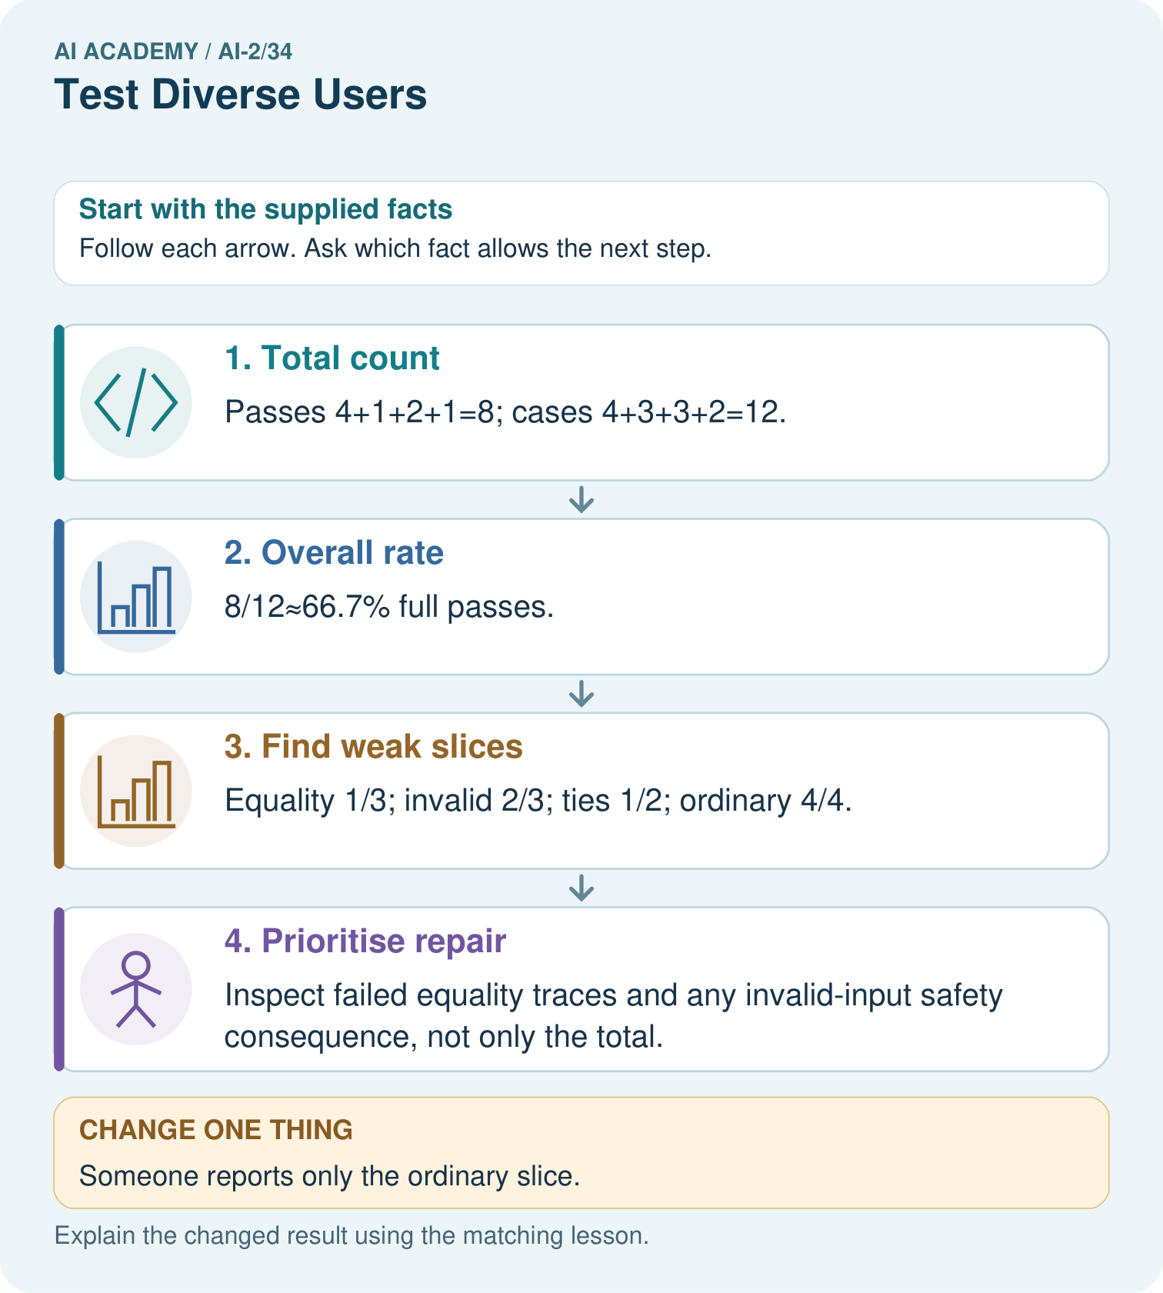
Can these records establish performance for different user groups?

My picture-based explanation and changed-case prediction
________________________________________________________________
________________________________________________________________
________________________________________________________________
________________________________________________________________
________________________________________________________________
________________________________________________________________
Support used: alone / hint / worked example. This record is practice evidence.
Project connection: Build a recommender evaluation matrix with routine, boundary, missing, invalid and tie cases, then add separately planned user-condition coverage.

