AI ACADEMY · WORKBOOK · ai-3/4

Sampling and Variability
Project: Verified Study Buddy

01. Recall and choose your starting point
Try the recall before opening notes. Then use a different colour or a labelled second line to correct your explanation.

Tokens and Context
Without opening the old lesson, explain one key idea from Tokens and Context. Give an example and a mistake that the idea helps you avoid.

My remembered idea, example and correction
________________________________________________________________
________________________________________________________________
________________________________________________________________

Predictive and Generative AI
Without opening the old lesson, explain one key idea from Predictive and Generative AI. Give an example and a mistake that the idea helps you avoid.

My remembered idea, example and correction
________________________________________________________________
________________________________________________________________
________________________________________________________________

02. Practise with fading help
Use W2: Compute the adjusted table for Sampling and temperature. Record the answer once; the lesson and workbook refer to the same attempt.
Given inputs | Procedure I chose | Middle steps | Result and check

The step I completed without help, and the hint I needed
________________________________________________________________
________________________________________________________________
________________________________________________________________

03. Individual reasoning check
Use the worked case for Sampling and temperature. Proposed explanation: “Sampling means equal chances”. Decide whether this explanation is supported. Point to the step or supplied fact that decides; explain your repair if needed.

My explanation before partner discussion
________________________________________________________________
________________________________________________________________
________________________________________________________________
________________________________________________________________

04. Independent transfer case

Independent case: Sample a new table independently
Probabilities A=0.5,B=0.3,C=0.2 in that order. Compute T=0.5 probabilities and cumulative boundaries. Trace u=0.5 and u=0.9 under T=1 and T=0.5. Explain the limit of the comparison.

My independent explanation, trace and limits
________________________________________________________________
________________________________________________________________
________________________________________________________________
________________________________________________________________
________________________________________________________________
________________________________________________________________
________________________________________________________________
Attempt this case before feedback. Record any help. Earlier examples below are further practice; a case already practised with feedback cannot establish fresh transfer.

05. Your learning target
Prompt A gives three identical wrong answers. Prompt B gives two correct answers and one wrong answer. Compare consistency and correctness without declaring either generally superior.

06. Solve the given case
One prompt produces three different valid quiz questions.
Does variability mean failure?
Show your trace, calculation or evidence

Write or draw your reasoning and evidence.
________________________________________________________________
________________________________________________________________
________________________________________________________________
________________________________________________________________
________________________________________________________________

07. Check a changed case
Prompt A is run three times and returns three different stories. Does this alone prove the prompt changed? Describe a fair comparison of two prompts.
My independent answer and reason

Write or draw your reasoning and evidence.
________________________________________________________________
________________________________________________________________
________________________________________________________________
________________________________________________________________
________________________________________________________________

Week 4 Test and reflect

08. Design a revealing test
Create a changed input, boundary case or missing-information case. Write the expected answer or safe response before testing.
Test record | My evidence
Changed input or condition
Expected answer or fallback
Observed result
Why the result occurred

09. Project checkpoint
Use low variability for structured study answers and allow more diversity only for labeled brainstorming.
The project change and evidence I will keep

Write or draw your reasoning and evidence.
________________________________________________________________
________________________________________________________________
________________________________________________________________
________________________________________________________________
________________________________________________________________

10. Self check
I can explain the mechanism. I can show evidence. I can handle a changed case. I can name a limit. Mark each as not yet, with help or independently, and attach supporting work.
Teacher review ____________________ Next step ____________________

11. Transfer practice from the original programme
Prompt A gives three identical wrong answers. Prompt B gives two correct answers and one wrong answer. Compare consistency and correctness without declaring either generally superior.

My independently reasoned answer
________________________________________________________________
________________________________________________________________
________________________________________________________________
________________________________________________________________
________________________________________________________________
________________________________________________________________
________________________________________________________________
Record support used: none, hint or teacher explanation.

12. W1 Trace boundaries
At T=1 select tokens for u=0,0.6,0.9 and 0.999. Explain the handling of u=1.

My reasoning and evidence
________________________________________________________________
________________________________________________________________
________________________________________________________________
________________________________________________________________
________________________________________________________________
________________________________________________________________

13. W2 Compute the adjusted table
At T=0.5 compute squared weights, total and normalised probabilities. Check the sum.

My reasoning and evidence
________________________________________________________________
________________________________________________________________
________________________________________________________________
________________________________________________________________
________________________________________________________________
________________________________________________________________

14. W3 Compare a fixed draw
Trace u=0.7 at T=1 and T=0.5. Does the different output demonstrate improved factual accuracy?

My reasoning and evidence
________________________________________________________________
________________________________________________________________
________________________________________________________________
________________________________________________________________
________________________________________________________________
________________________________________________________________

15. W4 Sample a new table independently
Probabilities A=0.5,B=0.3,C=0.2 in that order. Compute T=0.5 probabilities and cumulative boundaries. Trace u=0.5 and u=0.9 under T=1 and T=0.5. Explain the limit of the comparison.

My reasoning and evidence
________________________________________________________________
________________________________________________________________
________________________________________________________________
________________________________________________________________
________________________________________________________________
________________________________________________________________
________________________________________________________________
________________________________________________________________

16. W5 Specify a valid experiment
A student changes the prompt and model as well as temperature, then attributes a better answer to temperature. Propose a fair comparison and reject any unsupported universal claim.

My reasoning and evidence
________________________________________________________________
________________________________________________________________
________________________________________________________________
________________________________________________________________
________________________________________________________________
________________________________________________________________

17. A small attention calculation — W1 Compute scores and weights
For q=[1], keys [0],[ln(3)] and d=1, compute scores and softmax weights.

My reasoning and evidence
________________________________________________________________
________________________________________________________________
________________________________________________________________
________________________________________________________________
________________________________________________________________
________________________________________________________________

18. A small attention calculation — W2 Combine and mask
Use values [2],[6] for the preceding weights. Compute output and output when the second key is excluded.

My reasoning and evidence
________________________________________________________________
________________________________________________________________
________________________________________________________________
________________________________________________________________
________________________________________________________________
________________________________________________________________

19. A small attention calculation — W3 Trace equal scores
For q=[1,1], keys [1,0],[0,1], values [2,0],[0,4], compute scaled scores, weights and output.

My reasoning and evidence
________________________________________________________________
________________________________________________________________
________________________________________________________________
________________________________________________________________
________________________________________________________________
________________________________________________________________

20. A small attention calculation — W4 Calculate new attention independently
q=[1], keys [0],[ln(2)],[ln(3)], values [0],[3],[8], width 1. Compute scores, weights and output. Then mask the third item and recompute. Explain whether output establishes a factual claim.

My reasoning and evidence
________________________________________________________________
________________________________________________________________
________________________________________________________________
________________________________________________________________
________________________________________________________________
________________________________________________________________
________________________________________________________________
________________________________________________________________

21. A small attention calculation — W5 Check stability and shape
Scores are 1000 and 1000+ln(3); values 4 and 8. Compute stable shifted weights and output. What if one key has width two and the query width one?

My reasoning and evidence
________________________________________________________________
________________________________________________________________
________________________________________________________________
________________________________________________________________
________________________________________________________________
________________________________________________________________

22. Feedback, return check and learning record
Evidence | My record
Worked alone / hint / model
First step I repaired and why
New case checked later; date and result
What I can now explain without notes
One remaining question
Revisit this idea with your teacher after a delay. Familiarity is different from explaining and using it on a changed case.

23. Pictorial case practice: Sampling and Variability
A fictional two-token distribution illustrates variability in generation.
At T=1, A=0.8 and B=0.2. For positive T use p^(1/T), then normalise.
Use token order A,B and cumulative intervals [0,boundary),[boundary,1). Draw u=0.85.
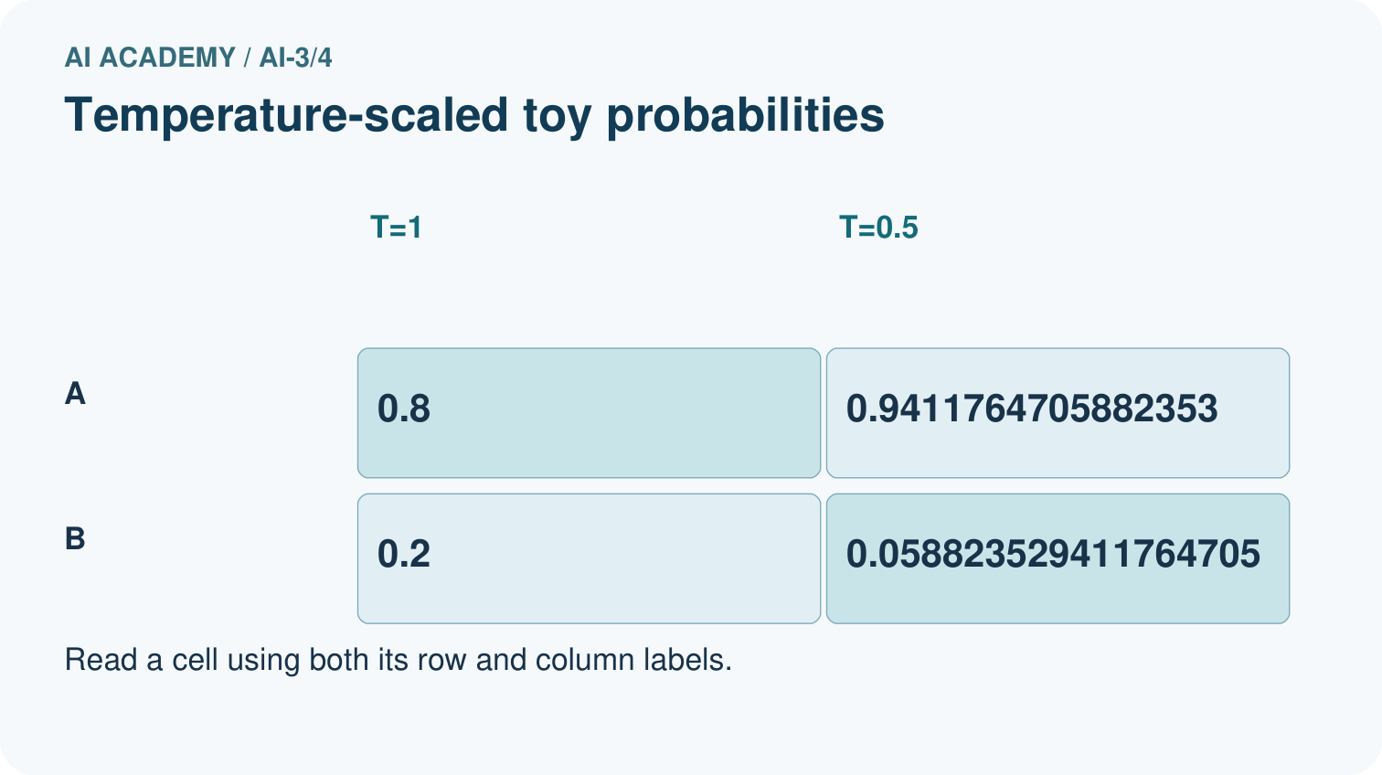
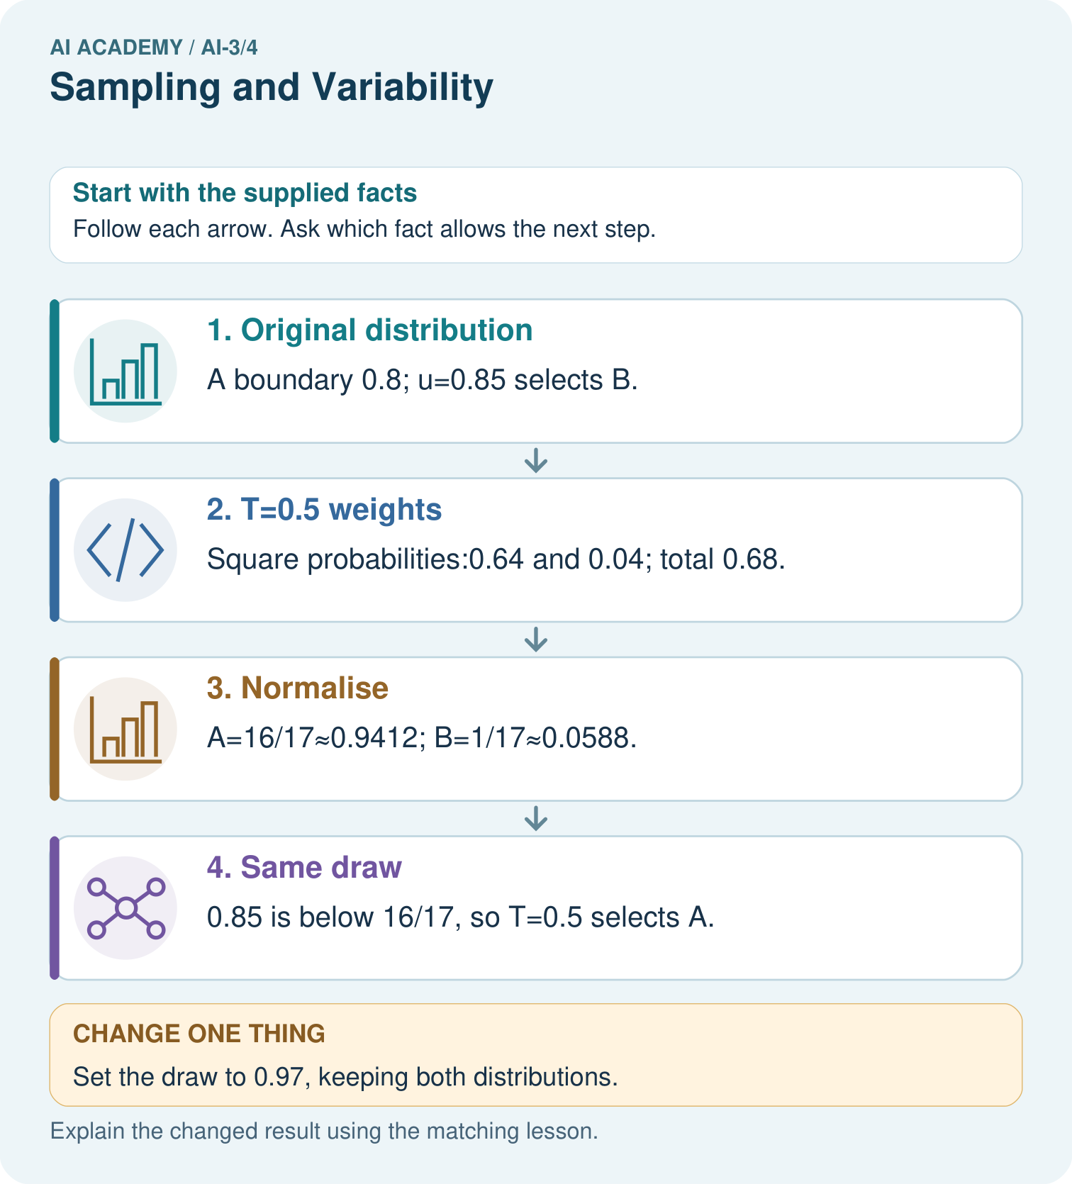
Does T=0.5 make B impossible, and does choosing A guarantee factual accuracy?

My picture-based explanation and changed-case prediction
________________________________________________________________
________________________________________________________________
________________________________________________________________
________________________________________________________________
________________________________________________________________
________________________________________________________________
Support used: alone / hint / worked example. This record is practice evidence.
Project connection: Keep Study Buddy generation settings fixed during prompt comparisons and check evidence regardless of variability.

