AI ACADEMY · WORKBOOK · ai-3/11

Visual Composition
Project: Verified Study Buddy

01. Recall and choose your starting point
Try the recall before opening notes. Then use a different colour or a labelled second line to correct your explanation.

Image Generation Models
Without opening the old lesson, explain one key idea from Image Generation Models. Give an example and a mistake that the idea helps you avoid.

My remembered idea, example and correction
________________________________________________________________
________________________________________________________________
________________________________________________________________

Structured Output and Schemas
Without opening the old lesson, explain one key idea from Structured Output and Schemas. Give an example and a mistake that the idea helps you avoid.

My remembered idea, example and correction
________________________________________________________________
________________________________________________________________
________________________________________________________________

Prompt as a Contract
Without opening the old lesson, explain one key idea from Prompt as a Contract. Give an example and a mistake that the idea helps you avoid.

My remembered idea, example and correction
________________________________________________________________
________________________________________________________________
________________________________________________________________

02. Practise with fading help
Use W2: Trace the worked case for Image generation and provenance. Record the answer once; the lesson and workbook refer to the same attempt.
Given inputs | Procedure I chose | Middle steps | Result and check

The step I completed without help, and the hint I needed
________________________________________________________________
________________________________________________________________
________________________________________________________________

03. Individual reasoning check
Use the worked case for Image generation and provenance. Proposed explanation: “The worked result establishes every future case”. Decide whether this explanation is supported. Point to the step or supplied fact that decides; explain your repair if needed.

My explanation before partner discussion
________________________________________________________________
________________________________________________________________
________________________________________________________________
________________________________________________________________

04. Independent transfer case

Independent case: Changed independent case
A supplied drawing description says three stars are above a triangle, while a circle crosses the edge of a rectangle. The brief requires three stars above the triangle and the circle fully inside the rectangle. Evaluate this description.

My independent explanation, trace and limits
________________________________________________________________
________________________________________________________________
________________________________________________________________
________________________________________________________________
________________________________________________________________
________________________________________________________________
________________________________________________________________
Attempt this case before feedback. Record any help. Earlier examples below are further practice; a case already practised with feedback cannot establish fresh transfer.

05. Your learning target
An image brief requires two trees, a bench between them and the sun upper-right. A result has all objects but the bench is left of both trees. Write a spatial test that detects this.

06. Solve the given case
Brief: large tree left, small bicycle right, open sky above. Output puts bicycle left.
Create a visual checklist.
Show your trace, calculation or evidence

Write or draw your reasoning and evidence.
________________________________________________________________
________________________________________________________________
________________________________________________________________
________________________________________________________________
________________________________________________________________

07. Check a changed case
A poster puts pale yellow labels on white and hides the main object behind decorations. Suggest two revisions and how to check them.
My independent answer and reason

Write or draw your reasoning and evidence.
________________________________________________________________
________________________________________________________________
________________________________________________________________
________________________________________________________________
________________________________________________________________

Week 11 Test and reflect

08. Design a revealing test
Create a changed input, boundary case or missing-information case. Write the expected answer or safe response before testing.
Test record | My evidence
Changed input or condition
Expected answer or fallback
Observed result
Why the result occurred

09. Project checkpoint
Create age-fit explanatory visuals with labeled purpose and no invented documentary evidence.
The project change and evidence I will keep

Write or draw your reasoning and evidence.
________________________________________________________________
________________________________________________________________
________________________________________________________________
________________________________________________________________
________________________________________________________________

10. Self check
I can explain the mechanism. I can show evidence. I can handle a changed case. I can name a limit. Mark each as not yet, with help or independently, and attach supporting work.
Teacher review ____________________ Next step ____________________

11. Transfer practice from the original programme
An image brief requires two trees, a bench between them and the sun upper-right. A result has all objects but the bench is left of both trees. Write a spatial test that detects this.

My independently reasoned answer
________________________________________________________________
________________________________________________________________
________________________________________________________________
________________________________________________________________
________________________________________________________________
________________________________________________________________
________________________________________________________________
Record support used: none, hint or teacher explanation.

12. W1 Explain the mechanism
Explain the weekly mechanism in your own words. Use the worked scenario to name its input, decision rule and output.

My reasoning and evidence
________________________________________________________________
________________________________________________________________
________________________________________________________________
________________________________________________________________
________________________________________________________________
________________________________________________________________

13. W2 Trace the worked case
A fictional poster requires exactly three labelled circles. Generated image shows four circles and one unreadable label. A caption calls it a photograph of a real lesson. Show the intermediate steps and give the conclusion with its scope.

My reasoning and evidence
________________________________________________________________
________________________________________________________________
________________________________________________________________
________________________________________________________________
________________________________________________________________
________________________________________________________________
________________________________________________________________

14. W3 Audit the limit
A report omits this qualification: Provenance tracks production history; it does not prove the content is accurate or establish every legal permission. Explain how omitting it could change a reader's interpretation, and write an accurate replacement.

My reasoning and evidence
________________________________________________________________
________________________________________________________________
________________________________________________________________
________________________________________________________________
________________________________________________________________
________________________________________________________________

15. W4 Apply a new case independently
A generated diagram requires two arrows and labels input/output. It has two arrows but swapped labels. Metadata records generation, yet the caption says experimental observation. Audit.

My reasoning and evidence
________________________________________________________________
________________________________________________________________
________________________________________________________________
________________________________________________________________
________________________________________________________________
________________________________________________________________
________________________________________________________________
________________________________________________________________

16. W5 Design a revealing follow-up
For the worked scenario, propose one additional case that could reveal a failure, describe its expected outcome before running it, and explain what would need to remain fixed for a fair comparison. Do not reuse W4 as a new final test after receiving feedback.

My reasoning and evidence
________________________________________________________________
________________________________________________________________
________________________________________________________________
________________________________________________________________
________________________________________________________________
________________________________________________________________
________________________________________________________________

17. Feedback, return check and learning record
Evidence | My record
Worked alone / hint / model
First step I repaired and why
New case checked later; date and result
What I can now explain without notes
One remaining question
Revisit this idea with your teacher after a delay. Familiarity is different from explaining and using it on a changed case.

18. Pictorial case practice: Visual Composition
A fictional Study Buddy requests a science-poster layout, then audits a supplied drawing description.
Brief: exactly two labelled bottles left of one beaker; one arrow from bottles toward beaker.
Supplied drawing description: two labelled bottles are right of a beaker; an arrow points from beaker toward bottles.
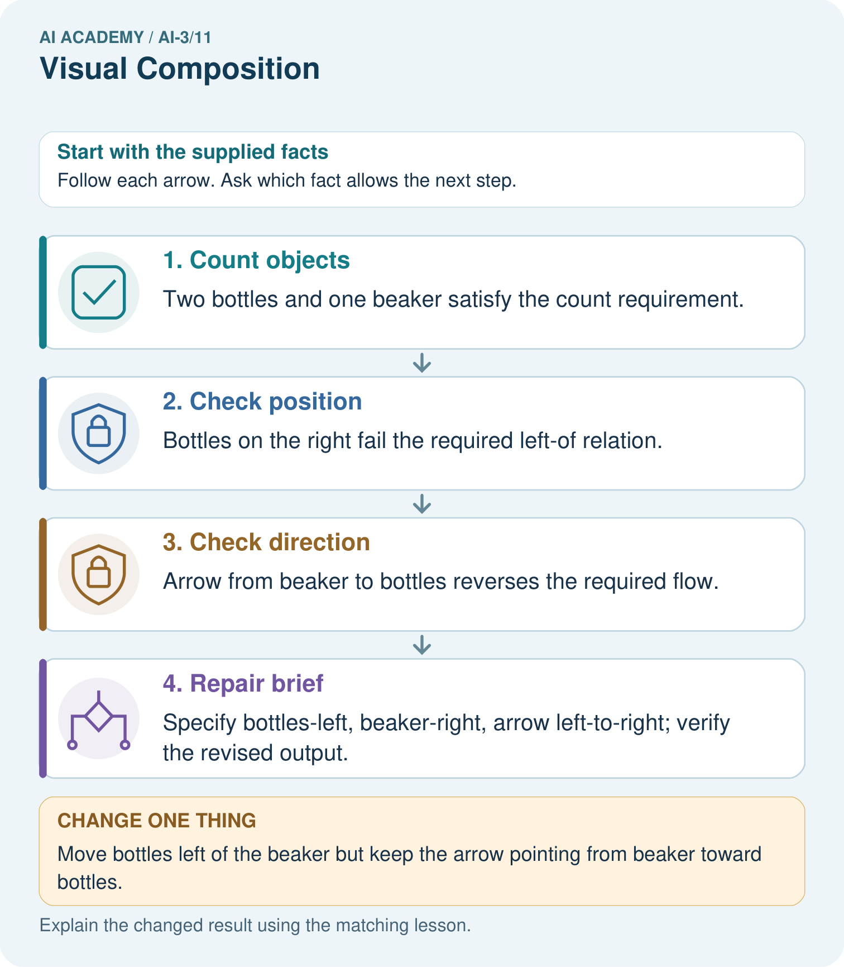
Which checks pass after that single change, and what still needs repair?

My picture-based explanation and changed-case prediction
________________________________________________________________
________________________________________________________________
________________________________________________________________
________________________________________________________________
________________________________________________________________
________________________________________________________________
Support used: alone / hint / worked example. This record is practice evidence.
Project connection: Create Study Buddy diagram rubrics covering counts, readable labels, containment, order and meaningful arrow direction.

