AI ACADEMY · WORKBOOK · ai-3/13

Multimodal Evidence
Project: Verified Study Buddy

01. Recall and choose your starting point
Try the recall before opening notes. Then use a different colour or a labelled second line to correct your explanation.

Speech and Audio Systems
Without opening the old lesson, explain one key idea from Speech and Audio Systems. Give an example and a mistake that the idea helps you avoid.

My remembered idea, example and correction
________________________________________________________________
________________________________________________________________
________________________________________________________________

Image Generation Models
Without opening the old lesson, explain one key idea from Image Generation Models. Give an example and a mistake that the idea helps you avoid.

My remembered idea, example and correction
________________________________________________________________
________________________________________________________________
________________________________________________________________

Iterative Prompting
Without opening the old lesson, explain one key idea from Iterative Prompting. Give an example and a mistake that the idea helps you avoid.

My remembered idea, example and correction
________________________________________________________________
________________________________________________________________
________________________________________________________________

02. Practise with fading help
Use W2: Trace the worked case for Speech pipelines and multimodal evidence. Record the answer once; the lesson and workbook refer to the same attempt.
Given inputs | Procedure I chose | Middle steps | Result and check

The step I completed without help, and the hint I needed
________________________________________________________________
________________________________________________________________
________________________________________________________________

03. Individual reasoning check
Use the worked case for Speech pipelines and multimodal evidence. Proposed explanation: “The worked result establishes every future case”. Decide whether this explanation is supported. Point to the step or supplied fact that decides; explain your repair if needed.

My explanation before partner discussion
________________________________________________________________
________________________________________________________________
________________________________________________________________
________________________________________________________________

04. Independent transfer case

Independent case: Changed independent case
A description reports two visible plants and a third opaque pot whose contents cannot be seen. A caption says “three plants”. What is supported?

My independent explanation, trace and limits
________________________________________________________________
________________________________________________________________
________________________________________________________________
________________________________________________________________
________________________________________________________________
________________________________________________________________
________________________________________________________________
Attempt this case before feedback. Record any help. Earlier examples below are further practice; a case already practised with feedback cannot establish fresh transfer.

05. Your learning target
A caption says four seedlings; the image shows three and an opaque box. Is a fourth seedling disproved? Write an evidence-aware response.

06. Solve the given case
An image shows three plants; caption claims a fourth outside the frame.
What can the image establish?
Show your trace, calculation or evidence

Write or draw your reasoning and evidence.
________________________________________________________________
________________________________________________________________
________________________________________________________________
________________________________________________________________
________________________________________________________________

07. Check a changed case
A chart image shows 12 plants; its caption says 21. What should a multimodal assistant report before drawing a conclusion?
My independent answer and reason

Write or draw your reasoning and evidence.
________________________________________________________________
________________________________________________________________
________________________________________________________________
________________________________________________________________
________________________________________________________________

Week 13 Test and reflect

08. Design a revealing test
Create a changed input, boundary case or missing-information case. Write the expected answer or safe response before testing.
Test record | My evidence
Changed input or condition
Expected answer or fallback
Observed result
Why the result occurred

09. Project checkpoint
Accept diagrams plus questions only when the source and topic align with the learner’s task.
The project change and evidence I will keep

Write or draw your reasoning and evidence.
________________________________________________________________
________________________________________________________________
________________________________________________________________
________________________________________________________________
________________________________________________________________

10. Self check
I can explain the mechanism. I can show evidence. I can handle a changed case. I can name a limit. Mark each as not yet, with help or independently, and attach supporting work.
Teacher review ____________________ Next step ____________________

11. Transfer practice from the original programme
A caption says four seedlings; the image shows three and an opaque box. Is a fourth seedling disproved? Write an evidence-aware response.

My independently reasoned answer
________________________________________________________________
________________________________________________________________
________________________________________________________________
________________________________________________________________
________________________________________________________________
________________________________________________________________
________________________________________________________________
Record support used: none, hint or teacher explanation.

12. W1 Explain the mechanism
Explain the weekly mechanism in your own words. Use the worked scenario to name its input, decision rule and output.

My reasoning and evidence
________________________________________________________________
________________________________________________________________
________________________________________________________________
________________________________________________________________
________________________________________________________________
________________________________________________________________

13. W2 Trace the worked case
Audio transcript reads fifteen boxes; a clear written inventory says fifty boxes. The original audio is unavailable and the assistant reports fifteen as certain. Show the intermediate steps and give the conclusion with its scope.

My reasoning and evidence
________________________________________________________________
________________________________________________________________
________________________________________________________________
________________________________________________________________
________________________________________________________________
________________________________________________________________
________________________________________________________________

14. W3 Audit the limit
A report omits this qualification: A stage-level accuracy or authority policy does not establish every modality agrees or every downstream claim is supported. Explain how omitting it could change a reader's interpretation, and write an accurate replacement.

My reasoning and evidence
________________________________________________________________
________________________________________________________________
________________________________________________________________
________________________________________________________________
________________________________________________________________
________________________________________________________________

15. W4 Apply a new case independently
Transcript says room E; a current written approval says room F. The task requires current approved room. Written approval is declared authoritative; trace the response and the transcription limit.

My reasoning and evidence
________________________________________________________________
________________________________________________________________
________________________________________________________________
________________________________________________________________
________________________________________________________________
________________________________________________________________
________________________________________________________________
________________________________________________________________

16. W5 Design a revealing follow-up
For the worked scenario, propose one additional case that could reveal a failure, describe its expected outcome before running it, and explain what would need to remain fixed for a fair comparison. Do not reuse W4 as a new final test after receiving feedback.

My reasoning and evidence
________________________________________________________________
________________________________________________________________
________________________________________________________________
________________________________________________________________
________________________________________________________________
________________________________________________________________
________________________________________________________________

17. Feedback, return check and learning record
Evidence | My record
Worked alone / hint / model
First step I repaired and why
New case checked later; date and result
What I can now explain without notes
One remaining question
Revisit this idea with your teacher after a delay. Familiarity is different from explaining and using it on a changed case.

18. Pictorial case practice: Multimodal Evidence
A fictional Study Buddy audits a desk description and a separate caption.
Description: one open transparent box visibly contains three pencils; one closed opaque box hides its contents.
Caption: “There are five pencils on this desk.” No other evidence reveals the closed box.
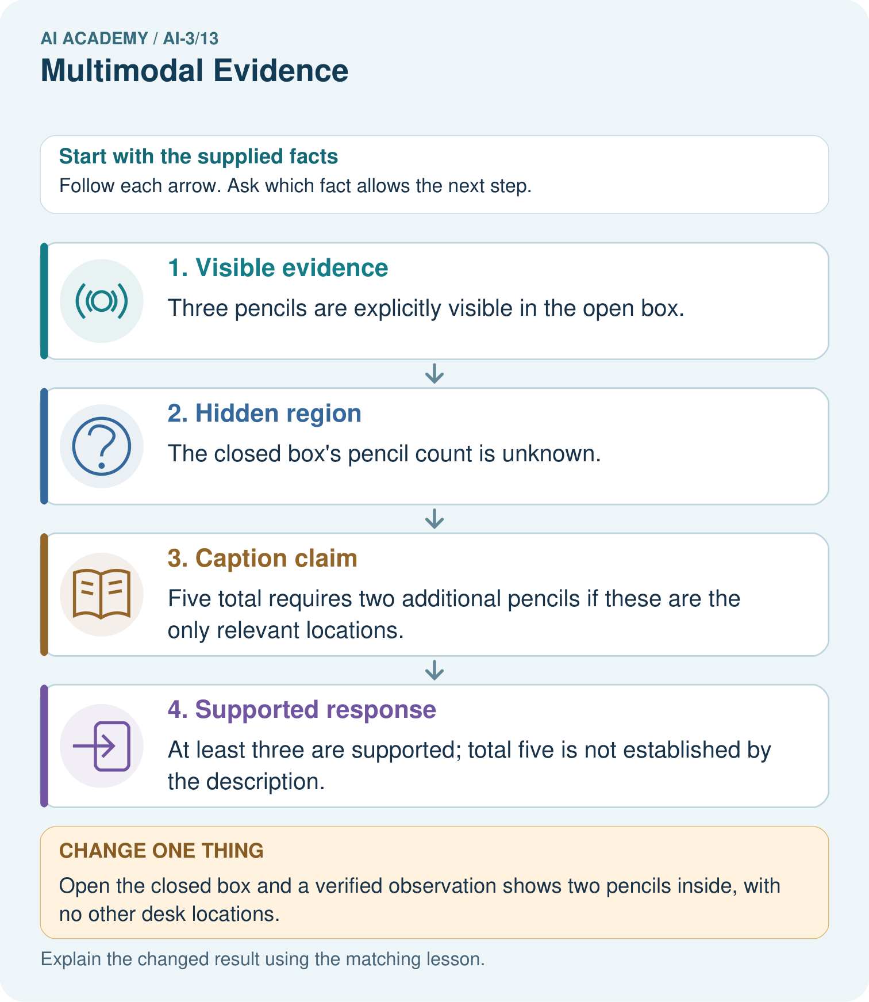
Why were both “exactly three” and “exactly five” unsupported before opening the box?

My picture-based explanation and changed-case prediction
________________________________________________________________
________________________________________________________________
________________________________________________________________
________________________________________________________________
________________________________________________________________
________________________________________________________________
Support used: alone / hint / worked example. This record is practice evidence.
Project connection: Label Study Buddy claims by their visual, audio or text evidence and retain uncertainty when modalities omit information.

