AI ACADEMY · WORKBOOK · ai-3/19

User Need and AI Contribution
Project: Verified Study Buddy

01. Recall and choose your starting point
Try the recall before opening notes. Then use a different colour or a labelled second line to correct your explanation.

Retrieval Augmented Generation
Without opening the old lesson, explain one key idea from Retrieval Augmented Generation. Give an example and a mistake that the idea helps you avoid.

My remembered idea, example and correction
________________________________________________________________
________________________________________________________________
________________________________________________________________

Verify Numbers and Dates
Without opening the old lesson, explain one key idea from Verify Numbers and Dates. Give an example and a mistake that the idea helps you avoid.

My remembered idea, example and correction
________________________________________________________________
________________________________________________________________
________________________________________________________________

Multimodal Evidence
Without opening the old lesson, explain one key idea from Multimodal Evidence. Give an example and a mistake that the idea helps you avoid.

My remembered idea, example and correction
________________________________________________________________
________________________________________________________________
________________________________________________________________

02. Practise with fading help
Use W2: Trace the worked case for Capstone requirements and corpus. Record the answer once; the lesson and workbook refer to the same attempt.
Given inputs | Procedure I chose | Middle steps | Result and check

The step I completed without help, and the hint I needed
________________________________________________________________
________________________________________________________________
________________________________________________________________

03. Individual reasoning check
Use the worked case for Capstone requirements and corpus. Proposed explanation: “The worked result establishes every future case”. Decide whether this explanation is supported. Point to the step or supplied fact that decides; explain your repair if needed.

My explanation before partner discussion
________________________________________________________________
________________________________________________________________
________________________________________________________________
________________________________________________________________

04. Independent transfer case

Independent case: Apply a new case independently
Student equipment assistant has public inventory I, restricted purchase ledger L and public booking notice B. Define eligible corpus, baseline and a missing-evidence test.

My independent explanation, trace and limits
________________________________________________________________
________________________________________________________________
________________________________________________________________
________________________________________________________________
________________________________________________________________
________________________________________________________________
________________________________________________________________
Attempt this case before feedback. Record any help. Earlier examples below are further practice; a case already practised with feedback cannot establish fresh transfer.

05. Your learning target
Students cannot find definitions in a 20-page handout. Compare an index with a grounded assistant. Define a success measure and a failure case for both.

06. Solve the given case
Learners struggle to locate definitions in an approved chapter; a proposed chatbot answers everything.
Narrow the need and AI contribution.
Show your trace, calculation or evidence

Write or draw your reasoning and evidence.
________________________________________________________________
________________________________________________________________
________________________________________________________________
________________________________________________________________
________________________________________________________________

07. Check a changed case
A student needs the exact due date from a course notice. Should the design start by generating a plausible date or locating the notice? Explain the AI contribution.
My independent answer and reason

Write or draw your reasoning and evidence.
________________________________________________________________
________________________________________________________________
________________________________________________________________
________________________________________________________________
________________________________________________________________

Week 19 Test and reflect

08. Design a revealing test
Create a changed input, boundary case or missing-information case. Write the expected answer or safe response before testing.
Test record | My evidence
Changed input or condition
Expected answer or fallback
Observed result
Why the result occurred

09. Project checkpoint
Justify exactly which Study Buddy stage uses AI and which stages remain deterministic.
The project change and evidence I will keep

Write or draw your reasoning and evidence.
________________________________________________________________
________________________________________________________________
________________________________________________________________
________________________________________________________________
________________________________________________________________

10. Self check
I can explain the mechanism. I can show evidence. I can handle a changed case. I can name a limit. Mark each as not yet, with help or independently, and attach supporting work.
Teacher review ____________________ Next step ____________________

11. Transfer practice from the original programme
Students cannot find definitions in a 20-page handout. Compare an index with a grounded assistant. Define a success measure and a failure case for both.

My independently reasoned answer
________________________________________________________________
________________________________________________________________
________________________________________________________________
________________________________________________________________
________________________________________________________________
________________________________________________________________
________________________________________________________________
Record support used: none, hint or teacher explanation.

12. W1 Explain the mechanism
Explain the weekly mechanism in your own words. Use the worked scenario to name its input, decision rule and output.

My reasoning and evidence
________________________________________________________________
________________________________________________________________
________________________________________________________________
________________________________________________________________
________________________________________________________________
________________________________________________________________

13. W2 Trace the worked case
Student room assistant corpus contains public register P, teacher-only guide T and current approval A. It must report approved room capacity or needs_review. Show the intermediate steps and give the conclusion with its scope.

My reasoning and evidence
________________________________________________________________
________________________________________________________________
________________________________________________________________
________________________________________________________________
________________________________________________________________
________________________________________________________________
________________________________________________________________

14. W3 Audit the limit
A report omits this qualification: A complete capstone plan is not evidence that the implementation meets it; evaluate after building. Explain how omitting it could change a reader's interpretation, and write an accurate replacement.

My reasoning and evidence
________________________________________________________________
________________________________________________________________
________________________________________________________________
________________________________________________________________
________________________________________________________________
________________________________________________________________

15. W4 Apply a new case independently
Student equipment assistant has public inventory I, restricted purchase ledger L and public booking notice B. Define eligible corpus, baseline and a missing-evidence test.

My reasoning and evidence
________________________________________________________________
________________________________________________________________
________________________________________________________________
________________________________________________________________
________________________________________________________________
________________________________________________________________
________________________________________________________________
________________________________________________________________

16. W5 Design a revealing follow-up
For the worked scenario, propose one additional case that could reveal a failure, describe its expected outcome before running it, and explain what would need to remain fixed for a fair comparison. Do not reuse W4 as a new final test after receiving feedback.

My reasoning and evidence
________________________________________________________________
________________________________________________________________
________________________________________________________________
________________________________________________________________
________________________________________________________________
________________________________________________________________
________________________________________________________________

17. Feedback, return check and learning record
Evidence | My record
Worked alone / hint / model
First step I repaired and why
New case checked later; date and result
What I can now explain without notes
One remaining question
Revisit this idea with your teacher after a delay. Familiarity is different from explaining and using it on a changed case.

18. Pictorial case practice: User Need and AI Contribution
Define a useful reading helper before choosing its AI features.
A pupil needs the meaning of unfamiliar words in an approved glossary. G3 defines habitat as the place an organism lives; no other sources are allowed.
All inputs and outcomes in this worked example are invented classroom data; no real model run is claimed.
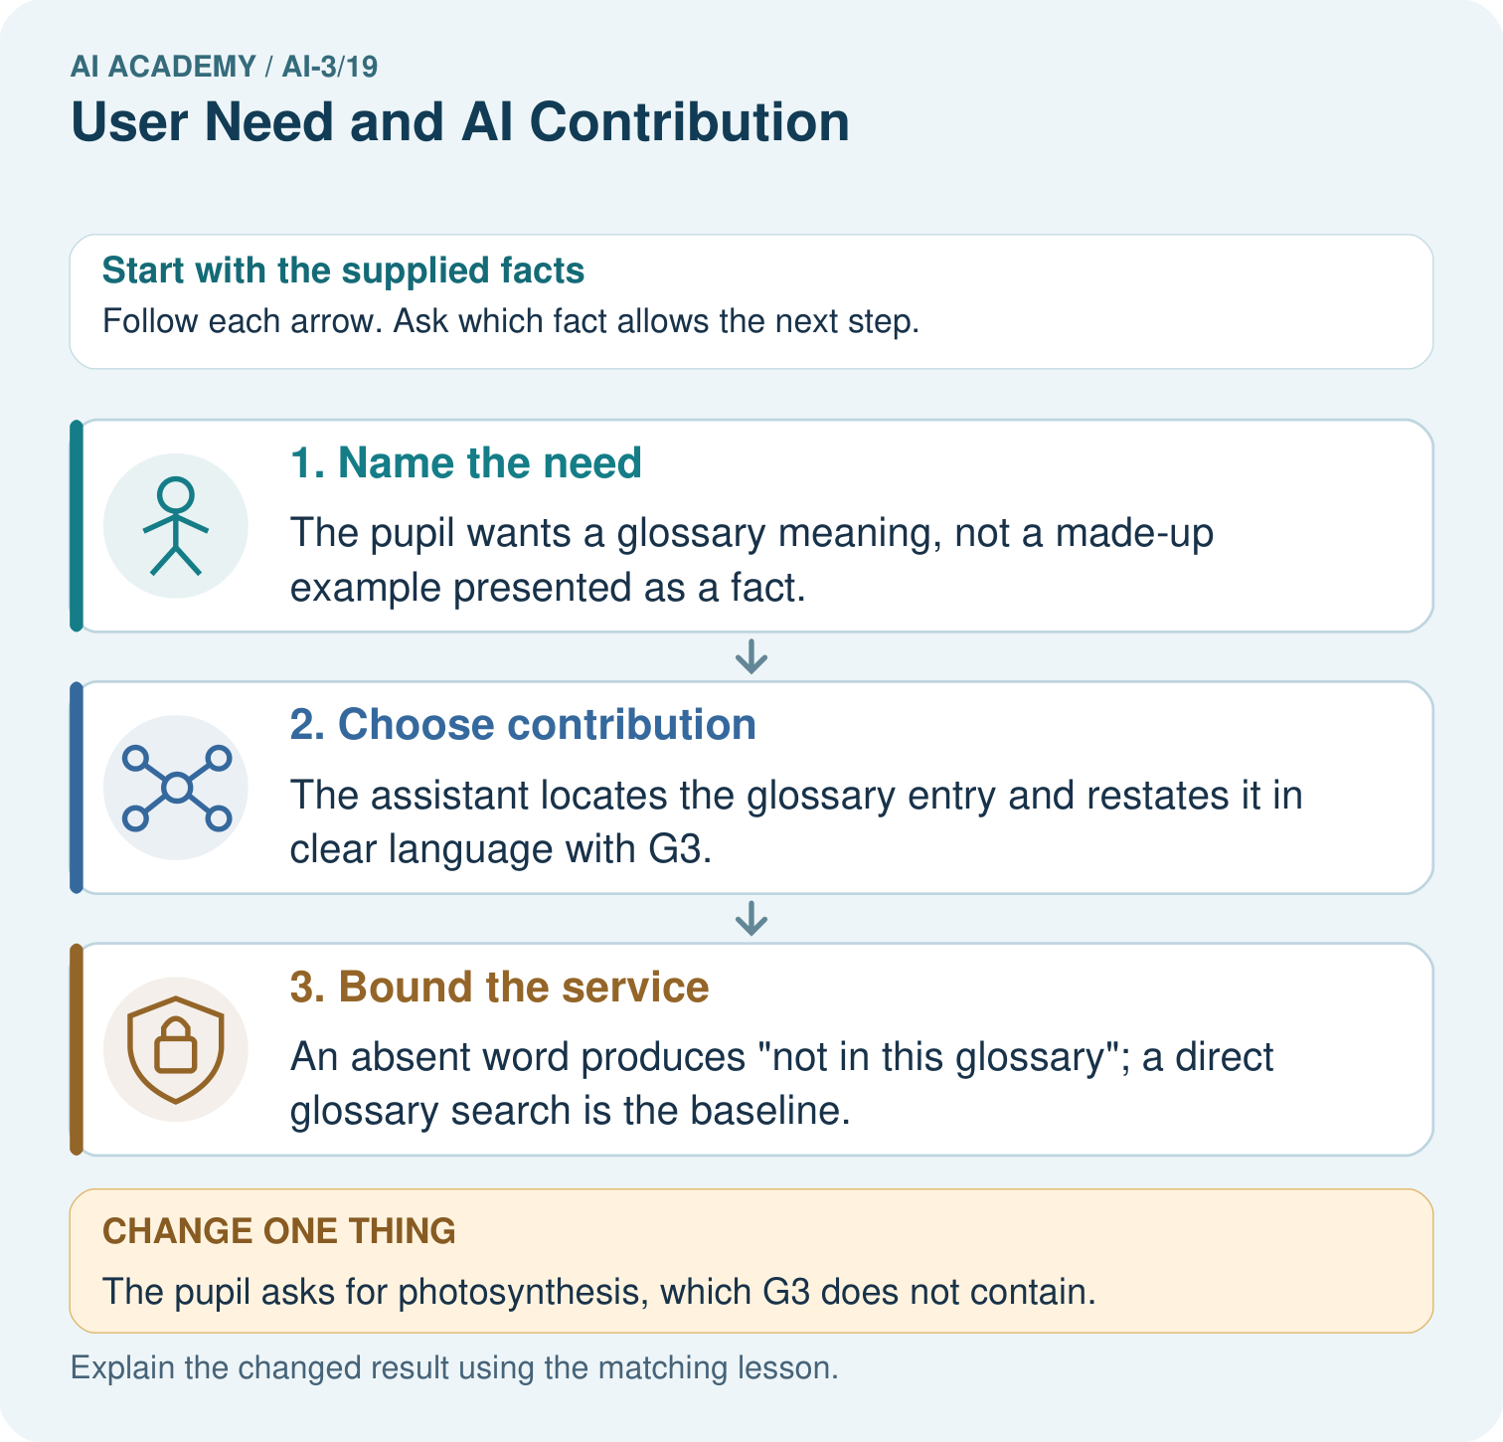
What non-AI baseline would reveal whether this helper adds value? Point to the relevant step in the picture, then write the changed result and the rule or evidence that supports it.

My picture-based explanation and changed-case prediction
________________________________________________________________
________________________________________________________________
________________________________________________________________
________________________________________________________________
________________________________________________________________
________________________________________________________________
Support used: alone / hint / worked example. This record is practice evidence.
Project connection: For your Verified Study Buddy, save the input, procedure, observed result and limitation of this check. Label this worked example as practice; use a different, previously unreviewed case when checking independent understanding.

