AI ACADEMY · WORKBOOK · ai-3/28

Privacy by Design
Project: Verified Study Buddy

01. Recall and choose your starting point
Try the recall before opening notes. Then use a different colour or a labelled second line to correct your explanation.

Red Team the Product
Without opening the old lesson, explain one key idea from Red Team the Product. Give an example and a mistake that the idea helps you avoid.

My remembered idea, example and correction
________________________________________________________________
________________________________________________________________
________________________________________________________________

Quality Rubrics
Without opening the old lesson, explain one key idea from Quality Rubrics. Give an example and a mistake that the idea helps you avoid.

My remembered idea, example and correction
________________________________________________________________
________________________________________________________________
________________________________________________________________

Requests Responses and JSON
Without opening the old lesson, explain one key idea from Requests Responses and JSON. Give an example and a mistake that the idea helps you avoid.

My remembered idea, example and correction
________________________________________________________________
________________________________________________________________
________________________________________________________________

02. Practise with fading help
Use W2: Trace the worked case for Data retention and deletion. Record the answer once; the lesson and workbook refer to the same attempt.
Given inputs | Procedure I chose | Middle steps | Result and check

The step I completed without help, and the hint I needed
________________________________________________________________
________________________________________________________________
________________________________________________________________

03. Individual reasoning check
Use the worked case for Data retention and deletion. Proposed explanation: “The worked result establishes every future case”. Decide whether this explanation is supported. Point to the step or supplied fact that decides; explain your repair if needed.

My explanation before partner discussion
________________________________________________________________
________________________________________________________________
________________________________________________________________
________________________________________________________________

04. Independent transfer case

Independent case: Apply a new case independently
Retention is5 days, inclusive deletion boundary. Ages4, 5, 6; a log stores complete content. Trace required action.

My independent explanation, trace and limits
________________________________________________________________
________________________________________________________________
________________________________________________________________
________________________________________________________________
________________________________________________________________
________________________________________________________________
________________________________________________________________
Attempt this case before feedback. Record any help. Earlier examples below are further practice; a case already practised with feedback cannot establish fresh transfer.

05. Your learning target
A study tool needs topic and reading level but proposes storing addresses and all conversations forever. Design a smaller record and a deletion rule.

06. Solve the given case
A study tool plans to retain names, addresses and all chats forever.
Design a smaller data plan.
Show your trace, calculation or evidence

Write or draw your reasoning and evidence.
________________________________________________________________
________________________________________________________________
________________________________________________________________
________________________________________________________________
________________________________________________________________

07. Check a changed case
A practice quiz needs a topic and difficulty. A form also asks for home address and date of birth. What should be removed and why?
My independent answer and reason

Write or draw your reasoning and evidence.
________________________________________________________________
________________________________________________________________
________________________________________________________________
________________________________________________________________
________________________________________________________________

Week 28 Test and reflect

08. Design a revealing test
Create a changed input, boundary case or missing-information case. Write the expected answer or safe response before testing.
Test record | My evidence
Changed input or condition
Expected answer or fallback
Observed result
Why the result occurred

09. Project checkpoint
Create a minimal data map and visible memory controls before expanding features.
The project change and evidence I will keep

Write or draw your reasoning and evidence.
________________________________________________________________
________________________________________________________________
________________________________________________________________
________________________________________________________________
________________________________________________________________

10. Self check
I can explain the mechanism. I can show evidence. I can handle a changed case. I can name a limit. Mark each as not yet, with help or independently, and attach supporting work.
Teacher review ____________________ Next step ____________________

11. Transfer practice from the original programme
A study tool needs topic and reading level but proposes storing addresses and all conversations forever. Design a smaller record and a deletion rule.

My independently reasoned answer
________________________________________________________________
________________________________________________________________
________________________________________________________________
________________________________________________________________
________________________________________________________________
________________________________________________________________
________________________________________________________________
Record support used: none, hint or teacher explanation.

12. W1 Explain the mechanism
Explain the weekly mechanism in your own words. Use the worked scenario to name its input, decision rule and output.

My reasoning and evidence
________________________________________________________________
________________________________________________________________
________________________________________________________________
________________________________________________________________
________________________________________________________________
________________________________________________________________

13. W2 Trace the worked case
Record ages are6, 7, 9 days. Cache contains copies of all three. Show the intermediate steps and give the conclusion with its scope.

My reasoning and evidence
________________________________________________________________
________________________________________________________________
________________________________________________________________
________________________________________________________________
________________________________________________________________
________________________________________________________________
________________________________________________________________

14. W3 Audit the limit
A report omits this qualification: This fictional retention exercise is not a statement of legal retention requirements. Explain how omitting it could change a reader's interpretation, and write an accurate replacement.

My reasoning and evidence
________________________________________________________________
________________________________________________________________
________________________________________________________________
________________________________________________________________
________________________________________________________________
________________________________________________________________

15. W4 Apply a new case independently
Retention is5 days, inclusive deletion boundary. Ages4, 5, 6; a log stores complete content. Trace required action.

My reasoning and evidence
________________________________________________________________
________________________________________________________________
________________________________________________________________
________________________________________________________________
________________________________________________________________
________________________________________________________________
________________________________________________________________
________________________________________________________________

16. W5 Design a revealing follow-up
For the worked scenario, propose one additional case that could reveal a failure, describe its expected outcome before running it, and explain what would need to remain fixed for a fair comparison. Do not reuse W4 as a new final test after receiving feedback.

My reasoning and evidence
________________________________________________________________
________________________________________________________________
________________________________________________________________
________________________________________________________________
________________________________________________________________
________________________________________________________________
________________________________________________________________

17. Feedback, return check and learning record
Evidence | My record
Worked alone / hint / model
First step I repaired and why
New case checked later; date and result
What I can now explain without notes
One remaining question
Revisit this idea with your teacher after a delay. Familiarity is different from explaining and using it on a changed case.

18. Pictorial case practice: Privacy by Design
Trace deletion through both a working folder and a cache.
Fictional retention policy: delete records aged at least 3 days. Ages A=2, B=3, C=4; the cache contains a copy of B.
All inputs and outcomes in this worked example are invented classroom data; no real model run is claimed.
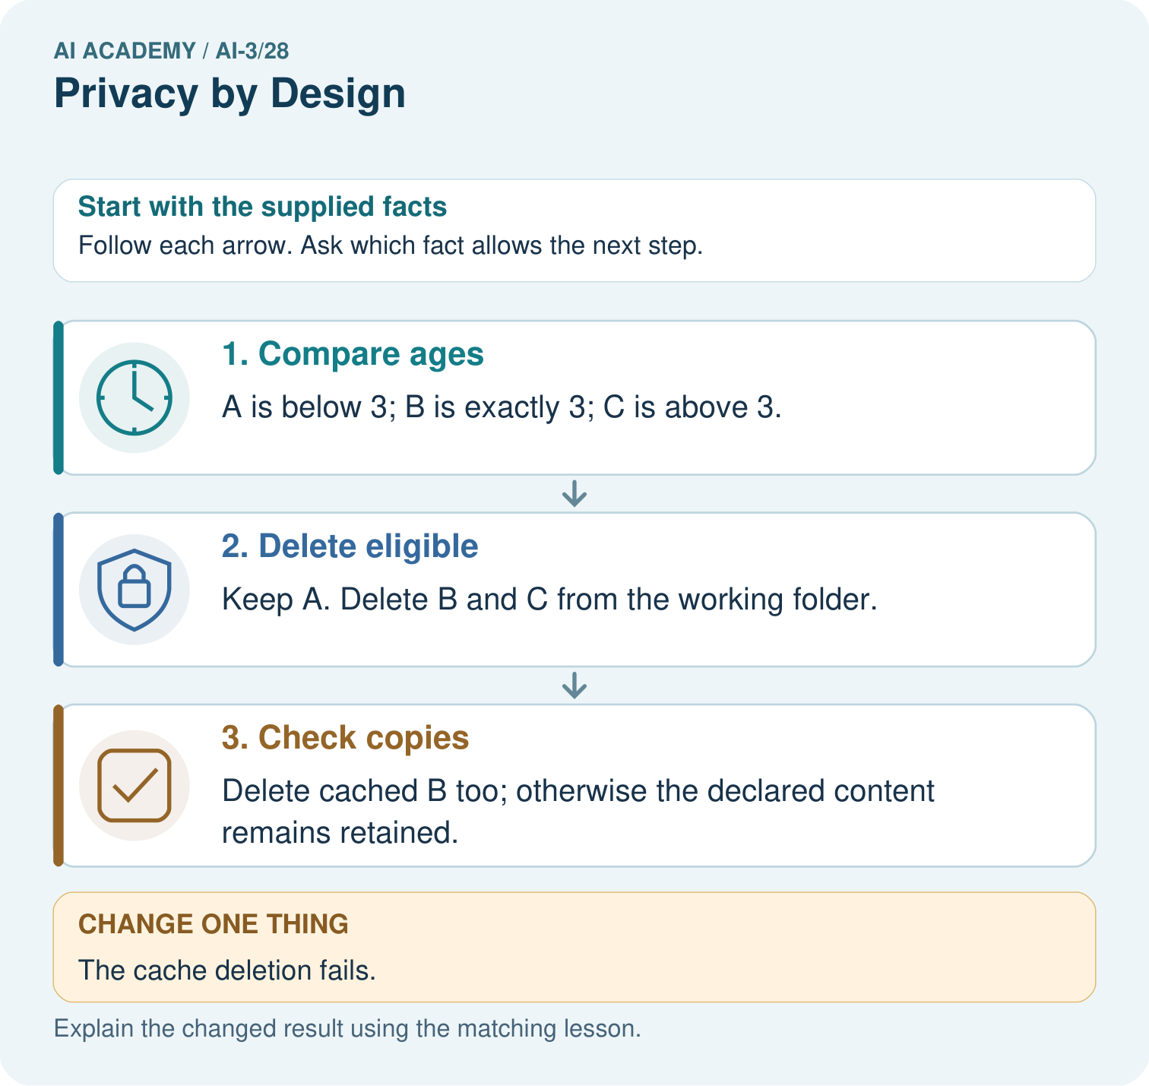
Which IDs and locations must appear in the deletion evidence? Point to the relevant step in the picture, then write the changed result and the rule or evidence that supports it.

My picture-based explanation and changed-case prediction
________________________________________________________________
________________________________________________________________
________________________________________________________________
________________________________________________________________
________________________________________________________________
________________________________________________________________
Support used: alone / hint / worked example. This record is practice evidence.
Project connection: For your Verified Study Buddy, save the input, procedure, observed result and limitation of this check. Label this worked example as practice; use a different, previously unreviewed case when checking independent understanding.

