AI ACADEMY · WORKBOOK · ai-3/35

Capstone Evaluate and Improve
Project: Verified Study Buddy

01. Recall and choose your starting point
Try the recall before opening notes. Then use a different colour or a labelled second line to correct your explanation.

Capstone Build
Without opening the old lesson, explain one key idea from Capstone Build. Give an example and a mistake that the idea helps you avoid.

My remembered idea, example and correction
________________________________________________________________
________________________________________________________________
________________________________________________________________

Human AI Workflow
Without opening the old lesson, explain one key idea from Human AI Workflow. Give an example and a mistake that the idea helps you avoid.

My remembered idea, example and correction
________________________________________________________________
________________________________________________________________
________________________________________________________________

Copyright and Provenance
Without opening the old lesson, explain one key idea from Copyright and Provenance. Give an example and a mistake that the idea helps you avoid.

My remembered idea, example and correction
________________________________________________________________
________________________________________________________________
________________________________________________________________

02. Practise with fading help
Use W2: Trace the worked case for Capstone evaluation and revision. Record the answer once; the lesson and workbook refer to the same attempt.
Given inputs | Procedure I chose | Middle steps | Result and check

The step I completed without help, and the hint I needed
________________________________________________________________
________________________________________________________________
________________________________________________________________

03. Individual reasoning check
Use the worked case for Capstone evaluation and revision. Proposed explanation: “The worked result establishes every future case”. Decide whether this explanation is supported. Point to the step or supplied fact that decides; explain your repair if needed.

My explanation before partner discussion
________________________________________________________________
________________________________________________________________
________________________________________________________________
________________________________________________________________

04. Independent transfer case

Independent case: Apply a new case independently
Twelve final cases baseline passes nine, candidate ten; candidate makes one unauthorised booking. Policy requires zero unauthorised actions. Decide release and revision evidence.

My independent explanation, trace and limits
________________________________________________________________
________________________________________________________________
________________________________________________________________
________________________________________________________________
________________________________________________________________
________________________________________________________________
________________________________________________________________
Attempt this case before feedback. Record any help. Earlier examples below are further practice; a case already practised with feedback cannot establish fresh transfer.

05. Your learning target
An assistant improves from 6/10 to 8/10 on reused development questions, but now answers one formerly safe unanswerable case with a guess. Assess the change and specify final testing.

06. Solve the given case
A revision improves supported answers from 6/10 to 8/10 on a development set.
What belongs in the report?
Show your trace, calculation or evidence

Write or draw your reasoning and evidence.
________________________________________________________________
________________________________________________________________
________________________________________________________________
________________________________________________________________
________________________________________________________________

07. Check a changed case
A revision improves four factual questions but fails two previously successful abstention cases. What should the evaluation report?
My independent answer and reason

Write or draw your reasoning and evidence.
________________________________________________________________
________________________________________________________________
________________________________________________________________
________________________________________________________________
________________________________________________________________

Week 35 Test and reflect

08. Design a revealing test
Create a changed input, boundary case or missing-information case. Write the expected answer or safe response before testing.
Test record | My evidence
Changed input or condition
Expected answer or fallback
Observed result
Why the result occurred

09. Project checkpoint
Publish baseline, diagnosis, change, before/after evidence, regressions, and next limit.
The project change and evidence I will keep

Write or draw your reasoning and evidence.
________________________________________________________________
________________________________________________________________
________________________________________________________________
________________________________________________________________
________________________________________________________________

10. Self check
I can explain the mechanism. I can show evidence. I can handle a changed case. I can name a limit. Mark each as not yet, with help or independently, and attach supporting work.
Teacher review ____________________ Next step ____________________

11. Transfer practice from the original programme
An assistant improves from 6/10 to 8/10 on reused development questions, but now answers one formerly safe unanswerable case with a guess. Assess the change and specify final testing.

My independently reasoned answer
________________________________________________________________
________________________________________________________________
________________________________________________________________
________________________________________________________________
________________________________________________________________
________________________________________________________________
________________________________________________________________
Record support used: none, hint or teacher explanation.

12. W1 Explain the mechanism
Explain the weekly mechanism in your own words. Use the worked scenario to name its input, decision rule and output.

My reasoning and evidence
________________________________________________________________
________________________________________________________________
________________________________________________________________
________________________________________________________________
________________________________________________________________
________________________________________________________________

13. W2 Trace the worked case
On ten final cases baseline passes seven and assistant eight. One assistant failure exposes a teacher-only source to a student. Show the intermediate steps and give the conclusion with its scope.

My reasoning and evidence
________________________________________________________________
________________________________________________________________
________________________________________________________________
________________________________________________________________
________________________________________________________________
________________________________________________________________
________________________________________________________________

14. W3 Audit the limit
A report omits this qualification: A revised procedure evaluated on inspected cases cannot be described as newly independent final testing. Explain how omitting it could change a reader's interpretation, and write an accurate replacement.

My reasoning and evidence
________________________________________________________________
________________________________________________________________
________________________________________________________________
________________________________________________________________
________________________________________________________________
________________________________________________________________

15. W4 Apply a new case independently
Twelve final cases baseline passes nine, candidate ten; candidate makes one unauthorised booking. Policy requires zero unauthorised actions. Decide release and revision evidence.

My reasoning and evidence
________________________________________________________________
________________________________________________________________
________________________________________________________________
________________________________________________________________
________________________________________________________________
________________________________________________________________
________________________________________________________________
________________________________________________________________

16. W5 Design a revealing follow-up
For the worked scenario, propose one additional case that could reveal a failure, describe its expected outcome before running it, and explain what would need to remain fixed for a fair comparison. Do not reuse W4 as a new final test after receiving feedback.

My reasoning and evidence
________________________________________________________________
________________________________________________________________
________________________________________________________________
________________________________________________________________
________________________________________________________________
________________________________________________________________
________________________________________________________________

17. Latency cost and resource use — W1 Explain the mechanism
Explain the weekly mechanism in your own words. Use the worked scenario to name its input, decision rule and output.

My reasoning and evidence
________________________________________________________________
________________________________________________________________
________________________________________________________________
________________________________________________________________
________________________________________________________________
________________________________________________________________

18. Latency cost and resource use — W2 Trace the worked case
A request uses 500 input units and 200 output units; starts at 10.0 seconds and finishes at 13.5. Show the intermediate steps and give the conclusion with its scope.

My reasoning and evidence
________________________________________________________________
________________________________________________________________
________________________________________________________________
________________________________________________________________
________________________________________________________________
________________________________________________________________
________________________________________________________________

19. Latency cost and resource use — W3 Audit the limit
A report omits this qualification: Resource comparisons require matched task conditions and quality evidence; a cheaper failing system is not automatically better. Explain how omitting it could change a reader's interpretation, and write an accurate replacement.

My reasoning and evidence
________________________________________________________________
________________________________________________________________
________________________________________________________________
________________________________________________________________
________________________________________________________________
________________________________________________________________

20. Latency cost and resource use — W4 Apply a new case independently
Request X uses 1000 input and 300 output units; Y uses 200 input and 100 output. Under the same fictional tariff compute individual and total cost.

My reasoning and evidence
________________________________________________________________
________________________________________________________________
________________________________________________________________
________________________________________________________________
________________________________________________________________
________________________________________________________________
________________________________________________________________
________________________________________________________________

21. Latency cost and resource use — W5 Design a revealing follow-up
For the worked scenario, propose one additional case that could reveal a failure, describe its expected outcome before running it, and explain what would need to remain fixed for a fair comparison. Do not reuse W4 as a new final test after receiving feedback.

My reasoning and evidence
________________________________________________________________
________________________________________________________________
________________________________________________________________
________________________________________________________________
________________________________________________________________
________________________________________________________________
________________________________________________________________

22. Feedback, return check and learning record
Evidence | My record
Worked alone / hint / model
First step I repaired and why
New case checked later; date and result
What I can now explain without notes
One remaining question
Revisit this idea with your teacher after a delay. Familiarity is different from explaining and using it on a changed case.

23. Pictorial case practice: Capstone Evaluate and Improve
Choose a study-buddy revision using task performance and a mandatory privacy gate.
On eight fixed validation cases, baseline passes 5 and candidate passes 7. One candidate response includes a restricted teacher note; privacy requires zero such exposures.
All inputs and outcomes in this worked example are invented classroom data; no real model run is claimed.
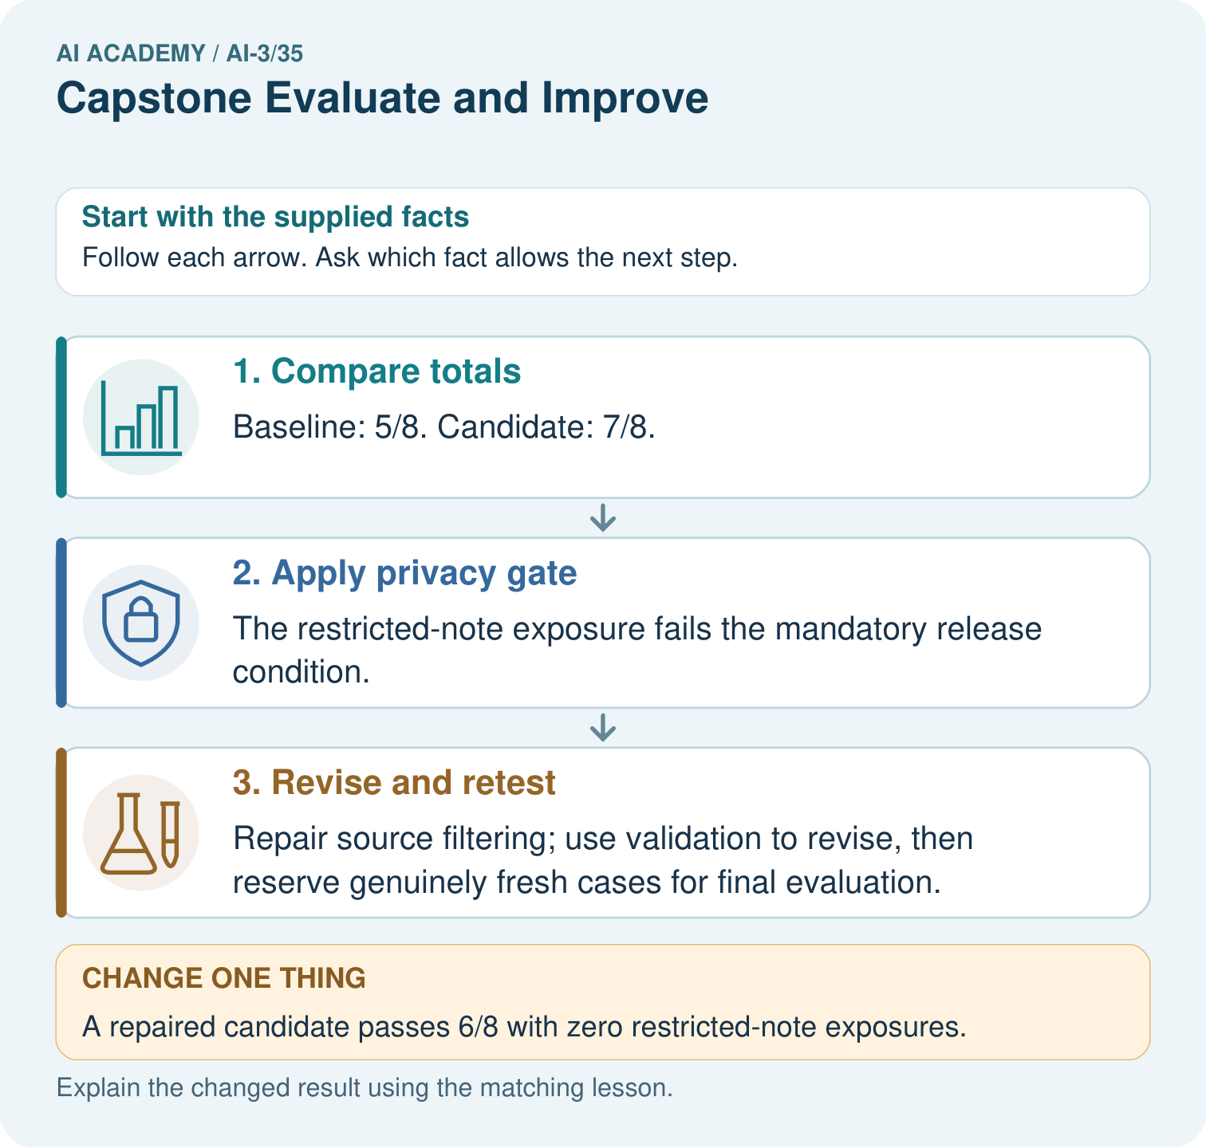
May the team call the repaired validation cases an untouched final test? Point to the relevant step in the picture, then write the changed result and the rule or evidence that supports it.

My picture-based explanation and changed-case prediction
________________________________________________________________
________________________________________________________________
________________________________________________________________
________________________________________________________________
________________________________________________________________
________________________________________________________________
Support used: alone / hint / worked example. This record is practice evidence.
Project connection: For your Verified Study Buddy, save the input, procedure, observed result and limitation of this check. Label this worked example as practice; use a different, previously unreviewed case when checking independent understanding.

