AI ACADEMY · WORKBOOK · ai-3/36

Creator Defense
Project: Verified Study Buddy

01. Recall and choose your starting point
Try the recall before opening notes. Then use a different colour or a labelled second line to correct your explanation.

Capstone Evaluate and Improve
Without opening the old lesson, explain one key idea from Capstone Evaluate and Improve. Give an example and a mistake that the idea helps you avoid.

My remembered idea, example and correction
________________________________________________________________
________________________________________________________________
________________________________________________________________

Capstone Design
Without opening the old lesson, explain one key idea from Capstone Design. Give an example and a mistake that the idea helps you avoid.

My remembered idea, example and correction
________________________________________________________________
________________________________________________________________
________________________________________________________________

Bias and Representation
Without opening the old lesson, explain one key idea from Bias and Representation. Give an example and a mistake that the idea helps you avoid.

My remembered idea, example and correction
________________________________________________________________
________________________________________________________________
________________________________________________________________

02. Practise with fading help
Use W2: Trace the worked case for Generative systems defense. Record the answer once; the lesson and workbook refer to the same attempt.
Given inputs | Procedure I chose | Middle steps | Result and check

The step I completed without help, and the hint I needed
________________________________________________________________
________________________________________________________________
________________________________________________________________

03. Individual reasoning check
Use the worked case for Generative systems defense. Proposed explanation: “The worked result establishes every future case”. Decide whether this explanation is supported. Point to the step or supplied fact that decides; explain your repair if needed.

My explanation before partner discussion
________________________________________________________________
________________________________________________________________
________________________________________________________________
________________________________________________________________

04. Independent transfer case

Independent case: Apply a new case independently
A defense has retrieval 8/10, support 6/10, fallback 3/4 and no measured latency. State the three rates and reject one unsupported claim.

My independent explanation, trace and limits
________________________________________________________________
________________________________________________________________
________________________________________________________________
________________________________________________________________
________________________________________________________________
________________________________________________________________
________________________________________________________________
Attempt this case before feedback. Record any help. Earlier examples below are further practice; a case already practised with feedback cannot establish fresh transfer.

05. Your learning target
Your assistant passes 9/12 final questions, including all six direct facts but only 3/6 ambiguous or absent-evidence cases. Report results and argue for a focused next step.

06. Solve the given case
Ten successful demos lead to a never hallucinates claim.
Write a defensible conclusion.
Show your trace, calculation or evidence

Write or draw your reasoning and evidence.
________________________________________________________________
________________________________________________________________
________________________________________________________________
________________________________________________________________
________________________________________________________________

07. Check a changed case
An audience asks whether your assistant is always correct. Give an evidence-based defense using results and a limit.
My independent answer and reason

Write or draw your reasoning and evidence.
________________________________________________________________
________________________________________________________________
________________________________________________________________
________________________________________________________________
________________________________________________________________

Week 36 Test and reflect

08. Design a revealing test
Create a changed input, boundary case or missing-information case. Write the expected answer or safe response before testing.
Test record | My evidence
Changed input or condition
Expected answer or fallback
Observed result
Why the result occurred

09. Project checkpoint
Final product card documents purpose, system map, sources, evals, limits, risks, and human oversight.
The project change and evidence I will keep

Write or draw your reasoning and evidence.
________________________________________________________________
________________________________________________________________
________________________________________________________________
________________________________________________________________
________________________________________________________________

10. Self check
I can explain the mechanism. I can show evidence. I can handle a changed case. I can name a limit. Mark each as not yet, with help or independently, and attach supporting work.
Teacher review ____________________ Next step ____________________

11. Transfer practice from the original programme
Your assistant passes 9/12 final questions, including all six direct facts but only 3/6 ambiguous or absent-evidence cases. Report results and argue for a focused next step.

My independently reasoned answer
________________________________________________________________
________________________________________________________________
________________________________________________________________
________________________________________________________________
________________________________________________________________
________________________________________________________________
________________________________________________________________
Record support used: none, hint or teacher explanation.

12. W1 Explain the mechanism
Explain the weekly mechanism in your own words. Use the worked scenario to name its input, decision rule and output.

My reasoning and evidence
________________________________________________________________
________________________________________________________________
________________________________________________________________
________________________________________________________________
________________________________________________________________
________________________________________________________________

13. W2 Trace the worked case
System reports 9/10 retrieved relevant records, 7/10 supported answers and zero actions in a read-only run. Presenter claims 90% fully correct and faster than baseline. Show the intermediate steps and give the conclusion with its scope.

My reasoning and evidence
________________________________________________________________
________________________________________________________________
________________________________________________________________
________________________________________________________________
________________________________________________________________
________________________________________________________________
________________________________________________________________

14. W3 Audit the limit
A report omits this qualification: A defense should preserve negative evidence and uncertainty rather than treating polished presentation as proof. Explain how omitting it could change a reader's interpretation, and write an accurate replacement.

My reasoning and evidence
________________________________________________________________
________________________________________________________________
________________________________________________________________
________________________________________________________________
________________________________________________________________
________________________________________________________________

15. W4 Apply a new case independently
A defense has retrieval 8/10, support 6/10, fallback 3/4 and no measured latency. State the three rates and reject one unsupported claim.

My reasoning and evidence
________________________________________________________________
________________________________________________________________
________________________________________________________________
________________________________________________________________
________________________________________________________________
________________________________________________________________
________________________________________________________________
________________________________________________________________

16. W5 Design a revealing follow-up
For the worked scenario, propose one additional case that could reveal a failure, describe its expected outcome before running it, and explain what would need to remain fixed for a fair comparison. Do not reuse W4 as a new final test after receiving feedback.

My reasoning and evidence
________________________________________________________________
________________________________________________________________
________________________________________________________________
________________________________________________________________
________________________________________________________________
________________________________________________________________
________________________________________________________________

17. Feedback, return check and learning record
Evidence | My record
Worked alone / hint / model
First step I repaired and why
New case checked later; date and result
What I can now explain without notes
One remaining question
Revisit this idea with your teacher after a delay. Familiarity is different from explaining and using it on a changed case.

18. Pictorial case practice: Creator Defense
Defend a study-buddy project using separate claims and matching evidence.
Set A: 15 answerable questions, with 12 relevant retrievals and 9 supported answers. Separate set B: 5 missing-source questions, with 4 appropriate fallbacks. No speed measurements exist.
All inputs and outcomes in this worked example are invented classroom data; no real model run is claimed.
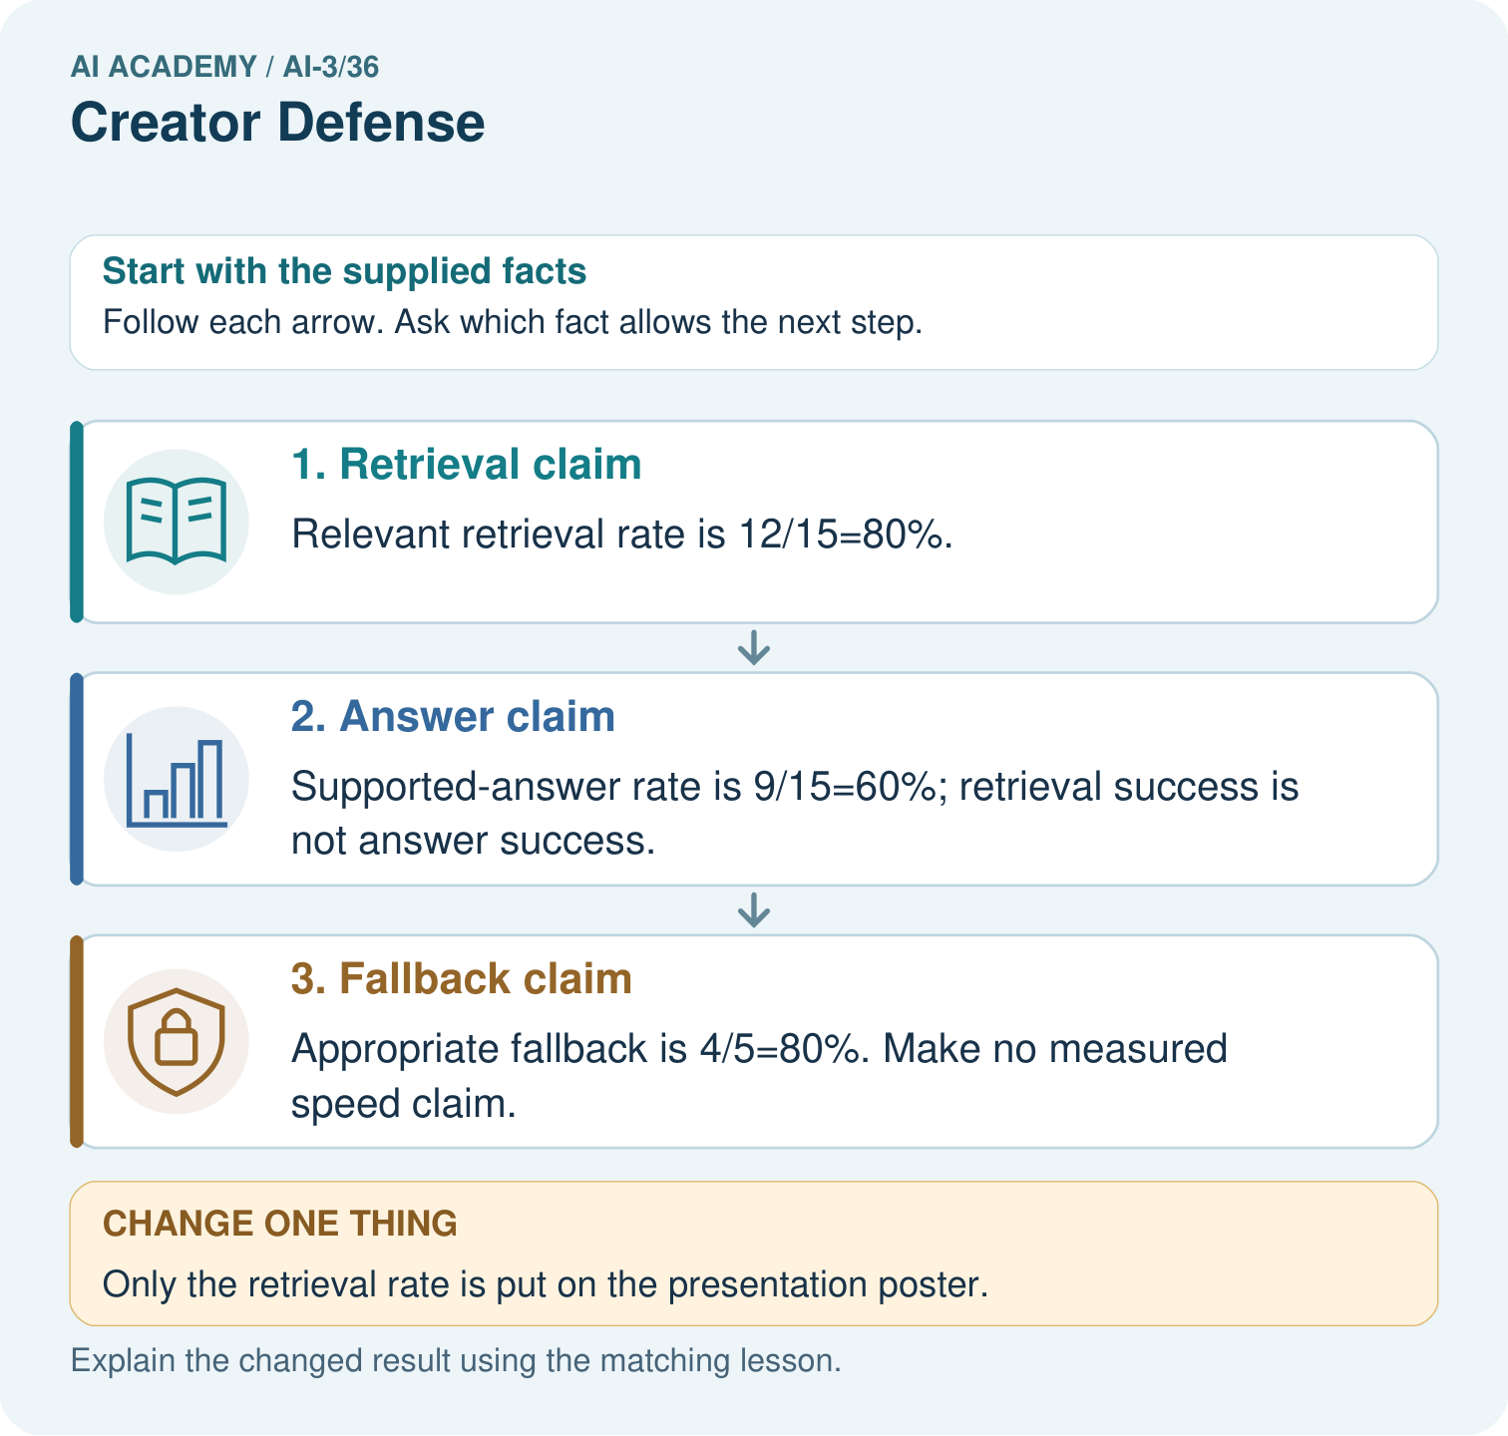
Which numbers would you display to make the defense honest? Point to the relevant step in the picture, then write the changed result and the rule or evidence that supports it.

My picture-based explanation and changed-case prediction
________________________________________________________________
________________________________________________________________
________________________________________________________________
________________________________________________________________
________________________________________________________________
________________________________________________________________
Support used: alone / hint / worked example. This record is practice evidence.
Project connection: For your Verified Study Buddy, save the input, procedure, observed result and limitation of this check. Label this worked example as practice; use a different, previously unreviewed case when checking independent understanding.

