AI ACADEMY · WORKBOOK · ai-4/4

Python and Table Readiness
Project: Responsible Plant Classifier

01. Recall and choose your starting point
Try the recall before opening notes. Then use a different colour or a labelled second line to correct your explanation.

Classification or Regression?
Without opening the old lesson, explain one key idea from Classification or Regression?. Give an example and a mistake that the idea helps you avoid.

My remembered idea, example and correction
________________________________________________________________
________________________________________________________________
________________________________________________________________

The ML Lifecycle
Without opening the old lesson, explain one key idea from The ML Lifecycle. Give an example and a mistake that the idea helps you avoid.

My remembered idea, example and correction
________________________________________________________________
________________________________________________________________
________________________________________________________________

02. Practise with fading help
Use W2: Classify records for Rows columns and schemas. Record the answer once; the lesson and workbook refer to the same attempt.
Given inputs | Procedure I chose | Middle steps | Result and check

The step I completed without help, and the hint I needed
________________________________________________________________
________________________________________________________________
________________________________________________________________

03. Individual reasoning check
Use the worked case for Rows columns and schemas. Proposed explanation: “A successful run proves the conclusion”. Decide whether this explanation is supported. Point to the step or supplied fact that decides; explain your repair if needed.

My explanation before partner discussion
________________________________________________________________
________________________________________________________________
________________________________________________________________
________________________________________________________________

04. Independent transfer case

Independent case: Changed independent case
Supplied values are3,7,14. Compute their mean. What should a function report for an empty list? How should it handle a missing fourth record?

My independent explanation, trace and limits
________________________________________________________________
________________________________________________________________
________________________________________________________________
________________________________________________________________
________________________________________________________________
________________________________________________________________
________________________________________________________________
Attempt this case before feedback. Record any help. Earlier examples below are further practice; a case already practised with feedback cannot establish fresh transfer.

05. Your learning target
Trace mean for [4,8,12] using sum(values)/len(values). What should the program do for []? Explain why returning 0 silently is misleading.

06. Solve the given case
Python lengths=[4,6,8]; total=sum(lengths); mean=total/len(lengths).
Trace and handle an empty list.
Show your trace, calculation or evidence

Write or draw your reasoning and evidence.
________________________________________________________________
________________________________________________________________
________________________________________________________________
________________________________________________________________
________________________________________________________________

07. Check a changed case
Trace Python: lengths = [4, 7, 9]; selected = lengths[1]; total = selected + 3. Give selected and total.
My independent answer and reason

Write or draw your reasoning and evidence.
________________________________________________________________
________________________________________________________________
________________________________________________________________
________________________________________________________________
________________________________________________________________

Week 4 Test and reflect

08. Design a revealing test
Create a changed input, boundary case or missing-information case. Write the expected answer or safe response before testing.
Test record | My evidence
Changed input or condition
Expected answer or fallback
Observed result
Why the result occurred

09. Project checkpoint
Create a tiny five-row plant table with explicit column names, types, units, and a reproducible summary calculation.
The project change and evidence I will keep

Write or draw your reasoning and evidence.
________________________________________________________________
________________________________________________________________
________________________________________________________________
________________________________________________________________
________________________________________________________________

10. Self check
I can explain the mechanism. I can show evidence. I can handle a changed case. I can name a limit. Mark each as not yet, with help or independently, and attach supporting work.
Teacher review ____________________ Next step ____________________

11. Transfer practice from the original programme
Trace mean for [4,8,12] using sum(values)/len(values). What should the program do for []? Explain why returning 0 silently is misleading.

My independently reasoned answer
________________________________________________________________
________________________________________________________________
________________________________________________________________
________________________________________________________________
________________________________________________________________
________________________________________________________________
________________________________________________________________
Record support used: none, hint or teacher explanation.

12. W1 State a schema
List the required fields, types and duration boundaries for the worked table.

My reasoning and evidence
________________________________________________________________
________________________________________________________________
________________________________________________________________
________________________________________________________________
________________________________________________________________
________________________________________________________________

13. W2 Classify records
Classify minutes values 0, 60, -1 and 61 under this schema.

My reasoning and evidence
________________________________________________________________
________________________________________________________________
________________________________________________________________
________________________________________________________________
________________________________________________________________
________________________________________________________________

14. W3 Repair a unit problem
A source says 180 seconds but the row says minutes: 180. Give a documented correction.

My reasoning and evidence
________________________________________________________________
________________________________________________________________
________________________________________________________________
________________________________________________________________
________________________________________________________________
________________________________________________________________

15. W4 Design a schema independently
For a fictional shelf audit, define label and book_count fields. Require a nonempty text label and an integer count from 0 to 40. Give two valid and two invalid records with reasons.

My reasoning and evidence
________________________________________________________________
________________________________________________________________
________________________________________________________________
________________________________________________________________
________________________________________________________________
________________________________________________________________
________________________________________________________________
________________________________________________________________

16. W5 Separate validity and truth
A row says Reading, 12 and passes. Does that establish the session really lasted 12 minutes?

My reasoning and evidence
________________________________________________________________
________________________________________________________________
________________________________________________________________
________________________________________________________________
________________________________________________________________
________________________________________________________________

17. File input and output — W1 Trace types
Before and after int("8"), identify the types and values.

My reasoning and evidence
________________________________________________________________
________________________________________________________________
________________________________________________________________
________________________________________________________________
________________________________________________________________
________________________________________________________________

18. File input and output — W2 Predict the total
A sandbox file has lines 5, 0 and 2. What total does the worked reader print?

My reasoning and evidence
________________________________________________________________
________________________________________________________________
________________________________________________________________
________________________________________________________________
________________________________________________________________
________________________________________________________________

19. File input and output — W3 Repair a path issue
The file is in the class-data folder but the script looks in its working folder. Give a safe repair.

My reasoning and evidence
________________________________________________________________
________________________________________________________________
________________________________________________________________
________________________________________________________________
________________________________________________________________
________________________________________________________________

20. File input and output — W4 Read independently
In a fresh sandbox file counters.txt put 4, 6 and 0 on separate lines. Adapt the reader, print the number of values and total. State the expected results.

My reasoning and evidence
________________________________________________________________
________________________________________________________________
________________________________________________________________
________________________________________________________________
________________________________________________________________
________________________________________________________________
________________________________________________________________
________________________________________________________________

21. File input and output — W5 Handle malformed data
The file contains twelve on one line. Why should the program not silently turn it into zero?

My reasoning and evidence
________________________________________________________________
________________________________________________________________
________________________________________________________________
________________________________________________________________
________________________________________________________________
________________________________________________________________

22. Exceptions and recovery — W1 Trace success
What does parse_minutes("0") return, and why is zero allowed?

My reasoning and evidence
________________________________________________________________
________________________________________________________________
________________________________________________________________
________________________________________________________________
________________________________________________________________
________________________________________________________________

23. Exceptions and recovery — W2 Trace two failures
Compare parse_minutes("abc") and parse_minutes("70").

My reasoning and evidence
________________________________________________________________
________________________________________________________________
________________________________________________________________
________________________________________________________________
________________________________________________________________
________________________________________________________________

24. Exceptions and recovery — W3 Repair a handler
An except block returns 0 for any failure. State two problems and a repair.

My reasoning and evidence
________________________________________________________________
________________________________________________________________
________________________________________________________________
________________________________________________________________
________________________________________________________________
________________________________________________________________

25. Exceptions and recovery — W4 Build independently
Adapt the function for count strings representing integers 0 through 10. Test "4", "0", "11", "four" and "-1" and record status/value.

My reasoning and evidence
________________________________________________________________
________________________________________________________________
________________________________________________________________
________________________________________________________________
________________________________________________________________
________________________________________________________________
________________________________________________________________
________________________________________________________________

26. Exceptions and recovery — W5 Choose recovery
A batch has 8 valid and 2 invalid lines. What should its report include?

My reasoning and evidence
________________________________________________________________
________________________________________________________________
________________________________________________________________
________________________________________________________________
________________________________________________________________
________________________________________________________________

27. Feedback, return check and learning record
Evidence | My record
Worked alone / hint / model
First step I repaired and why
New case checked later; date and result
What I can now explain without notes
One remaining question
Revisit this idea with your teacher after a delay. Familiarity is different from explaining and using it on a changed case.

28. Pictorial case practice: Python and Table Readiness
Inspect a small table before asking Python to compute an average.
Plant heights in cm: P=2, Q=6, R=None, S=0. None means unmeasured; zero is a recorded valid height.
All inputs and outcomes in this worked example are invented classroom data; no real model run is claimed.
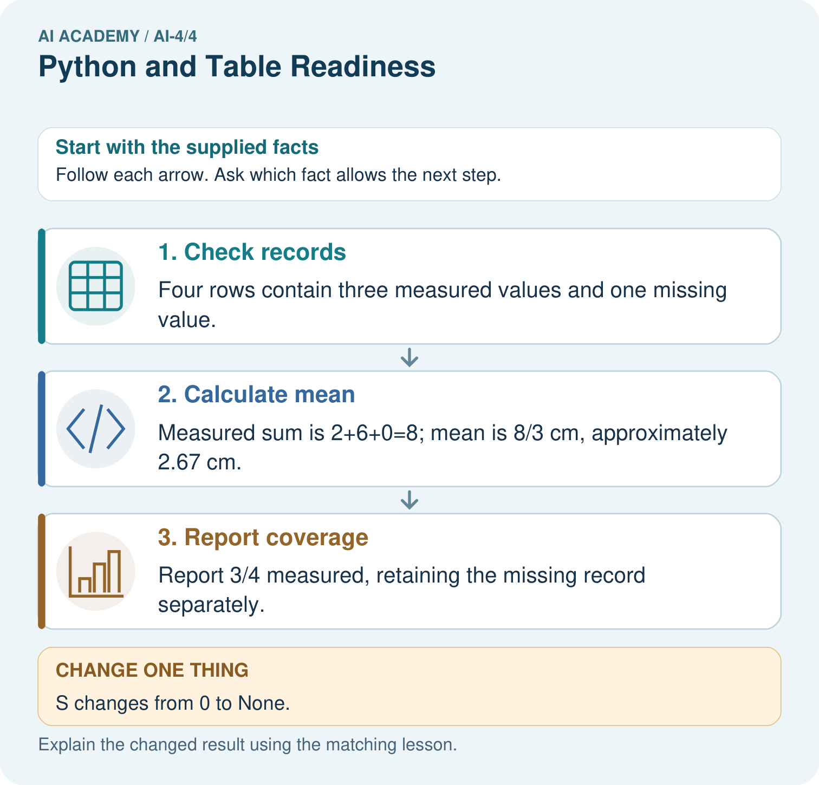
Why should the missing value not silently become zero? Point to the relevant step in the picture, then write the changed result and the rule or evidence that supports it.

My picture-based explanation and changed-case prediction
________________________________________________________________
________________________________________________________________
________________________________________________________________
________________________________________________________________
________________________________________________________________
________________________________________________________________
Support used: alone / hint / worked example. This record is practice evidence.
Project connection: For your Responsible Plant Classifier, save the input, procedure, observed result and limitation of this check. Label this worked example as practice; use a different, previously unreviewed case when checking independent understanding.

