AI ACADEMY · WORKBOOK · ai-4/7

Sampling and Intended Use
Project: Responsible Plant Classifier

01. Recall and choose your starting point
Try the recall before opening notes. Then use a different colour or a labelled second line to correct your explanation.

Label Quality
Without opening the old lesson, explain one key idea from Label Quality. Give an example and a mistake that the idea helps you avoid.

My remembered idea, example and correction
________________________________________________________________
________________________________________________________________
________________________________________________________________

Python and Table Readiness
Without opening the old lesson, explain one key idea from Python and Table Readiness. Give an example and a mistake that the idea helps you avoid.

My remembered idea, example and correction
________________________________________________________________
________________________________________________________________
________________________________________________________________

The ML Lifecycle
Without opening the old lesson, explain one key idea from The ML Lifecycle. Give an example and a mistake that the idea helps you avoid.

My remembered idea, example and correction
________________________________________________________________
________________________________________________________________
________________________________________________________________

02. Practise with fading help
Use W2: Interpret the audit counts for Dataset inspection and cards. Record the answer once; the lesson and workbook refer to the same attempt.
Given inputs | Procedure I chose | Middle steps | Result and check

The step I completed without help, and the hint I needed
________________________________________________________________
________________________________________________________________
________________________________________________________________

03. Individual reasoning check
Use the worked case for Dataset inspection and cards. Proposed explanation: “A complete card certifies data quality”. Decide whether this explanation is supported. Point to the step or supplied fact that decides; explain your repair if needed.

My explanation before partner discussion
________________________________________________________________
________________________________________________________________
________________________________________________________________
________________________________________________________________

04. Independent transfer case

Independent case: Changed independent case
Training plant photos are all indoors on one phone. Intended use includes outdoor photos on other cameras. Plan a sampling check before making a general accuracy claim.

My independent explanation, trace and limits
________________________________________________________________
________________________________________________________________
________________________________________________________________
________________________________________________________________
________________________________________________________________
________________________________________________________________
________________________________________________________________
Attempt this case before feedback. Record any help. Earlier examples below are further practice; a case already practised with feedback cannot establish fresh transfer.

05. Your learning target
Training uses indoor photos from one phone; deployment uses outdoor photos from several phones. Specify two evaluation slices and explain why adding more indoor photos may not resolve the gap.

06. Solve the given case
Training photos use indoor white backgrounds; intended use is outdoors.
Identify the coverage gap.
Show your trace, calculation or evidence

Write or draw your reasoning and evidence.
________________________________________________________________
________________________________________________________________
________________________________________________________________
________________________________________________________________
________________________________________________________________

07. Check a changed case
Training photographs all show mature plants in bright light, but intended users photograph seedlings indoors. What claim is unsupported and what data is needed?
My independent answer and reason

Write or draw your reasoning and evidence.
________________________________________________________________
________________________________________________________________
________________________________________________________________
________________________________________________________________
________________________________________________________________

Week 7 Test and reflect

08. Design a revealing test
Create a changed input, boundary case or missing-information case. Write the expected answer or safe response before testing.
Test record | My evidence
Changed input or condition
Expected answer or fallback
Observed result
Why the result occurred

09. Project checkpoint
Freeze the Plant Classifier intended-use statement and a coverage table for species, lighting, camera, and health class.
The project change and evidence I will keep

Write or draw your reasoning and evidence.
________________________________________________________________
________________________________________________________________
________________________________________________________________
________________________________________________________________
________________________________________________________________

10. Self check
I can explain the mechanism. I can show evidence. I can handle a changed case. I can name a limit. Mark each as not yet, with help or independently, and attach supporting work.
Teacher review ____________________ Next step ____________________

11. Transfer practice from the original programme
Training uses indoor photos from one phone; deployment uses outdoor photos from several phones. Specify two evaluation slices and explain why adding more indoor photos may not resolve the gap.

My independently reasoned answer
________________________________________________________________
________________________________________________________________
________________________________________________________________
________________________________________________________________
________________________________________________________________
________________________________________________________________
________________________________________________________________
Record support used: none, hint or teacher explanation.

12. W1 Define the row and source
For Robot practice v1, state what one row is intended to represent, the source, the unit and the meaning of None.

My reasoning and evidence
________________________________________________________________
________________________________________________________________
________________________________________________________________
________________________________________________________________
________________________________________________________________
________________________________________________________________

13. W2 Interpret the audit counts
Explain each number in 5 4 2 1. How many extra ID occurrences are there, and how many rows belong to a repeated-ID group?

My reasoning and evidence
________________________________________________________________
________________________________________________________________
________________________________________________________________
________________________________________________________________
________________________________________________________________
________________________________________________________________

14. W3 Reject an unsupported correction
A learner changes None to 0 and -2 to 2, then reports a clean dataset. Explain why this is not a justified repair and what record should be kept.

My reasoning and evidence
________________________________________________________________
________________________________________________________________
________________________________________________________________
________________________________________________________________
________________________________________________________________
________________________________________________________________

15. W4 Inspect and document independently
A new fictional indoor trip export has (P,4), (Q,None), (Q,None), (R,-1), (S,6), (T,0), with durations in minutes and the same schema. Count raw rows, distinct IDs, missing durations, negative durations and extra ID occurrences. Identify overlap. Draft a short dataset card stating source, row meaning, unit, findings, unchanged version and one excluded use.

My reasoning and evidence
________________________________________________________________
________________________________________________________________
________________________________________________________________
________________________________________________________________
________________________________________________________________
________________________________________________________________
________________________________________________________________
________________________________________________________________

16. W5 State an evidence gap
Someone duplicates each row ten times and claims the export now covers more kinds of trips. Explain what changed and what did not.

My reasoning and evidence
________________________________________________________________
________________________________________________________________
________________________________________________________________
________________________________________________________________
________________________________________________________________
________________________________________________________________

17. Feedback, return check and learning record
Evidence | My record
Worked alone / hint / model
First step I repaired and why
New case checked later; date and result
What I can now explain without notes
One remaining question
Revisit this idea with your teacher after a delay. Familiarity is different from explaining and using it on a changed case.

18. Pictorial case practice: Sampling and Intended Use
Sample for the conditions in which the plant classifier will actually be used.
Training set: 12 windowsill plants photographed at midday. Intended use includes evening desk photos; no evening examples have been collected.
All inputs and outcomes in this worked example are invented classroom data; no real model run is claimed.
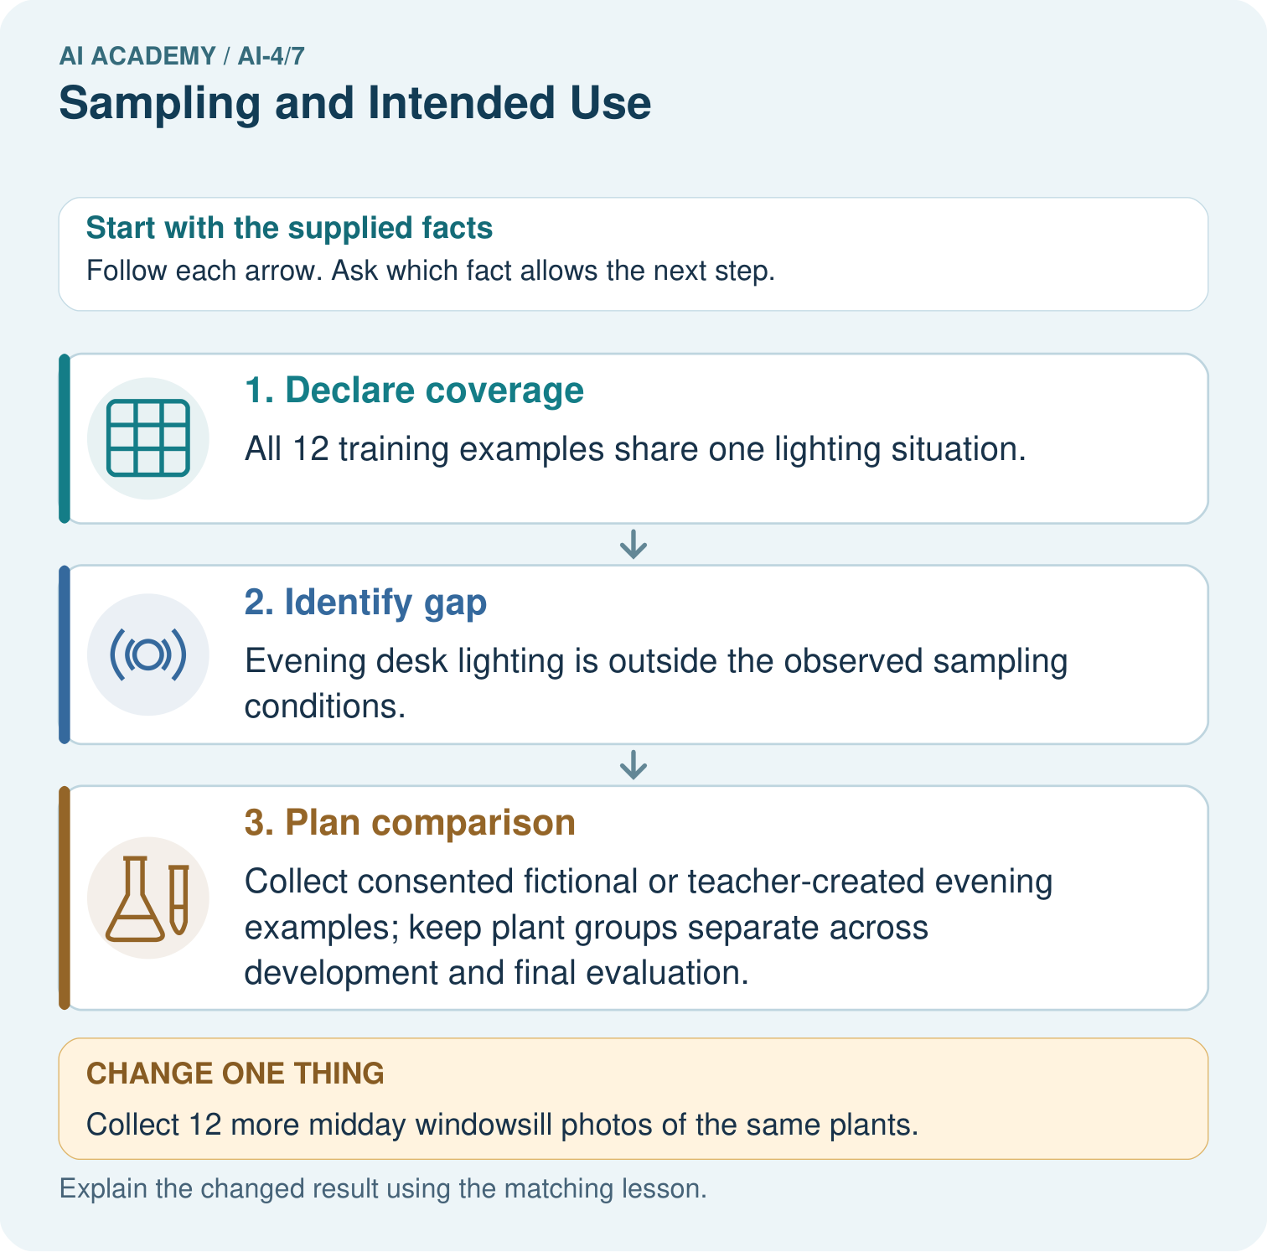
Which collection would address the intended-use gap most directly? Point to the relevant step in the picture, then write the changed result and the rule or evidence that supports it.

My picture-based explanation and changed-case prediction
________________________________________________________________
________________________________________________________________
________________________________________________________________
________________________________________________________________
________________________________________________________________
________________________________________________________________
Support used: alone / hint / worked example. This record is practice evidence.
Project connection: For your Responsible Plant Classifier, save the input, procedure, observed result and limitation of this check. Label this worked example as practice; use a different, previously unreviewed case when checking independent understanding.

