AI ACADEMY · WORKBOOK · ai-4/8

Leakage
Project: Responsible Plant Classifier

01. Recall and choose your starting point
Try the recall before opening notes. Then use a different colour or a labelled second line to correct your explanation.

Sampling and Intended Use
Without opening the old lesson, explain one key idea from Sampling and Intended Use. Give an example and a mistake that the idea helps you avoid.

My remembered idea, example and correction
________________________________________________________________
________________________________________________________________
________________________________________________________________

Inspect Before Modeling
Without opening the old lesson, explain one key idea from Inspect Before Modeling. Give an example and a mistake that the idea helps you avoid.

My remembered idea, example and correction
________________________________________________________________
________________________________________________________________
________________________________________________________________

Features, Labels, Targets
Without opening the old lesson, explain one key idea from Features, Labels, Targets. Give an example and a mistake that the idea helps you avoid.

My remembered idea, example and correction
________________________________________________________________
________________________________________________________________
________________________________________________________________

02. Practise with fading help
Use W2: Distinguish frames from groups for Splits and related examples. Record the answer once; the lesson and workbook refer to the same attempt.
Given inputs | Procedure I chose | Middle steps | Result and check

The step I completed without help, and the hint I needed
________________________________________________________________
________________________________________________________________
________________________________________________________________

03. Individual reasoning check
Use the worked case for Splits and related examples. Proposed explanation: “Different row IDs mean independent examples”. Decide whether this explanation is supported. Point to the step or supplied fact that decides; explain your repair if needed.

My explanation before partner discussion
________________________________________________________________
________________________________________________________________
________________________________________________________________
________________________________________________________________

04. Independent transfer case

Independent case: Changed independent case
Each of five plants has four photos. A random photo split puts different views of every plant in both training and test sets. Explain the problem and repair.

My independent explanation, trace and limits
________________________________________________________________
________________________________________________________________
________________________________________________________________
________________________________________________________________
________________________________________________________________
________________________________________________________________
________________________________________________________________
Attempt this case before feedback. Record any help. Earlier examples below are further practice; a case already practised with feedback cannot establish fresh transfer.

05. Your learning target
Five photos of each leaf are randomly split by file into train and test. Why can accuracy be optimistic? Give a corrected grouping rule.

06. Solve the given case
Ten photos per leaf are randomly split so one leaf appears in train and test.
Explain and repair leakage.
Show your trace, calculation or evidence

Write or draw your reasoning and evidence.
________________________________________________________________
________________________________________________________________
________________________________________________________________
________________________________________________________________
________________________________________________________________

07. Check a changed case
A feature records the expert's final species decision, made after the prediction time. Why is this leakage, and what should happen to it?
My independent answer and reason

Write or draw your reasoning and evidence.
________________________________________________________________
________________________________________________________________
________________________________________________________________
________________________________________________________________
________________________________________________________________

Week 8 Test and reflect

08. Design a revealing test
Create a changed input, boundary case or missing-information case. Write the expected answer or safe response before testing.
Test record | My evidence
Changed input or condition
Expected answer or fallback
Observed result
Why the result occurred

09. Project checkpoint
Audit filenames, metadata, post-diagnosis fields, and duplicate plant identities; record every removed leakage path.
The project change and evidence I will keep

Write or draw your reasoning and evidence.
________________________________________________________________
________________________________________________________________
________________________________________________________________
________________________________________________________________
________________________________________________________________

10. Self check
I can explain the mechanism. I can show evidence. I can handle a changed case. I can name a limit. Mark each as not yet, with help or independently, and attach supporting work.
Teacher review ____________________ Next step ____________________

11. Transfer practice from the original programme
Five photos of each leaf are randomly split by file into train and test. Why can accuracy be optimistic? Give a corrected grouping rule.

My independently reasoned answer
________________________________________________________________
________________________________________________________________
________________________________________________________________
________________________________________________________________
________________________________________________________________
________________________________________________________________
________________________________________________________________
Record support used: none, hint or teacher explanation.

12. W1 Explain the three roles
Explain what training, validation and test sets are used for. What changes if you repeatedly choose a model using its test score?

My reasoning and evidence
________________________________________________________________
________________________________________________________________
________________________________________________________________
________________________________________________________________
________________________________________________________________
________________________________________________________________

13. W2 Distinguish frames from groups
For the worked A through F plan, give training, validation and test counts first in groups and then in rows. Interpret [] from the code and state one problem it cannot detect.

My reasoning and evidence
________________________________________________________________
________________________________________________________________
________________________________________________________________
________________________________________________________________
________________________________________________________________
________________________________________________________________

14. W3 Repair a related example leak
A1 and A2 are in training and A3 is in test. Explain why unique frame IDs and a fixed random seed do not fix this. Propose a repair and what to record.

My reasoning and evidence
________________________________________________________________
________________________________________________________________
________________________________________________________________
________________________________________________________________
________________________________________________________________
________________________________________________________________

15. W4 Audit and repair independently
Eight frames come from trips P (P1 P2 P3), Q (Q1 Q2), R (R1), S (S1 S2). A proposed split is training P1 Q1 R1; validation P2 S1; test Q2 P3 S2. Identify shared groups for each pair of sets. Repair it by assigning P and Q to training, R to validation and S to test. List all frames in each role and give row and group counts. State one limit of the repaired plan.

My reasoning and evidence
________________________________________________________________
________________________________________________________________
________________________________________________________________
________________________________________________________________
________________________________________________________________
________________________________________________________________
________________________________________________________________
________________________________________________________________

16. W5 Match separation to the claim
A model will be evaluated on new routes. Route North has trips A and B; route South has C and D. A proposed split trains on A and C and tests on B and D. Explain the problem and give a route-based alternative. Is this enough for a strong performance claim?

My reasoning and evidence
________________________________________________________________
________________________________________________________________
________________________________________________________________
________________________________________________________________
________________________________________________________________
________________________________________________________________

17. Scaling without leakage — W1 Learn the scale from training
Using A,B,C, give the minimum, maximum and range for each feature. Transform all three training rows and query (11,120). Explain which rows supplied the scale.

My reasoning and evidence
________________________________________________________________
________________________________________________________________
________________________________________________________________
________________________________________________________________
________________________________________________________________
________________________________________________________________

18. Scaling without leakage — W2 Trace the changed prediction
For query (11,120), calculate raw and scaled distances to A,B,C. Give both k=1 predictions. Does this prove that scaling always improves predictions?

My reasoning and evidence
________________________________________________________________
________________________________________________________________
________________________________________________________________
________________________________________________________________
________________________________________________________________
________________________________________________________________

19. Scaling without leakage — W3 Keep one coordinate system
Transform (12,80) using the stored training scale. Explain the negative value and why validation must not fit its own scale. Give the worked validation and baseline scores.

My reasoning and evidence
________________________________________________________________
________________________________________________________________
________________________________________________________________
________________________________________________________________
________________________________________________________________
________________________________________________________________

20. Scaling without leakage — W4 Scale a fresh dataset independently
New training rows are P (20,1000) clear, Q (40,600) blocked, R (40,1000) blocked. Fit minima and ranges. For query (22,680), show transformed features, raw and scaled distances to P,Q,R, and both k=1 predictions. Transform new row (50,520) with the same scale.

My reasoning and evidence
________________________________________________________________
________________________________________________________________
________________________________________________________________
________________________________________________________________
________________________________________________________________
________________________________________________________________
________________________________________________________________
________________________________________________________________

21. Scaling without leakage — W5 Repair two preprocessing mistakes
A learner fits scales using training plus validation features but no labels. Another divides by a zero training range. Explain both problems and give a recorded repair for each.

My reasoning and evidence
________________________________________________________________
________________________________________________________________
________________________________________________________________
________________________________________________________________
________________________________________________________________
________________________________________________________________

22. Feedback, return check and learning record
Evidence | My record
Worked alone / hint / model
First step I repaired and why
New case checked later; date and result
What I can now explain without notes
One remaining question
Revisit this idea with your teacher after a delay. Familiarity is different from explaining and using it on a changed case.

23. Pictorial case practice: Leakage
Split by plant identity when testing generalisation to new plants.
Plants Cedar, Elm and Fir each have three views. Aim: recognise previously unseen plants. Plan: Cedar and Elm train; Fir final test.
All inputs and outcomes in this worked example are invented classroom data; no real model run is claimed.
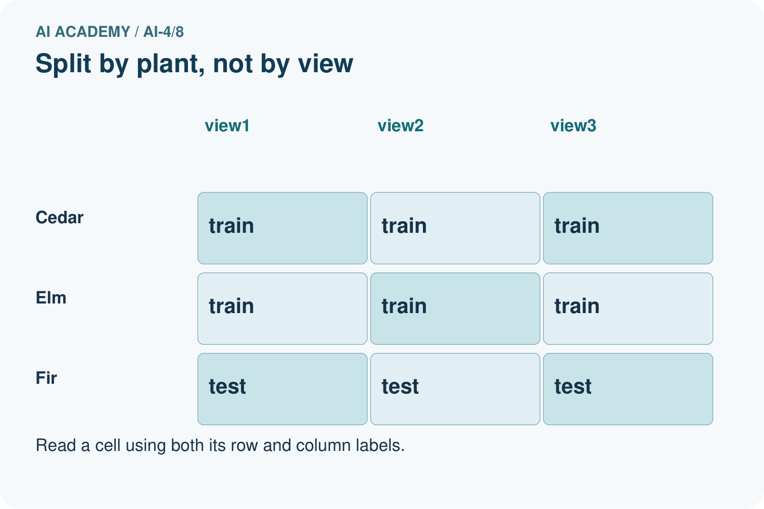
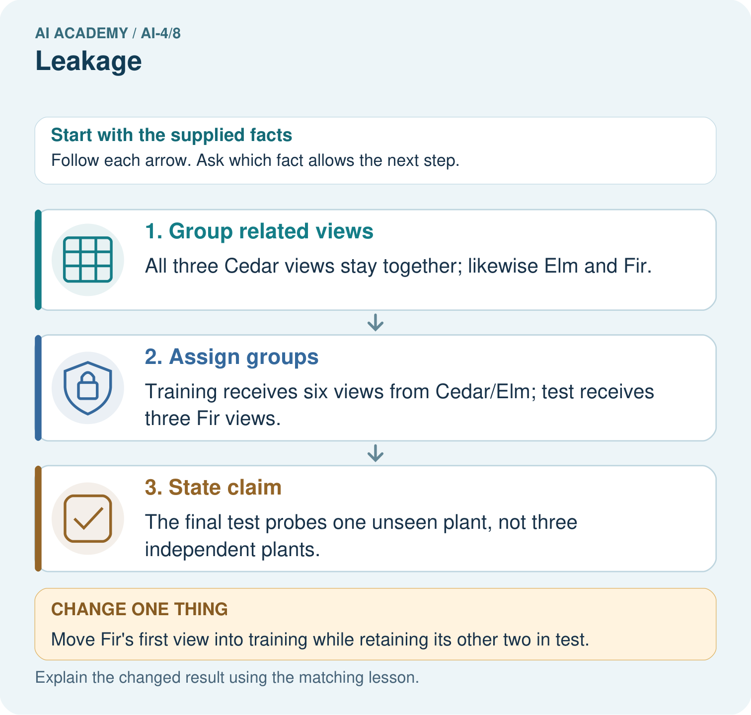
How many independently new plant identities are in the original test? Point to the relevant step in the picture, then write the changed result and the rule or evidence that supports it.

My picture-based explanation and changed-case prediction
________________________________________________________________
________________________________________________________________
________________________________________________________________
________________________________________________________________
________________________________________________________________
________________________________________________________________
Support used: alone / hint / worked example. This record is practice evidence.
Project connection: For your Responsible Plant Classifier, save the input, procedure, observed result and limitation of this check. Label this worked example as practice; use a different, previously unreviewed case when checking independent understanding.

