AI ACADEMY · WORKBOOK · ai-4/10

Baselines First
Project: Responsible Plant Classifier

01. Recall and choose your starting point
Try the recall before opening notes. Then use a different colour or a labelled second line to correct your explanation.

Dataset Cards
Without opening the old lesson, explain one key idea from Dataset Cards. Give an example and a mistake that the idea helps you avoid.

My remembered idea, example and correction
________________________________________________________________
________________________________________________________________
________________________________________________________________

Sampling and Intended Use
Without opening the old lesson, explain one key idea from Sampling and Intended Use. Give an example and a mistake that the idea helps you avoid.

My remembered idea, example and correction
________________________________________________________________
________________________________________________________________
________________________________________________________________

Python and Table Readiness
Without opening the old lesson, explain one key idea from Python and Table Readiness. Give an example and a mistake that the idea helps you avoid.

My remembered idea, example and correction
________________________________________________________________
________________________________________________________________
________________________________________________________________

02. Practise with fading help
Use W2: Calculate the validation score for A baseline before a model. Record the answer once; the lesson and workbook refer to the same attempt.
Given inputs | Procedure I chose | Middle steps | Result and check

The step I completed without help, and the hint I needed
________________________________________________________________
________________________________________________________________
________________________________________________________________

03. Individual reasoning check
Use the worked case for A baseline before a model. Proposed explanation: “A simple baseline does not need training data”. Decide whether this explanation is supported. Point to the step or supplied fact that decides; explain your repair if needed.

My explanation before partner discussion
________________________________________________________________
________________________________________________________________
________________________________________________________________
________________________________________________________________

04. Independent transfer case

Independent case: Fit and compare independently
New training labels are blocked, clear, blocked, blocked, clear. New validation labels are clear, blocked, clear, blocked. Fit the same baseline rule and list its four predictions. A supplied candidate predicts clear, blocked, blocked, blocked. Score both on these rows and state the difference in correct examples and percentage points. What claim remains unsupported?

My independent explanation, trace and limits
________________________________________________________________
________________________________________________________________
________________________________________________________________
________________________________________________________________
________________________________________________________________
________________________________________________________________
________________________________________________________________
Attempt this case before feedback. Record any help. Earlier examples below are further practice; a case already practised with feedback cannot establish fresh transfer.

05. Your learning target
A dataset contains 27 healthy and 3 spotted leaves. An always-healthy baseline gets what accuracy and spotted recall? What must a new model improve upon?

06. Solve the given case
A test set has eighteen healthy and two spotted leaves. Baseline always predicts healthy.
Calculate and critique accuracy.
Show your trace, calculation or evidence

Write or draw your reasoning and evidence.
________________________________________________________________
________________________________________________________________
________________________________________________________________
________________________________________________________________
________________________________________________________________

07. Check a changed case
A dataset has 18 grass and 2 fern examples. A baseline always predicts grass. Compute accuracy and name a serious limitation.
My independent answer and reason

Write or draw your reasoning and evidence.
________________________________________________________________
________________________________________________________________
________________________________________________________________
________________________________________________________________
________________________________________________________________

Week 10 Test and reflect

08. Design a revealing test
Create a changed input, boundary case or missing-information case. Write the expected answer or safe response before testing.
Test record | My evidence
Changed input or condition
Expected answer or fallback
Observed result
Why the result occurred

09. Project checkpoint
Record majority and transparent-rule baselines for the Plant Classifier using the frozen test plan.
The project change and evidence I will keep

Write or draw your reasoning and evidence.
________________________________________________________________
________________________________________________________________
________________________________________________________________
________________________________________________________________
________________________________________________________________

10. Self check
I can explain the mechanism. I can show evidence. I can handle a changed case. I can name a limit. Mark each as not yet, with help or independently, and attach supporting work.
Teacher review ____________________ Next step ____________________

11. Transfer practice from the original programme
A dataset contains 27 healthy and 3 spotted leaves. An always-healthy baseline gets what accuracy and spotted recall? What must a new model improve upon?

My independently reasoned answer
________________________________________________________________
________________________________________________________________
________________________________________________________________
________________________________________________________________
________________________________________________________________
________________________________________________________________
________________________________________________________________
Record support used: none, hint or teacher explanation.

12. W1 Choose from training evidence
Count clear and blocked in the worked training list. State the constant prediction and the declared tie rule. Explain why the validation majority does not choose this baseline.

My reasoning and evidence
________________________________________________________________
________________________________________________________________
________________________________________________________________
________________________________________________________________
________________________________________________________________
________________________________________________________________

13. W2 Calculate the validation score
List the four baseline predictions and mark which validation rows are correct. Give correct/total and accuracy. Explain why 4/6 is not the answer.

My reasoning and evidence
________________________________________________________________
________________________________________________________________
________________________________________________________________
________________________________________________________________
________________________________________________________________
________________________________________________________________

14. W3 Make the comparison fair
A candidate is scored on ten easy rows and the baseline on four difficult rows. Describe a fair comparison and two details you must record.

My reasoning and evidence
________________________________________________________________
________________________________________________________________
________________________________________________________________
________________________________________________________________
________________________________________________________________
________________________________________________________________

15. W4 Fit and compare independently
New training labels are blocked, clear, blocked, blocked, clear. New validation labels are clear, blocked, clear, blocked. Fit the same baseline rule and list its four predictions. A supplied candidate predicts clear, blocked, blocked, blocked. Score both on these rows and state the difference in correct examples and percentage points. What claim remains unsupported?

My reasoning and evidence
________________________________________________________________
________________________________________________________________
________________________________________________________________
________________________________________________________________
________________________________________________________________
________________________________________________________________
________________________________________________________________
________________________________________________________________

16. W5 Explain the hidden error
A training-derived clear baseline gets nine of ten validation cases correct; the labels are nine clear and one blocked. State its accuracy and missed case. If a candidate also gets nine correct, must it miss the same case? Explain.

My reasoning and evidence
________________________________________________________________
________________________________________________________________
________________________________________________________________
________________________________________________________________
________________________________________________________________
________________________________________________________________

17. Feedback, return check and learning record
Evidence | My record
Worked alone / hint / model
First step I repaired and why
New case checked later; date and result
What I can now explain without notes
One remaining question
Revisit this idea with your teacher after a delay. Familiarity is different from explaining and using it on a changed case.

18. Pictorial case practice: Baselines First
Make a simple baseline earn its place before claiming a better classifier.
Training labels: healthy, healthy, spotted. Majority baseline predicts healthy. Validation references: healthy, spotted, healthy, spotted.
All inputs and outcomes in this worked example are invented classroom data; no real model run is claimed.
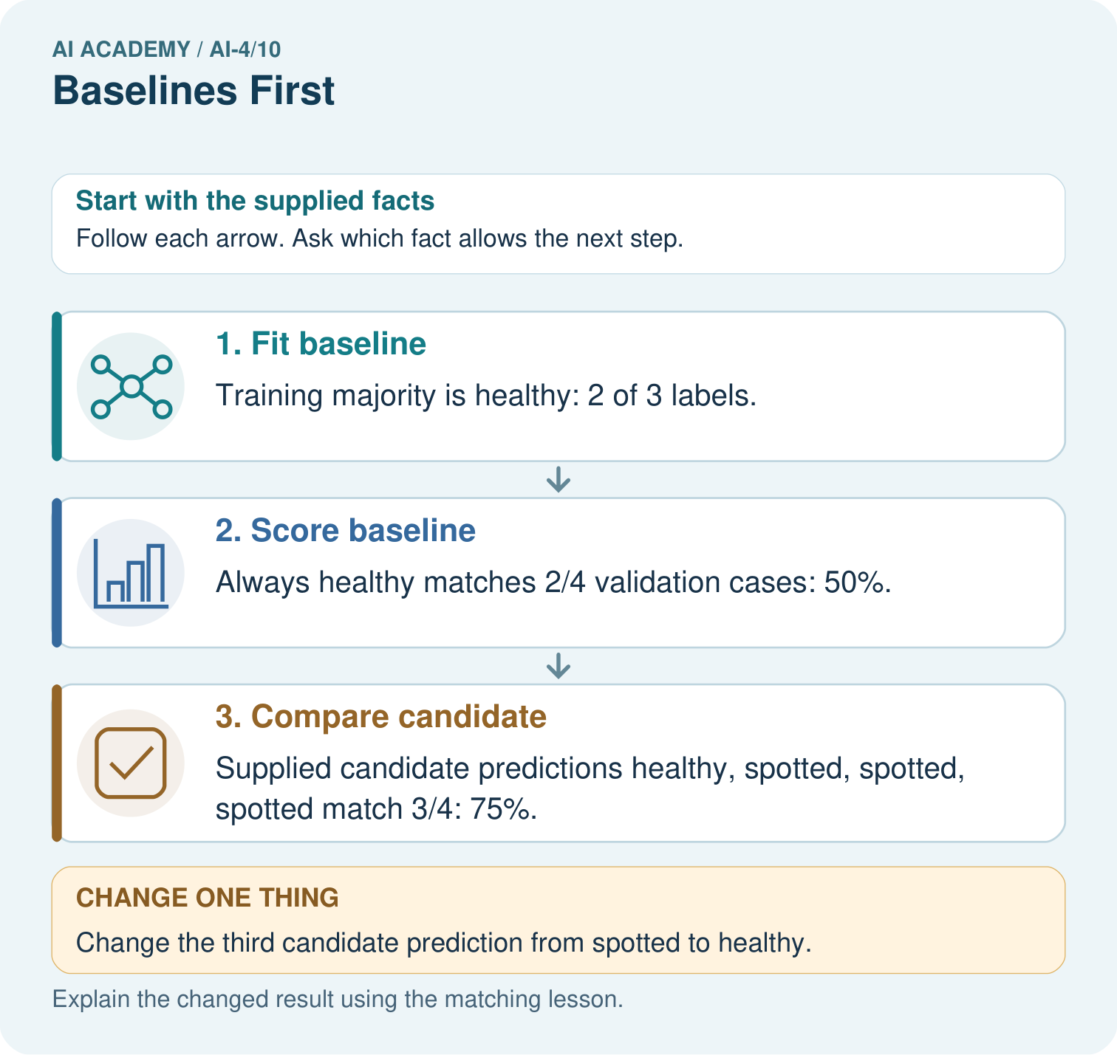
Can the candidate’s training accuracy replace this validation comparison? Point to the relevant step in the picture, then write the changed result and the rule or evidence that supports it.

My picture-based explanation and changed-case prediction
________________________________________________________________
________________________________________________________________
________________________________________________________________
________________________________________________________________
________________________________________________________________
________________________________________________________________
Support used: alone / hint / worked example. This record is practice evidence.
Project connection: For your Responsible Plant Classifier, save the input, procedure, observed result and limitation of this check. Label this worked example as practice; use a different, previously unreviewed case when checking independent understanding.

