AI ACADEMY · WORKBOOK · ai-4/12

Nearest Neighbors
Project: Responsible Plant Classifier

01. Recall and choose your starting point
Try the recall before opening notes. Then use a different colour or a labelled second line to correct your explanation.

Decision Trees
Without opening the old lesson, explain one key idea from Decision Trees. Give an example and a mistake that the idea helps you avoid.

My remembered idea, example and correction
________________________________________________________________
________________________________________________________________
________________________________________________________________

Dataset Cards
Without opening the old lesson, explain one key idea from Dataset Cards. Give an example and a mistake that the idea helps you avoid.

My remembered idea, example and correction
________________________________________________________________
________________________________________________________________
________________________________________________________________

Label Quality
Without opening the old lesson, explain one key idea from Label Quality. Give an example and a mistake that the idea helps you avoid.

My remembered idea, example and correction
________________________________________________________________
________________________________________________________________
________________________________________________________________

02. Practise with fading help
Use W2: Apply neighbour and tie rules for Nearest neighbours and distances. Record the answer once; the lesson and workbook refer to the same attempt.
Given inputs | Procedure I chose | Middle steps | Result and check

The step I completed without help, and the hint I needed
________________________________________________________________
________________________________________________________________
________________________________________________________________

03. Individual reasoning check
Use the worked case for Nearest neighbours and distances. Proposed explanation: “A negative difference is a negative distance”. Decide whether this explanation is supported. Point to the step or supplied fact that decides; explain your repair if needed.

My explanation before partner discussion
________________________________________________________________
________________________________________________________________
________________________________________________________________
________________________________________________________________

04. Independent transfer case

Independent case: Changed independent case
Training points: A length1 healthy, B length5 spotted, C length9 healthy. Query length7. Use absolute distance; for a nearest-neighbor tie choose the alphabetically earlier ID. Compare k=1 and k=3.

My independent explanation, trace and limits
________________________________________________________________
________________________________________________________________
________________________________________________________________
________________________________________________________________
________________________________________________________________
________________________________________________________________
________________________________________________________________
Attempt this case before feedback. Record any help. Earlier examples below are further practice; a case already practised with feedback cannot establish fresh transfer.

05. Your learning target
Training lengths 2(H),6(S),10(H); query=8. Compute distances. Explain the tie and why combining length in mm with width in cm changes a two-feature distance.

06. Solve the given case
One-dimensional training points: 2 healthy, 4 healthy, 8 spotted. Query=6; absolute distance.
Find k=1 neighbours and handle ties.
Show your trace, calculation or evidence

Write or draw your reasoning and evidence.
________________________________________________________________
________________________________________________________________
________________________________________________________________
________________________________________________________________
________________________________________________________________

07. Check a changed case
For one feature, labeled points are 2:fern and 8:grass. A new point is 6. Under one-nearest-neighbor with absolute distance, predict its label.
My independent answer and reason

Write or draw your reasoning and evidence.
________________________________________________________________
________________________________________________________________
________________________________________________________________
________________________________________________________________
________________________________________________________________

Week 12 Test and reflect

08. Design a revealing test
Create a changed input, boundary case or missing-information case. Write the expected answer or safe response before testing.
Test record | My evidence
Changed input or condition
Expected answer or fallback
Observed result
Why the result occurred

09. Project checkpoint
Implement a transparent k-NN paper prototype for the Plant Classifier and record the chosen features, scaling, distance, and k.
The project change and evidence I will keep

Write or draw your reasoning and evidence.
________________________________________________________________
________________________________________________________________
________________________________________________________________
________________________________________________________________
________________________________________________________________

10. Self check
I can explain the mechanism. I can show evidence. I can handle a changed case. I can name a limit. Mark each as not yet, with help or independently, and attach supporting work.
Teacher review ____________________ Next step ____________________

11. Transfer practice from the original programme
Training lengths 2(H),6(S),10(H); query=8. Compute distances. Explain the tie and why combining length in mm with width in cm changes a two-feature distance.

My independently reasoned answer
________________________________________________________________
________________________________________________________________
________________________________________________________________
________________________________________________________________
________________________________________________________________
________________________________________________________________
________________________________________________________________
Record support used: none, hint or teacher explanation.

12. W1 Calculate feature distances
For query 3 cm, calculate distances to all five training rows. Explain why A and B tie even though their labels differ.

My reasoning and evidence
________________________________________________________________
________________________________________________________________
________________________________________________________________
________________________________________________________________
________________________________________________________________
________________________________________________________________

13. W2 Apply neighbour and tie rules
For query 3, list the selected IDs and predictions for k=1 and k=3 using alphabetical ID order on equal distances. Explain what changes and what remains the same.

My reasoning and evidence
________________________________________________________________
________________________________________________________________
________________________________________________________________
________________________________________________________________
________________________________________________________________
________________________________________________________________

14. W3 Keep evaluation examples separate
Why must the three validation reference labels not enter the neighbour pool? Give the fixed k=3 score and baseline score on the worked validation examples.

My reasoning and evidence
________________________________________________________________
________________________________________________________________
________________________________________________________________
________________________________________________________________
________________________________________________________________
________________________________________________________________

15. W4 Find neighbours independently
New training rows are P at 1 cm clear, Q at 5 blocked, R at 7 blocked, S at 11 clear, T at 13 blocked. For query 6, give all distances, order the IDs by distance then alphabetically, and predict with k=1 and k=3. Using the same training pool and k=3, score validation (6,blocked),(10,clear),(12,blocked). Compare the training-majority baseline.

My reasoning and evidence
________________________________________________________________
________________________________________________________________
________________________________________________________________
________________________________________________________________
________________________________________________________________
________________________________________________________________
________________________________________________________________
________________________________________________________________

16. W5 Interpret a vote and a match
Two of three neighbours vote clear. Does that prove a two-thirds chance of a correct prediction? Does an exact feature match guarantee a correct label? Explain both limits.

My reasoning and evidence
________________________________________________________________
________________________________________________________________
________________________________________________________________
________________________________________________________________
________________________________________________________________
________________________________________________________________

17. Feedback, return check and learning record
Evidence | My record
Worked alone / hint / model
First step I repaired and why
New case checked later; date and result
What I can now explain without notes
One remaining question
Revisit this idea with your teacher after a delay. Familiarity is different from explaining and using it on a changed case.

18. Pictorial case practice: Nearest Neighbors
Let a nearest-neighbour picture show each distance before voting.
Training: A length 2 healthy; B length8 spotted; C length11 spotted. Query length5 cm. Distance is absolute difference; ties use alphabetically earlier ID.
All inputs and outcomes in this worked example are invented classroom data; no real model run is claimed.
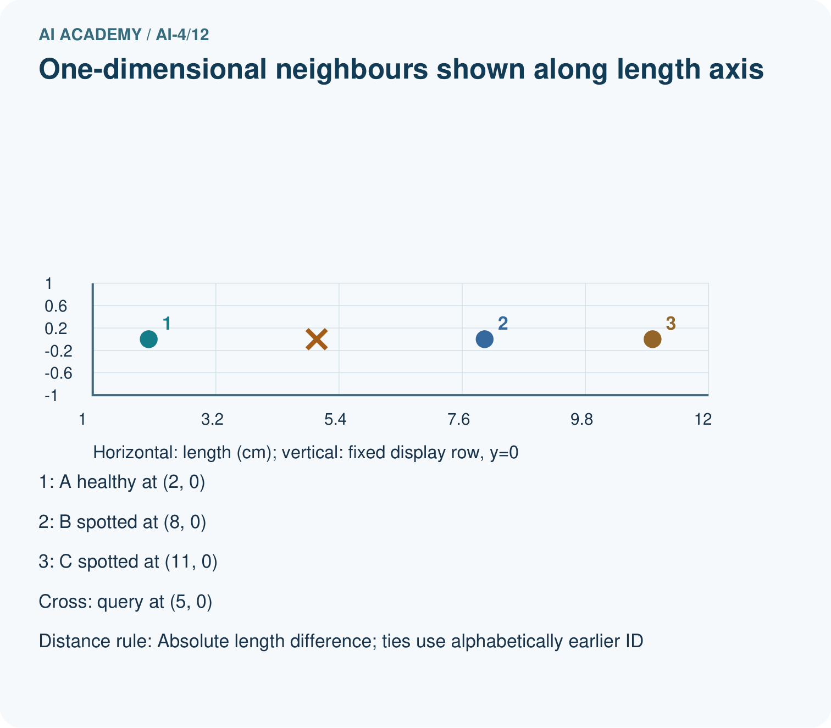
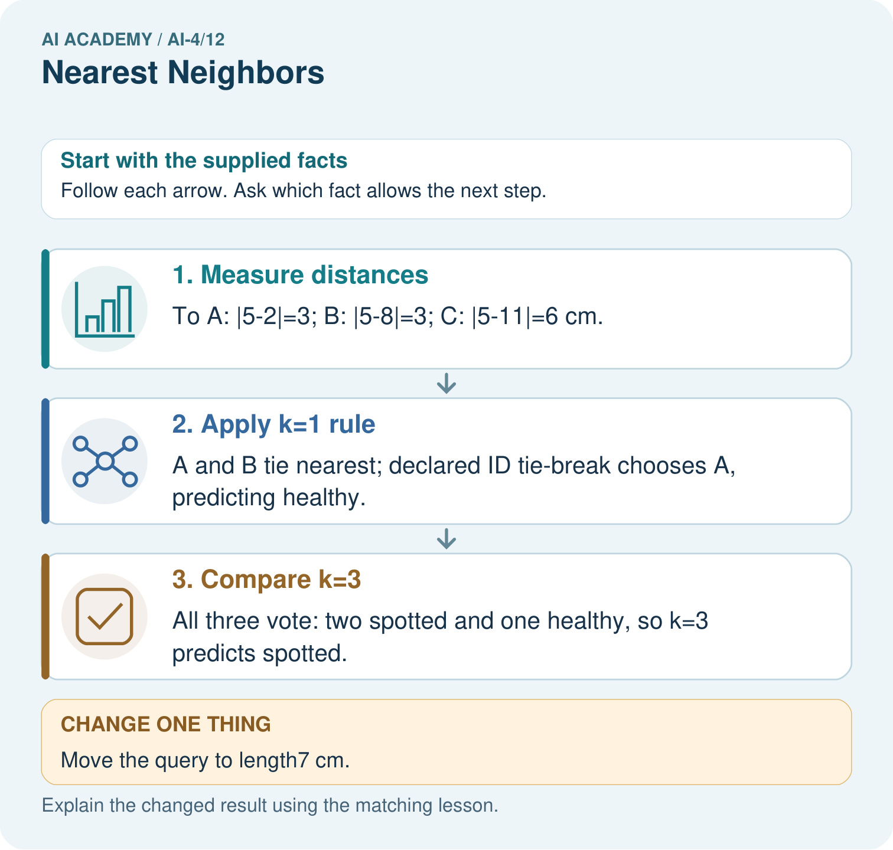
Why is the k=1 outcome at length5 not uniquely determined without a tie rule? Point to the relevant step in the picture, then write the changed result and the rule or evidence that supports it.

My picture-based explanation and changed-case prediction
________________________________________________________________
________________________________________________________________
________________________________________________________________
________________________________________________________________
________________________________________________________________
________________________________________________________________
Support used: alone / hint / worked example. This record is practice evidence.
Project connection: For your Responsible Plant Classifier, save the input, procedure, observed result and limitation of this check. Label this worked example as practice; use a different, previously unreviewed case when checking independent understanding.

