AI ACADEMY · WORKBOOK · ai-4/14

Scores and Calibration Intuition
Project: Responsible Plant Classifier

01. Recall and choose your starting point
Try the recall before opening notes. Then use a different colour or a labelled second line to correct your explanation.

Train a Classifier
Without opening the old lesson, explain one key idea from Train a Classifier. Give an example and a mistake that the idea helps you avoid.

My remembered idea, example and correction
________________________________________________________________
________________________________________________________________
________________________________________________________________

Decision Trees
Without opening the old lesson, explain one key idea from Decision Trees. Give an example and a mistake that the idea helps you avoid.

My remembered idea, example and correction
________________________________________________________________
________________________________________________________________
________________________________________________________________

Leakage
Without opening the old lesson, explain one key idea from Leakage. Give an example and a mistake that the idea helps you avoid.

My remembered idea, example and correction
________________________________________________________________
________________________________________________________________
________________________________________________________________

02. Practise with fading help
Use W2: Locate the discrepancy for Calibration as a group property. Record the answer once; the lesson and workbook refer to the same attempt.
Given inputs | Procedure I chose | Middle steps | Result and check

The step I completed without help, and the hint I needed
________________________________________________________________
________________________________________________________________
________________________________________________________________

03. Individual reasoning check
Use the worked case for Calibration as a group property. Proposed explanation: “A final answer is enough”. Decide whether this explanation is supported. Point to the step or supplied fact that decides; explain your repair if needed.

My explanation before partner discussion
________________________________________________________________
________________________________________________________________
________________________________________________________________
________________________________________________________________

04. Independent transfer case

Independent case: Apply independently
Twenty cases all predict .3 with eight positives; ten all predict .7 with seven positives. Give plot points and interpret.

My independent explanation, trace and limits
________________________________________________________________
________________________________________________________________
________________________________________________________________
________________________________________________________________
________________________________________________________________
________________________________________________________________
________________________________________________________________
Attempt this case before feedback. Record any help. Earlier examples below are further practice; a case already practised with feedback cannot establish fresh transfer.

05. Your learning target
Twenty cases receive score .7 and fourteen are correct. Explain what the observed rate suggests and what it does not establish about another score group.

06. Solve the given case
Ten cases receive probability .8 for spotted; eight are spotted.
Interpret calibration and its limits.
Show your trace, calculation or evidence

Write or draw your reasoning and evidence.
________________________________________________________________
________________________________________________________________
________________________________________________________________
________________________________________________________________
________________________________________________________________

07. Check a changed case
Among 20 predictions with score 0.8, 12 are correct. What is observed accuracy in this group and how does it compare with 0.8?
My independent answer and reason

Write or draw your reasoning and evidence.
________________________________________________________________
________________________________________________________________
________________________________________________________________
________________________________________________________________
________________________________________________________________

Week 14 Test and reflect

08. Design a revealing test
Create a changed input, boundary case or missing-information case. Write the expected answer or safe response before testing.
Test record | My evidence
Changed input or condition
Expected answer or fallback
Observed result
Why the result occurred

09. Project checkpoint
Add an uncertainty band to the Plant Classifier and define what the interface says when scores fall inside it.
The project change and evidence I will keep

Write or draw your reasoning and evidence.
________________________________________________________________
________________________________________________________________
________________________________________________________________
________________________________________________________________
________________________________________________________________

10. Self check
I can explain the mechanism. I can show evidence. I can handle a changed case. I can name a limit. Mark each as not yet, with help or independently, and attach supporting work.
Teacher review ____________________ Next step ____________________

11. Transfer practice from the original programme
Twenty cases receive score .7 and fourteen are correct. Explain what the observed rate suggests and what it does not establish about another score group.

My independently reasoned answer
________________________________________________________________
________________________________________________________________
________________________________________________________________
________________________________________________________________
________________________________________________________________
________________________________________________________________
________________________________________________________________
Record support used: none, hint or teacher explanation.

12. W1 Compute frequencies
Give the observed frequencies for the two worked groups.

My reasoning and evidence
________________________________________________________________
________________________________________________________________
________________________________________________________________
________________________________________________________________
________________________________________________________________
________________________________________________________________

13. W2 Locate the discrepancy
Which worked group overstates positive frequency and by how much?

My reasoning and evidence
________________________________________________________________
________________________________________________________________
________________________________________________________________
________________________________________________________________
________________________________________________________________
________________________________________________________________

14. W3 Separate ranking
Why can constant .5 predictions look calibrated but rank poorly?

My reasoning and evidence
________________________________________________________________
________________________________________________________________
________________________________________________________________
________________________________________________________________
________________________________________________________________
________________________________________________________________

15. W4 Apply independently
Twenty cases all predict .3 with eight positives; ten all predict .7 with seven positives. Give plot points and interpret.

My reasoning and evidence
________________________________________________________________
________________________________________________________________
________________________________________________________________
________________________________________________________________
________________________________________________________________
________________________________________________________________
________________________________________________________________
________________________________________________________________

16. W5 Protect evaluation
What is wrong with calibrating and reporting success on the same final-test records?

My reasoning and evidence
________________________________________________________________
________________________________________________________________
________________________________________________________________
________________________________________________________________
________________________________________________________________
________________________________________________________________

17. Feedback, return check and learning record
Evidence | My record
Worked alone / hint / model
First step I repaired and why
New case checked later; date and result
What I can now explain without notes
One remaining question
Revisit this idea with your teacher after a delay. Familiarity is different from explaining and using it on a changed case.

18. Pictorial case practice: Scores and Calibration Intuition
Treat calibration as a comparison across groups of probability scores.
Toy classifier outputs p(spotted)=0.8 on ten cases; eight are actually spotted. Another ten have p=0.2; four are spotted.
All inputs and outcomes in this worked example are invented classroom data; no real model run is claimed.
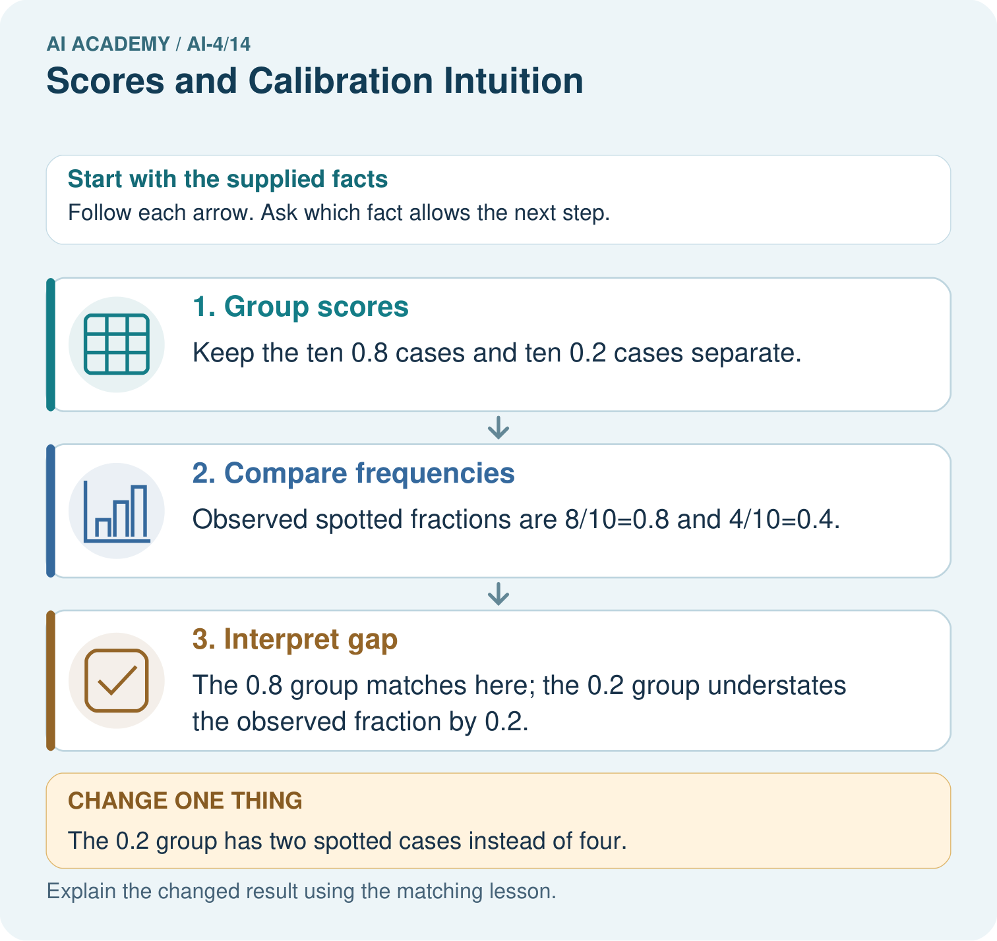
Does a calibrated 0.8 score mean every such leaf is spotted? Point to the relevant step in the picture, then write the changed result and the rule or evidence that supports it.

My picture-based explanation and changed-case prediction
________________________________________________________________
________________________________________________________________
________________________________________________________________
________________________________________________________________
________________________________________________________________
________________________________________________________________
Support used: alone / hint / worked example. This record is practice evidence.
Project connection: For your Responsible Plant Classifier, save the input, procedure, observed result and limitation of this check. Label this worked example as practice; use a different, previously unreviewed case when checking independent understanding.

