AI ACADEMY · WORKBOOK · ai-4/15

Confusion Matrix
Project: Responsible Plant Classifier

01. Recall and choose your starting point
Try the recall before opening notes. Then use a different colour or a labelled second line to correct your explanation.

Scores and Calibration Intuition
Without opening the old lesson, explain one key idea from Scores and Calibration Intuition. Give an example and a mistake that the idea helps you avoid.

My remembered idea, example and correction
________________________________________________________________
________________________________________________________________
________________________________________________________________

Nearest Neighbors
Without opening the old lesson, explain one key idea from Nearest Neighbors. Give an example and a mistake that the idea helps you avoid.

My remembered idea, example and correction
________________________________________________________________
________________________________________________________________
________________________________________________________________

Dataset Cards
Without opening the old lesson, explain one key idea from Dataset Cards. Give an example and a mistake that the idea helps you avoid.

My remembered idea, example and correction
________________________________________________________________
________________________________________________________________
________________________________________________________________

02. Practise with fading help
Use W2: Explain the two error types for Confusion matrices. Record the answer once; the lesson and workbook refer to the same attempt.
Given inputs | Procedure I chose | Middle steps | Result and check

The step I completed without help, and the hint I needed
________________________________________________________________
________________________________________________________________
________________________________________________________________

03. Individual reasoning check
Use the worked case for Confusion matrices. Proposed explanation: “Positive means good”. Decide whether this explanation is supported. Point to the step or supplied fact that decides; explain your repair if needed.

My explanation before partner discussion
________________________________________________________________
________________________________________________________________
________________________________________________________________
________________________________________________________________

04. Independent transfer case

Independent case: Changed independent case
On20 cases: true positives5, false negatives4, false positives2, true negatives9. Build the confusion matrix with actual class as rows and predicted class as columns. Compute accuracy.

My independent explanation, trace and limits
________________________________________________________________
________________________________________________________________
________________________________________________________________
________________________________________________________________
________________________________________________________________
________________________________________________________________
________________________________________________________________
Attempt this case before feedback. Record any help. Earlier examples below are further practice; a case already practised with feedback cannot establish fresh transfer.

05. Your learning target
Positive=spotted. TP=6,FN=2,FP=3,TN=9. Draw a matrix with actual labels in rows and predictions in columns. Compute total and accuracy.

06. Solve the given case
Positive is spotted. TP=8, FP=2, FN=4, TN=6.
Build actual-row/predicted-column matrix and total.
Show your trace, calculation or evidence

Write or draw your reasoning and evidence.
________________________________________________________________
________________________________________________________________
________________________________________________________________
________________________________________________________________
________________________________________________________________

07. Check a changed case
Treat fern as positive. Counts are TP=6, FP=2, FN=3 and TN=9. How many examples and how many correct predictions are there?
My independent answer and reason

Write or draw your reasoning and evidence.
________________________________________________________________
________________________________________________________________
________________________________________________________________
________________________________________________________________
________________________________________________________________

Week 15 Test and reflect

08. Design a revealing test
Create a changed input, boundary case or missing-information case. Write the expected answer or safe response before testing.
Test record | My evidence
Changed input or condition
Expected answer or fallback
Observed result
Why the result occurred

09. Project checkpoint
Publish the Plant Classifier confusion matrix with positive-class definition, counts, denominator, and test-set version.
The project change and evidence I will keep

Write or draw your reasoning and evidence.
________________________________________________________________
________________________________________________________________
________________________________________________________________
________________________________________________________________
________________________________________________________________

10. Self check
I can explain the mechanism. I can show evidence. I can handle a changed case. I can name a limit. Mark each as not yet, with help or independently, and attach supporting work.
Teacher review ____________________ Next step ____________________

11. Transfer practice from the original programme
Positive=spotted. TP=6,FN=2,FP=3,TN=9. Draw a matrix with actual labels in rows and predictions in columns. Compute total and accuracy.

My independently reasoned answer
________________________________________________________________
________________________________________________________________
________________________________________________________________
________________________________________________________________
________________________________________________________________
________________________________________________________________
________________________________________________________________
Record support used: none, hint or teacher explanation.

12. W1 Build the count matrix
Use all eight worked IDs. Draw a matrix with reference rows and prediction columns, both ordered clear then blocked. Place the IDs in cells before writing the counts.

My reasoning and evidence
________________________________________________________________
________________________________________________________________
________________________________________________________________
________________________________________________________________
________________________________________________________________
________________________________________________________________

13. W2 Explain the two error types
Declare blocked positive. Give TP,TN,FP,FN counts and explain V3 and V4 in plain language. Does positive mean a desirable outcome?

My reasoning and evidence
________________________________________________________________
________________________________________________________________
________________________________________________________________
________________________________________________________________
________________________________________________________________
________________________________________________________________

14. W3 Audit totals and equal accuracy
Give the worked row totals, column totals, total count and accuracy. Compare its errors with [[3,0],[3,2]] using the same axes and eight reference records.

My reasoning and evidence
________________________________________________________________
________________________________________________________________
________________________________________________________________
________________________________________________________________
________________________________________________________________
________________________________________________________________

15. W4 Count a fresh evaluation independently
Each pair below is reference then prediction: R1 clear/clear, R2 clear/blocked, R3 clear/blocked, R4 blocked/blocked, R5 blocked/clear, R6 blocked/blocked. Use clear then blocked on both axes and reference rows. Build the matrix, give row and column totals, name TP,TN,FP,FN with blocked positive, and calculate accuracy.

My reasoning and evidence
________________________________________________________________
________________________________________________________________
________________________________________________________________
________________________________________________________________
________________________________________________________________
________________________________________________________________
________________________________________________________________
________________________________________________________________

16. W5 Interpret a zero count carefully
A report gives zero false positives but omits the evaluated sample size, axes and class definitions. What information is missing, and why does zero not prove that future false alarms are impossible?

My reasoning and evidence
________________________________________________________________
________________________________________________________________
________________________________________________________________
________________________________________________________________
________________________________________________________________
________________________________________________________________

17. Feedback, return check and learning record
Evidence | My record
Worked alone / hint / model
First step I repaired and why
New case checked later; date and result
What I can now explain without notes
One remaining question
Revisit this idea with your teacher after a delay. Familiarity is different from explaining and using it on a changed case.

18. Pictorial case practice: Confusion Matrix
Read the confusion matrix as four distinct stories about a plant decision.
Positive means spotted. Toy results: TP=4, FN=1, FP=3, TN=12. Rows are actual spotted/healthy; columns predicted spotted/healthy.
All inputs and outcomes in this worked example are invented classroom data; no real model run is claimed.
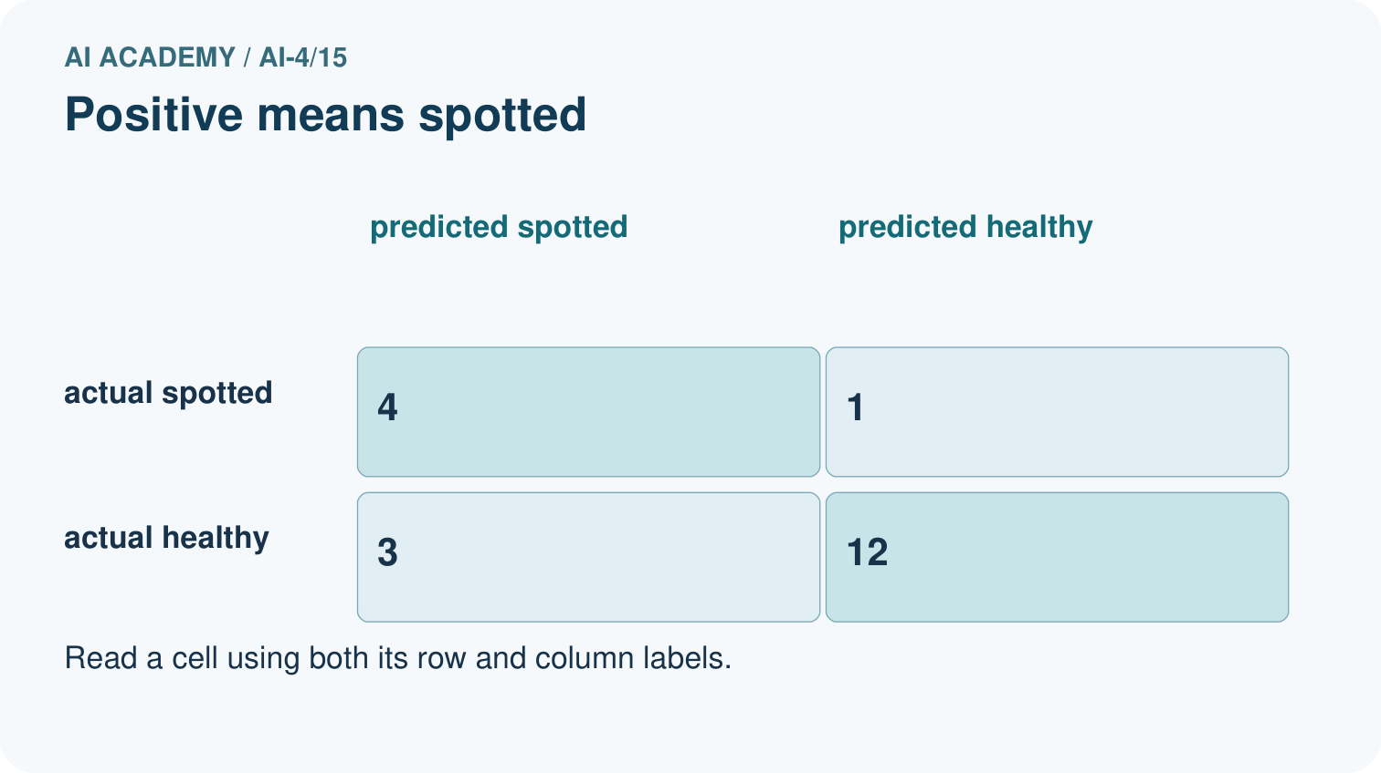
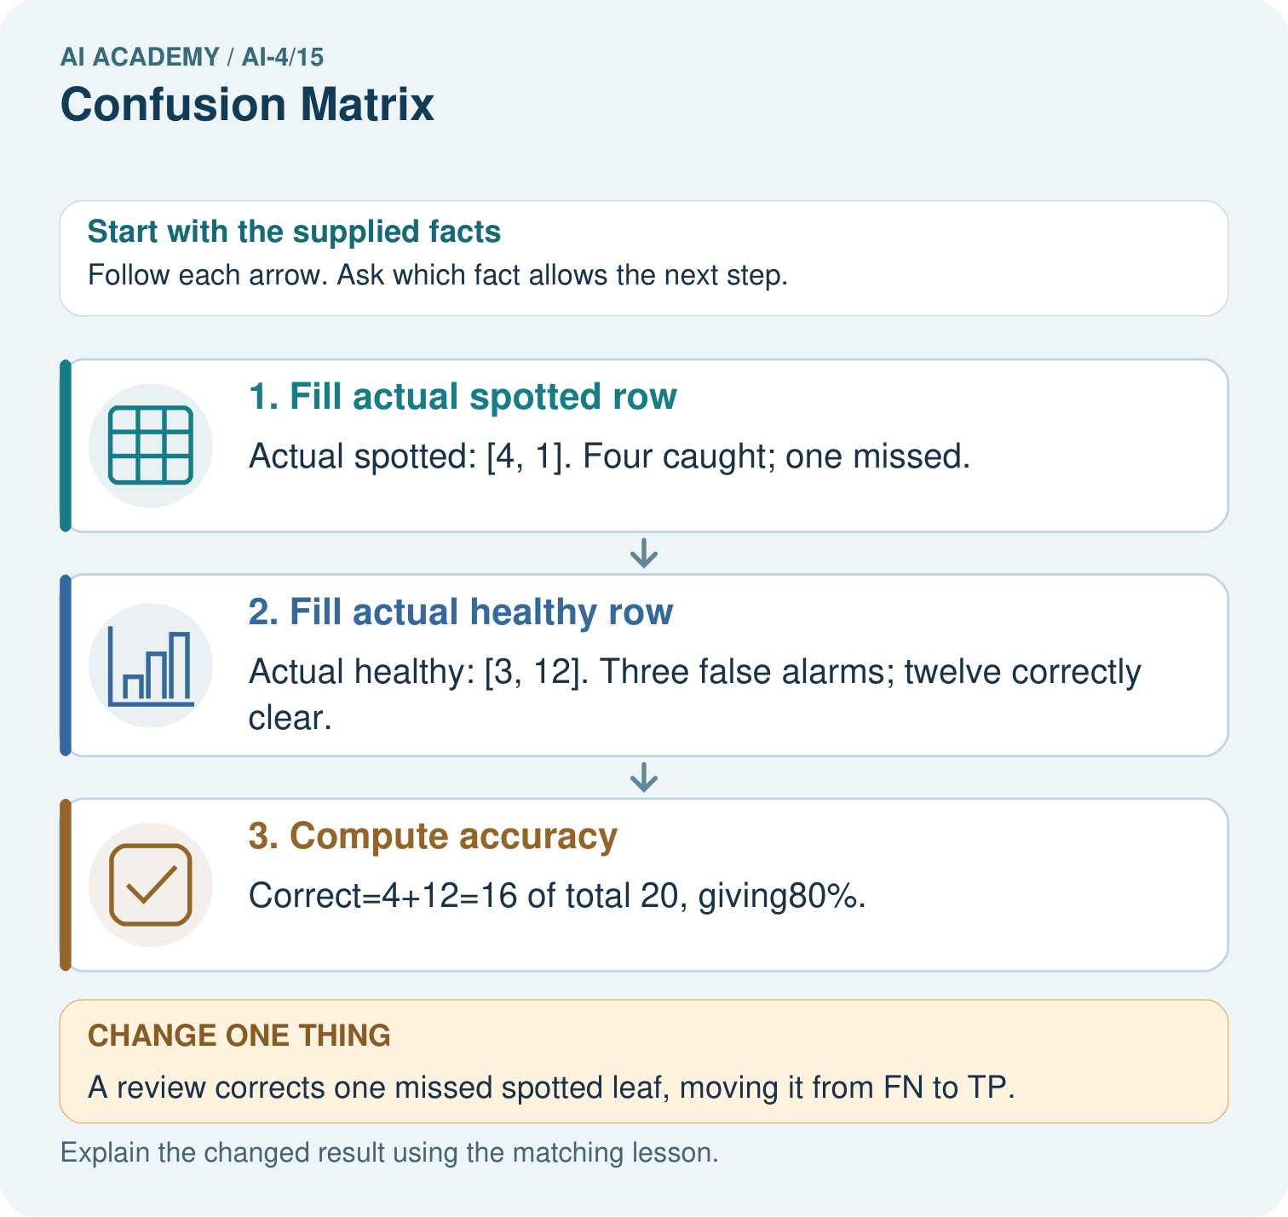
Why is adding TP alone without reducing FN an incorrect revision? Point to the relevant step in the picture, then write the changed result and the rule or evidence that supports it.

My picture-based explanation and changed-case prediction
________________________________________________________________
________________________________________________________________
________________________________________________________________
________________________________________________________________
________________________________________________________________
________________________________________________________________
Support used: alone / hint / worked example. This record is practice evidence.
Project connection: For your Responsible Plant Classifier, save the input, procedure, observed result and limitation of this check. Label this worked example as practice; use a different, previously unreviewed case when checking independent understanding.

