AI ACADEMY · WORKBOOK · ai-4/19

Regression and Residuals
Project: Responsible Plant Classifier

01. Recall and choose your starting point
Try the recall before opening notes. Then use a different colour or a labelled second line to correct your explanation.

Error Analysis
Without opening the old lesson, explain one key idea from Error Analysis. Give an example and a mistake that the idea helps you avoid.

My remembered idea, example and correction
________________________________________________________________
________________________________________________________________
________________________________________________________________

Accuracy and Imbalance
Without opening the old lesson, explain one key idea from Accuracy and Imbalance. Give an example and a mistake that the idea helps you avoid.

My remembered idea, example and correction
________________________________________________________________
________________________________________________________________
________________________________________________________________

Train a Classifier
Without opening the old lesson, explain one key idea from Train a Classifier. Give an example and a mistake that the idea helps you avoid.

My remembered idea, example and correction
________________________________________________________________
________________________________________________________________
________________________________________________________________

02. Practise with fading help
Use W2: Explain cancellation for Regression and residuals. Record the answer once; the lesson and workbook refer to the same attempt.
Given inputs | Procedure I chose | Middle steps | Result and check

The step I completed without help, and the hint I needed
________________________________________________________________
________________________________________________________________
________________________________________________________________

03. Individual reasoning check
Use the worked case for Regression and residuals. Proposed explanation: “A final answer is enough”. Decide whether this explanation is supported. Point to the step or supplied fact that decides; explain your repair if needed.

My explanation before partner discussion
________________________________________________________________
________________________________________________________________
________________________________________________________________
________________________________________________________________

04. Independent transfer case

Independent case: Apply independently
Observed [6, 10, 13], predicted [8, 9, 11] cm. Give residuals, mean residual and error directions.

My independent explanation, trace and limits
________________________________________________________________
________________________________________________________________
________________________________________________________________
________________________________________________________________
________________________________________________________________
________________________________________________________________
________________________________________________________________
Attempt this case before feedback. Record any help. Earlier examples below are further practice; a case already practised with feedback cannot establish fresh transfer.

05. Your learning target
Actual leaf length is 7 cm and prediction is 10 cm. Using residual=actual−predicted, calculate residual and absolute error. Interpret the sign.

06. Solve the given case
Actual height=12 cm, prediction=9 cm. Residual means actual minus predicted.
Calculate and interpret.
Show your trace, calculation or evidence

Write or draw your reasoning and evidence.
________________________________________________________________
________________________________________________________________
________________________________________________________________
________________________________________________________________
________________________________________________________________

07. Check a changed case
Define residual as actual minus predicted. Actual height is 14 cm and prediction is 17 cm. Calculate residual and interpret its sign.
My independent answer and reason

Write or draw your reasoning and evidence.
________________________________________________________________
________________________________________________________________
________________________________________________________________
________________________________________________________________
________________________________________________________________

Week 19 Test and reflect

08. Design a revealing test
Create a changed input, boundary case or missing-information case. Write the expected answer or safe response before testing.
Test record | My evidence
Changed input or condition
Expected answer or fallback
Observed result
Why the result occurred

09. Project checkpoint
Use a miniature growth-prediction side experiment to distinguish regression evidence from the main classifier metrics.
The project change and evidence I will keep

Write or draw your reasoning and evidence.
________________________________________________________________
________________________________________________________________
________________________________________________________________
________________________________________________________________
________________________________________________________________

10. Self check
I can explain the mechanism. I can show evidence. I can handle a changed case. I can name a limit. Mark each as not yet, with help or independently, and attach supporting work.
Teacher review ____________________ Next step ____________________

11. Transfer practice from the original programme
Actual leaf length is 7 cm and prediction is 10 cm. Using residual=actual−predicted, calculate residual and absolute error. Interpret the sign.

My independently reasoned answer
________________________________________________________________
________________________________________________________________
________________________________________________________________
________________________________________________________________
________________________________________________________________
________________________________________________________________
________________________________________________________________
Record support used: none, hint or teacher explanation.

12. W1 Calculate residuals
Compute the worked residuals and identify overprediction.

My reasoning and evidence
________________________________________________________________
________________________________________________________________
________________________________________________________________
________________________________________________________________
________________________________________________________________
________________________________________________________________

13. W2 Explain cancellation
Why does mean residual zero not imply perfect predictions?

My reasoning and evidence
________________________________________________________________
________________________________________________________________
________________________________________________________________
________________________________________________________________
________________________________________________________________
________________________________________________________________

14. W3 Read a pattern
Interpret residuals -2, 0, 3 ordered by growth stage.

My reasoning and evidence
________________________________________________________________
________________________________________________________________
________________________________________________________________
________________________________________________________________
________________________________________________________________
________________________________________________________________

15. W4 Apply independently
Observed [6, 10, 13], predicted [8, 9, 11] cm. Give residuals, mean residual and error directions.

My reasoning and evidence
________________________________________________________________
________________________________________________________________
________________________________________________________________
________________________________________________________________
________________________________________________________________
________________________________________________________________
________________________________________________________________
________________________________________________________________

16. W5 Check units
A report combines 2 cm and .02 m as if they were different magnitudes. Repair it.

My reasoning and evidence
________________________________________________________________
________________________________________________________________
________________________________________________________________
________________________________________________________________
________________________________________________________________
________________________________________________________________

17. Feedback, return check and learning record
Evidence | My record
Worked alone / hint / model
First step I repaired and why
New case checked later; date and result
What I can now explain without notes
One remaining question
Revisit this idea with your teacher after a delay. Familiarity is different from explaining and using it on a changed case.

18. Pictorial case practice: Regression and Residuals
Use residual signs to say whether each plant-height estimate is too high or low.
Residual=observed-predicted. Observed heights [5, 8, 12] cm; predicted [7, 7, 10] cm.
All inputs and outcomes in this worked example are invented classroom data; no real model run is claimed.
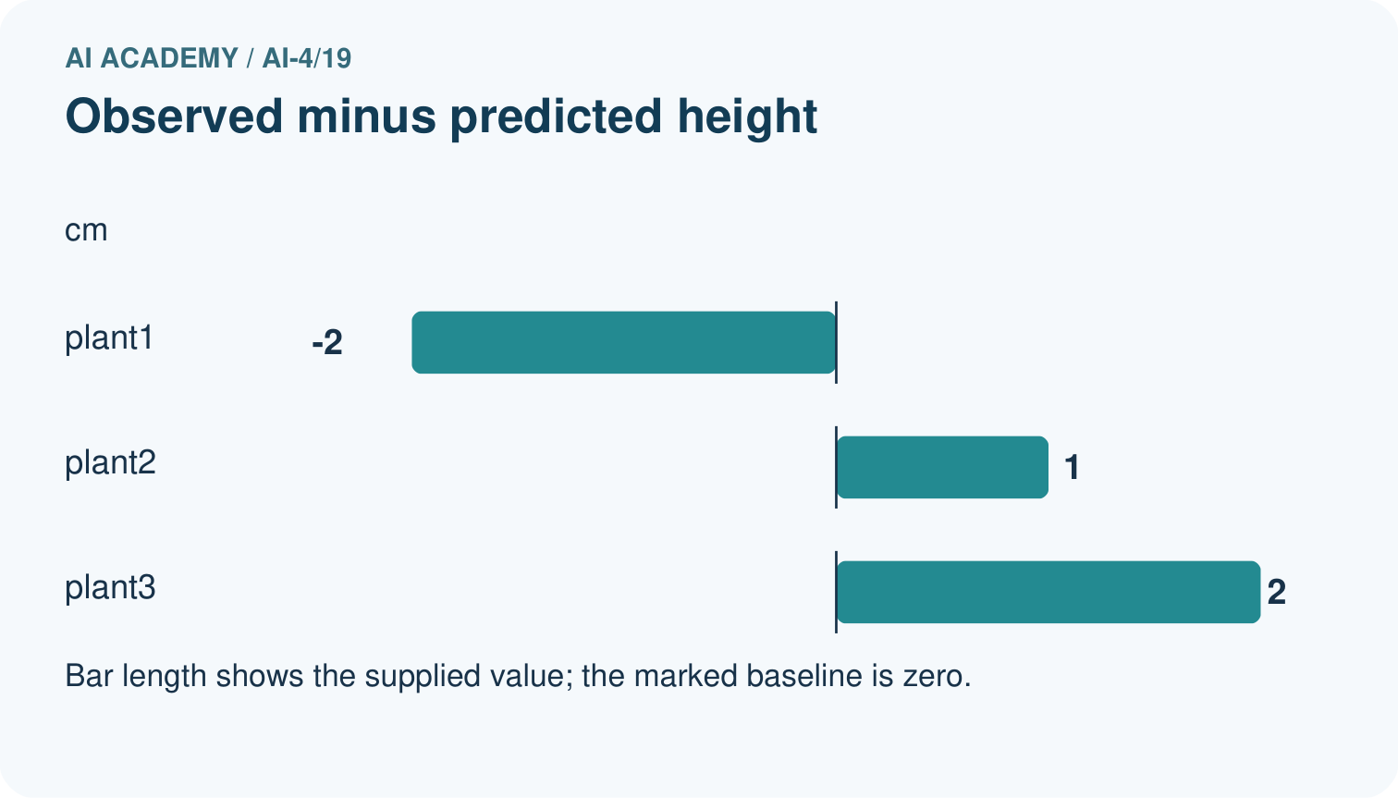
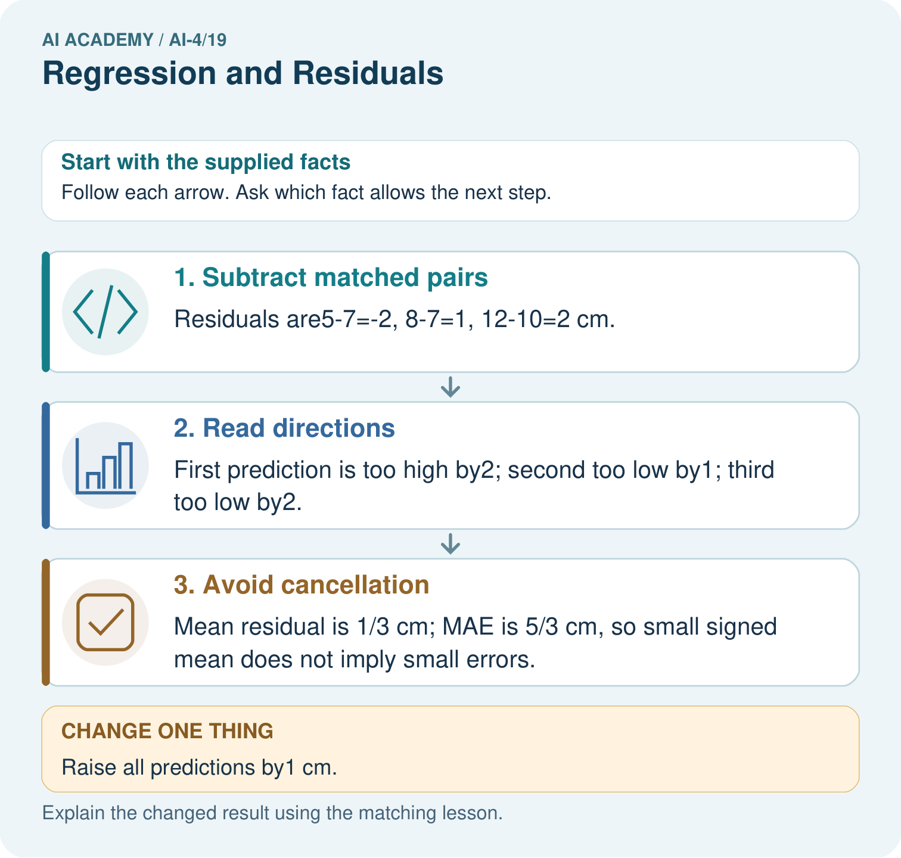
Which statistic reveals the size of errors without cancellation? Point to the relevant step in the picture, then write the changed result and the rule or evidence that supports it.

My picture-based explanation and changed-case prediction
________________________________________________________________
________________________________________________________________
________________________________________________________________
________________________________________________________________
________________________________________________________________
________________________________________________________________
Support used: alone / hint / worked example. This record is practice evidence.
Project connection: For your Responsible Plant Classifier, save the input, procedure, observed result and limitation of this check. Label this worked example as practice; use a different, previously unreviewed case when checking independent understanding.

