AI ACADEMY · WORKBOOK · ai-4/24

Train, Validation, Test
Project: Responsible Plant Classifier

01. Recall and choose your starting point
Try the recall before opening notes. Then use a different colour or a labelled second line to correct your explanation.

Hold Out Test Data
Without opening the old lesson, explain one key idea from Hold Out Test Data. Give an example and a mistake that the idea helps you avoid.

My remembered idea, example and correction
________________________________________________________________
________________________________________________________________
________________________________________________________________

Absolute Error and MAE
Without opening the old lesson, explain one key idea from Absolute Error and MAE. Give an example and a mistake that the idea helps you avoid.

My remembered idea, example and correction
________________________________________________________________
________________________________________________________________
________________________________________________________________

Error Analysis
Without opening the old lesson, explain one key idea from Error Analysis. Give an example and a mistake that the idea helps you avoid.

My remembered idea, example and correction
________________________________________________________________
________________________________________________________________
________________________________________________________________

02. Practise with fading help
Use W2: Assign data roles for Validation and model selection. Record the answer once; the lesson and workbook refer to the same attempt.
Given inputs | Procedure I chose | Middle steps | Result and check

The step I completed without help, and the hint I needed
________________________________________________________________
________________________________________________________________
________________________________________________________________

03. Individual reasoning check
Use the worked case for Validation and model selection. Proposed explanation: “A final answer is enough”. Decide whether this explanation is supported. Point to the step or supplied fact that decides; explain your repair if needed.

My explanation before partner discussion
________________________________________________________________
________________________________________________________________
________________________________________________________________
________________________________________________________________

04. Independent transfer case

Independent case: Apply independently
Training errors P 2 Q 0 R 1; validation errors P 4 Q 6 R 4. Rule: smallest validation MAE, then simpler; P is simpler than R. Choose and state the test action.

My independent explanation, trace and limits
________________________________________________________________
________________________________________________________________
________________________________________________________________
________________________________________________________________
________________________________________________________________
________________________________________________________________
________________________________________________________________
Attempt this case before feedback. Record any help. Earlier examples below are further practice; a case already practised with feedback cannot establish fresh transfer.

05. Your learning target
You have 30 leaves with 3 views each. Allocate 18 leaves to train,6 to validation,6 to test. How many images are in each? Where is a learned normalisation mean fitted?

06. Solve the given case
Split 100 independent leaves into 60 train,20 validation,20 test.
Explain roles and preprocessing.
Show your trace, calculation or evidence

Write or draw your reasoning and evidence.
________________________________________________________________
________________________________________________________________
________________________________________________________________
________________________________________________________________
________________________________________________________________

07. Check a changed case
Assign roles: set A fits model parameters; B selects between two models; C is opened once after choices are fixed. Which is train, validation and test?
My independent answer and reason

Write or draw your reasoning and evidence.
________________________________________________________________
________________________________________________________________
________________________________________________________________
________________________________________________________________
________________________________________________________________

Week 24 Test and reflect

08. Design a revealing test
Create a changed input, boundary case or missing-information case. Write the expected answer or safe response before testing.
Test record | My evidence
Changed input or condition
Expected answer or fallback
Observed result
Why the result occurred

09. Project checkpoint
Publish the grouped split strategy and counts for the Plant Classifier, including why plant identity stays within one split.
The project change and evidence I will keep

Write or draw your reasoning and evidence.
________________________________________________________________
________________________________________________________________
________________________________________________________________
________________________________________________________________
________________________________________________________________

10. Self check
I can explain the mechanism. I can show evidence. I can handle a changed case. I can name a limit. Mark each as not yet, with help or independently, and attach supporting work.
Teacher review ____________________ Next step ____________________

11. Transfer practice from the original programme
You have 30 leaves with 3 views each. Allocate 18 leaves to train,6 to validation,6 to test. How many images are in each? Where is a learned normalisation mean fitted?

My independently reasoned answer
________________________________________________________________
________________________________________________________________
________________________________________________________________
________________________________________________________________
________________________________________________________________
________________________________________________________________
________________________________________________________________
Record support used: none, hint or teacher explanation.

12. W1 Choose a candidate
Apply the worked selection rule. Explain why B is not chosen.

My reasoning and evidence
________________________________________________________________
________________________________________________________________
________________________________________________________________
________________________________________________________________
________________________________________________________________
________________________________________________________________

13. W2 Assign data roles
Where should parameter fitting, setting selection and final reporting occur?

My reasoning and evidence
________________________________________________________________
________________________________________________________________
________________________________________________________________
________________________________________________________________
________________________________________________________________
________________________________________________________________

14. W3 Record another attempt
A team creates D after reading validation mistakes. What changes in the record?

My reasoning and evidence
________________________________________________________________
________________________________________________________________
________________________________________________________________
________________________________________________________________
________________________________________________________________
________________________________________________________________

15. W4 Apply independently
Training errors P 2 Q 0 R 1; validation errors P 4 Q 6 R 4. Rule: smallest validation MAE, then simpler; P is simpler than R. Choose and state the test action.

My reasoning and evidence
________________________________________________________________
________________________________________________________________
________________________________________________________________
________________________________________________________________
________________________________________________________________
________________________________________________________________
________________________________________________________________
________________________________________________________________

16. W5 Limit a claim
Why is the winning validation score not a guaranteed future score?

My reasoning and evidence
________________________________________________________________
________________________________________________________________
________________________________________________________________
________________________________________________________________
________________________________________________________________
________________________________________________________________

17. Feedback, return check and learning record
Evidence | My record
Worked alone / hint / model
First step I repaired and why
New case checked later; date and result
What I can now explain without notes
One remaining question
Revisit this idea with your teacher after a delay. Familiarity is different from explaining and using it on a changed case.

18. Pictorial case practice: Train, Validation, Test
Assign a separate job to training, validation and final test evidence.
Candidates A and B have training MAE1 and 0 cm; validation MAE2 and 3 cm. Selection rule is smallest validation MAE.
All inputs and outcomes in this worked example are invented classroom data; no real model run is claimed.
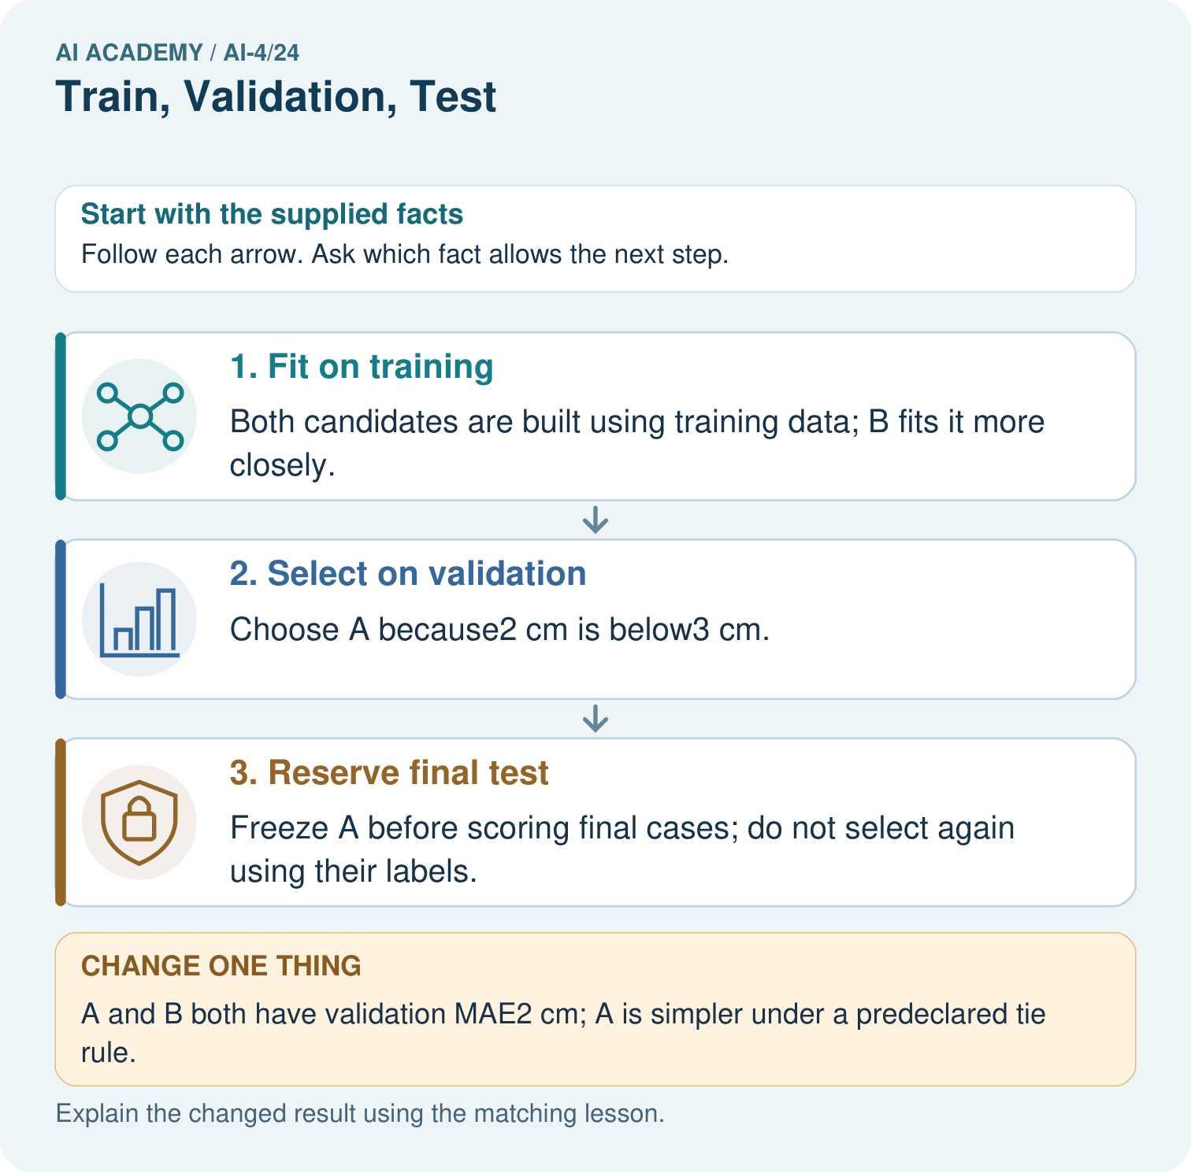
Why does B’s zero training MAE not settle the original choice? Point to the relevant step in the picture, then write the changed result and the rule or evidence that supports it.

My picture-based explanation and changed-case prediction
________________________________________________________________
________________________________________________________________
________________________________________________________________
________________________________________________________________
________________________________________________________________
________________________________________________________________
Support used: alone / hint / worked example. This record is practice evidence.
Project connection: For your Responsible Plant Classifier, save the input, procedure, observed result and limitation of this check. Label this worked example as practice; use a different, previously unreviewed case when checking independent understanding.

