AI ACADEMY · WORKBOOK · ai-4/28

Learning Curves
Project: Responsible Plant Classifier

01. Recall and choose your starting point
Try the recall before opening notes. Then use a different colour or a labelled second line to correct your explanation.

Overfitting
Without opening the old lesson, explain one key idea from Overfitting. Give an example and a mistake that the idea helps you avoid.

My remembered idea, example and correction
________________________________________________________________
________________________________________________________________
________________________________________________________________

Metrics Match Consequences
Without opening the old lesson, explain one key idea from Metrics Match Consequences. Give an example and a mistake that the idea helps you avoid.

My remembered idea, example and correction
________________________________________________________________
________________________________________________________________
________________________________________________________________

Train a Regression Model
Without opening the old lesson, explain one key idea from Train a Regression Model. Give an example and a mistake that the idea helps you avoid.

My remembered idea, example and correction
________________________________________________________________
________________________________________________________________
________________________________________________________________

02. Practise with fading help
Use W2: Read both curves for Learning curves and variability. Record the answer once; the lesson and workbook refer to the same attempt.
Given inputs | Procedure I chose | Middle steps | Result and check

The step I completed without help, and the hint I needed
________________________________________________________________
________________________________________________________________
________________________________________________________________

03. Individual reasoning check
Use the worked case for Learning curves and variability. Proposed explanation: “A final answer is enough”. Decide whether this explanation is supported. Point to the step or supplied fact that decides; explain your repair if needed.

My explanation before partner discussion
________________________________________________________________
________________________________________________________________
________________________________________________________________
________________________________________________________________

04. Independent transfer case

Independent case: Apply independently
At sizes 12 and 24, validation errors are [6, 8, 7] and [4, 7, 7]. Calculate means/ranges and a careful comparison.

My independent explanation, trace and limits
________________________________________________________________
________________________________________________________________
________________________________________________________________
________________________________________________________________
________________________________________________________________
________________________________________________________________
________________________________________________________________
Attempt this case before feedback. Record any help. Earlier examples below are further practice; a case already practised with feedback cannot establish fresh transfer.

05. Your learning target
Training sizes 20,40,80 yield validation accuracies 62%,70%,73%. Is doubling again guaranteed to yield 76%? Describe a defensible next experiment.

06. Solve the given case
With20,40,80 training leaves, fixed-set validation accuracy is60%,70%,78%.
Interpret the curve and uncertainty.
Show your trace, calculation or evidence

Write or draw your reasoning and evidence.
________________________________________________________________
________________________________________________________________
________________________________________________________________
________________________________________________________________
________________________________________________________________

07. Check a changed case
As training examples grow from 50 to 100 to 200, validation accuracy is 60%, 72%, 78%. What does the curve suggest, and what does it not guarantee?
My independent answer and reason

Write or draw your reasoning and evidence.
________________________________________________________________
________________________________________________________________
________________________________________________________________
________________________________________________________________
________________________________________________________________

Week 28 Test and reflect

08. Design a revealing test
Create a changed input, boundary case or missing-information case. Write the expected answer or safe response before testing.
Test record | My evidence
Changed input or condition
Expected answer or fallback
Observed result
Why the result occurred

09. Project checkpoint
Plot Plant Classifier train/validation performance at several training sizes and document the chosen next action.
The project change and evidence I will keep

Write or draw your reasoning and evidence.
________________________________________________________________
________________________________________________________________
________________________________________________________________
________________________________________________________________
________________________________________________________________

10. Self check
I can explain the mechanism. I can show evidence. I can handle a changed case. I can name a limit. Mark each as not yet, with help or independently, and attach supporting work.
Teacher review ____________________ Next step ____________________

11. Transfer practice from the original programme
Training sizes 20,40,80 yield validation accuracies 62%,70%,73%. Is doubling again guaranteed to yield 76%? Describe a defensible next experiment.

My independently reasoned answer
________________________________________________________________
________________________________________________________________
________________________________________________________________
________________________________________________________________
________________________________________________________________
________________________________________________________________
________________________________________________________________
Record support used: none, hint or teacher explanation.

12. W1 Summarize repeats
Calculate the mean and range for the 20-row condition.

My reasoning and evidence
________________________________________________________________
________________________________________________________________
________________________________________________________________
________________________________________________________________
________________________________________________________________
________________________________________________________________

13. W2 Read both curves
Why can training error rise while validation error falls?

My reasoning and evidence
________________________________________________________________
________________________________________________________________
________________________________________________________________
________________________________________________________________
________________________________________________________________
________________________________________________________________

14. W3 Avoid extrapolation
Can the 40-row result guarantee a mean MAE of 2.5 at 80 rows?

My reasoning and evidence
________________________________________________________________
________________________________________________________________
________________________________________________________________
________________________________________________________________
________________________________________________________________
________________________________________________________________

15. W4 Apply independently
At sizes 12 and 24, validation errors are [6, 8, 7] and [4, 7, 7]. Calculate means/ranges and a careful comparison.

My reasoning and evidence
________________________________________________________________
________________________________________________________________
________________________________________________________________
________________________________________________________________
________________________________________________________________
________________________________________________________________
________________________________________________________________
________________________________________________________________

16. W5 Explain the spread
Why is an observed range not a confidence interval?

My reasoning and evidence
________________________________________________________________
________________________________________________________________
________________________________________________________________
________________________________________________________________
________________________________________________________________
________________________________________________________________

17. Feedback, return check and learning record
Evidence | My record
Worked alone / hint / model
First step I repaired and why
New case checked later; date and result
What I can now explain without notes
One remaining question
Revisit this idea with your teacher after a delay. Familiarity is different from explaining and using it on a changed case.

18. Pictorial case practice: Learning Curves
Read a learning curve with repeated-run spread rather than drawing a certainty arrow.
At 10 training plants validation errors across3 runs are [6, 5, 7]; at 20 plants errors [4, 5, 3], on the same 10-case validation set.
All inputs and outcomes in this worked example are invented classroom data; no real model run is claimed.
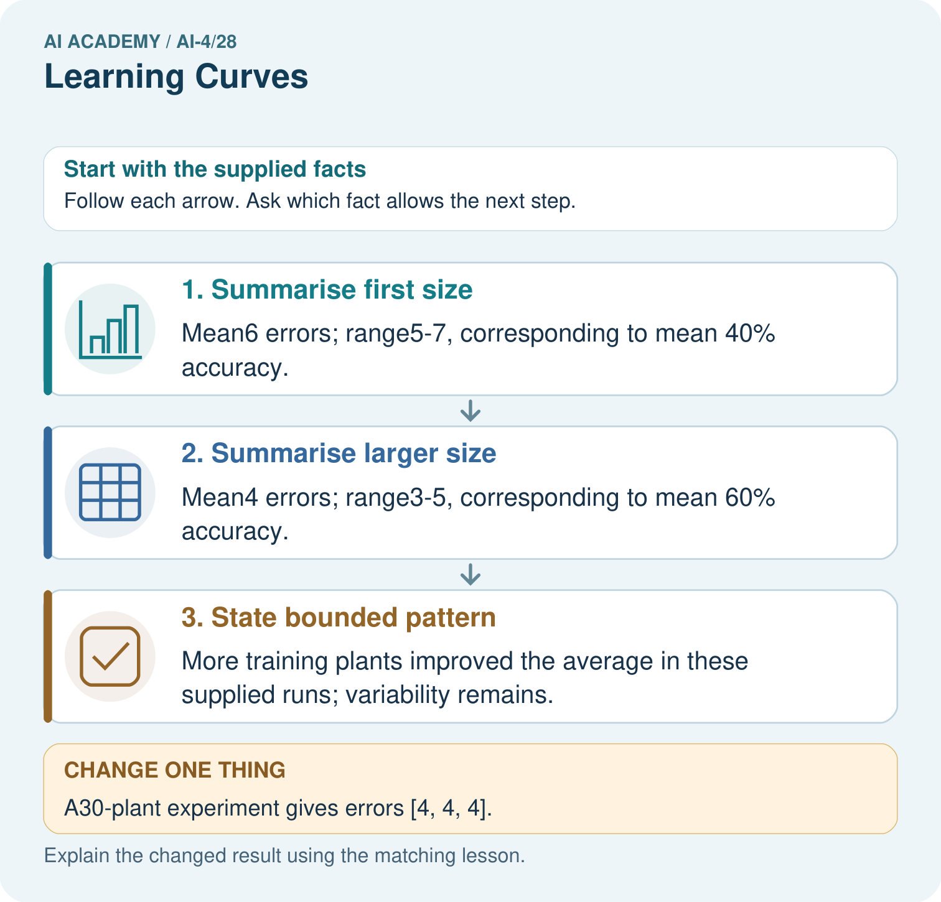
What comparison is valid if the validation set changes between sizes? Point to the relevant step in the picture, then write the changed result and the rule or evidence that supports it.

My picture-based explanation and changed-case prediction
________________________________________________________________
________________________________________________________________
________________________________________________________________
________________________________________________________________
________________________________________________________________
________________________________________________________________
Support used: alone / hint / worked example. This record is practice evidence.
Project connection: For your Responsible Plant Classifier, save the input, procedure, observed result and limitation of this check. Label this worked example as practice; use a different, previously unreviewed case when checking independent understanding.

