AI ACADEMY · WORKBOOK · ai-4/29

Feature Engineering
Project: Responsible Plant Classifier

01. Recall and choose your starting point
Try the recall before opening notes. Then use a different colour or a labelled second line to correct your explanation.

Learning Curves
Without opening the old lesson, explain one key idea from Learning Curves. Give an example and a mistake that the idea helps you avoid.

My remembered idea, example and correction
________________________________________________________________
________________________________________________________________
________________________________________________________________

Reproducible Experiments
Without opening the old lesson, explain one key idea from Reproducible Experiments. Give an example and a mistake that the idea helps you avoid.

My remembered idea, example and correction
________________________________________________________________
________________________________________________________________
________________________________________________________________

Hold Out Test Data
Without opening the old lesson, explain one key idea from Hold Out Test Data. Give an example and a mistake that the idea helps you avoid.

My remembered idea, example and correction
________________________________________________________________
________________________________________________________________
________________________________________________________________

02. Practise with fading help
Use W2: Transform validation for Feature engineering. Record the answer once; the lesson and workbook refer to the same attempt.
Given inputs | Procedure I chose | Middle steps | Result and check

The step I completed without help, and the hint I needed
________________________________________________________________
________________________________________________________________
________________________________________________________________

03. Individual reasoning check
Use the worked case for Feature engineering. Proposed explanation: “A final answer is enough”. Decide whether this explanation is supported. Point to the step or supplied fact that decides; explain your repair if needed.

My explanation before partner discussion
________________________________________________________________
________________________________________________________________
________________________________________________________________
________________________________________________________________

04. Independent transfer case

Independent case: Apply independently
Training areas [4, 8, 12]. A new rectangle has length 3 width 4. Compute the training mean and centered new feature; state units.

My independent explanation, trace and limits
________________________________________________________________
________________________________________________________________
________________________________________________________________
________________________________________________________________
________________________________________________________________
________________________________________________________________
________________________________________________________________
Attempt this case before feedback. Record any help. Earlier examples below are further practice; a case already practised with feedback cannot establish fresh transfer.

05. Your learning target
Length=12 cm, width=30 mm. Compute length/width using matching units. Explain handling for zero or missing width and where learned scaling is fitted.

06. Solve the given case
Features are leaf length and width in cm; add length/width.
Compute for8 and2; state boundary checks.
Show your trace, calculation or evidence

Write or draw your reasoning and evidence.
________________________________________________________________
________________________________________________________________
________________________________________________________________
________________________________________________________________
________________________________________________________________

07. Check a changed case
A feature is leaf_length divided by leaf_width. A row has width zero. What should the preprocessing rule do before division?
My independent answer and reason

Write or draw your reasoning and evidence.
________________________________________________________________
________________________________________________________________
________________________________________________________________
________________________________________________________________
________________________________________________________________

Week 29 Test and reflect

08. Design a revealing test
Create a changed input, boundary case or missing-information case. Write the expected answer or safe response before testing.
Test record | My evidence
Changed input or condition
Expected answer or fallback
Observed result
Why the result occurred

09. Project checkpoint
Add only justified Plant Classifier features, with formula, source fields, expected benefit, and leakage test.
The project change and evidence I will keep

Write or draw your reasoning and evidence.
________________________________________________________________
________________________________________________________________
________________________________________________________________
________________________________________________________________
________________________________________________________________

10. Self check
I can explain the mechanism. I can show evidence. I can handle a changed case. I can name a limit. Mark each as not yet, with help or independently, and attach supporting work.
Teacher review ____________________ Next step ____________________

11. Transfer practice from the original programme
Length=12 cm, width=30 mm. Compute length/width using matching units. Explain handling for zero or missing width and where learned scaling is fitted.

My independently reasoned answer
________________________________________________________________
________________________________________________________________
________________________________________________________________
________________________________________________________________
________________________________________________________________
________________________________________________________________
________________________________________________________________
Record support used: none, hint or teacher explanation.

12. W1 Compute features
Compute the worked areas and their training mean.

My reasoning and evidence
________________________________________________________________
________________________________________________________________
________________________________________________________________
________________________________________________________________
________________________________________________________________
________________________________________________________________

13. W2 Transform validation
Center the validation area using the frozen training mean.

My reasoning and evidence
________________________________________________________________
________________________________________________________________
________________________________________________________________
________________________________________________________________
________________________________________________________________
________________________________________________________________

14. W3 Reject leakage
Why is delivery delay invalid for a prediction made before dispatch?

My reasoning and evidence
________________________________________________________________
________________________________________________________________
________________________________________________________________
________________________________________________________________
________________________________________________________________
________________________________________________________________

15. W4 Apply independently
Training areas [4, 8, 12]. A new rectangle has length 3 width 4. Compute the training mean and centered new feature; state units.

My reasoning and evidence
________________________________________________________________
________________________________________________________________
________________________________________________________________
________________________________________________________________
________________________________________________________________
________________________________________________________________
________________________________________________________________
________________________________________________________________

16. W5 Plan a fair comparison
How would you test adding area without claiming it must help?

My reasoning and evidence
________________________________________________________________
________________________________________________________________
________________________________________________________________
________________________________________________________________
________________________________________________________________
________________________________________________________________

17. Relationships and confounding — W1 Describe the evidence
State the pattern in the three worked records without using caused or guaranteed.

My reasoning and evidence
________________________________________________________________
________________________________________________________________
________________________________________________________________
________________________________________________________________
________________________________________________________________
________________________________________________________________

18. Relationships and confounding — W2 Identify a confounder
Explain how prior experience could relate to both practice time and score.

My reasoning and evidence
________________________________________________________________
________________________________________________________________
________________________________________________________________
________________________________________________________________
________________________________________________________________
________________________________________________________________

19. Relationships and confounding — W3 Repair an overclaim
A learner predicts every student gains 2 points per extra hour. Explain why that is unsupported.

My reasoning and evidence
________________________________________________________________
________________________________________________________________
________________________________________________________________
________________________________________________________________
________________________________________________________________
________________________________________________________________

20. Relationships and confounding — W4 Plan independently
A fictional dataset links more hints used with lower scores. Give a noncausal explanation and plan a fairer comparison of whether hints help.

My reasoning and evidence
________________________________________________________________
________________________________________________________________
________________________________________________________________
________________________________________________________________
________________________________________________________________
________________________________________________________________
________________________________________________________________
________________________________________________________________

21. Relationships and confounding — W5 State a remaining limit
Even a better comparison has only four fictional groups. What should be reported?

My reasoning and evidence
________________________________________________________________
________________________________________________________________
________________________________________________________________
________________________________________________________________
________________________________________________________________
________________________________________________________________

22. Feedback, return check and learning record
Evidence | My record
Worked alone / hint / model
First step I repaired and why
New case checked later; date and result
What I can now explain without notes
One remaining question
Revisit this idea with your teacher after a delay. Familiarity is different from explaining and using it on a changed case.

23. Pictorial case practice: Feature Engineering
Engineer a feature with a transformation defined before evaluating a new leaf.
Training rectangular leaf cards have areas [2, 6, 10] cm². Area=length×width; center by training mean. Query length 2, width 4 cm.
All inputs and outcomes in this worked example are invented classroom data; no real model run is claimed.
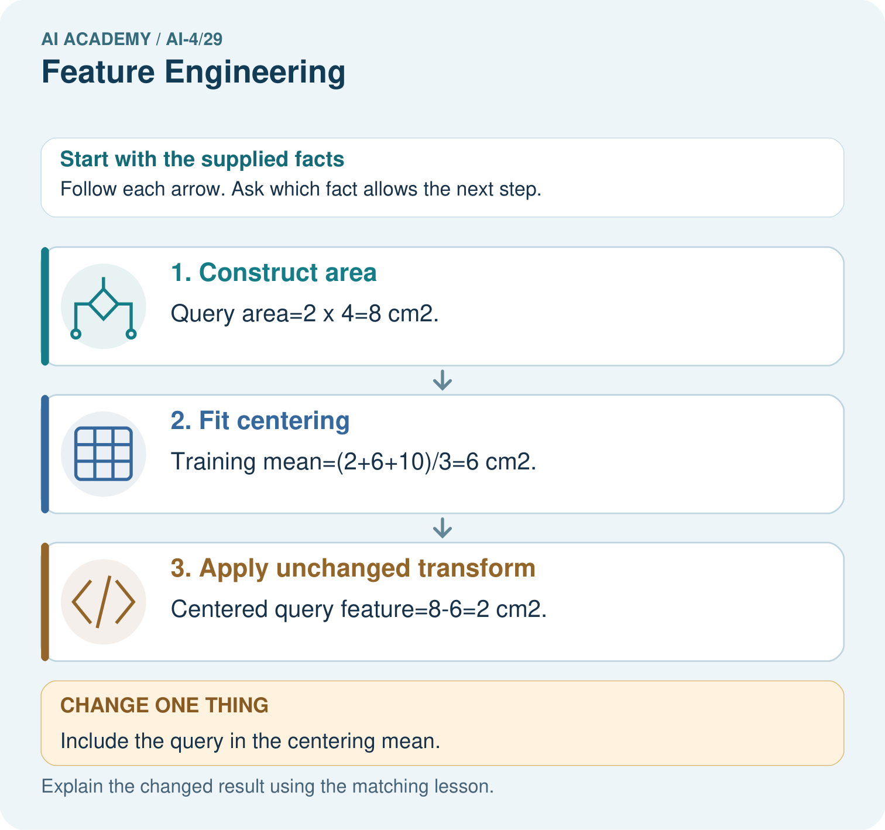
What should be saved so another group transforms the query identically? Point to the relevant step in the picture, then write the changed result and the rule or evidence that supports it.

My picture-based explanation and changed-case prediction
________________________________________________________________
________________________________________________________________
________________________________________________________________
________________________________________________________________
________________________________________________________________
________________________________________________________________
Support used: alone / hint / worked example. This record is practice evidence.
Project connection: For your Responsible Plant Classifier, save the input, procedure, observed result and limitation of this check. Label this worked example as practice; use a different, previously unreviewed case when checking independent understanding.

