AI ACADEMY · WORKBOOK · ai-4/30

Improve Generalization
Project: Responsible Plant Classifier

01. Recall and choose your starting point
Try the recall before opening notes. Then use a different colour or a labelled second line to correct your explanation.

Feature Engineering
Without opening the old lesson, explain one key idea from Feature Engineering. Give an example and a mistake that the idea helps you avoid.

My remembered idea, example and correction
________________________________________________________________
________________________________________________________________
________________________________________________________________

Overfitting
Without opening the old lesson, explain one key idea from Overfitting. Give an example and a mistake that the idea helps you avoid.

My remembered idea, example and correction
________________________________________________________________
________________________________________________________________
________________________________________________________________

Train, Validation, Test
Without opening the old lesson, explain one key idea from Train, Validation, Test. Give an example and a mistake that the idea helps you avoid.

My remembered idea, example and correction
________________________________________________________________
________________________________________________________________
________________________________________________________________

02. Practise with fading help
Use W2: Interpret a gap for Overfitting and model capacity. Record the answer once; the lesson and workbook refer to the same attempt.
Given inputs | Procedure I chose | Middle steps | Result and check

The step I completed without help, and the hint I needed
________________________________________________________________
________________________________________________________________
________________________________________________________________

03. Individual reasoning check
Use the worked case for Overfitting and model capacity. Proposed explanation: “A final answer is enough”. Decide whether this explanation is supported. Point to the step or supplied fact that decides; explain your repair if needed.

My explanation before partner discussion
________________________________________________________________
________________________________________________________________
________________________________________________________________
________________________________________________________________

04. Independent transfer case

Independent case: Changed independent case
Spotted leaves have blue backgrounds and healthy leaves white backgrounds in training. Design a generalisation investigation with fresh evaluation.

My independent explanation, trace and limits
________________________________________________________________
________________________________________________________________
________________________________________________________________
________________________________________________________________
________________________________________________________________
________________________________________________________________
________________________________________________________________
Attempt this case before feedback. Record any help. Earlier examples below are further practice; a case already practised with feedback cannot establish fresh transfer.

05. Your learning target
All spotted training leaves use black backgrounds. Propose a collection and comparison that tests the background shortcut without tuning on final test examples.

06. Solve the given case
A classifier relies on tray colour; new trays reduce performance.
Propose controlled improvement.
Show your trace, calculation or evidence

Write or draw your reasoning and evidence.
________________________________________________________________
________________________________________________________________
________________________________________________________________
________________________________________________________________
________________________________________________________________

07. Check a changed case
A team proposes more representative training examples and a simpler model. How should it compare changes while protecting the final test?
My independent answer and reason

Write or draw your reasoning and evidence.
________________________________________________________________
________________________________________________________________
________________________________________________________________
________________________________________________________________
________________________________________________________________

Week 30 Test and reflect

08. Design a revealing test
Create a changed input, boundary case or missing-information case. Write the expected answer or safe response before testing.
Test record | My evidence
Changed input or condition
Expected answer or fallback
Observed result
Why the result occurred

09. Project checkpoint
Improve Plant Classifier with one approved change and a full before/after evidence table.
The project change and evidence I will keep

Write or draw your reasoning and evidence.
________________________________________________________________
________________________________________________________________
________________________________________________________________
________________________________________________________________
________________________________________________________________

10. Self check
I can explain the mechanism. I can show evidence. I can handle a changed case. I can name a limit. Mark each as not yet, with help or independently, and attach supporting work.
Teacher review ____________________ Next step ____________________

11. Transfer practice from the original programme
All spotted training leaves use black backgrounds. Propose a collection and comparison that tests the background shortcut without tuning on final test examples.

My independently reasoned answer
________________________________________________________________
________________________________________________________________
________________________________________________________________
________________________________________________________________
________________________________________________________________
________________________________________________________________
________________________________________________________________
Record support used: none, hint or teacher explanation.

12. W1 Select from evidence
Choose among the three worked candidates and explain the training trap.

My reasoning and evidence
________________________________________________________________
________________________________________________________________
________________________________________________________________
________________________________________________________________
________________________________________________________________
________________________________________________________________

13. W2 Interpret a gap
Does a training-validation gap alone prove overfitting?

My reasoning and evidence
________________________________________________________________
________________________________________________________________
________________________________________________________________
________________________________________________________________
________________________________________________________________
________________________________________________________________

14. W3 Propose a controlled change
Describe one fair next development comparison.

My reasoning and evidence
________________________________________________________________
________________________________________________________________
________________________________________________________________
________________________________________________________________
________________________________________________________________
________________________________________________________________

15. W4 Apply independently
Models A training 4 validation 5, B training 1 validation 2, C training 0 validation 2. Lowest validation MAE then simpler; B is simpler than C. Choose and justify.

My reasoning and evidence
________________________________________________________________
________________________________________________________________
________________________________________________________________
________________________________________________________________
________________________________________________________________
________________________________________________________________
________________________________________________________________
________________________________________________________________

16. W5 Limit a diagnosis
What extra evidence would you inspect before concluding a model memorized noise?

My reasoning and evidence
________________________________________________________________
________________________________________________________________
________________________________________________________________
________________________________________________________________
________________________________________________________________
________________________________________________________________

17. Distribution shift — W1 Compare conditions
Calculate each worked error rate and the difference.

My reasoning and evidence
________________________________________________________________
________________________________________________________________
________________________________________________________________
________________________________________________________________
________________________________________________________________
________________________________________________________________

18. Distribution shift — W2 Read pooled evidence
Why is 8/40 incomplete by itself?

My reasoning and evidence
________________________________________________________________
________________________________________________________________
________________________________________________________________
________________________________________________________________
________________________________________________________________
________________________________________________________________

19. Distribution shift — W3 Wait for labels
Can changed predictions alone prove an accuracy drop?

My reasoning and evidence
________________________________________________________________
________________________________________________________________
________________________________________________________________
________________________________________________________________
________________________________________________________________
________________________________________________________________

20. Distribution shift — W4 Apply independently
Old-like data has 3 errors/30 and new-condition data 5/10. Give both rates and the pooled rate.

My reasoning and evidence
________________________________________________________________
________________________________________________________________
________________________________________________________________
________________________________________________________________
________________________________________________________________
________________________________________________________________
________________________________________________________________
________________________________________________________________

21. Distribution shift — W5 Plan a response
State a safe classroom response to inputs outside the supported range.

My reasoning and evidence
________________________________________________________________
________________________________________________________________
________________________________________________________________
________________________________________________________________
________________________________________________________________
________________________________________________________________

22. Feedback, return check and learning record
Evidence | My record
Worked alone / hint / model
First step I repaired and why
New case checked later; date and result
What I can now explain without notes
One remaining question
Revisit this idea with your teacher after a delay. Familiarity is different from explaining and using it on a changed case.

23. Pictorial case practice: Improve Generalization
Test whether a plant model follows the leaf or a convenient background shortcut.
Toy training photos show spotted leaves on red cards and healthy leaves on grey cards. Intended use allows both backgrounds for either class.
All inputs and outcomes in this worked example are invented classroom data; no real model run is claimed.
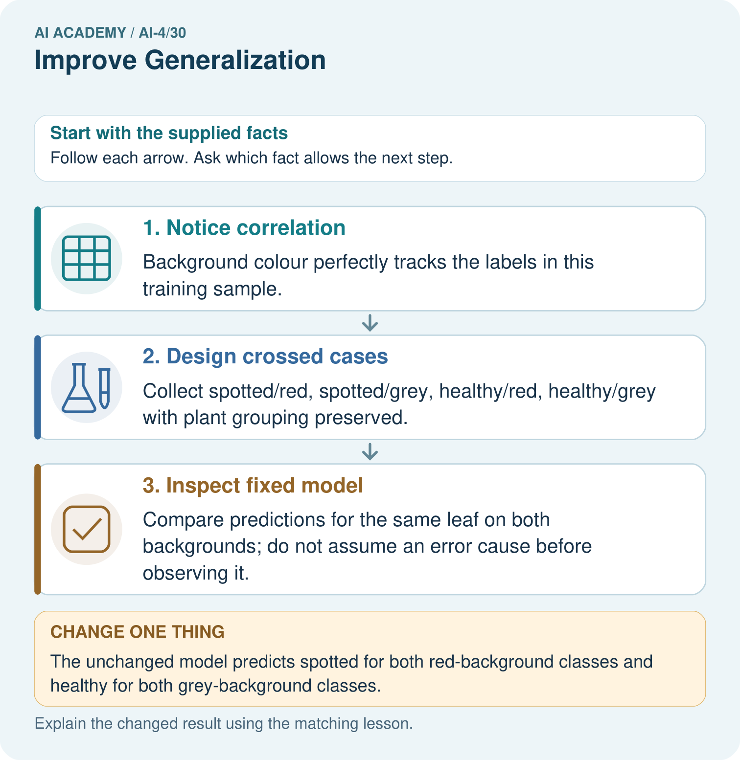
What fresh evidence is needed after adding crossed training data? Point to the relevant step in the picture, then write the changed result and the rule or evidence that supports it.

My picture-based explanation and changed-case prediction
________________________________________________________________
________________________________________________________________
________________________________________________________________
________________________________________________________________
________________________________________________________________
________________________________________________________________
Support used: alone / hint / worked example. This record is practice evidence.
Project connection: For your Responsible Plant Classifier, save the input, procedure, observed result and limitation of this check. Label this worked example as practice; use a different, previously unreviewed case when checking independent understanding.

