AI ACADEMY · WORKBOOK · ai-4/31

Subgroup Performance
Project: Responsible Plant Classifier

01. Recall and choose your starting point
Try the recall before opening notes. Then use a different colour or a labelled second line to correct your explanation.

Improve Generalization
Without opening the old lesson, explain one key idea from Improve Generalization. Give an example and a mistake that the idea helps you avoid.

My remembered idea, example and correction
________________________________________________________________
________________________________________________________________
________________________________________________________________

Learning Curves
Without opening the old lesson, explain one key idea from Learning Curves. Give an example and a mistake that the idea helps you avoid.

My remembered idea, example and correction
________________________________________________________________
________________________________________________________________
________________________________________________________________

Metrics Match Consequences
Without opening the old lesson, explain one key idea from Metrics Match Consequences. Give an example and a mistake that the idea helps you avoid.

My remembered idea, example and correction
________________________________________________________________
________________________________________________________________
________________________________________________________________

02. Practise with fading help
Use W2: Check sensitivity for Subgroup evaluation. Record the answer once; the lesson and workbook refer to the same attempt.
Given inputs | Procedure I chose | Middle steps | Result and check

The step I completed without help, and the hint I needed
________________________________________________________________
________________________________________________________________
________________________________________________________________

03. Individual reasoning check
Use the worked case for Subgroup evaluation. Proposed explanation: “A final answer is enough”. Decide whether this explanation is supported. Point to the step or supplied fact that decides; explain your repair if needed.

My explanation before partner discussion
________________________________________________________________
________________________________________________________________
________________________________________________________________
________________________________________________________________

04. Independent transfer case

Independent case: Apply independently
Groups X 1 error/10 and Y 2/4: calculate separate and pooled rates, then state one limit.

My independent explanation, trace and limits
________________________________________________________________
________________________________________________________________
________________________________________________________________
________________________________________________________________
________________________________________________________________
________________________________________________________________
________________________________________________________________
Attempt this case before feedback. Record any help. Earlier examples below are further practice; a case already practised with feedback cannot establish fresh transfer.

05. Your learning target
Device A gets 18/20 correct; B gets 6/10. Compute overall accuracy and the subgroup gap. What causal claim is not supported?

06. Solve the given case
A has18/20 correct; B has6/10.
Compute subgroup results and evidence limits.
Show your trace, calculation or evidence

Write or draw your reasoning and evidence.
________________________________________________________________
________________________________________________________________
________________________________________________________________
________________________________________________________________
________________________________________________________________

07. Check a changed case
Accuracy is 18/20 in bright light and 6/10 in dim light. Compute both rates and the percentage-point gap.
My independent answer and reason

Write or draw your reasoning and evidence.
________________________________________________________________
________________________________________________________________
________________________________________________________________
________________________________________________________________
________________________________________________________________

Week 31 Test and reflect

08. Design a revealing test
Create a changed input, boundary case or missing-information case. Write the expected answer or safe response before testing.
Test record | My evidence
Changed input or condition
Expected answer or fallback
Observed result
Why the result occurred

09. Project checkpoint
Add subgroup tables and a minimum acceptable threshold to the Plant Classifier release criteria.
The project change and evidence I will keep

Write or draw your reasoning and evidence.
________________________________________________________________
________________________________________________________________
________________________________________________________________
________________________________________________________________
________________________________________________________________

10. Self check
I can explain the mechanism. I can show evidence. I can handle a changed case. I can name a limit. Mark each as not yet, with help or independently, and attach supporting work.
Teacher review ____________________ Next step ____________________

11. Transfer practice from the original programme
Device A gets 18/20 correct; B gets 6/10. Compute overall accuracy and the subgroup gap. What causal claim is not supported?

My independently reasoned answer
________________________________________________________________
________________________________________________________________
________________________________________________________________
________________________________________________________________
________________________________________________________________
________________________________________________________________
________________________________________________________________
Record support used: none, hint or teacher explanation.

12. W1 Calculate group rates
Calculate the worked group and pooled rates.

My reasoning and evidence
________________________________________________________________
________________________________________________________________
________________________________________________________________
________________________________________________________________
________________________________________________________________
________________________________________________________________

13. W2 Check sensitivity
How does correcting one B error affect its rate?

My reasoning and evidence
________________________________________________________________
________________________________________________________________
________________________________________________________________
________________________________________________________________
________________________________________________________________
________________________________________________________________

14. W3 Report missing coverage
Group C has no evaluated cases. What is its measured error rate?

My reasoning and evidence
________________________________________________________________
________________________________________________________________
________________________________________________________________
________________________________________________________________
________________________________________________________________
________________________________________________________________

15. W4 Apply independently
Groups X 1 error/10 and Y 2/4: calculate separate and pooled rates, then state one limit.

My reasoning and evidence
________________________________________________________________
________________________________________________________________
________________________________________________________________
________________________________________________________________
________________________________________________________________
________________________________________________________________
________________________________________________________________
________________________________________________________________

16. W5 Avoid a fairness shortcut
Why does equal accuracy not settle whether use is fair?

My reasoning and evidence
________________________________________________________________
________________________________________________________________
________________________________________________________________
________________________________________________________________
________________________________________________________________
________________________________________________________________

17. Feedback, return check and learning record
Evidence | My record
Worked alone / hint / model
First step I repaired and why
New case checked later; date and result
What I can now explain without notes
One remaining question
Revisit this idea with your teacher after a delay. Familiarity is different from explaining and using it on a changed case.

18. Pictorial case practice: Subgroup Performance
Calculate subgroup and pooled error rates without letting the larger group hide a gap.
Group Sun: 2 errors in20 photos; Shade: 3 errors in5. Same error definition; related plant views are documented.
All inputs and outcomes in this worked example are invented classroom data; no real model run is claimed.
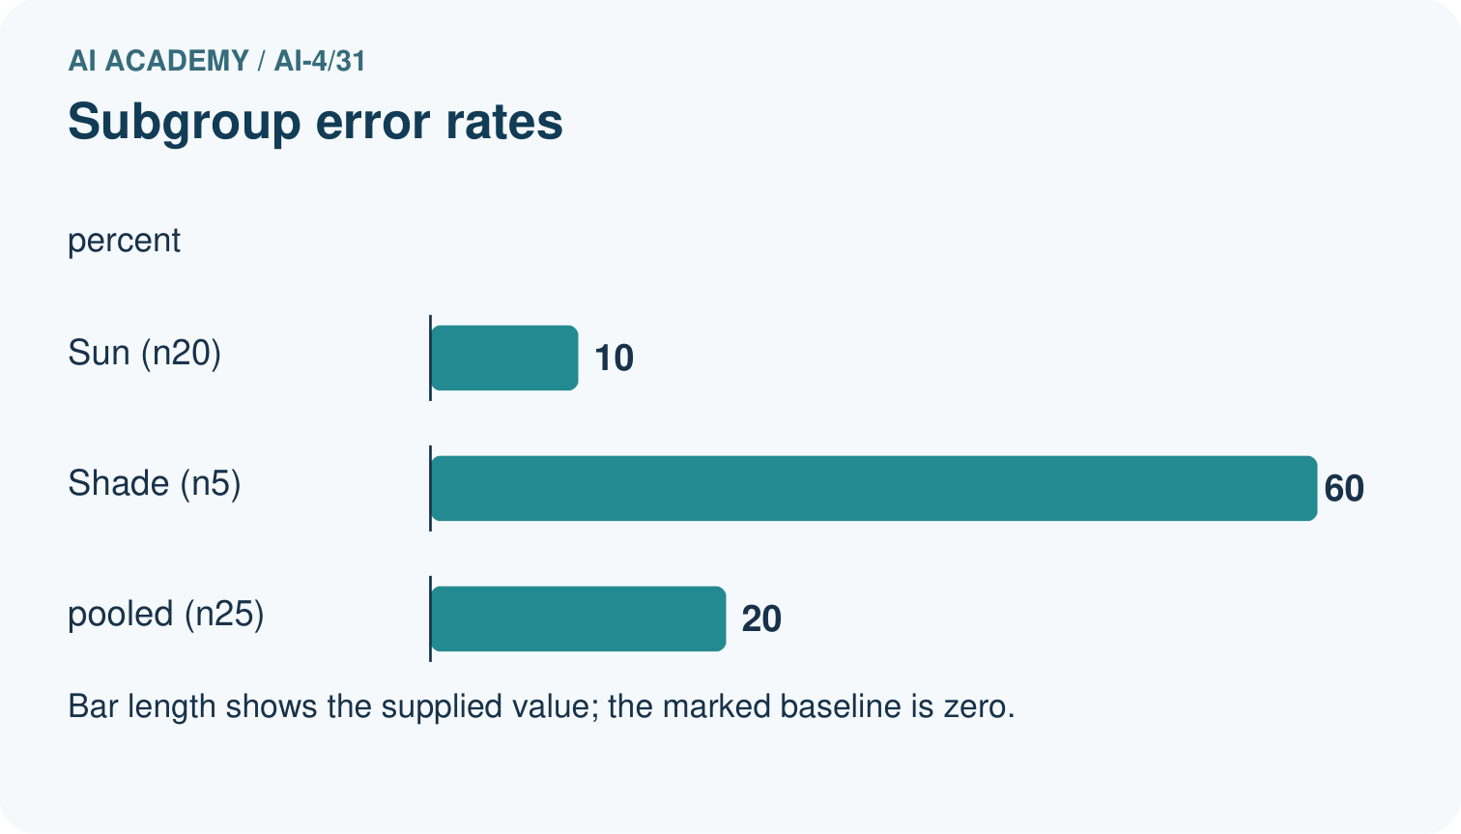
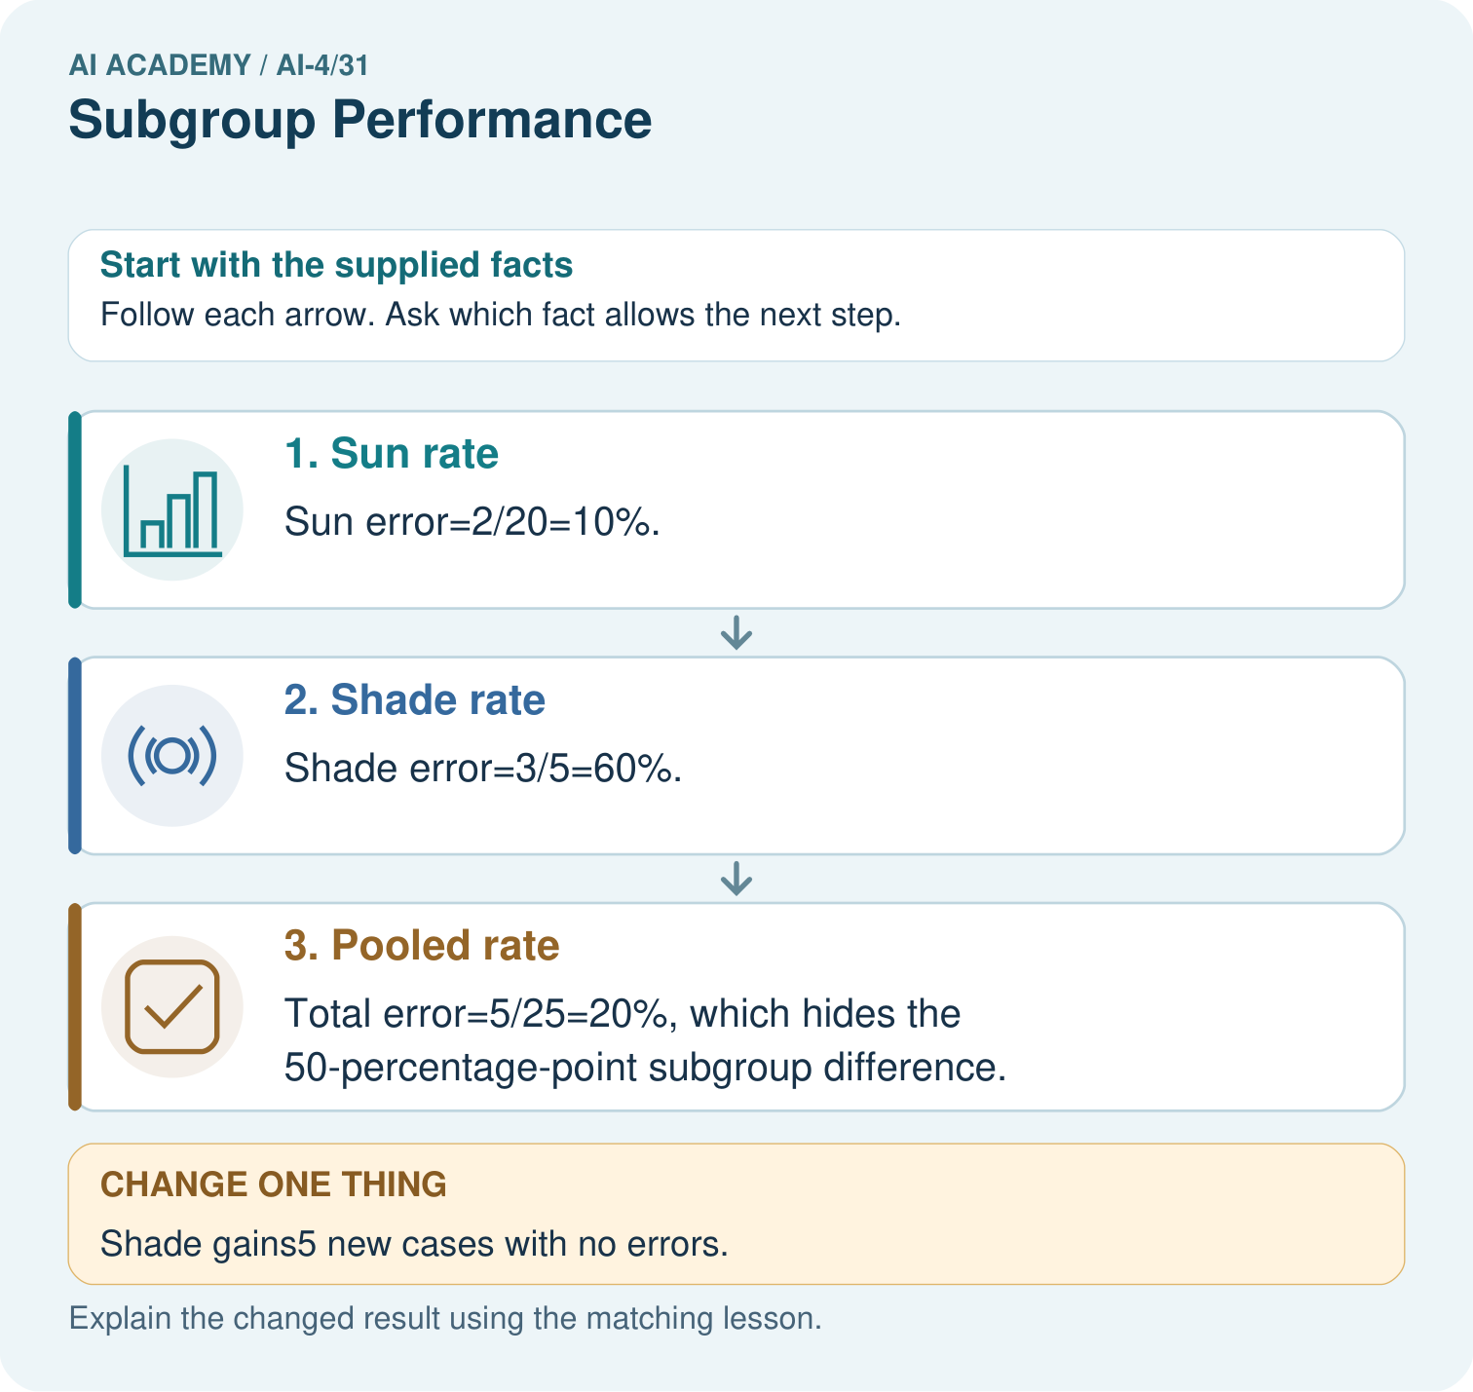
Why should the report retain subgroup rates alongside the total? Point to the relevant step in the picture, then write the changed result and the rule or evidence that supports it.

My picture-based explanation and changed-case prediction
________________________________________________________________
________________________________________________________________
________________________________________________________________
________________________________________________________________
________________________________________________________________
________________________________________________________________
Support used: alone / hint / worked example. This record is practice evidence.
Project connection: For your Responsible Plant Classifier, save the input, procedure, observed result and limitation of this check. Label this worked example as practice; use a different, previously unreviewed case when checking independent understanding.

