AI ACADEMY · WORKBOOK · ai-4/35

Capstone Train, Analyze, Improve
Project: Responsible Plant Classifier

01. Recall and choose your starting point
Try the recall before opening notes. Then use a different colour or a labelled second line to correct your explanation.

Capstone Dataset and Baseline
Without opening the old lesson, explain one key idea from Capstone Dataset and Baseline. Give an example and a mistake that the idea helps you avoid.

My remembered idea, example and correction
________________________________________________________________
________________________________________________________________
________________________________________________________________

Proxy Features and Fairness
Without opening the old lesson, explain one key idea from Proxy Features and Fairness. Give an example and a mistake that the idea helps you avoid.

My remembered idea, example and correction
________________________________________________________________
________________________________________________________________
________________________________________________________________

Feature Engineering
Without opening the old lesson, explain one key idea from Feature Engineering. Give an example and a mistake that the idea helps you avoid.

My remembered idea, example and correction
________________________________________________________________
________________________________________________________________
________________________________________________________________

02. Practise with fading help
Use W2: Audit a difference for Capstone evaluation and revision. Record the answer once; the lesson and workbook refer to the same attempt.
Given inputs | Procedure I chose | Middle steps | Result and check

The step I completed without help, and the hint I needed
________________________________________________________________
________________________________________________________________
________________________________________________________________

03. Individual reasoning check
Use the worked case for Capstone evaluation and revision. Proposed explanation: “A final answer is enough”. Decide whether this explanation is supported. Point to the step or supplied fact that decides; explain your repair if needed.

My explanation before partner discussion
________________________________________________________________
________________________________________________________________
________________________________________________________________
________________________________________________________________

04. Independent transfer case

Independent case: Apply independently
Frozen candidate[[6, 2],[1, 3]] and baseline[[8, 0],[4, 0]] on 12 cases. Compute candidate metrics and compare error types.

My independent explanation, trace and limits
________________________________________________________________
________________________________________________________________
________________________________________________________________
________________________________________________________________
________________________________________________________________
________________________________________________________________
________________________________________________________________
Attempt this case before feedback. Record any help. Earlier examples below are further practice; a case already practised with feedback cannot establish fresh transfer.

05. Your learning target
A new model reduces validation errors from 8 to 5 but the team also removed three hard cases. Can improvement be attributed to the model? Propose a repair to the experiment.

06. Solve the given case
Baseline validation accuracy70%; model80%; most remaining errors are dim images.
Plan improvement evidence.
Show your trace, calculation or evidence

Write or draw your reasoning and evidence.
________________________________________________________________
________________________________________________________________
________________________________________________________________
________________________________________________________________
________________________________________________________________

07. Check a changed case
A revision raises overall validation accuracy from 80% to 84% but lowers dim-light accuracy from 60% to 40%. How should the improvement claim change?
My independent answer and reason

Write or draw your reasoning and evidence.
________________________________________________________________
________________________________________________________________
________________________________________________________________
________________________________________________________________
________________________________________________________________

Week 35 Test and reflect

08. Design a revealing test
Create a changed input, boundary case or missing-information case. Write the expected answer or safe response before testing.
Test record | My evidence
Changed input or condition
Expected answer or fallback
Observed result
Why the result occurred

09. Project checkpoint
Finalize the Plant Classifier experiment record, confusion matrix, subgroup table, model card, and honest remaining-limit statement.
The project change and evidence I will keep

Write or draw your reasoning and evidence.
________________________________________________________________
________________________________________________________________
________________________________________________________________
________________________________________________________________
________________________________________________________________

10. Self check
I can explain the mechanism. I can show evidence. I can handle a changed case. I can name a limit. Mark each as not yet, with help or independently, and attach supporting work.
Teacher review ____________________ Next step ____________________

11. Transfer practice from the original programme
A new model reduces validation errors from 8 to 5 but the team also removed three hard cases. Can improvement be attributed to the model? Propose a repair to the experiment.

My independently reasoned answer
________________________________________________________________
________________________________________________________________
________________________________________________________________
________________________________________________________________
________________________________________________________________
________________________________________________________________
________________________________________________________________
Record support used: none, hint or teacher explanation.

12. W1 Score the frozen test
Compute the worked candidate metrics and baseline accuracy.

My reasoning and evidence
________________________________________________________________
________________________________________________________________
________________________________________________________________
________________________________________________________________
________________________________________________________________
________________________________________________________________

13. W2 Audit a difference
What does the one-correct-case improvement establish?

My reasoning and evidence
________________________________________________________________
________________________________________________________________
________________________________________________________________
________________________________________________________________
________________________________________________________________
________________________________________________________________

14. W3 Label a revision
A threshold changes after test errors are read. Label its score on the same rows.

My reasoning and evidence
________________________________________________________________
________________________________________________________________
________________________________________________________________
________________________________________________________________
________________________________________________________________
________________________________________________________________

15. W4 Apply independently
Frozen candidate[[6, 2],[1, 3]] and baseline[[8, 0],[4, 0]] on 12 cases. Compute candidate metrics and compare error types.

My reasoning and evidence
________________________________________________________________
________________________________________________________________
________________________________________________________________
________________________________________________________________
________________________________________________________________
________________________________________________________________
________________________________________________________________
________________________________________________________________

16. W5 Update the card
What must remain visible when version 2 is proposed without a fresh test?

My reasoning and evidence
________________________________________________________________
________________________________________________________________
________________________________________________________________
________________________________________________________________
________________________________________________________________
________________________________________________________________

17. Feedback, return check and learning record
Evidence | My record
Worked alone / hint / model
First step I repaired and why
New case checked later; date and result
What I can now explain without notes
One remaining question
Revisit this idea with your teacher after a delay. Familiarity is different from explaining and using it on a changed case.

18. Pictorial case practice: Capstone Train, Analyze, Improve
Choose the next capstone revision from explicit false alarms and misses.
Positive=spotted. CandidateTP4, FN 2, FP 1, TN 9; baselineTP0, FN 6, FP 0, TN 10. Both evaluate the same16 cases.
All inputs and outcomes in this worked example are invented classroom data; no real model run is claimed.
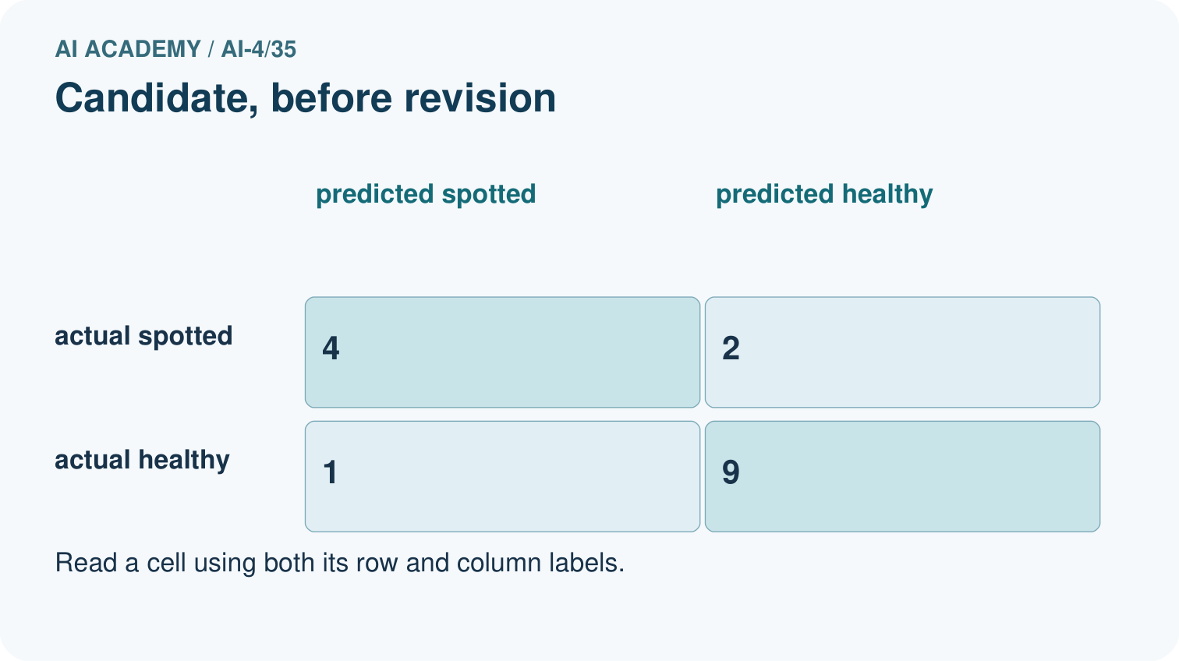
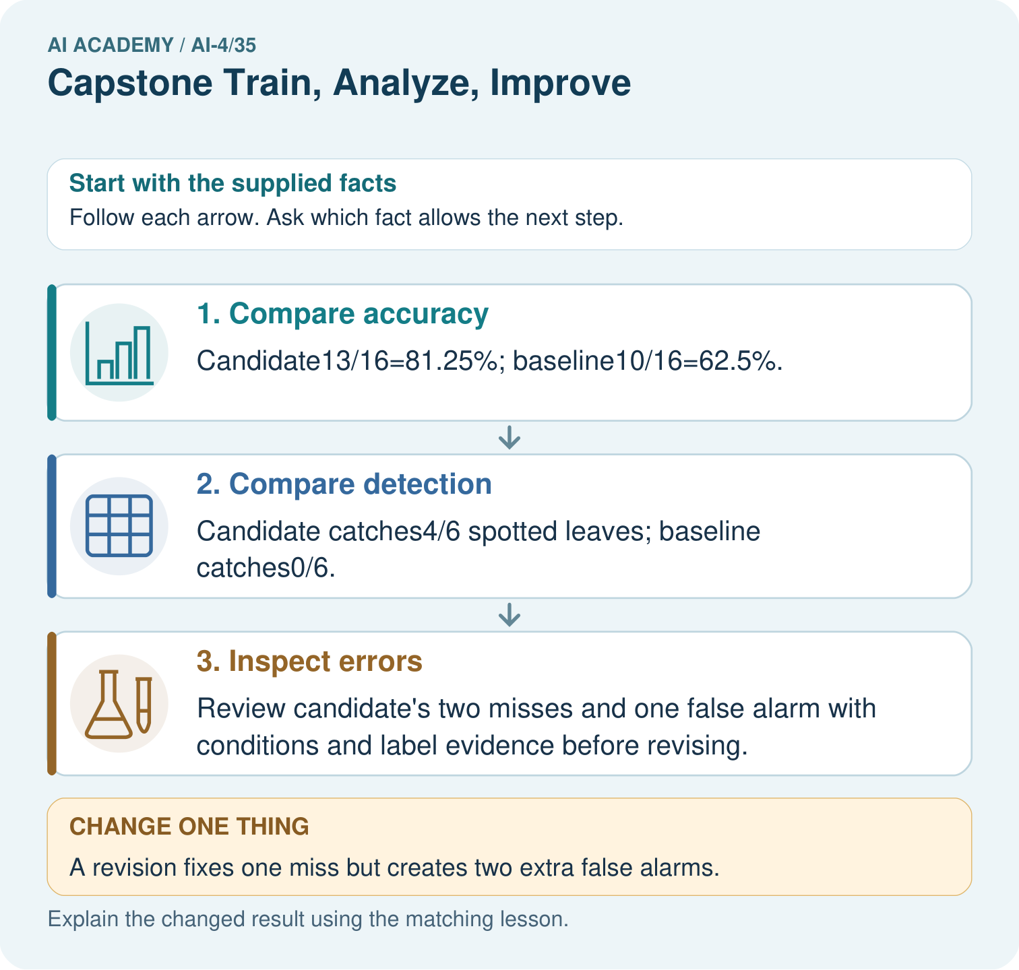
Why is “the revision is better” incomplete? Point to the relevant step in the picture, then write the changed result and the rule or evidence that supports it.

My picture-based explanation and changed-case prediction
________________________________________________________________
________________________________________________________________
________________________________________________________________
________________________________________________________________
________________________________________________________________
________________________________________________________________
Support used: alone / hint / worked example. This record is practice evidence.
Project connection: For your Responsible Plant Classifier, save the input, procedure, observed result and limitation of this check. Label this worked example as practice; use a different, previously unreviewed case when checking independent understanding.

