AI ACADEMY · WORKBOOK · ai-4/36

ML Builder Expo
Project: Responsible Plant Classifier

01. Recall and choose your starting point
Try the recall before opening notes. Then use a different colour or a labelled second line to correct your explanation.

Capstone Train, Analyze, Improve
Without opening the old lesson, explain one key idea from Capstone Train, Analyze, Improve. Give an example and a mistake that the idea helps you avoid.

My remembered idea, example and correction
________________________________________________________________
________________________________________________________________
________________________________________________________________

Model Cards and Human Review
Without opening the old lesson, explain one key idea from Model Cards and Human Review. Give an example and a mistake that the idea helps you avoid.

My remembered idea, example and correction
________________________________________________________________
________________________________________________________________
________________________________________________________________

Improve Generalization
Without opening the old lesson, explain one key idea from Improve Generalization. Give an example and a mistake that the idea helps you avoid.

My remembered idea, example and correction
________________________________________________________________
________________________________________________________________
________________________________________________________________

02. Practise with fading help
Use W2: Trace evidence for Machine learning project defense. Record the answer once; the lesson and workbook refer to the same attempt.
Given inputs | Procedure I chose | Middle steps | Result and check

The step I completed without help, and the hint I needed
________________________________________________________________
________________________________________________________________
________________________________________________________________

03. Individual reasoning check
Use the worked case for Machine learning project defense. Proposed explanation: “A final answer is enough”. Decide whether this explanation is supported. Point to the step or supplied fact that decides; explain your repair if needed.

My explanation before partner discussion
________________________________________________________________
________________________________________________________________
________________________________________________________________
________________________________________________________________

04. Independent transfer case

Independent case: Apply independently
Review a defense claiming 95 percent success on 20 cases but omitting the baseline, split history and errors. Give three revision requests and explain why polish is insufficient.

My independent explanation, trace and limits
________________________________________________________________
________________________________________________________________
________________________________________________________________
________________________________________________________________
________________________________________________________________
________________________________________________________________
________________________________________________________________
Attempt this case before feedback. Record any help. Earlier examples below are further practice; a case already practised with feedback cannot establish fresh transfer.

05. Your learning target
Final counts are TP=12,FN=3,FP=5,TN=20. Compute accuracy, precision and recall, then state one limitation and a review trigger for the model defense.

06. Solve the given case
Final classifier gets16/20 correct; two of four errors are false negatives.
Report supported metrics and what is missing.
Show your trace, calculation or evidence

Write or draw your reasoning and evidence.
________________________________________________________________
________________________________________________________________
________________________________________________________________
________________________________________________________________
________________________________________________________________

07. Check a changed case
Your expo model succeeds on three demonstration plants. What evidence should accompany the demo and what limitation should you state?
My independent answer and reason

Write or draw your reasoning and evidence.
________________________________________________________________
________________________________________________________________
________________________________________________________________
________________________________________________________________
________________________________________________________________

Week 36 Test and reflect

08. Design a revealing test
Create a changed input, boundary case or missing-information case. Write the expected answer or safe response before testing.
Test record | My evidence
Changed input or condition
Expected answer or fallback
Observed result
Why the result occurred

09. Project checkpoint
Deliver the final Responsible Plant Classifier product card, live evidence trace, model card, and human-oversight commitment.
The project change and evidence I will keep

Write or draw your reasoning and evidence.
________________________________________________________________
________________________________________________________________
________________________________________________________________
________________________________________________________________
________________________________________________________________

10. Self check
I can explain the mechanism. I can show evidence. I can handle a changed case. I can name a limit. Mark each as not yet, with help or independently, and attach supporting work.
Teacher review ____________________ Next step ____________________

11. Transfer practice from the original programme
Final counts are TP=12,FN=3,FP=5,TN=20. Compute accuracy, precision and recall, then state one limitation and a review trigger for the model defense.

My independently reasoned answer
________________________________________________________________
________________________________________________________________
________________________________________________________________
________________________________________________________________
________________________________________________________________
________________________________________________________________
________________________________________________________________
Record support used: none, hint or teacher explanation.

12. W1 Write an opening
Draft a three-sentence opening with purpose, a result and a limit.

My reasoning and evidence
________________________________________________________________
________________________________________________________________
________________________________________________________________
________________________________________________________________
________________________________________________________________
________________________________________________________________

13. W2 Trace evidence
Name the files needed to audit one reported accuracy figure.

My reasoning and evidence
________________________________________________________________
________________________________________________________________
________________________________________________________________
________________________________________________________________
________________________________________________________________
________________________________________________________________

14. W3 Answer critique
A peer asks whether your model works for every school. Give a supported response.

My reasoning and evidence
________________________________________________________________
________________________________________________________________
________________________________________________________________
________________________________________________________________
________________________________________________________________
________________________________________________________________

15. W4 Apply independently
Review a defense claiming 95 percent success on 20 cases but omitting the baseline, split history and errors. Give three revision requests and explain why polish is insufficient.

My reasoning and evidence
________________________________________________________________
________________________________________________________________
________________________________________________________________
________________________________________________________________
________________________________________________________________
________________________________________________________________
________________________________________________________________
________________________________________________________________

16. W5 Plan the next step
Write one next investigation tied to an observed limitation, and identify what must stay held out.

My reasoning and evidence
________________________________________________________________
________________________________________________________________
________________________________________________________________
________________________________________________________________
________________________________________________________________
________________________________________________________________

17. Feedback, return check and learning record
Evidence | My record
Worked alone / hint / model
First step I repaired and why
New case checked later; date and result
What I can now explain without notes
One remaining question
Revisit this idea with your teacher after a delay. Familiarity is different from explaining and using it on a changed case.

18. Pictorial case practice: ML Builder Expo
Present a plant-classifier expo claim that another team could check.
Toy expo evidence: 15 held-out photos from 5 plants; candidate12 correct, baseline10 correct. Three candidate failures are recorded; no outdoor trial exists.
All inputs and outcomes in this worked example are invented classroom data; no real model run is claimed.
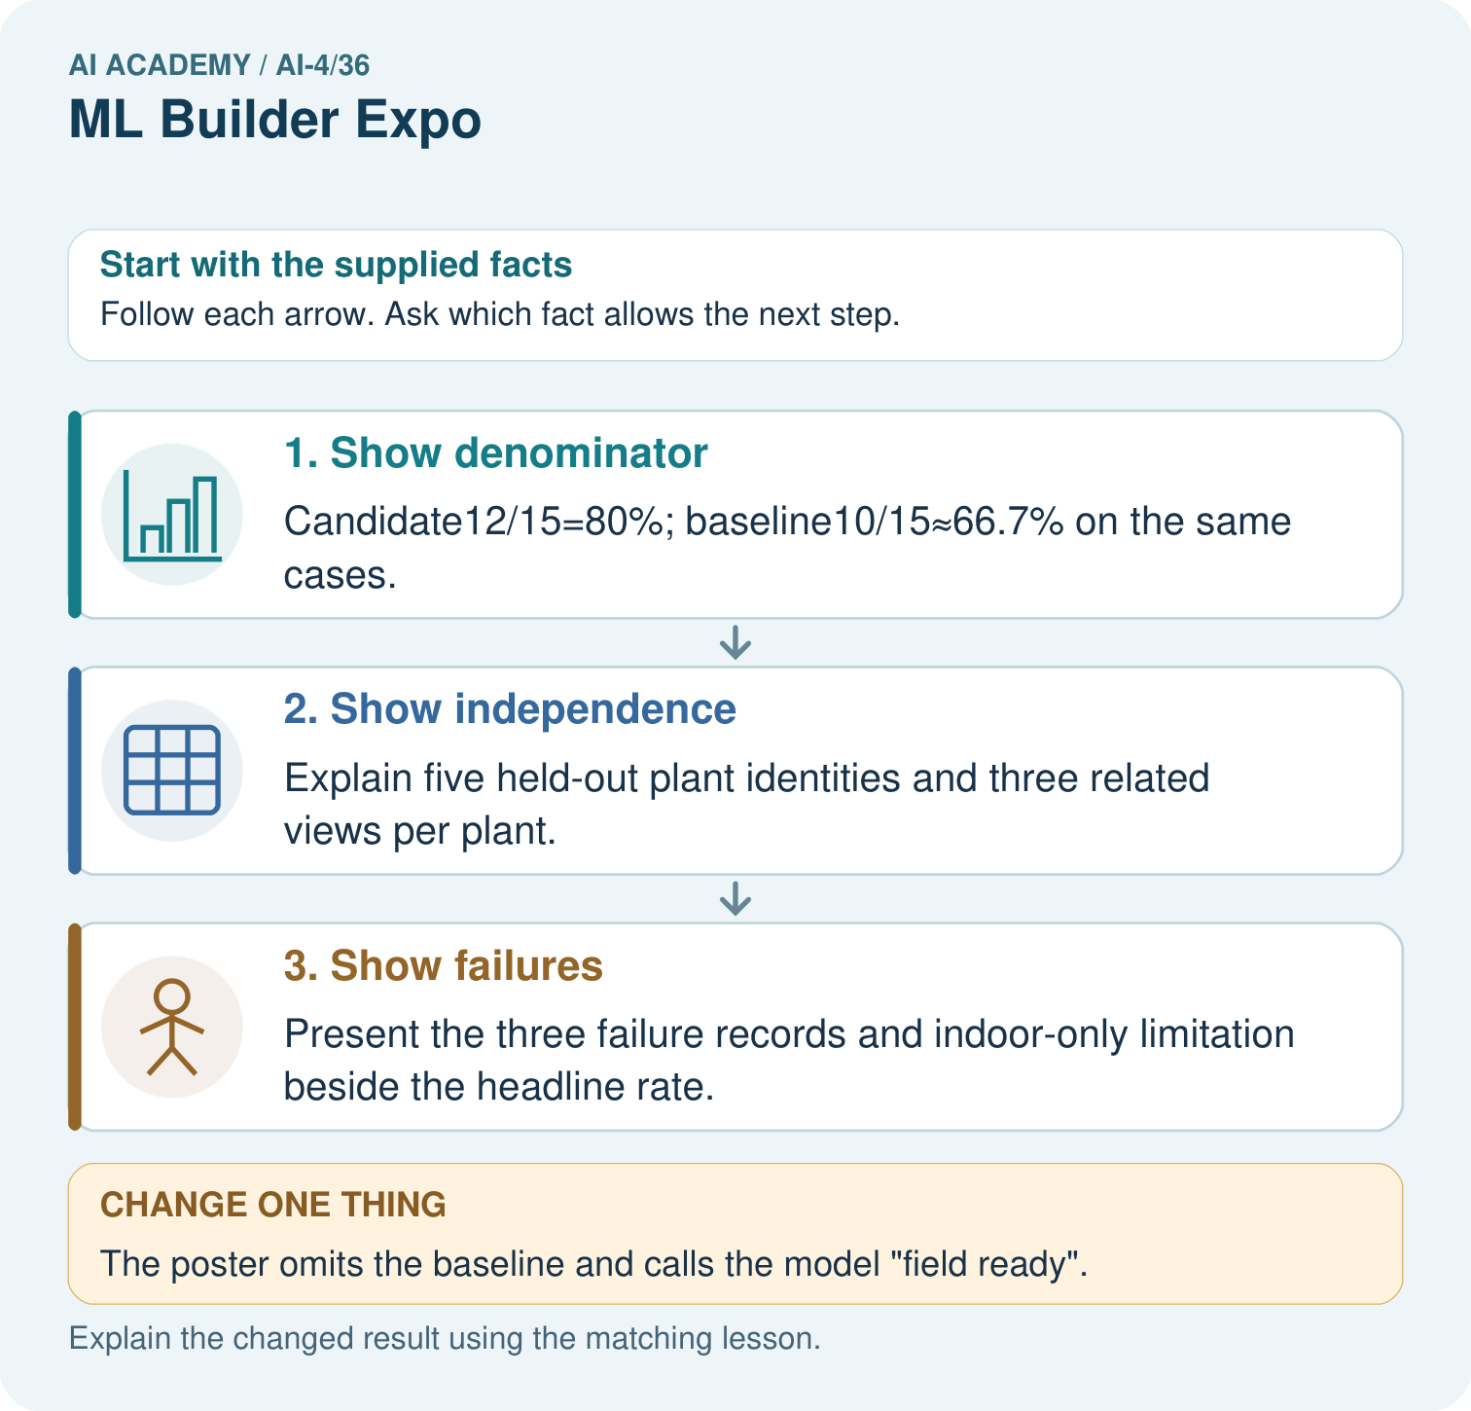
Which three supporting items should be visible at the expo? Point to the relevant step in the picture, then write the changed result and the rule or evidence that supports it.

My picture-based explanation and changed-case prediction
________________________________________________________________
________________________________________________________________
________________________________________________________________
________________________________________________________________
________________________________________________________________
________________________________________________________________
Support used: alone / hint / worked example. This record is practice evidence.
Project connection: For your Responsible Plant Classifier, save the input, procedure, observed result and limitation of this check. Label this worked example as practice; use a different, previously unreviewed case when checking independent understanding.

