AI ACADEMY · WORKBOOK · ai-5/4

Activation functions
Project: Image-pattern Network Investigation

01. Recall and choose your starting point
Try the recall before opening notes. Then use a different colour or a labelled second line to correct your explanation.

Bias terms and decision boundaries
Without opening the old lesson, explain one key idea from Bias terms and decision boundaries. Give an example and a mistake that the idea helps you avoid.

My remembered idea, example and correction
________________________________________________________________
________________________________________________________________
________________________________________________________________

Representing inputs as vectors
Without opening the old lesson, explain one key idea from Representing inputs as vectors. Give an example and a mistake that the idea helps you avoid.

My remembered idea, example and correction
________________________________________________________________
________________________________________________________________
________________________________________________________________

02. Practise with fading help
Use W2: Apply a declared class rule for Activation functions. Record the answer once; the lesson and workbook refer to the same attempt.
Given inputs | Procedure I chose | Middle steps | Result and check

The step I completed without help, and the hint I needed
________________________________________________________________
________________________________________________________________
________________________________________________________________

03. Individual reasoning check
Use the worked case for Activation functions. Proposed explanation: “ReLU returns a class label”. Decide whether this explanation is supported. Point to the step or supplied fact that decides; explain your repair if needed.

My explanation before partner discussion
________________________________________________________________
________________________________________________________________
________________________________________________________________
________________________________________________________________

04. Independent transfer case

Independent case: Trace a new chain independently
Let z = x - 2, a = ReLU(z), y = 2a + 1. For x = 0, 2, 5, record every z, a and y. Then replace ReLU with identity and give all three y values. Which inputs have the same ReLU output, and why?

My independent explanation, trace and limits
________________________________________________________________
________________________________________________________________
________________________________________________________________
________________________________________________________________
________________________________________________________________
________________________________________________________________
________________________________________________________________
Attempt this case before feedback. Record any help. Earlier examples below are further practice; a case already practised with feedback cannot establish fresh transfer.

05. W1 Trace three activations
For scores -2, 0, 2, list identity and ReLU outputs. Explain why ReLU(2) is not 1.

My reasoning and evidence
________________________________________________________________
________________________________________________________________
________________________________________________________________
________________________________________________________________
________________________________________________________________
________________________________________________________________

06. W2 Apply a declared class rule
Use the lesson sigmoid values for -2, 0, 2. Predict classes under a >= 0.5, then explain the zero-score case.

My reasoning and evidence
________________________________________________________________
________________________________________________________________
________________________________________________________________
________________________________________________________________
________________________________________________________________
________________________________________________________________

07. W3 Check the midpoint
Compare ReLU at inputs -2, 0, 2. Give the average of the two endpoint outputs and the output at the midpoint; explain what this shows.

My reasoning and evidence
________________________________________________________________
________________________________________________________________
________________________________________________________________
________________________________________________________________
________________________________________________________________
________________________________________________________________

08. W4 Trace a new chain independently
Let z = x - 2, a = ReLU(z), y = 2a + 1. For x = 0, 2, 5, record every z, a and y. Then replace ReLU with identity and give all three y values. Which inputs have the same ReLU output, and why?

My reasoning and evidence
________________________________________________________________
________________________________________________________________
________________________________________________________________
________________________________________________________________
________________________________________________________________
________________________________________________________________
________________________________________________________________
________________________________________________________________

09. W5 Limit a probability claim
A model returns a sigmoid value 0.9 on one case. Does the numerical range alone establish a calibrated 90 percent probability? Explain what needs checking.

My reasoning and evidence
________________________________________________________________
________________________________________________________________
________________________________________________________________
________________________________________________________________
________________________________________________________________
________________________________________________________________

10. Project checkpoint and reflection
Add a labelled activation functions evidence sheet to Image-pattern Network Investigation. Show how you can trace identity relu and sigmoid on a numerical score. Use the supplied fictional case and keep its inputs, intermediate steps, calculation or prediction, and limitation. Connect this record to last week’s record; a matching answer without a trace is insufficient.

My project change, supporting evidence and remaining limit
________________________________________________________________
________________________________________________________________
________________________________________________________________
________________________________________________________________
________________________________________________________________
________________________________________________________________

11. Feedback, return check and learning record
Evidence | My record
Worked alone / hint / model
First step I repaired and why
New case checked later; date and result
What I can now explain without notes
One remaining question
Revisit this idea with your teacher after a delay. Familiarity is different from explaining and using it on a changed case.

12. Pictorial case practice: Activation functions
See what ReLU removes before the next weighted step.
Toy network z=x-3; h=max(0, z); y=3h+2. Inputs x=1, 3, 4.
All inputs and outcomes in this worked example are invented classroom data; no real model run is claimed.
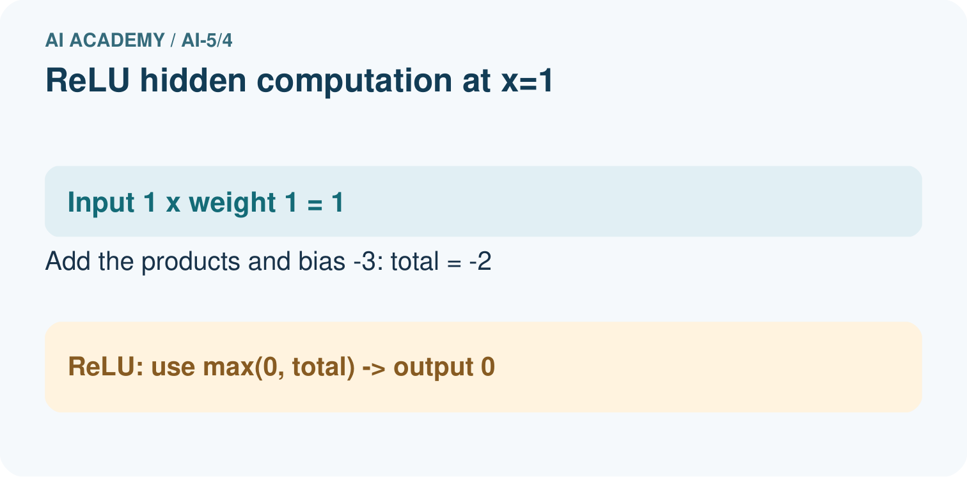
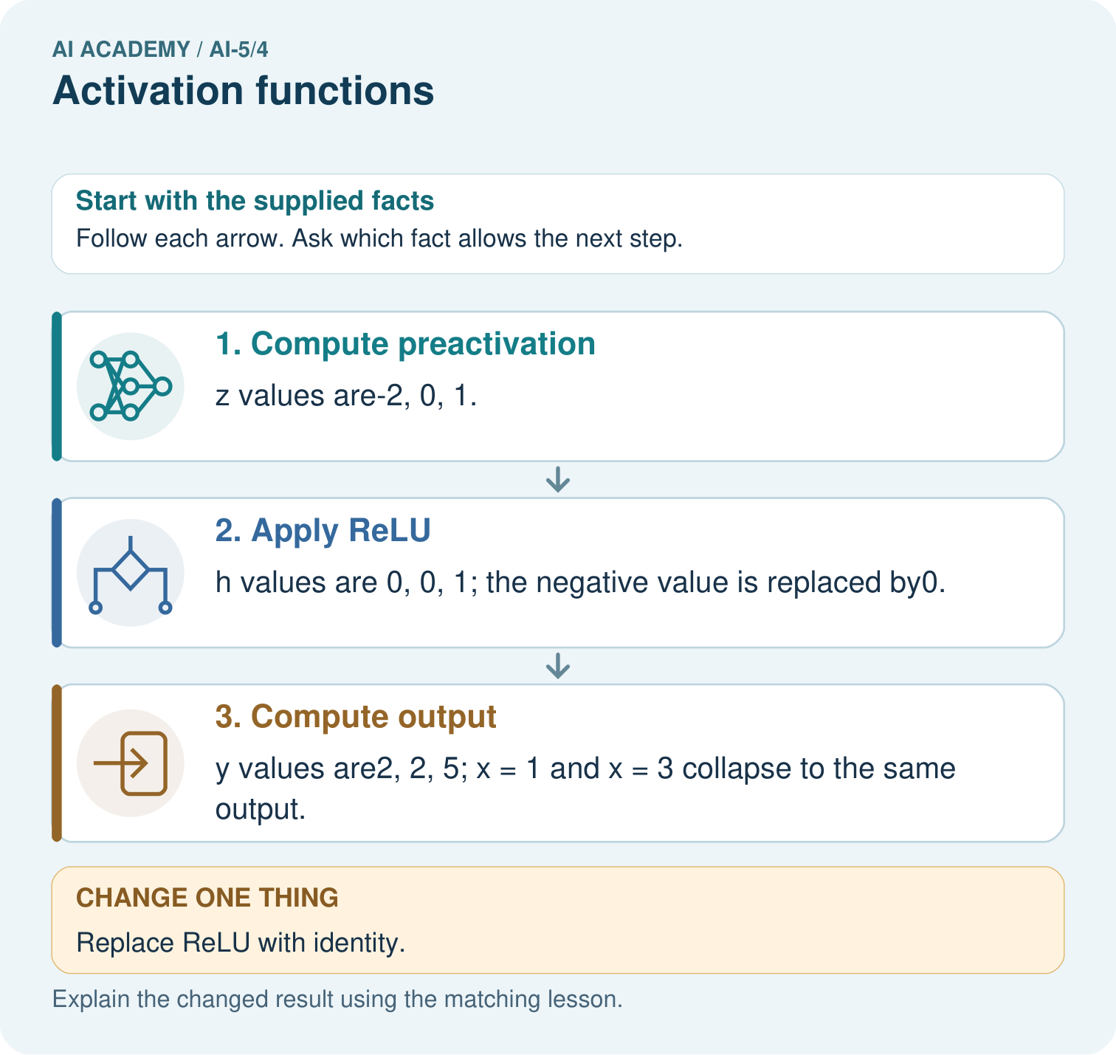
Which original inputs cannot be distinguished by this network’s final output? Point to the relevant step in the picture, then write the changed result and the rule or evidence that supports it.

My picture-based explanation and changed-case prediction
________________________________________________________________
________________________________________________________________
________________________________________________________________
________________________________________________________________
________________________________________________________________
________________________________________________________________
Support used: alone / hint / worked example. This record is practice evidence.
Project connection: For your Image-pattern Network Investigation, save the input, procedure, observed result and limitation of this check. Label this worked example as practice; use a different, previously unreviewed case when checking independent understanding.

