AI ACADEMY · WORKBOOK · ai-5/7

Parameters and architecture
Project: Image-pattern Network Investigation

01. Recall and choose your starting point
Try the recall before opening notes. Then use a different colour or a labelled second line to correct your explanation.

Forward passes by hand
Without opening the old lesson, explain one key idea from Forward passes by hand. Give an example and a mistake that the idea helps you avoid.

My remembered idea, example and correction
________________________________________________________________
________________________________________________________________
________________________________________________________________

Activation functions
Without opening the old lesson, explain one key idea from Activation functions. Give an example and a mistake that the idea helps you avoid.

My remembered idea, example and correction
________________________________________________________________
________________________________________________________________
________________________________________________________________

Representing inputs as vectors
Without opening the old lesson, explain one key idea from Representing inputs as vectors. Give an example and a mistake that the idea helps you avoid.

My remembered idea, example and correction
________________________________________________________________
________________________________________________________________
________________________________________________________________

02. Practise with fading help
Use W2: Sort the quantities for Parameters and architecture. Record the answer once; the lesson and workbook refer to the same attempt.
Given inputs | Procedure I chose | Middle steps | Result and check

The step I completed without help, and the hint I needed
________________________________________________________________
________________________________________________________________
________________________________________________________________

03. Individual reasoning check
Use the worked case for Parameters and architecture. Proposed explanation: “Count one bias per input”. Decide whether this explanation is supported. Point to the step or supplied fact that decides; explain your repair if needed.

My explanation before partner discussion
________________________________________________________________
________________________________________________________________
________________________________________________________________
________________________________________________________________

04. Independent transfer case

Independent case: Count a new architecture independently
A dense 3 to 2 to 2 network uses ReLU in the hidden layer and identity in the output layer, with one bias per unit. Give each layer count and the total. If hidden width becomes 4, recount and explain why activation values are excluded.

My independent explanation, trace and limits
________________________________________________________________
________________________________________________________________
________________________________________________________________
________________________________________________________________
________________________________________________________________
________________________________________________________________
________________________________________________________________
Attempt this case before feedback. Record any help. Earlier examples below are further practice; a case already practised with feedback cannot establish fresh transfer.

05. W1 Count a single layer
A dense layer has 4 inputs and 2 outputs with one bias per output. Count weights, biases and total.

My reasoning and evidence
________________________________________________________________
________________________________________________________________
________________________________________________________________
________________________________________________________________
________________________________________________________________
________________________________________________________________

06. W2 Sort the quantities
Classify hidden activation 0.7, weight -2, hidden width 3 and learning rate 0.1 as computed value, parameter, architecture choice or training setting.

My reasoning and evidence
________________________________________________________________
________________________________________________________________
________________________________________________________________
________________________________________________________________
________________________________________________________________
________________________________________________________________

07. W3 Change the bias convention
Recount the 2 to 3 to 1 model if every bias is omitted. State what the original count assumed.

My reasoning and evidence
________________________________________________________________
________________________________________________________________
________________________________________________________________
________________________________________________________________
________________________________________________________________
________________________________________________________________

08. W4 Count a new architecture independently
A dense 3 to 2 to 2 network uses ReLU in the hidden layer and identity in the output layer, with one bias per unit. Give each layer count and the total. If hidden width becomes 4, recount and explain why activation values are excluded.

My reasoning and evidence
________________________________________________________________
________________________________________________________________
________________________________________________________________
________________________________________________________________
________________________________________________________________
________________________________________________________________
________________________________________________________________
________________________________________________________________

09. W5 Limit a size claim
A team says its 26-parameter model must outperform a 14-parameter model. Give a fair check and one reason the claim is unsupported.

My reasoning and evidence
________________________________________________________________
________________________________________________________________
________________________________________________________________
________________________________________________________________
________________________________________________________________
________________________________________________________________

10. Project checkpoint and reflection
Add a labelled parameters and architecture evidence sheet to Image-pattern Network Investigation. Show how you can distinguish architectural choices from parameter values. Use the supplied fictional case and keep its inputs, intermediate steps, calculation or prediction, and limitation. Connect this record to last week’s record; a matching answer without a trace is insufficient.

My project change, supporting evidence and remaining limit
________________________________________________________________
________________________________________________________________
________________________________________________________________
________________________________________________________________
________________________________________________________________
________________________________________________________________

11. Feedback, return check and learning record
Evidence | My record
Worked alone / hint / model
First step I repaired and why
New case checked later; date and result
What I can now explain without notes
One remaining question
Revisit this idea with your teacher after a delay. Familiarity is different from explaining and using it on a changed case.

12. Pictorial case practice: Parameters and architecture
Count trainable weights and biases separately from activation functions.
Dense toy architecture2 inputs→3 hidden units→1 output. Every hidden and output unit has one bias; hidden activation is ReLU.
All inputs and outcomes in this worked example are invented classroom data; no real model run is claimed.
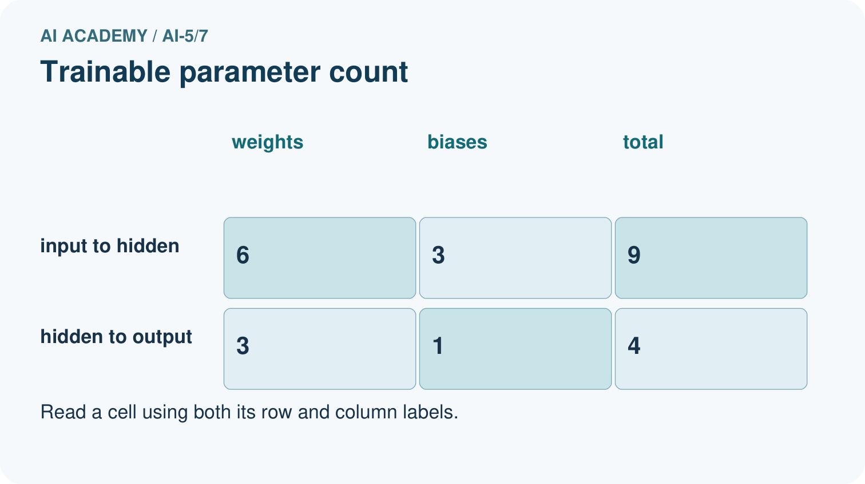
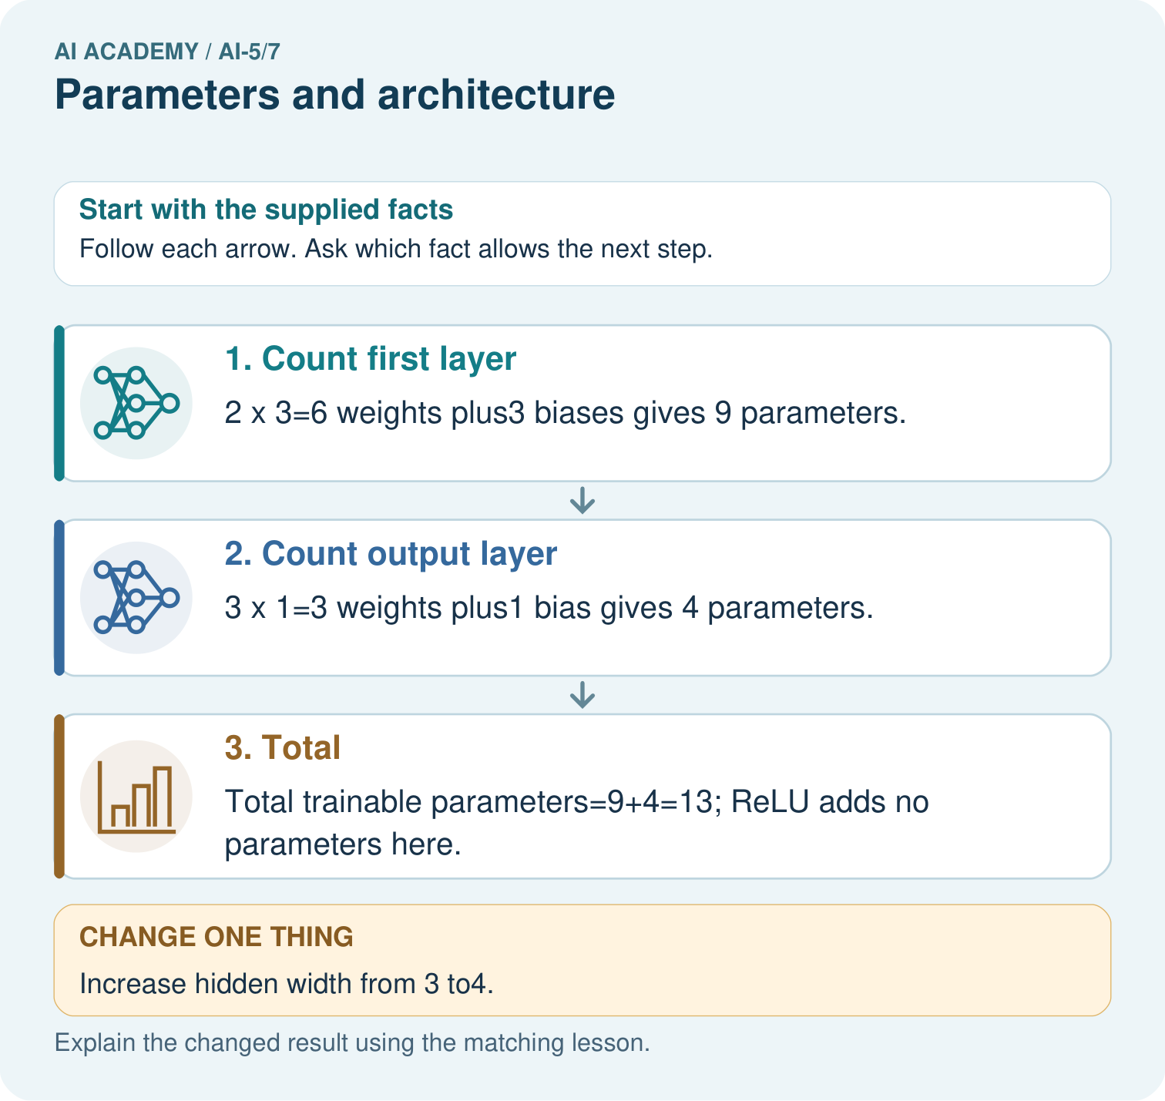
How many new parameters did that one hidden unit add? Point to the relevant step in the picture, then write the changed result and the rule or evidence that supports it.

My picture-based explanation and changed-case prediction
________________________________________________________________
________________________________________________________________
________________________________________________________________
________________________________________________________________
________________________________________________________________
________________________________________________________________
Support used: alone / hint / worked example. This record is practice evidence.
Project connection: For your Image-pattern Network Investigation, save the input, procedure, observed result and limitation of this check. Label this worked example as practice; use a different, previously unreviewed case when checking independent understanding.

