AI ACADEMY · WORKBOOK · ai-5/12

Training a small network
Project: Image-pattern Network Investigation

01. Recall and choose your starting point
Try the recall before opening notes. Then use a different colour or a labelled second line to correct your explanation.

Updating parameters
Without opening the old lesson, explain one key idea from Updating parameters. Give an example and a mistake that the idea helps you avoid.

My remembered idea, example and correction
________________________________________________________________
________________________________________________________________
________________________________________________________________

Slopes and local change
Without opening the old lesson, explain one key idea from Slopes and local change. Give an example and a mistake that the idea helps you avoid.

My remembered idea, example and correction
________________________________________________________________
________________________________________________________________
________________________________________________________________

Forward passes by hand
Without opening the old lesson, explain one key idea from Forward passes by hand. Give an example and a mistake that the idea helps you avoid.

My remembered idea, example and correction
________________________________________________________________
________________________________________________________________
________________________________________________________________

02. Practise with fading help
Use W2: Check the mean convention for Training a small network. Record the answer once; the lesson and workbook refer to the same attempt.
Given inputs | Procedure I chose | Middle steps | Result and check

The step I completed without help, and the hint I needed
________________________________________________________________
________________________________________________________________
________________________________________________________________

03. Individual reasoning check
Use the worked case for Training a small network. Proposed explanation: “Every parameter was trained”. Decide whether this explanation is supported. Point to the step or supplied fact that decides; explain your repair if needed.

My explanation before partner discussion
________________________________________________________________
________________________________________________________________
________________________________________________________________
________________________________________________________________

04. Independent transfer case

Independent case: Run a new training case independently
Keep h = ReLU(x), train only v, and use one pair (2, 2), v = 0 and rate 0.125. Use squared error and gradient 2 times (2v - 2) times 2. Perform two updates, reporting each new v and loss. Explain why the second update changes nothing.

My independent explanation, trace and limits
________________________________________________________________
________________________________________________________________
________________________________________________________________
________________________________________________________________
________________________________________________________________
________________________________________________________________
________________________________________________________________
Attempt this case before feedback. Record any help. Earlier examples below are further practice; a case already practised with feedback cannot establish fresh transfer.

05. W1 Trace the first update
At v = 0, calculate both predictions, errors, MSE and gradient, then update at rate 0.1.

My reasoning and evidence
________________________________________________________________
________________________________________________________________
________________________________________________________________
________________________________________________________________
________________________________________________________________
________________________________________________________________

06. W2 Check the mean convention
At v = 1, the sum of squared errors is 5. A learner uses gradient -10 with rate 0.1. Explain the mismatch with this lesson and give the next v under MSE.

My reasoning and evidence
________________________________________________________________
________________________________________________________________
________________________________________________________________
________________________________________________________________
________________________________________________________________
________________________________________________________________

07. W3 Freeze before checking
At final v = 1.875, calculate the prediction and squared error on reserved pair (3, 6). May its target be included in the four reported training updates?

My reasoning and evidence
________________________________________________________________
________________________________________________________________
________________________________________________________________
________________________________________________________________
________________________________________________________________
________________________________________________________________

08. W4 Run a new training case independently
Keep h = ReLU(x), train only v, and use one pair (2, 2), v = 0 and rate 0.125. Use squared error and gradient 2 times (2v - 2) times 2. Perform two updates, reporting each new v and loss. Explain why the second update changes nothing.

My reasoning and evidence
________________________________________________________________
________________________________________________________________
________________________________________________________________
________________________________________________________________
________________________________________________________________
________________________________________________________________
________________________________________________________________
________________________________________________________________

09. W5 Expose a frozen representation limit
For the lesson architecture at x = -1, give h and prediction for any finite v. If target is -2, calculate squared error and explain why changing v cannot fix it.

My reasoning and evidence
________________________________________________________________
________________________________________________________________
________________________________________________________________
________________________________________________________________
________________________________________________________________
________________________________________________________________

10. Project checkpoint and reflection
Add a labelled training a small network evidence sheet to Image-pattern Network Investigation. Show how you can trace repeated forward loss gradient and update steps. Use the supplied fictional case and keep its inputs, intermediate steps, calculation or prediction, and limitation. Connect this record to last week’s record; a matching answer without a trace is insufficient.

My project change, supporting evidence and remaining limit
________________________________________________________________
________________________________________________________________
________________________________________________________________
________________________________________________________________
________________________________________________________________
________________________________________________________________

11. Feedback, return check and learning record
Evidence | My record
Worked alone / hint / model
First step I repaired and why
New case checked later; date and result
What I can now explain without notes
One remaining question
Revisit this idea with your teacher after a delay. Familiarity is different from explaining and using it on a changed case.

12. Pictorial case practice: Training a small network
Train a single output weight while clearly marking the frozen hidden computation.
Toy h=ReLU(x), y=vh. One training pair x = 3, target 3; start v = 0; squared loss; rate 1/18.
All inputs and outcomes in this worked example are invented classroom data; no real model run is claimed.
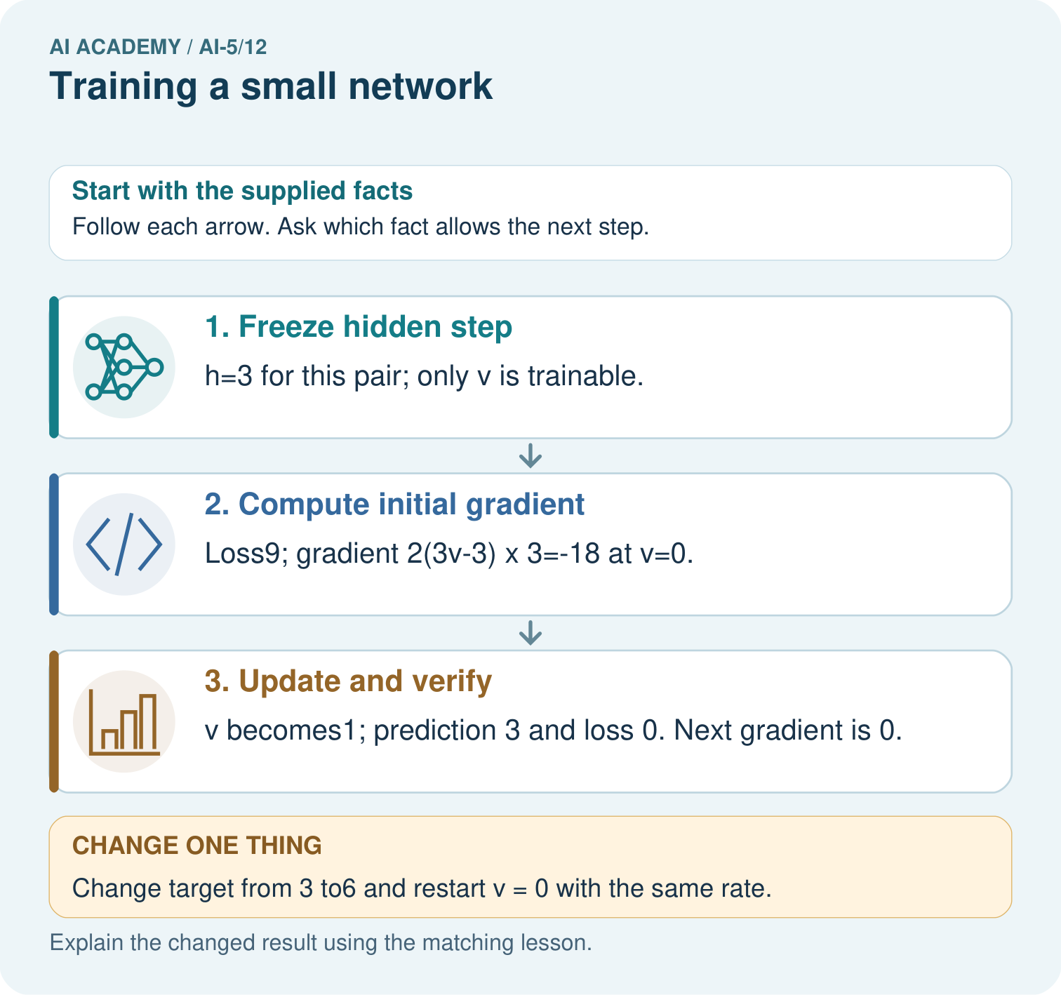
Which parameter changed, and which part was not trained? Point to the relevant step in the picture, then write the changed result and the rule or evidence that supports it.

My picture-based explanation and changed-case prediction
________________________________________________________________
________________________________________________________________
________________________________________________________________
________________________________________________________________
________________________________________________________________
________________________________________________________________
Support used: alone / hint / worked example. This record is practice evidence.
Project connection: For your Image-pattern Network Investigation, save the input, procedure, observed result and limitation of this check. Label this worked example as practice; use a different, previously unreviewed case when checking independent understanding.

