AI ACADEMY · WORKBOOK · ai-5/15

Training and validation curves
Project: Image-pattern Network Investigation

01. Recall and choose your starting point
Try the recall before opening notes. Then use a different colour or a labelled second line to correct your explanation.

Learning rate experiments
Without opening the old lesson, explain one key idea from Learning rate experiments. Give an example and a mistake that the idea helps you avoid.

My remembered idea, example and correction
________________________________________________________________
________________________________________________________________
________________________________________________________________

Training a small network
Without opening the old lesson, explain one key idea from Training a small network. Give an example and a mistake that the idea helps you avoid.

My remembered idea, example and correction
________________________________________________________________
________________________________________________________________
________________________________________________________________

Slopes and local change
Without opening the old lesson, explain one key idea from Slopes and local change. Give an example and a mistake that the idea helps you avoid.

My remembered idea, example and correction
________________________________________________________________
________________________________________________________________
________________________________________________________________

02. Practise with fading help
Use W2: Use the declared rule for Training and validation curves. Record the answer once; the lesson and workbook refer to the same attempt.
Given inputs | Procedure I chose | Middle steps | Result and check

The step I completed without help, and the hint I needed
________________________________________________________________
________________________________________________________________
________________________________________________________________

03. Individual reasoning check
Use the worked case for Training and validation curves. Proposed explanation: “The last checkpoint is always best”. Decide whether this explanation is supported. Point to the step or supplied fact that decides; explain your repair if needed.

My explanation before partner discussion
________________________________________________________________
________________________________________________________________
________________________________________________________________
________________________________________________________________

04. Independent transfer case

Independent case: Evaluate new checkpoints independently
Use h = ReLU(x), y = vh, candidate v values 1, 1.5 and 2. Training pairs are (1, 2), (2, 4); validation pairs are (1, 1), (2, 2). Calculate both MSE columns and select by minimum validation MSE. Explain the disagreement with selection by training loss.

My independent explanation, trace and limits
________________________________________________________________
________________________________________________________________
________________________________________________________________
________________________________________________________________
________________________________________________________________
________________________________________________________________
________________________________________________________________
Attempt this case before feedback. Record any help. Earlier examples below are further practice; a case already practised with feedback cannot establish fresh transfer.

05. W1 Recover a plotted point
At v = 1, compute both validation predictions, residuals and MSE on (3, 4.5) and (4, 6).

My reasoning and evidence
________________________________________________________________
________________________________________________________________
________________________________________________________________
________________________________________________________________
________________________________________________________________
________________________________________________________________

06. W2 Use the declared rule
Observed validation MSE at checkpoints 0 to 4 is [5, 2, 1, 1, 1.2]. Lowest loss wins with earlier exact ties. Which checkpoint is selected? What if training loss is lowest at checkpoint 4?

My reasoning and evidence
________________________________________________________________
________________________________________________________________
________________________________________________________________
________________________________________________________________
________________________________________________________________
________________________________________________________________

07. W3 Repair incompatible measures
A training report shows sum of squared errors 12 over six rows. Validation shows mean squared error 3 over two rows in the same target units. A learner says training error is four times larger. Repair the comparison.

My reasoning and evidence
________________________________________________________________
________________________________________________________________
________________________________________________________________
________________________________________________________________
________________________________________________________________
________________________________________________________________

08. W4 Evaluate new checkpoints independently
Use h = ReLU(x), y = vh, candidate v values 1, 1.5 and 2. Training pairs are (1, 2), (2, 4); validation pairs are (1, 1), (2, 2). Calculate both MSE columns and select by minimum validation MSE. Explain the disagreement with selection by training loss.

My reasoning and evidence
________________________________________________________________
________________________________________________________________
________________________________________________________________
________________________________________________________________
________________________________________________________________
________________________________________________________________
________________________________________________________________
________________________________________________________________

09. W5 Limit a curve diagnosis
Training loss falls while validation loss rises. Give two checks before declaring model complexity the cause, and explain why repeatedly selecting with validation makes it development evidence.

My reasoning and evidence
________________________________________________________________
________________________________________________________________
________________________________________________________________
________________________________________________________________
________________________________________________________________
________________________________________________________________

10. Project checkpoint and reflection
Add a labelled training and validation curves evidence sheet to Image-pattern Network Investigation. Show how you can compute comparable training and validation losses at saved checkpoints. Use the supplied fictional case and keep its inputs, intermediate steps, calculation or prediction, and limitation. Connect this record to last week’s record; a matching answer without a trace is insufficient.

My project change, supporting evidence and remaining limit
________________________________________________________________
________________________________________________________________
________________________________________________________________
________________________________________________________________
________________________________________________________________
________________________________________________________________

11. Feedback, return check and learning record
Evidence | My record
Worked alone / hint / model
First step I repaired and why
New case checked later; date and result
What I can now explain without notes
One remaining question
Revisit this idea with your teacher after a delay. Familiarity is different from explaining and using it on a changed case.

12. Pictorial case practice: Training and validation curves
Plot training and validation loss for checkpoints before opening final cases.
Supplied checkpoint losses: epoch 1 train4, val3; epoch 2 train2, val2; epoch 3 train1, val2.5. Selection: smallest validation loss.
All inputs and outcomes in this worked example are invented classroom data; no real model run is claimed.
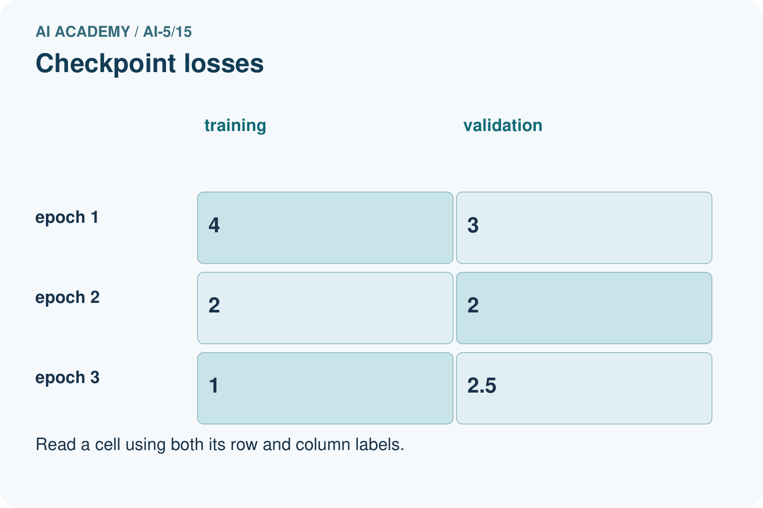
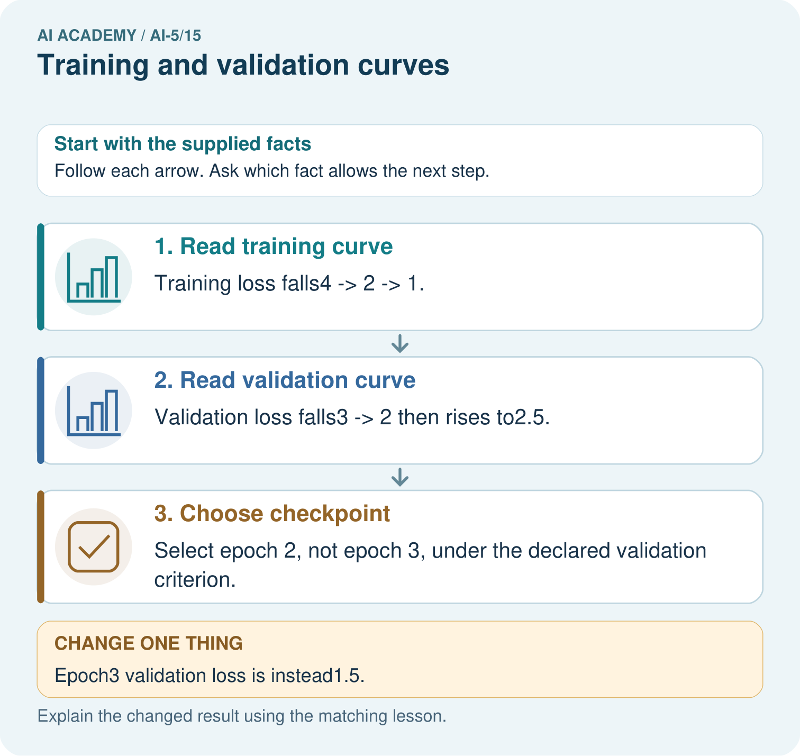
Can the original epoch 3 training loss 1 justify claiming best generalisation? Point to the relevant step in the picture, then write the changed result and the rule or evidence that supports it.

My picture-based explanation and changed-case prediction
________________________________________________________________
________________________________________________________________
________________________________________________________________
________________________________________________________________
________________________________________________________________
________________________________________________________________
Support used: alone / hint / worked example. This record is practice evidence.
Project connection: For your Image-pattern Network Investigation, save the input, procedure, observed result and limitation of this check. Label this worked example as practice; use a different, previously unreviewed case when checking independent understanding.

