AI ACADEMY · WORKBOOK · ai-5/18

Debugging shapes and gradients
Project: Image-pattern Network Investigation

01. Recall and choose your starting point
Try the recall before opening notes. Then use a different colour or a labelled second line to correct your explanation.

Initialisation and reproducibility
Without opening the old lesson, explain one key idea from Initialisation and reproducibility. Give an example and a mistake that the idea helps you avoid.

My remembered idea, example and correction
________________________________________________________________
________________________________________________________________
________________________________________________________________

Training and validation curves
Without opening the old lesson, explain one key idea from Training and validation curves. Give an example and a mistake that the idea helps you avoid.

My remembered idea, example and correction
________________________________________________________________
________________________________________________________________
________________________________________________________________

Training a small network
Without opening the old lesson, explain one key idea from Training a small network. Give an example and a mistake that the idea helps you avoid.

My remembered idea, example and correction
________________________________________________________________
________________________________________________________________
________________________________________________________________

02. Practise with fading help
Use W2: Expose a hidden bias error for Debugging shapes and gradients. Record the answer once; the lesson and workbook refer to the same attempt.
Given inputs | Procedure I chose | Middle steps | Result and check

The step I completed without help, and the hint I needed
________________________________________________________________
________________________________________________________________
________________________________________________________________

03. Individual reasoning check
Use the worked case for Debugging shapes and gradients. Proposed explanation: “Matching output shape guarantees the computation”. Decide whether this explanation is supported. Point to the step or supplied fact that decides; explain your repair if needed.

My explanation before partner discussion
________________________________________________________________
________________________________________________________________
________________________________________________________________
________________________________________________________________

04. Independent transfer case

Independent case: Debug a new gradient independently
Use y = 3a + c, target 2, loss (y - 2) squared, at [a, c] = [0, 1]. A program returns gradient [-2, -6] in order [a, c]. Use symmetric step 0.1 to check each coordinate, then update both with the corrected gradient and rate 0.05. Report new parameters and loss.

My independent explanation, trace and limits
________________________________________________________________
________________________________________________________________
________________________________________________________________
________________________________________________________________
________________________________________________________________
________________________________________________________________
________________________________________________________________
Attempt this case before feedback. Record any help. Earlier examples below are further practice; a case already practised with feedback cannot establish fresh transfer.

05. W1 Reject a shape mismatch
The layer expects W shape 3 by 2, b length 3 and x length 2. A submitted x has length 3. Should the last feature be silently ignored? State the failed contract and repair process.

My reasoning and evidence
________________________________________________________________
________________________________________________________________
________________________________________________________________
________________________________________________________________
________________________________________________________________
________________________________________________________________

06. W2 Expose a hidden bias error
Compute scores and activations for x = [3, 1] with the lesson layer, then omit the third bias. Identify the first discrepancy and the resulting activation error.

My reasoning and evidence
________________________________________________________________
________________________________________________________________
________________________________________________________________
________________________________________________________________
________________________________________________________________
________________________________________________________________

07. W3 Check an update sign
For the diagnostic model at [1, 0], gradient [-4, -2] and rate 0.05, calculate the correct new parameters and loss. Compare with adding the gradient step.

My reasoning and evidence
________________________________________________________________
________________________________________________________________
________________________________________________________________
________________________________________________________________
________________________________________________________________
________________________________________________________________

08. W4 Debug a new gradient independently
Use y = 3a + c, target 2, loss (y - 2) squared, at [a, c] = [0, 1]. A program returns gradient [-2, -6] in order [a, c]. Use symmetric step 0.1 to check each coordinate, then update both with the corrected gradient and rate 0.05. Report new parameters and loss.

My reasoning and evidence
________________________________________________________________
________________________________________________________________
________________________________________________________________
________________________________________________________________
________________________________________________________________
________________________________________________________________
________________________________________________________________
________________________________________________________________

09. W5 Keep independent regression checks
A program passes only the x = [1, 2] final-activation test. Propose one intermediate-value check, one malformed-input check and one additional input that exposes the bias omission.

My reasoning and evidence
________________________________________________________________
________________________________________________________________
________________________________________________________________
________________________________________________________________
________________________________________________________________
________________________________________________________________

10. Project checkpoint and reflection
Add a labelled debugging shapes and gradients evidence sheet to Image-pattern Network Investigation. Show how you can check dimension contracts before computing a layer. Use the supplied fictional case and keep its inputs, intermediate steps, calculation or prediction, and limitation. Connect this record to last week’s record; a matching answer without a trace is insufficient.

My project change, supporting evidence and remaining limit
________________________________________________________________
________________________________________________________________
________________________________________________________________
________________________________________________________________
________________________________________________________________
________________________________________________________________

11. Feedback, return check and learning record
Evidence | My record
Worked alone / hint / model
First step I repaired and why
New case checked later; date and result
What I can now explain without notes
One remaining question
Revisit this idea with your teacher after a delay. Familiarity is different from explaining and using it on a changed case.

12. Pictorial case practice: Debugging shapes and gradients
Catch a gradient -order bug before the optimiser changes parameters.
Toy y=2a+3c, target 4, start [a, c]=[1, 0]. Loss (y-4)². Program claims gradient [-12,-8] in order [a, c].
All inputs and outcomes in this worked example are invented classroom data; no real model run is claimed.
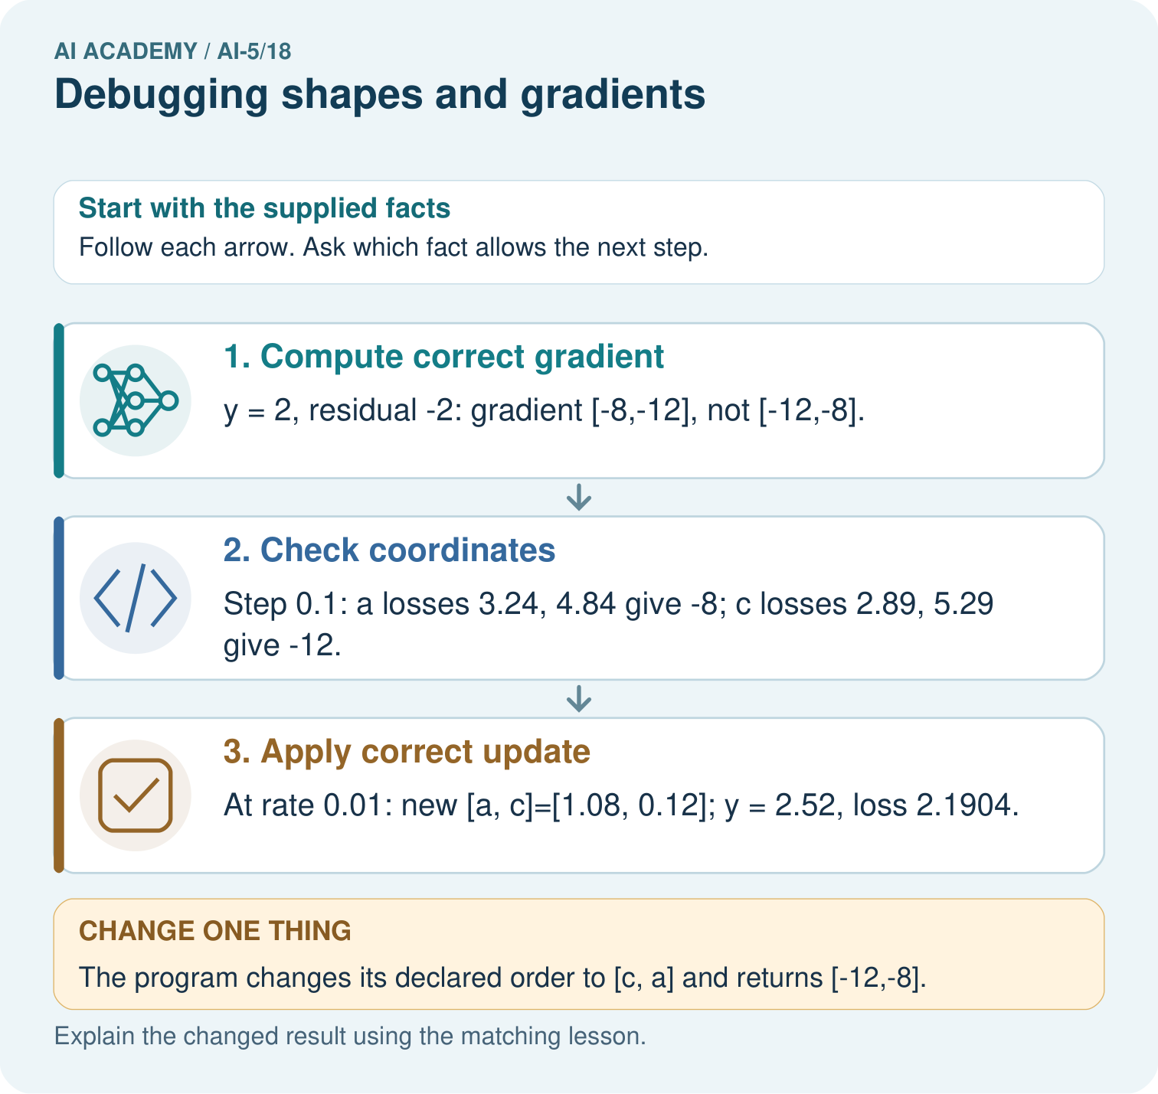
What should a debugging record pair with every gradient value? Point to the relevant step in the picture, then write the changed result and the rule or evidence that supports it.

My picture-based explanation and changed-case prediction
________________________________________________________________
________________________________________________________________
________________________________________________________________
________________________________________________________________
________________________________________________________________
________________________________________________________________
Support used: alone / hint / worked example. This record is practice evidence.
Project connection: For your Image-pattern Network Investigation, save the input, procedure, observed result and limitation of this check. Label this worked example as practice; use a different, previously unreviewed case when checking independent understanding.

