AI ACADEMY · WORKBOOK · ai-5/20

Image tensors and channels
Project: Image-pattern Network Investigation

01. Recall and choose your starting point
Try the recall before opening notes. Then use a different colour or a labelled second line to correct your explanation.

Learned representations
Without opening the old lesson, explain one key idea from Learned representations. Give an example and a mistake that the idea helps you avoid.

My remembered idea, example and correction
________________________________________________________________
________________________________________________________________
________________________________________________________________

Initialisation and reproducibility
Without opening the old lesson, explain one key idea from Initialisation and reproducibility. Give an example and a mistake that the idea helps you avoid.

My remembered idea, example and correction
________________________________________________________________
________________________________________________________________
________________________________________________________________

Learning rate experiments
Without opening the old lesson, explain one key idea from Learning rate experiments. Give an example and a mistake that the idea helps you avoid.

My remembered idea, example and correction
________________________________________________________________
________________________________________________________________
________________________________________________________________

02. Practise with fading help
Use W2: Audit an axis conversion for Image tensors and channels. Record the answer once; the lesson and workbook refer to the same attempt.
Given inputs | Procedure I chose | Middle steps | Result and check

The step I completed without help, and the hint I needed
________________________________________________________________
________________________________________________________________
________________________________________________________________

03. Individual reasoning check
Use the worked case for Image tensors and channels. Proposed explanation: “Three channels mean three images”. Decide whether this explanation is supported. Point to the step or supplied fact that decides; explain your repair if needed.

My explanation before partner discussion
________________________________________________________________
________________________________________________________________
________________________________________________________________
________________________________________________________________

04. Independent transfer case

Independent case: Convert a new image independently
A one-row two-column RGB image has pixels [10, 20, 30] then [40, 50, 60]. State its HWC shape and all three CHW planes. Give the green value at row 0 column 1 in both layouts. A batch contains four copies: give its NHWC shape and total channel-value count.

My independent explanation, trace and limits
________________________________________________________________
________________________________________________________________
________________________________________________________________
________________________________________________________________
________________________________________________________________
________________________________________________________________
________________________________________________________________
Attempt this case before feedback. Record any help. Earlier examples below are further practice; a case already practised with feedback cannot establish fresh transfer.

05. W1 Read a pixel precisely
For the lesson image, give image[1][0], image[1][0][2], the HWC shape, pixel count and number of channel values.

My reasoning and evidence
________________________________________________________________
________________________________________________________________
________________________________________________________________
________________________________________________________________
________________________________________________________________
________________________________________________________________

06. W2 Audit an axis conversion
A program flattens the lesson HWC array and groups the first four values into a 2 by 2 red plane. Give that incorrect plane and the correct plane. Identify a position where they disagree.

My reasoning and evidence
________________________________________________________________
________________________________________________________________
________________________________________________________________
________________________________________________________________
________________________________________________________________
________________________________________________________________

07. W3 Check scaling and lost colour
Scale [255, 128, 0] by 255, keeping the middle value as a fraction. Then calculate the classroom RGB means of pure red and pure green. Which operation loses the distinction between those colours?

My reasoning and evidence
________________________________________________________________
________________________________________________________________
________________________________________________________________
________________________________________________________________
________________________________________________________________
________________________________________________________________

08. W4 Convert a new image independently
A one-row two-column RGB image has pixels [10, 20, 30] then [40, 50, 60]. State its HWC shape and all three CHW planes. Give the green value at row 0 column 1 in both layouts. A batch contains four copies: give its NHWC shape and total channel-value count.

My reasoning and evidence
________________________________________________________________
________________________________________________________________
________________________________________________________________
________________________________________________________________
________________________________________________________________
________________________________________________________________
________________________________________________________________
________________________________________________________________

09. W5 Design revealing pipeline checks
The lesson image is loaded with red and blue exchanged, then scaled twice. Give two expected checks that would expose these errors even though the shape is correct.

My reasoning and evidence
________________________________________________________________
________________________________________________________________
________________________________________________________________
________________________________________________________________
________________________________________________________________
________________________________________________________________

10. Project checkpoint and reflection
Add a labelled image tensors and channels evidence sheet to Image-pattern Network Investigation. Show how you can read a pixel using declared row column and channel axes. Use the supplied fictional case and keep its inputs, intermediate steps, calculation or prediction, and limitation. Connect this record to last week’s record; a matching answer without a trace is insufficient.

My project change, supporting evidence and remaining limit
________________________________________________________________
________________________________________________________________
________________________________________________________________
________________________________________________________________
________________________________________________________________
________________________________________________________________

11. Feedback, return check and learning record
Evidence | My record
Worked alone / hint / model
First step I repaired and why
New case checked later; date and result
What I can now explain without notes
One remaining question
Revisit this idea with your teacher after a delay. Familiarity is different from explaining and using it on a changed case.

12. Pictorial case practice: Image tensors and channels
Move colour values between tensor layouts without changing the pixels.
Toy RGB image has 2 rows, 1 column. Top pixel [1, 4, 7]; bottom [2, 5, 8]. HWC means height, width, channel.
All inputs and outcomes in this worked example are invented classroom data; no real model run is claimed.
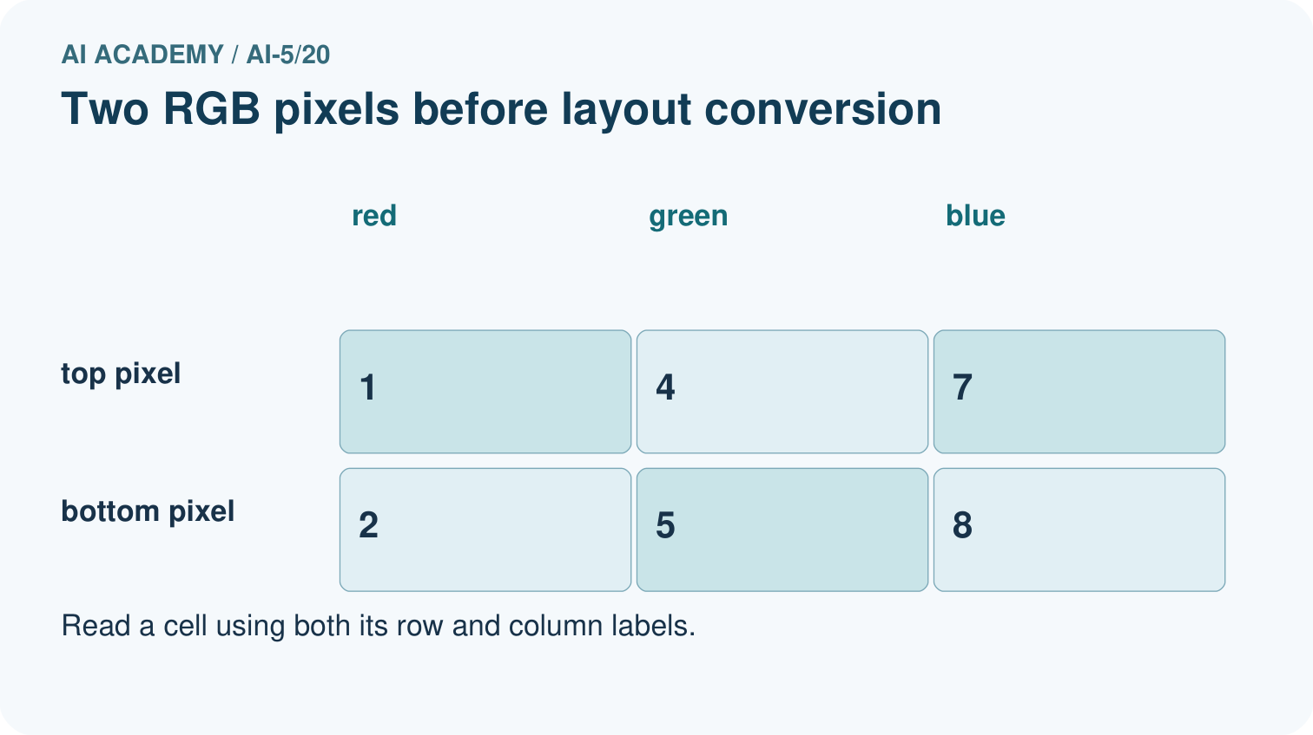
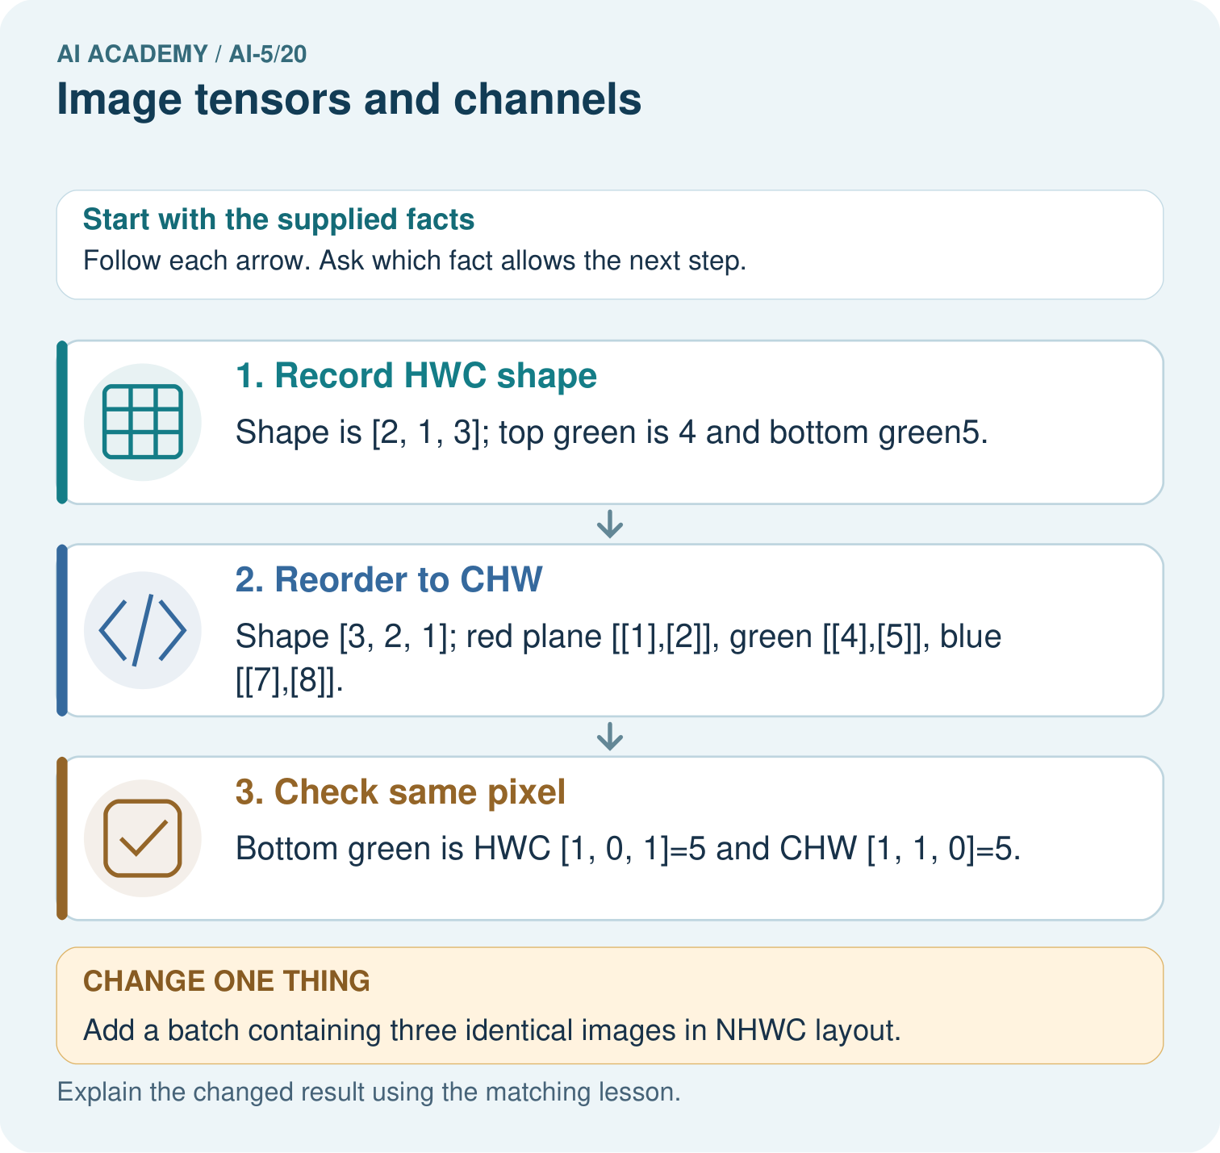
Where is the bottom green pixel in the first batched image? Point to the relevant step in the picture, then write the changed result and the rule or evidence that supports it.

My picture-based explanation and changed-case prediction
________________________________________________________________
________________________________________________________________
________________________________________________________________
________________________________________________________________
________________________________________________________________
________________________________________________________________
Support used: alone / hint / worked example. This record is practice evidence.
Project connection: For your Image-pattern Network Investigation, save the input, procedure, observed result and limitation of this check. Label this worked example as practice; use a different, previously unreviewed case when checking independent understanding.

