AI ACADEMY · WORKBOOK · ai-5/24

Augmentation and leakage
Project: Image-pattern Network Investigation

01. Recall and choose your starting point
Try the recall before opening notes. Then use a different colour or a labelled second line to correct your explanation.

Training a small image model
Without opening the old lesson, explain one key idea from Training a small image model. Give an example and a mistake that the idea helps you avoid.

My remembered idea, example and correction
________________________________________________________________
________________________________________________________________
________________________________________________________________

Convolution as a local operation
Without opening the old lesson, explain one key idea from Convolution as a local operation. Give an example and a mistake that the idea helps you avoid.

My remembered idea, example and correction
________________________________________________________________
________________________________________________________________
________________________________________________________________

Debugging shapes and gradients
Without opening the old lesson, explain one key idea from Debugging shapes and gradients. Give an example and a mistake that the idea helps you avoid.

My remembered idea, example and correction
________________________________________________________________
________________________________________________________________
________________________________________________________________

02. Practise with fading help
Use W2: Keep the equality boundary for Augmentation and leakage. Record the answer once; the lesson and workbook refer to the same attempt.
Given inputs | Procedure I chose | Middle steps | Result and check

The step I completed without help, and the hint I needed
________________________________________________________________
________________________________________________________________
________________________________________________________________

03. Individual reasoning check
Use the worked case for Augmentation and leakage. Proposed explanation: “Every image flip preserves the label”. Decide whether this explanation is supported. Point to the step or supplied fact that decides; explain your repair if needed.

My explanation before partner discussion
________________________________________________________________
________________________________________________________________
________________________________________________________________
________________________________________________________________

04. Independent transfer case

Independent case: Design a grouped split independently
Six fictional source groups J, K, L, M, N and O each have one original and three derived records. Assign J, K and L to training, M to validation and N, O to final test. Keep all four records per training group but only originals for evaluation. Give source and retained-record counts per split, total retained records and excluded derived records.

My independent explanation, trace and limits
________________________________________________________________
________________________________________________________________
________________________________________________________________
________________________________________________________________
________________________________________________________________
________________________________________________________________
________________________________________________________________
Attempt this case before feedback. Record any help. Earlier examples below are further practice; a case already practised with feedback cannot establish fresh transfer.

05. W1 Check the label after a transformation
For rows [0, 1], [0, 1], compute d and class before and after swapping rows and after swapping columns.

My reasoning and evidence
________________________________________________________________
________________________________________________________________
________________________________________________________________
________________________________________________________________
________________________________________________________________
________________________________________________________________

06. W2 Keep the equality boundary
For rows [1, 0], [0, 1], compute d and class before and after a column swap. Why is always replacing a label by 1 minus the label incorrect?

My reasoning and evidence
________________________________________________________________
________________________________________________________________
________________________________________________________________
________________________________________________________________
________________________________________________________________
________________________________________________________________

07. W3 Audit related records
Training contains P original and Q original. Validation contains P crop and R original. Final test contains S original. P crop is derived from P original. Identify the overlap and explain what must be rerun if this validation set already selected a model.

My reasoning and evidence
________________________________________________________________
________________________________________________________________
________________________________________________________________
________________________________________________________________
________________________________________________________________
________________________________________________________________

08. W4 Design a grouped split independently
Six fictional source groups J, K, L, M, N and O each have one original and three derived records. Assign J, K and L to training, M to validation and N, O to final test. Keep all four records per training group but only originals for evaluation. Give source and retained-record counts per split, total retained records and excluded derived records.

My reasoning and evidence
________________________________________________________________
________________________________________________________________
________________________________________________________________
________________________________________________________________
________________________________________________________________
________________________________________________________________
________________________________________________________________
________________________________________________________________

09. W5 Match a training budget
Eight source images each have an original plus two variants. Compare four epochs of these 24 records with four epochs of the eight originals, using one-example batches. Give both update counts and one way to match budgets without using final outcomes.

My reasoning and evidence
________________________________________________________________
________________________________________________________________
________________________________________________________________
________________________________________________________________
________________________________________________________________
________________________________________________________________

10. Project checkpoint and reflection
Add a labelled augmentation and leakage evidence sheet to Image-pattern Network Investigation. Show how you can check whether a transformation preserves the task label. Use the supplied fictional case and keep its inputs, intermediate steps, calculation or prediction, and limitation. Connect this record to last week’s record; a matching answer without a trace is insufficient.

My project change, supporting evidence and remaining limit
________________________________________________________________
________________________________________________________________
________________________________________________________________
________________________________________________________________
________________________________________________________________
________________________________________________________________

11. Feedback, return check and learning record
Evidence | My record
Worked alone / hint / model
First step I repaired and why
New case checked later; date and result
What I can now explain without notes
One remaining question
Revisit this idea with your teacher after a delay. Familiarity is different from explaining and using it on a changed case.

12. Pictorial case practice: Augmentation and leakage
Keep every augmented image with its original source group.
Fictional sources A, B, C, D each have original+horizontal-flip copies. A/B train, C validation, D final test.
All inputs and outcomes in this worked example are invented classroom data; no real model run is claimed.
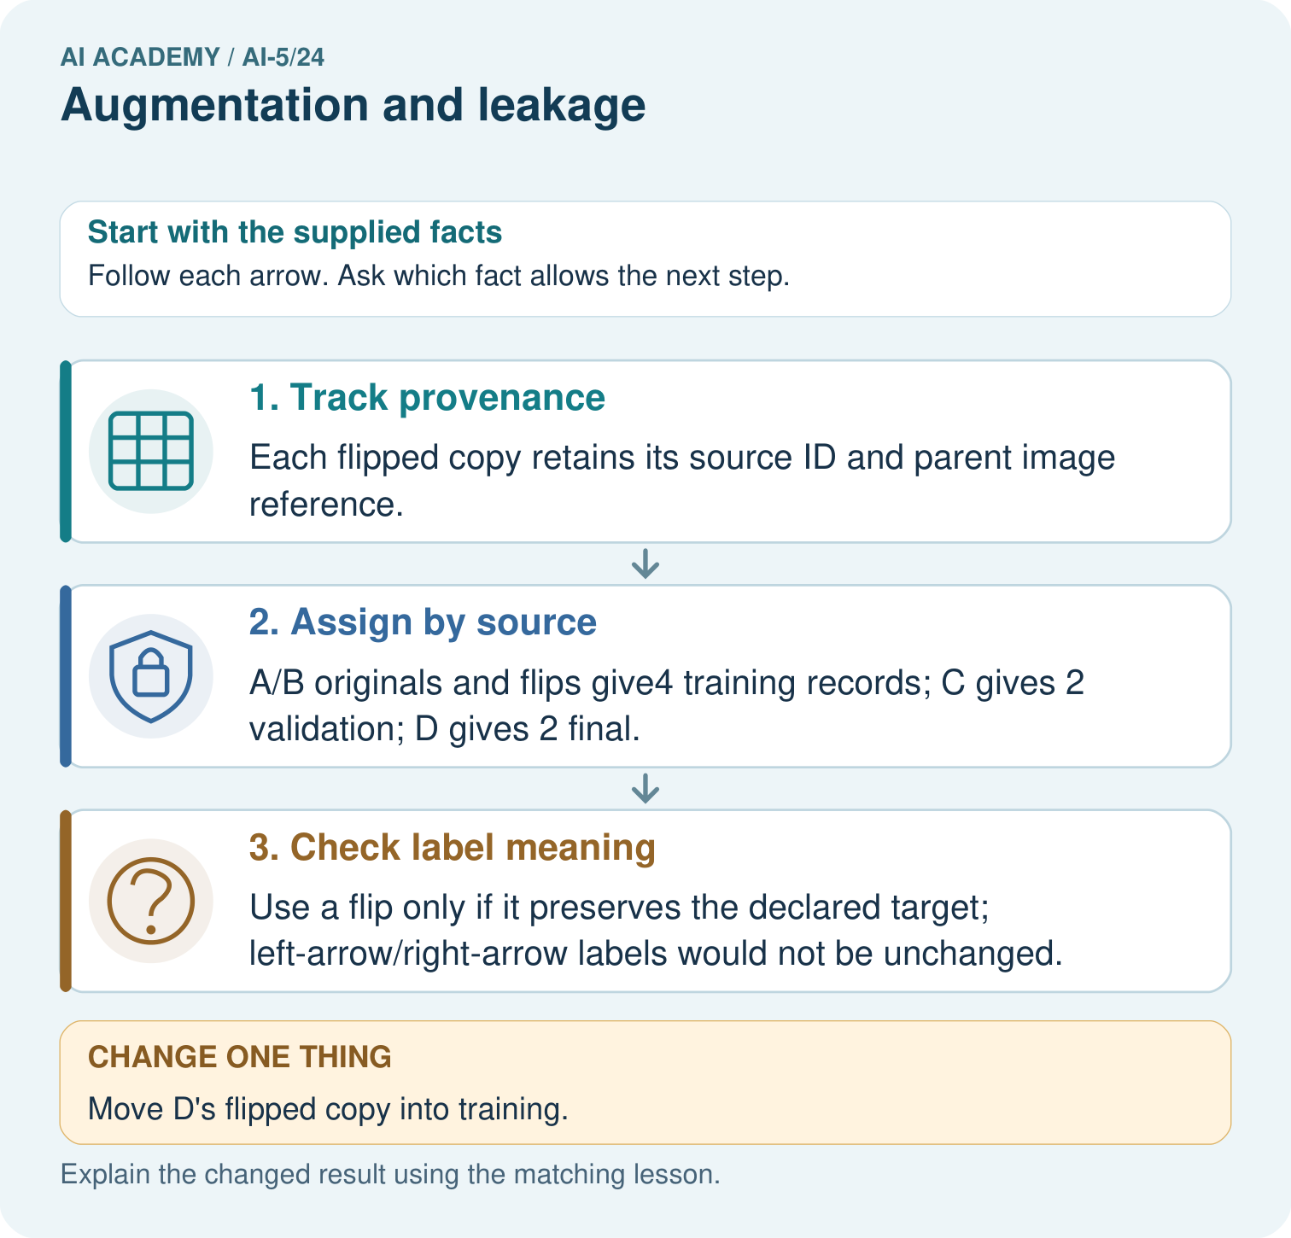
How many independent source groups are in the final test? Point to the relevant step in the picture, then write the changed result and the rule or evidence that supports it.

My picture-based explanation and changed-case prediction
________________________________________________________________
________________________________________________________________
________________________________________________________________
________________________________________________________________
________________________________________________________________
________________________________________________________________
Support used: alone / hint / worked example. This record is practice evidence.
Project connection: For your Image-pattern Network Investigation, save the input, procedure, observed result and limitation of this check. Label this worked example as practice; use a different, previously unreviewed case when checking independent understanding.

