AI ACADEMY · WORKBOOK · ai-5/25

Sequence representations
Project: Image-pattern Network Investigation

01. Recall and choose your starting point
Try the recall before opening notes. Then use a different colour or a labelled second line to correct your explanation.

Augmentation and leakage
Without opening the old lesson, explain one key idea from Augmentation and leakage. Give an example and a mistake that the idea helps you avoid.

My remembered idea, example and correction
________________________________________________________________
________________________________________________________________
________________________________________________________________

Pooling and spatial information
Without opening the old lesson, explain one key idea from Pooling and spatial information. Give an example and a mistake that the idea helps you avoid.

My remembered idea, example and correction
________________________________________________________________
________________________________________________________________
________________________________________________________________

Learned representations
Without opening the old lesson, explain one key idea from Learned representations. Give an example and a mistake that the idea helps you avoid.

My remembered idea, example and correction
________________________________________________________________
________________________________________________________________
________________________________________________________________

02. Practise with fading help
Use W2: Expose an order collision for Sequence representations. Record the answer once; the lesson and workbook refer to the same attempt.
Given inputs | Procedure I chose | Middle steps | Result and check

The step I completed without help, and the hint I needed
________________________________________________________________
________________________________________________________________
________________________________________________________________

03. Individual reasoning check
Use the worked case for Sequence representations. Proposed explanation: “Larger token IDs mean more of a concept”. Decide whether this explanation is supported. Point to the step or supplied fact that decides; explain your repair if needed.

My explanation before partner discussion
________________________________________________________________
________________________________________________________________
________________________________________________________________
________________________________________________________________

04. Independent transfer case

Independent case: Apply a fresh schema independently
Use PAD = 0, UNK = 1, OPEN = 2, CLOSE = 3, CHECK = 4 and five stored positions. Encode OPEN CHECK CLOSE and give its mask and final real position. Separately, sensor values [0, 6, 3, 0, 0] have that same mask. Calculate their masked mean and the incorrect mean over all five slots.

My independent explanation, trace and limits
________________________________________________________________
________________________________________________________________
________________________________________________________________
________________________________________________________________
________________________________________________________________
________________________________________________________________
________________________________________________________________
Attempt this case before feedback. Record any help. Earlier examples below are further practice; a case already practised with feedback cannot establish fresh transfer.

05. W1 Encode and recover the final event
Encode GO TURN STOP using the lesson vocabulary and four positions. Give its mask, real length and final real event.

My reasoning and evidence
________________________________________________________________
________________________________________________________________
________________________________________________________________
________________________________________________________________
________________________________________________________________
________________________________________________________________

06. W2 Expose an order collision
Give two logs made of exactly GO, TURN and STOP once each that have equal count vectors but different answers to whether the final event is STOP.

My reasoning and evidence
________________________________________________________________
________________________________________________________________
________________________________________________________________
________________________________________________________________
________________________________________________________________
________________________________________________________________

07. W3 Separate unknown from padding
Encode WAIT GO. Which positions are real? Compare it with PAUSE GO, and state what information the encoding loses.

My reasoning and evidence
________________________________________________________________
________________________________________________________________
________________________________________________________________
________________________________________________________________
________________________________________________________________
________________________________________________________________

08. W4 Apply a fresh schema independently
Use PAD = 0, UNK = 1, OPEN = 2, CLOSE = 3, CHECK = 4 and five stored positions. Encode OPEN CHECK CLOSE and give its mask and final real position. Separately, sensor values [0, 6, 3, 0, 0] have that same mask. Calculate their masked mean and the incorrect mean over all five slots.

My reasoning and evidence
________________________________________________________________
________________________________________________________________
________________________________________________________________
________________________________________________________________
________________________________________________________________
________________________________________________________________
________________________________________________________________
________________________________________________________________

09. W5 Audit length and empty input
The encoder receives five events ending in STOP, then an empty log. What should it do under the lesson contract? Why should a program not simply crop the first and assume a final event for the second?

My reasoning and evidence
________________________________________________________________
________________________________________________________________
________________________________________________________________
________________________________________________________________
________________________________________________________________
________________________________________________________________

10. Project checkpoint and reflection
Add a labelled sequence representations evidence sheet to Image-pattern Network Investigation. Show how you can encode an ordered sequence with an explicit vocabulary. Use the supplied fictional case and keep its inputs, intermediate steps, calculation or prediction, and limitation. Connect this record to last week’s record; a matching answer without a trace is insufficient.

My project change, supporting evidence and remaining limit
________________________________________________________________
________________________________________________________________
________________________________________________________________
________________________________________________________________
________________________________________________________________
________________________________________________________________

11. Feedback, return check and learning record
Evidence | My record
Worked alone / hint / model
First step I repaired and why
New case checked later; date and result
What I can now explain without notes
One remaining question
Revisit this idea with your teacher after a delay. Familiarity is different from explaining and using it on a changed case.

12. Pictorial case practice: Sequence representations
Distinguish padding positions from meaningful zero sensor readings.
Toy tokensPAD0, UNK1, LEFT2, RIGHT3; stored length4. SequenceLEFT RIGHT encodes [2, 3, 0, 0], mask [1, 1, 0, 0].
All inputs and outcomes in this worked example are invented classroom data; no real model run is claimed.
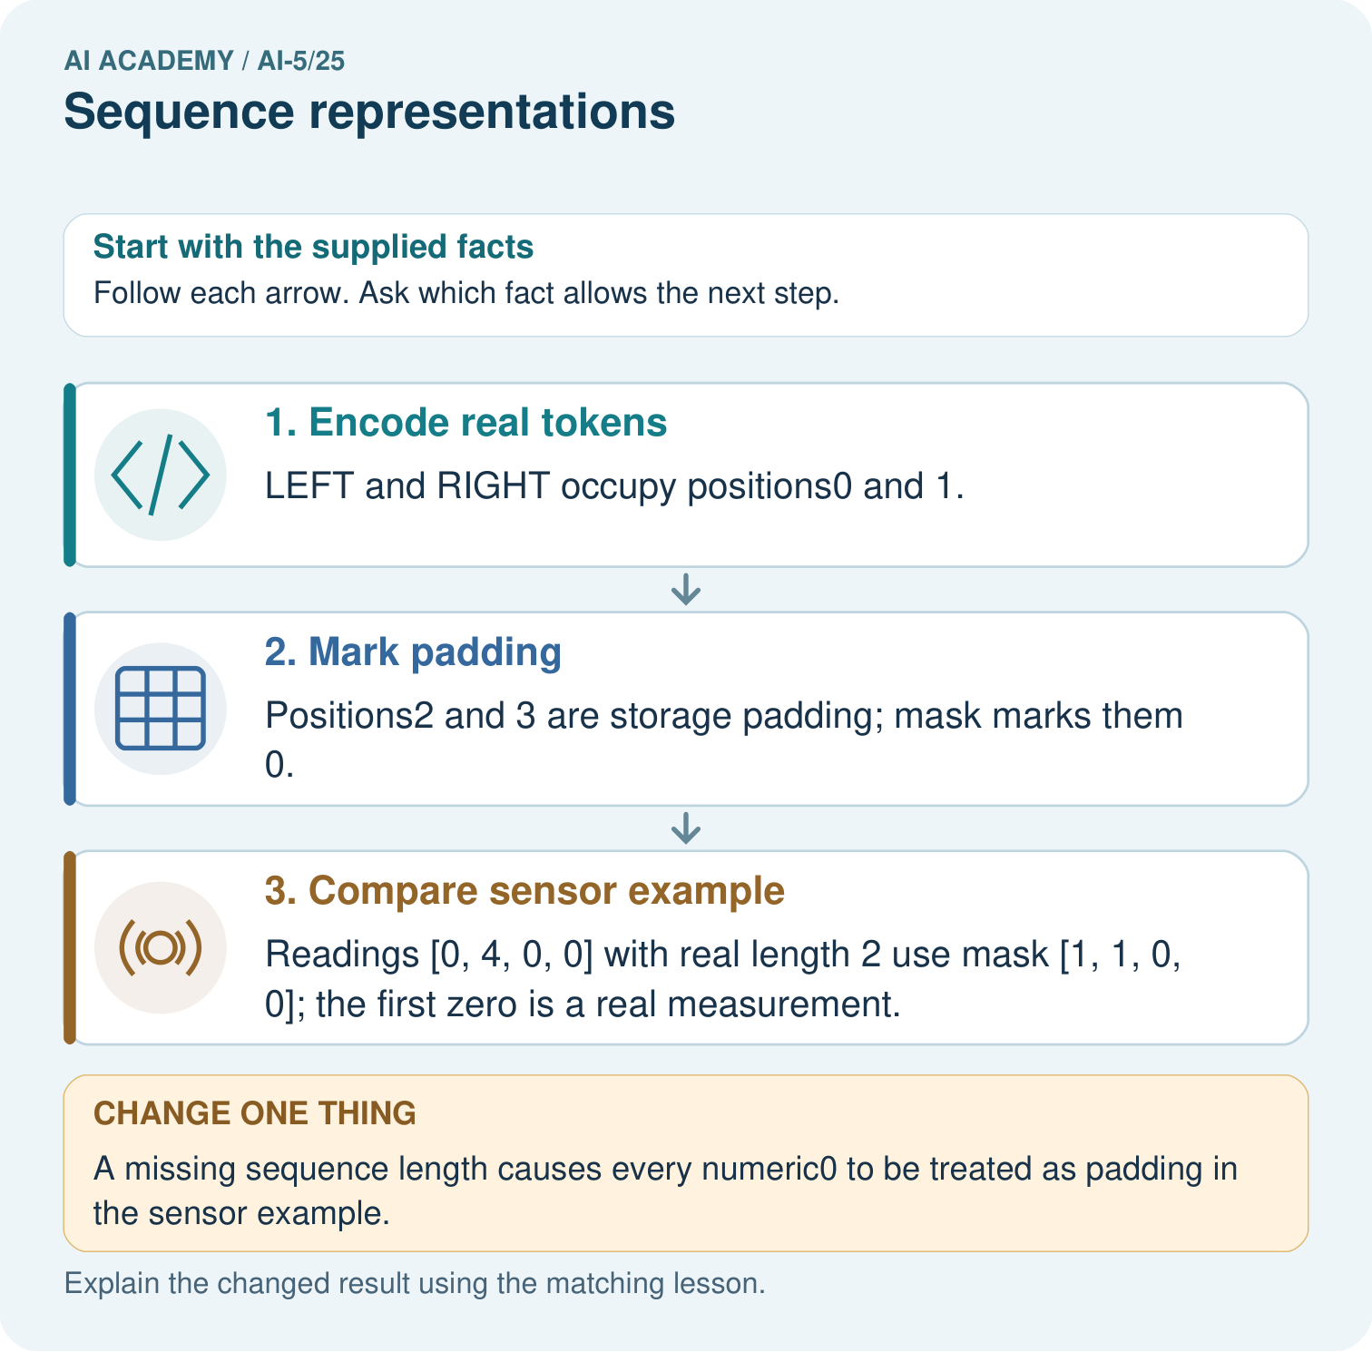
Which record lets the program distinguish the first and last zeros? Point to the relevant step in the picture, then write the changed result and the rule or evidence that supports it.

My picture-based explanation and changed-case prediction
________________________________________________________________
________________________________________________________________
________________________________________________________________
________________________________________________________________
________________________________________________________________
________________________________________________________________
Support used: alone / hint / worked example. This record is practice evidence.
Project connection: For your Image-pattern Network Investigation, save the input, procedure, observed result and limitation of this check. Label this worked example as practice; use a different, previously unreviewed case when checking independent understanding.

