AI ACADEMY · WORKBOOK · ai-5/26

Embeddings and neighbourhoods
Project: Image-pattern Network Investigation

01. Recall and choose your starting point
Try the recall before opening notes. Then use a different colour or a labelled second line to correct your explanation.

Sequence representations
Without opening the old lesson, explain one key idea from Sequence representations. Give an example and a mistake that the idea helps you avoid.

My remembered idea, example and correction
________________________________________________________________
________________________________________________________________
________________________________________________________________

Training a small image model
Without opening the old lesson, explain one key idea from Training a small image model. Give an example and a mistake that the idea helps you avoid.

My remembered idea, example and correction
________________________________________________________________
________________________________________________________________
________________________________________________________________

Image tensors and channels
Without opening the old lesson, explain one key idea from Image tensors and channels. Give an example and a mistake that the idea helps you avoid.

My remembered idea, example and correction
________________________________________________________________
________________________________________________________________
________________________________________________________________

02. Practise with fading help
Use W2: Calculate distances and a tie for Embeddings and neighbourhoods. Record the answer once; the lesson and workbook refer to the same attempt.
Given inputs | Procedure I chose | Middle steps | Result and check

The step I completed without help, and the hint I needed
________________________________________________________________
________________________________________________________________
________________________________________________________________

03. Individual reasoning check
Use the worked case for Embeddings and neighbourhoods. Proposed explanation: “Token ID differences define embedding distances”. Decide whether this explanation is supported. Point to the step or supplied fact that decides; explain your repair if needed.

My explanation before partner discussion
________________________________________________________________
________________________________________________________________
________________________________________________________________
________________________________________________________________

04. Independent transfer case

Independent case: Find a neighbourhood independently
A separate table contains A [0, 0], B [2, 0] and C [1, 2]. For query [1, 0], give all squared distances and every nearest candidate. Then calculate the mean of A and B and compare it with the query. Can that mean identify which ordered pair produced it?

My independent explanation, trace and limits
________________________________________________________________
________________________________________________________________
________________________________________________________________
________________________________________________________________
________________________________________________________________
________________________________________________________________
________________________________________________________________
Attempt this case before feedback. Record any help. Earlier examples below are further practice; a case already practised with feedback cannot establish fresh transfer.

05. W1 Trace the lookup shape
Using the original table, embed TURN WAIT STOP with one right-padding slot. Give the vector sequence, mask and shape.

My reasoning and evidence
________________________________________________________________
________________________________________________________________
________________________________________________________________
________________________________________________________________
________________________________________________________________
________________________________________________________________

06. W2 Calculate distances and a tie
For query [1, 0], compute squared distances to GO, TURN, STOP and WAIT in the original table. Return all nearest candidates.

My reasoning and evidence
________________________________________________________________
________________________________________________________________
________________________________________________________________
________________________________________________________________
________________________________________________________________
________________________________________________________________

07. W3 Trace a trainable row
For the isolated GO-row update, give the gradient, updated vector, starting loss and new loss. Which other token now shares the vector?

My reasoning and evidence
________________________________________________________________
________________________________________________________________
________________________________________________________________
________________________________________________________________
________________________________________________________________
________________________________________________________________

08. W4 Find a neighbourhood independently
A separate table contains A [0, 0], B [2, 0] and C [1, 2]. For query [1, 0], give all squared distances and every nearest candidate. Then calculate the mean of A and B and compare it with the query. Can that mean identify which ordered pair produced it?

My reasoning and evidence
________________________________________________________________
________________________________________________________________
________________________________________________________________
________________________________________________________________
________________________________________________________________
________________________________________________________________
________________________________________________________________
________________________________________________________________

09. W5 Keep the lookup consistent
A developer swaps the IDs of GO and STOP but leaves the embedding rows unchanged. What goes wrong, and what must be saved or changed together?

My reasoning and evidence
________________________________________________________________
________________________________________________________________
________________________________________________________________
________________________________________________________________
________________________________________________________________
________________________________________________________________

10. Project checkpoint and reflection
Add a labelled embeddings and neighbourhoods evidence sheet to Image-pattern Network Investigation. Show how you can look up a vector using a token id and preserve sequence shape. Use the supplied fictional case and keep its inputs, intermediate steps, calculation or prediction, and limitation. Connect this record to last week’s record; a matching answer without a trace is insufficient.

My project change, supporting evidence and remaining limit
________________________________________________________________
________________________________________________________________
________________________________________________________________
________________________________________________________________
________________________________________________________________
________________________________________________________________

11. Feedback, return check and learning record
Evidence | My record
Worked alone / hint / model
First step I repaired and why
New case checked later; date and result
What I can now explain without notes
One remaining question
Revisit this idea with your teacher after a delay. Familiarity is different from explaining and using it on a changed case.

12. Pictorial case practice: Embeddings and neighbourhoods
Measure embedding neighbours without turning numerical proximity into factual certainty.
Toy tableP=[0, 1], Q=[3, 1], R=[1, 4]; query [1, 1]. Use squared Euclidean distance.
All inputs and outcomes in this worked example are invented classroom data; no real model run is claimed.
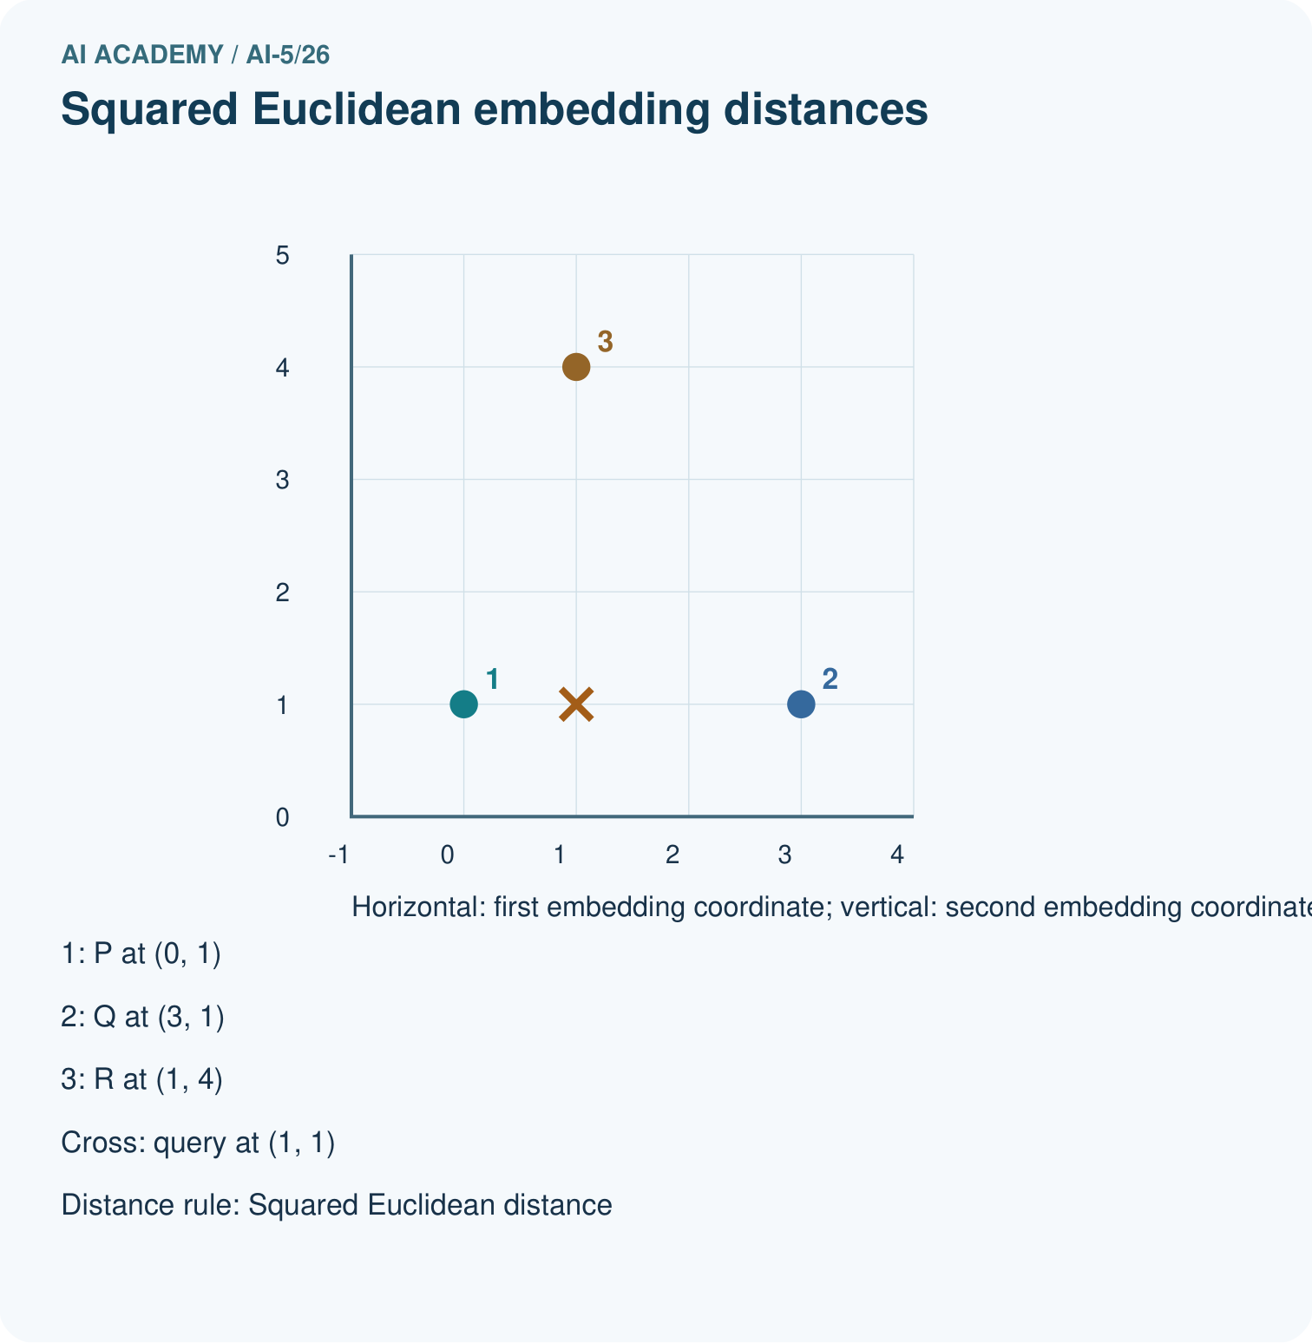
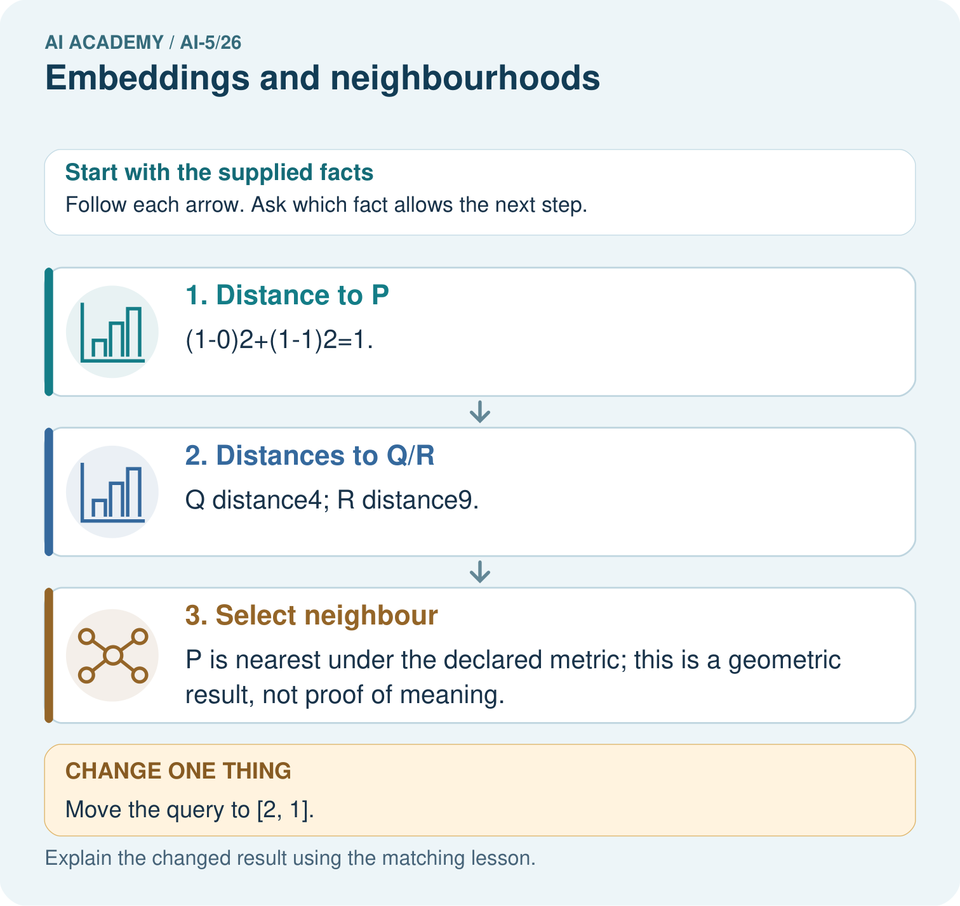
What would justify claiming nearby vectors mean related topics? Point to the relevant step in the picture, then write the changed result and the rule or evidence that supports it.

My picture-based explanation and changed-case prediction
________________________________________________________________
________________________________________________________________
________________________________________________________________
________________________________________________________________
________________________________________________________________
________________________________________________________________
Support used: alone / hint / worked example. This record is practice evidence.
Project connection: For your Image-pattern Network Investigation, save the input, procedure, observed result and limitation of this check. Label this worked example as practice; use a different, previously unreviewed case when checking independent understanding.

