AI ACADEMY · WORKBOOK · ai-5/27

Similarity and normalisation
Project: Image-pattern Network Investigation

01. Recall and choose your starting point
Try the recall before opening notes. Then use a different colour or a labelled second line to correct your explanation.

Embeddings and neighbourhoods
Without opening the old lesson, explain one key idea from Embeddings and neighbourhoods. Give an example and a mistake that the idea helps you avoid.

My remembered idea, example and correction
________________________________________________________________
________________________________________________________________
________________________________________________________________

Augmentation and leakage
Without opening the old lesson, explain one key idea from Augmentation and leakage. Give an example and a mistake that the idea helps you avoid.

My remembered idea, example and correction
________________________________________________________________
________________________________________________________________
________________________________________________________________

Convolution as a local operation
Without opening the old lesson, explain one key idea from Convolution as a local operation. Give an example and a mistake that the idea helps you avoid.

My remembered idea, example and correction
________________________________________________________________
________________________________________________________________
________________________________________________________________

02. Practise with fading help
Use W2: Compare the rankings for Similarity and normalisation. Record the answer once; the lesson and workbook refer to the same attempt.
Given inputs | Procedure I chose | Middle steps | Result and check

The step I completed without help, and the hint I needed
________________________________________________________________
________________________________________________________________
________________________________________________________________

03. Individual reasoning check
Use the worked case for Similarity and normalisation. Proposed explanation: “Cosine is a probability”. Decide whether this explanation is supported. Point to the step or supplied fact that decides; explain your repair if needed.

My explanation before partner discussion
________________________________________________________________
________________________________________________________________
________________________________________________________________
________________________________________________________________

04. Independent transfer case

Independent case: Compare a new case independently
Use query [5, 0] and candidates P [10, 0], R [4, 3] and S [0, 5]. Calculate all raw squared distances and cosines, name each winner, and give squared distances after normalising both query and candidates. Explain the changed ranking.

My independent explanation, trace and limits
________________________________________________________________
________________________________________________________________
________________________________________________________________
________________________________________________________________
________________________________________________________________
________________________________________________________________
________________________________________________________________
Attempt this case before feedback. Record any help. Earlier examples below are further practice; a case already practised with feedback cannot establish fresh transfer.

05. W1 Trace the unit vectors
For Q [3, 4], A [6, 8] and C [-3, -4], give each length and unit vector. Explain one distinction that normalisation removes and one that it preserves.

My reasoning and evidence
________________________________________________________________
________________________________________________________________
________________________________________________________________
________________________________________________________________
________________________________________________________________
________________________________________________________________

06. W2 Compare the rankings
For query Q, write the raw squared distances and cosines to A, B and C from the lesson. Name the winner under each rule. Calculate squared distances after normalising both sides and check the relationship to cosine.

My reasoning and evidence
________________________________________________________________
________________________________________________________________
________________________________________________________________
________________________________________________________________
________________________________________________________________
________________________________________________________________

07. W3 Handle a vector without direction
A candidate set contains Z [0, 0] and B [3, 0]. With nonzero query Q, what happens under this lesson’s zero-vector policy? What if Q is zero, or Z is the only candidate? Explain why replacing an undefined cosine with zero is misleading.

My reasoning and evidence
________________________________________________________________
________________________________________________________________
________________________________________________________________
________________________________________________________________
________________________________________________________________
________________________________________________________________

08. W4 Compare a new case independently
Use query [5, 0] and candidates P [10, 0], R [4, 3] and S [0, 5]. Calculate all raw squared distances and cosines, name each winner, and give squared distances after normalising both query and candidates. Explain the changed ranking.

My reasoning and evidence
________________________________________________________________
________________________________________________________________
________________________________________________________________
________________________________________________________________
________________________________________________________________
________________________________________________________________
________________________________________________________________
________________________________________________________________

09. W5 Audit a proposed improvement
For event-count vectors [3, 4] and [6, 8], what useful information can normalisation remove? A team chooses cosine because it improves results on the final evaluation set, then calls that same set independent evidence. Explain how to repair the evaluation plan.

My reasoning and evidence
________________________________________________________________
________________________________________________________________
________________________________________________________________
________________________________________________________________
________________________________________________________________
________________________________________________________________

10. Project checkpoint and reflection
Add a labelled similarity and normalisation evidence sheet to Image-pattern Network Investigation. Show how you can calculate vector length and normalise a nonzero vector. Use the supplied fictional case and keep its inputs, intermediate steps, calculation or prediction, and limitation. Connect this record to last week’s record; a matching answer without a trace is insufficient.

My project change, supporting evidence and remaining limit
________________________________________________________________
________________________________________________________________
________________________________________________________________
________________________________________________________________
________________________________________________________________
________________________________________________________________

11. Feedback, return check and learning record
Evidence | My record
Worked alone / hint / model
First step I repaired and why
New case checked later; date and result
What I can now explain without notes
One remaining question
Revisit this idea with your teacher after a delay. Familiarity is different from explaining and using it on a changed case.

12. Pictorial case practice: Similarity and normalisation
Compare angular alignment with raw distance on the same vectors.
Query [2, 0]; P=[8, 0]; Q=[2, 1]. Nonzero vectors only; compare squared Euclidean distance and cosine.
All inputs and outcomes in this worked example are invented classroom data; no real model run is claimed.
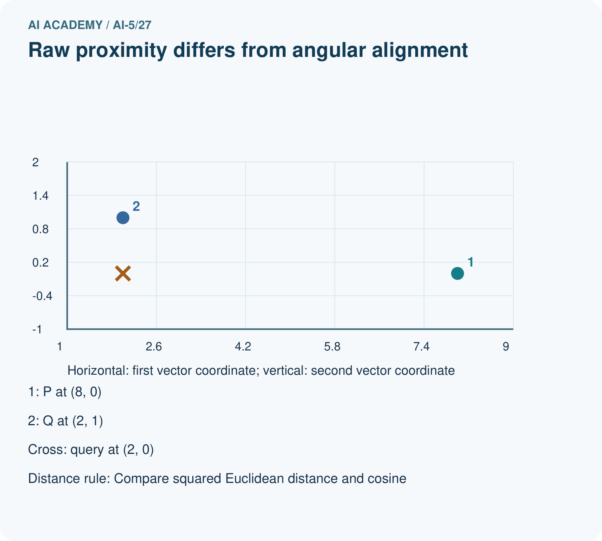
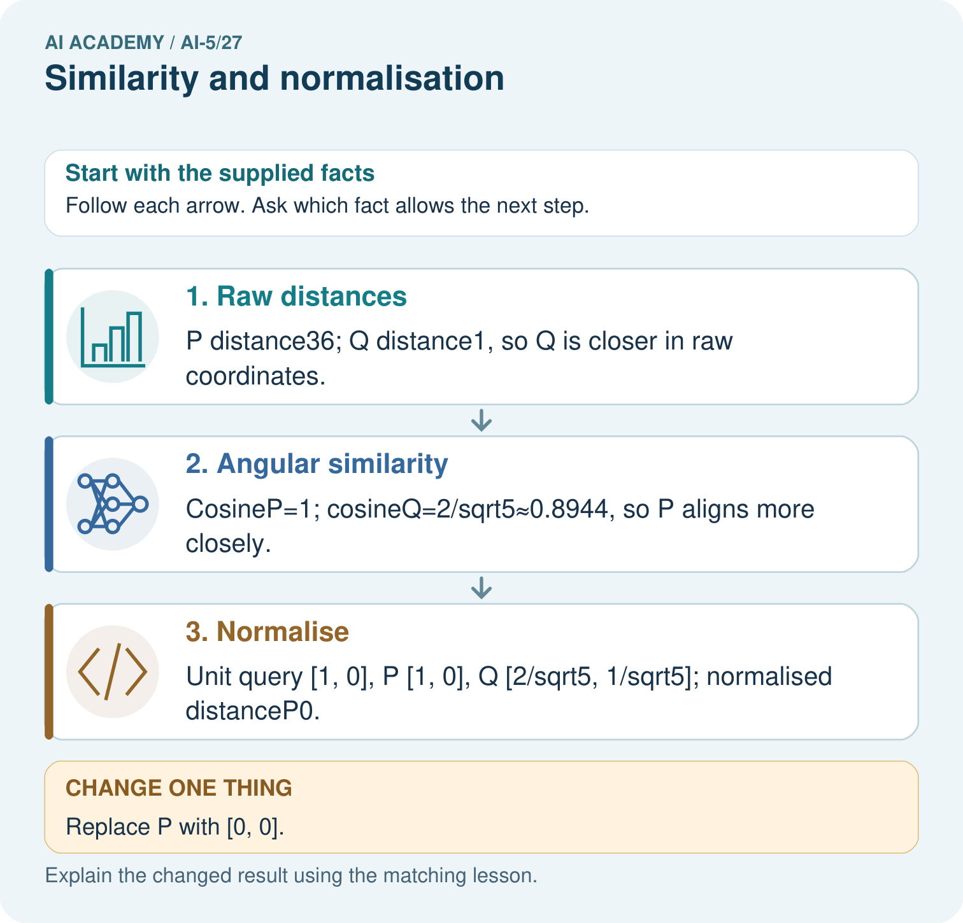
Why do the original two metrics select different winners? Point to the relevant step in the picture, then write the changed result and the rule or evidence that supports it.

My picture-based explanation and changed-case prediction
________________________________________________________________
________________________________________________________________
________________________________________________________________
________________________________________________________________
________________________________________________________________
________________________________________________________________
Support used: alone / hint / worked example. This record is practice evidence.
Project connection: For your Image-pattern Network Investigation, save the input, procedure, observed result and limitation of this check. Label this worked example as practice; use a different, previously unreviewed case when checking independent understanding.

