AI ACADEMY · WORKBOOK · ai-5/28

Transfer learning
Project: Image-pattern Network Investigation

01. Recall and choose your starting point
Try the recall before opening notes. Then use a different colour or a labelled second line to correct your explanation.

Similarity and normalisation
Without opening the old lesson, explain one key idea from Similarity and normalisation. Give an example and a mistake that the idea helps you avoid.

My remembered idea, example and correction
________________________________________________________________
________________________________________________________________
________________________________________________________________

Sequence representations
Without opening the old lesson, explain one key idea from Sequence representations. Give an example and a mistake that the idea helps you avoid.

My remembered idea, example and correction
________________________________________________________________
________________________________________________________________
________________________________________________________________

Pooling and spatial information
Without opening the old lesson, explain one key idea from Pooling and spatial information. Give an example and a mistake that the idea helps you avoid.

My remembered idea, example and correction
________________________________________________________________
________________________________________________________________
________________________________________________________________

02. Practise with fading help
Use W2: Fit and compare for Transfer learning. Record the answer once; the lesson and workbook refer to the same attempt.
Given inputs | Procedure I chose | Middle steps | Result and check

The step I completed without help, and the hint I needed
________________________________________________________________
________________________________________________________________
________________________________________________________________

03. Individual reasoning check
Use the worked case for Transfer learning. Proposed explanation: “Frozen means the whole model cannot learn”. Decide whether this explanation is supported. Point to the step or supplied fact that decides; explain your repair if needed.

My explanation before partner discussion
________________________________________________________________
________________________________________________________________
________________________________________________________________
________________________________________________________________

04. Independent transfer case

Independent case: Fit a new head independently
A separate frozen extractor is h = 2*x1 + x2. Training inputs [1, 0], [1, 2], [2, 1], [3, 1] have labels 0, 0, 1, 1. Compare thresholds 2, 4 and 6 using prediction 1 when h >= threshold; choose the fewest mistakes, breaking ties toward the smaller threshold. Score it on validation [2, 0] with label 1 and [0, 2] with label 0. Compare with the training-majority baseline, whose tie rule chooses 0.

My independent explanation, trace and limits
________________________________________________________________
________________________________________________________________
________________________________________________________________
________________________________________________________________
________________________________________________________________
________________________________________________________________
________________________________________________________________
Attempt this case before feedback. Record any help. Earlier examples below are further practice; a case already practised with feedback cannot establish fresh transfer.

05. W1 Trace the reused pipeline
For input [4, 2], compute h using the original extractor and the class at threshold 5. Identify the frozen weights and bias, the fitted quantity, and why h is not a probability.

My reasoning and evidence
________________________________________________________________
________________________________________________________________
________________________________________________________________
________________________________________________________________
________________________________________________________________
________________________________________________________________

06. W2 Fit and compare
For the four target training records, give the number of mistakes at thresholds 3, 5 and 7 and choose the fitted threshold. Then score that head and the declared constant baseline on V1 and V2. Explain which data fitted the head.

My reasoning and evidence
________________________________________________________________
________________________________________________________________
________________________________________________________________
________________________________________________________________
________________________________________________________________
________________________________________________________________

07. W3 Diagnose a lost distinction
For the first-count-greater target, explain why the original extractor cannot distinguish U [1, 3] from V [3, 1]. Trace the hand-chosen [1, -1] extractor and threshold 1. Does this show that fine tuning has been trained and independently validated?

My reasoning and evidence
________________________________________________________________
________________________________________________________________
________________________________________________________________
________________________________________________________________
________________________________________________________________
________________________________________________________________

08. W4 Fit a new head independently
A separate frozen extractor is h = 2*x1 + x2. Training inputs [1, 0], [1, 2], [2, 1], [3, 1] have labels 0, 0, 1, 1. Compare thresholds 2, 4 and 6 using prediction 1 when h >= threshold; choose the fewest mistakes, breaking ties toward the smaller threshold. Score it on validation [2, 0] with label 1 and [0, 2] with label 0. Compare with the training-majority baseline, whose tie rule chooses 0.

My reasoning and evidence
________________________________________________________________
________________________________________________________________
________________________________________________________________
________________________________________________________________
________________________________________________________________
________________________________________________________________
________________________________________________________________
________________________________________________________________

09. W5 Plan credible evidence
A report omits the source checkpoint and preprocessing, claims faster learning without timing, and repeatedly chooses settings using the final evaluation set. Name the missing records and propose a fair comparison with a model trained from scratch.

My reasoning and evidence
________________________________________________________________
________________________________________________________________
________________________________________________________________
________________________________________________________________
________________________________________________________________
________________________________________________________________

10. Project checkpoint and reflection
Add a labelled transfer learning evidence sheet to Image-pattern Network Investigation. Show how you can trace a reused feature extractor and a newly fitted output head. Use the supplied fictional case and keep its inputs, intermediate steps, calculation or prediction, and limitation. Connect this record to last week’s record; a matching answer without a trace is insufficient.

My project change, supporting evidence and remaining limit
________________________________________________________________
________________________________________________________________
________________________________________________________________
________________________________________________________________
________________________________________________________________
________________________________________________________________

11. Feedback, return check and learning record
Evidence | My record
Worked alone / hint / model
First step I repaired and why
New case checked later; date and result
What I can now explain without notes
One remaining question
Revisit this idea with your teacher after a delay. Familiarity is different from explaining and using it on a changed case.

12. Pictorial case practice: Transfer learning
Transfer a fixed feature extractor while identifying what is actually refitted.
Frozen extractorh=left+2right. New-task training inputs [1, 0]label0,[2, 1]label0,[1, 3]label1. Class1 whenh>=threshold; candidates3 or5.
All inputs and outcomes in this worked example are invented classroom data; no real model run is claimed.
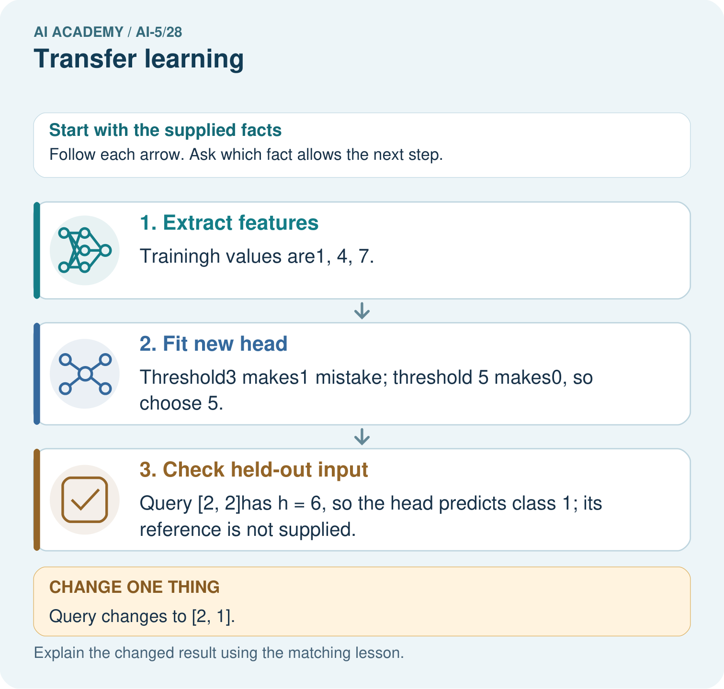
Which part was trained for the new task? Point to the relevant step in the picture, then write the changed result and the rule or evidence that supports it.

My picture-based explanation and changed-case prediction
________________________________________________________________
________________________________________________________________
________________________________________________________________
________________________________________________________________
________________________________________________________________
________________________________________________________________
Support used: alone / hint / worked example. This record is practice evidence.
Project connection: For your Image-pattern Network Investigation, save the input, procedure, observed result and limitation of this check. Label this worked example as practice; use a different, previously unreviewed case when checking independent understanding.

