AI ACADEMY · WORKBOOK · ai-5/29

Uncertainty and failure analysis
Project: Image-pattern Network Investigation

01. Recall and choose your starting point
Try the recall before opening notes. Then use a different colour or a labelled second line to correct your explanation.

Transfer learning
Without opening the old lesson, explain one key idea from Transfer learning. Give an example and a mistake that the idea helps you avoid.

My remembered idea, example and correction
________________________________________________________________
________________________________________________________________
________________________________________________________________

Embeddings and neighbourhoods
Without opening the old lesson, explain one key idea from Embeddings and neighbourhoods. Give an example and a mistake that the idea helps you avoid.

My remembered idea, example and correction
________________________________________________________________
________________________________________________________________
________________________________________________________________

Training a small image model
Without opening the old lesson, explain one key idea from Training a small image model. Give an example and a mistake that the idea helps you avoid.

My remembered idea, example and correction
________________________________________________________________
________________________________________________________________
________________________________________________________________

02. Practise with fading help
Use W2: Count both types of error for Uncertainty and failure analysis. Record the answer once; the lesson and workbook refer to the same attempt.
Given inputs | Procedure I chose | Middle steps | Result and check

The step I completed without help, and the hint I needed
________________________________________________________________
________________________________________________________________
________________________________________________________________

03. Individual reasoning check
Use the worked case for Uncertainty and failure analysis. Proposed explanation: “A low p1 always means low confidence”. Decide whether this explanation is supported. Point to the step or supplied fact that decides; explain your repair if needed.

My explanation before partner discussion
________________________________________________________________
________________________________________________________________
________________________________________________________________
________________________________________________________________

04. Independent transfer case

Independent case: Analyse new outputs independently
Four new cases have (p1, reference label): K (0.85, 0), L (0.70, 1), M (0.30, 0), N (0.05, 0). Give predictions and confidences, overall accuracy, and accepted cases at cutoff 0.80. Calculate coverage and accepted-case accuracy. Does this policy improve accuracy on the accepted subset here?

My independent explanation, trace and limits
________________________________________________________________
________________________________________________________________
________________________________________________________________
________________________________________________________________
________________________________________________________________
________________________________________________________________
________________________________________________________________
Attempt this case before feedback. Record any help. Earlier examples below are further practice; a case already practised with feedback cannot establish fresh transfer.

05. W1 Separate confidence from correctness
For B, E and F, give the predicted class, selected-class confidence and correctness. Explain why p1 = 0.10 does not mean F has low confidence in its predicted class.

My reasoning and evidence
________________________________________________________________
________________________________________________________________
________________________________________________________________
________________________________________________________________
________________________________________________________________
________________________________________________________________

06. W2 Count both types of error
For all six cases, list false positives and false negatives, count true positives and true negatives, and calculate overall accuracy. Why might a single accuracy hide useful information?

My reasoning and evidence
________________________________________________________________
________________________________________________________________
________________________________________________________________
________________________________________________________________
________________________________________________________________
________________________________________________________________

07. W3 Audit the review policy
At cutoff 0.80, list accepted and deferred cases, coverage and accepted-case accuracy. Can you calculate final accuracy after human review from the supplied data? What does the report function return for accepted-case accuracy at cutoff 0.99?

My reasoning and evidence
________________________________________________________________
________________________________________________________________
________________________________________________________________
________________________________________________________________
________________________________________________________________
________________________________________________________________

08. W4 Analyse new outputs independently
Four new cases have (p1, reference label): K (0.85, 0), L (0.70, 1), M (0.30, 0), N (0.05, 0). Give predictions and confidences, overall accuracy, and accepted cases at cutoff 0.80. Calculate coverage and accepted-case accuracy. Does this policy improve accuracy on the accepted subset here?

My reasoning and evidence
________________________________________________________________
________________________________________________________________
________________________________________________________________
________________________________________________________________
________________________________________________________________
________________________________________________________________
________________________________________________________________
________________________________________________________________

09. W5 Design a failure investigation
All three blurred cases are wrong. A team claims blur caused the errors and plans to put clear images in training and their blurred copies in final evaluation. Identify the unsupported claim and the split problem; propose a better investigation.

My reasoning and evidence
________________________________________________________________
________________________________________________________________
________________________________________________________________
________________________________________________________________
________________________________________________________________
________________________________________________________________

10. Project checkpoint and reflection
Add a labelled uncertainty and failure analysis evidence sheet to Image-pattern Network Investigation. Show how you can distinguish a predicted class, confidence score and observed correctness. Use the supplied fictional case and keep its inputs, intermediate steps, calculation or prediction, and limitation. Connect this record to last week’s record; a matching answer without a trace is insufficient.

My project change, supporting evidence and remaining limit
________________________________________________________________
________________________________________________________________
________________________________________________________________
________________________________________________________________
________________________________________________________________
________________________________________________________________

11. Feedback, return check and learning record
Evidence | My record
Worked alone / hint / model
First step I repaired and why
New case checked later; date and result
What I can now explain without notes
One remaining question
Revisit this idea with your teacher after a delay. Familiarity is different from explaining and using it on a changed case.

12. Pictorial case practice: Uncertainty and failure analysis
Keep positive-class probability separate from confidence in the chosen label.
Supplied p(class 1): A: 0.9 reference 0; B: 0.6 reference 1; C: 0.2 reference 0. Predict class 1 at p>=0.5; confidence=max(p, 1-p).
All inputs and outcomes in this worked example are invented classroom data; no real model run is claimed.
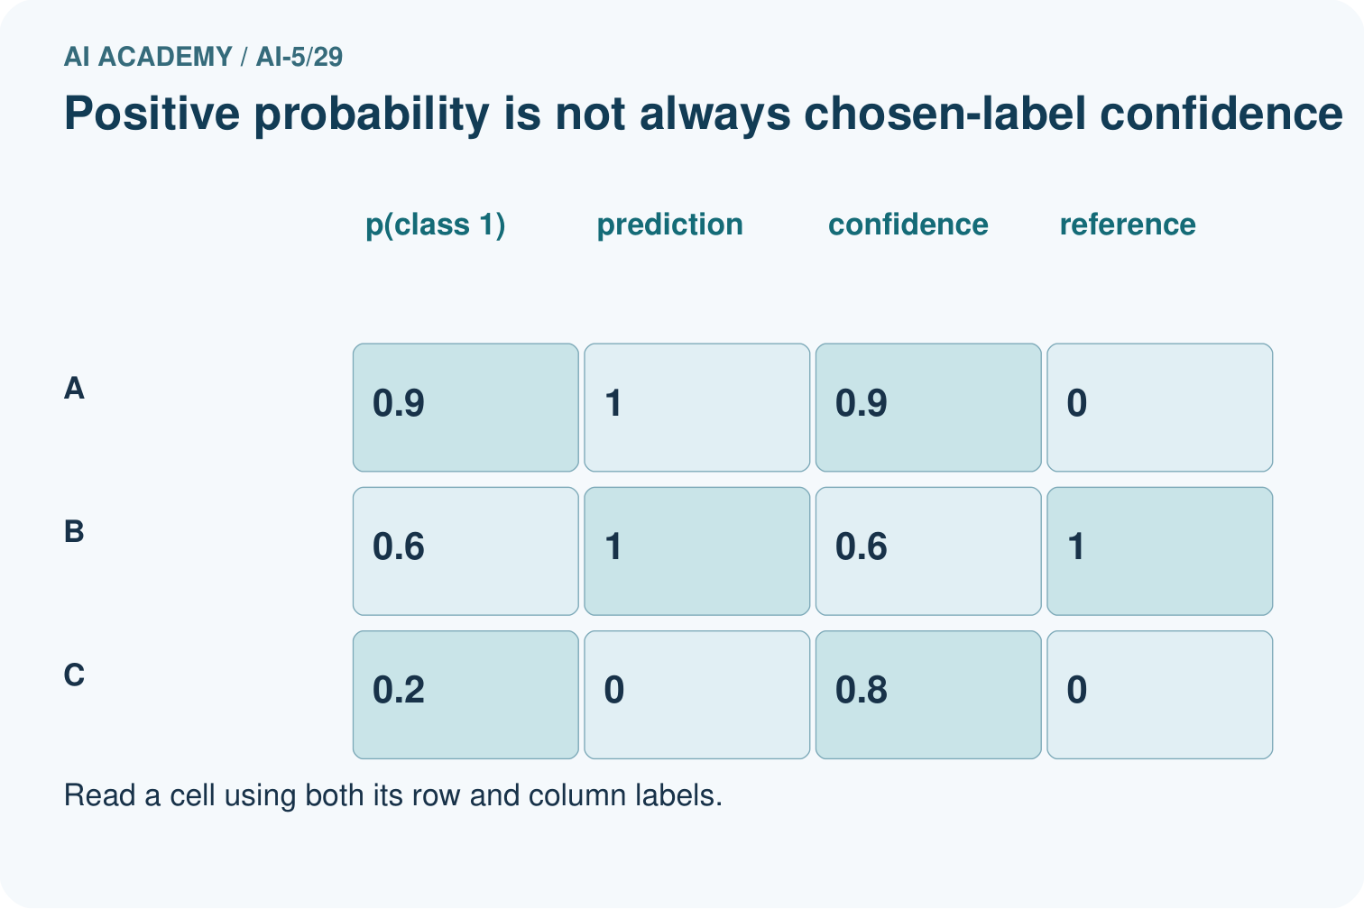
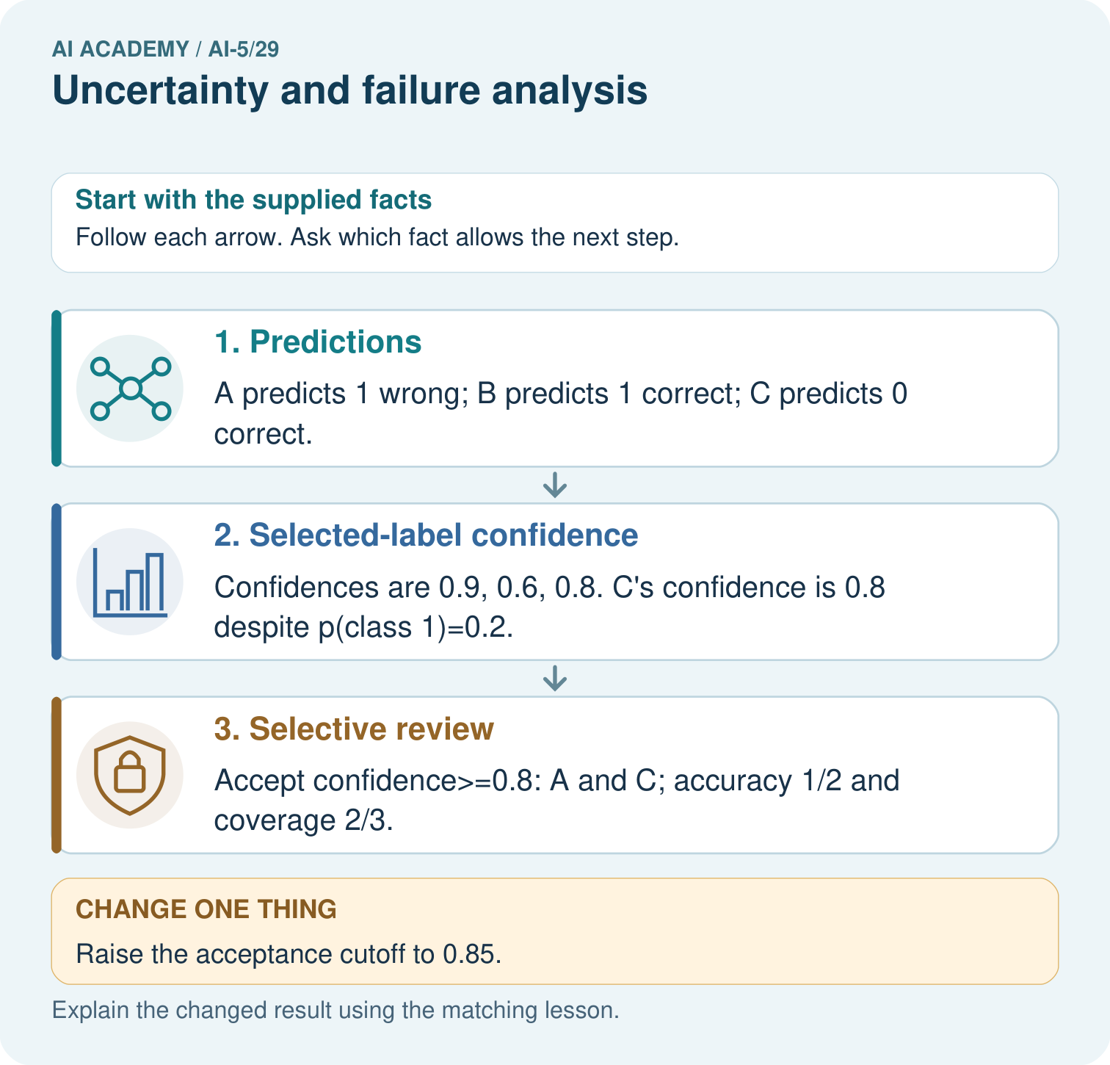
What is C’s positive-class probability and chosen-label confidence? Point to the relevant step in the picture, then write the changed result and the rule or evidence that supports it.

My picture-based explanation and changed-case prediction
________________________________________________________________
________________________________________________________________
________________________________________________________________
________________________________________________________________
________________________________________________________________
________________________________________________________________
Support used: alone / hint / worked example. This record is practice evidence.
Project connection: For your Image-pattern Network Investigation, save the input, procedure, observed result and limitation of this check. Label this worked example as practice; use a different, previously unreviewed case when checking independent understanding.

