AI ACADEMY · WORKBOOK · ai-5/31

Efficiency and resource measurement
Project: Image-pattern Network Investigation

01. Recall and choose your starting point
Try the recall before opening notes. Then use a different colour or a labelled second line to correct your explanation.

Dataset shift in neural models
Without opening the old lesson, explain one key idea from Dataset shift in neural models. Give an example and a mistake that the idea helps you avoid.

My remembered idea, example and correction
________________________________________________________________
________________________________________________________________
________________________________________________________________

Transfer learning
Without opening the old lesson, explain one key idea from Transfer learning. Give an example and a mistake that the idea helps you avoid.

My remembered idea, example and correction
________________________________________________________________
________________________________________________________________
________________________________________________________________

Sequence representations
Without opening the old lesson, explain one key idea from Sequence representations. Give an example and a mistake that the idea helps you avoid.

My remembered idea, example and correction
________________________________________________________________
________________________________________________________________
________________________________________________________________

02. Practise with fading help
Use W2: Compare under requirements for Efficiency and resource measurement. Record the answer once; the lesson and workbook refer to the same attempt.
Given inputs | Procedure I chose | Middle steps | Result and check

The step I completed without help, and the hint I needed
________________________________________________________________
________________________________________________________________
________________________________________________________________

03. Individual reasoning check
Use the worked case for Efficiency and resource measurement. Proposed explanation: “Fewer parameters always means faster”. Decide whether this explanation is supported. Point to the step or supplied fact that decides; explain your repair if needed.

My explanation before partner discussion
________________________________________________________________
________________________________________________________________
________________________________________________________________
________________________________________________________________

04. Independent transfer case

Independent case: Evaluate a new case independently
For 50 shared validation cases, P has times 0.6, 0.5, 0.4 seconds and 47 correct; Q has 0.3, 0.4, 0.5 seconds and 45 correct. Require at least 92 percent accuracy and at most 12 ms amortised time. Give median times, amortised times, throughput, accuracy and eligible models. A separate dense network has dimensions 3 to 2 to 1 with one bias per output: find its parameter count and raw bytes at four bytes each.

My independent explanation, trace and limits
________________________________________________________________
________________________________________________________________
________________________________________________________________
________________________________________________________________
________________________________________________________________
________________________________________________________________
________________________________________________________________
Attempt this case before feedback. Record any help. Earlier examples below are further practice; a case already practised with feedback cannot establish fresh transfer.

05. W1 Summarise repeated timings
For A and B, calculate median pass time, amortised milliseconds per example and median-pass throughput. State the measured boundary and one latency claim these numbers cannot support.

My reasoning and evidence
________________________________________________________________
________________________________________________________________
________________________________________________________________
________________________________________________________________
________________________________________________________________
________________________________________________________________

06. W2 Compare under requirements
With at least 91 correct out of 100 and at most 25 ms amortised time required, which model qualifies? Calculate B’s time reduction relative to A and explain why the percentage throughput increase differs.

My reasoning and evidence
________________________________________________________________
________________________________________________________________
________________________________________________________________
________________________________________________________________
________________________________________________________________
________________________________________________________________

07. W3 Separate storage and memory
Count weights, biases and total parameters in the 4 to 3 to 2 network. Calculate raw parameter bytes at four bytes each. Explain why this cannot be reported as peak training memory or an energy measurement.

My reasoning and evidence
________________________________________________________________
________________________________________________________________
________________________________________________________________
________________________________________________________________
________________________________________________________________
________________________________________________________________

08. W4 Evaluate a new case independently
For 50 shared validation cases, P has times 0.6, 0.5, 0.4 seconds and 47 correct; Q has 0.3, 0.4, 0.5 seconds and 45 correct. Require at least 92 percent accuracy and at most 12 ms amortised time. Give median times, amortised times, throughput, accuracy and eligible models. A separate dense network has dimensions 3 to 2 to 1 with one bias per output: find its parameter count and raw bytes at four bytes each.

My reasoning and evidence
________________________________________________________________
________________________________________________________________
________________________________________________________________
________________________________________________________________
________________________________________________________________
________________________________________________________________
________________________________________________________________
________________________________________________________________

09. W5 Repair an unfair benchmark
A runs on one device with batch size 1; B runs on another with batch size 32. Only B’s fastest trial and the winning training run are reported. Explain how to compare and report the results fairly.

My reasoning and evidence
________________________________________________________________
________________________________________________________________
________________________________________________________________
________________________________________________________________
________________________________________________________________
________________________________________________________________

10. Project checkpoint and reflection
Add a labelled efficiency and resource measurement evidence sheet to Image-pattern Network Investigation. Show how you can calculate throughput and amortised time per example from repeated timings. Use the supplied fictional case and keep its inputs, intermediate steps, calculation or prediction, and limitation. Connect this record to last week’s record; a matching answer without a trace is insufficient.

My project change, supporting evidence and remaining limit
________________________________________________________________
________________________________________________________________
________________________________________________________________
________________________________________________________________
________________________________________________________________
________________________________________________________________

11. Feedback, return check and learning record
Evidence | My record
Worked alone / hint / model
First step I repaired and why
New case checked later; date and result
What I can now explain without notes
One remaining question
Revisit this idea with your teacher after a delay. Familiarity is different from explaining and using it on a changed case.

12. Pictorial case practice: Efficiency and resource measurement
Compare speed and quality under the same case count and acceptance contract.
Both evaluate40 cases. P times [0.32, 0.40, 0.48]seconds, 38 correct; Q times [0.20, 0.24, 0.28]seconds, 36 correct. Requireaccuracy>=93% and mean amortised time<=12ms/case.
All inputs and outcomes in this worked example are invented classroom data; no real model run is claimed.
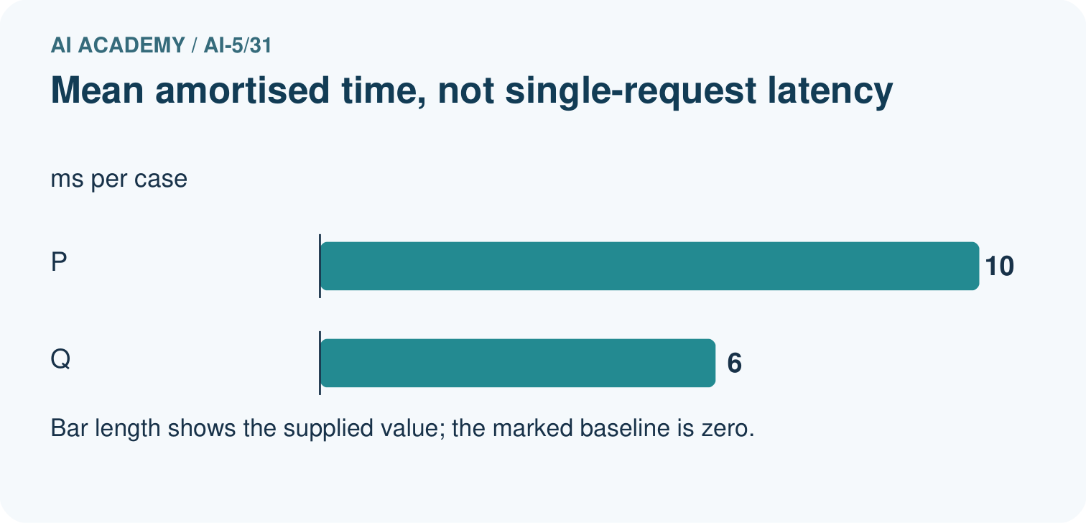
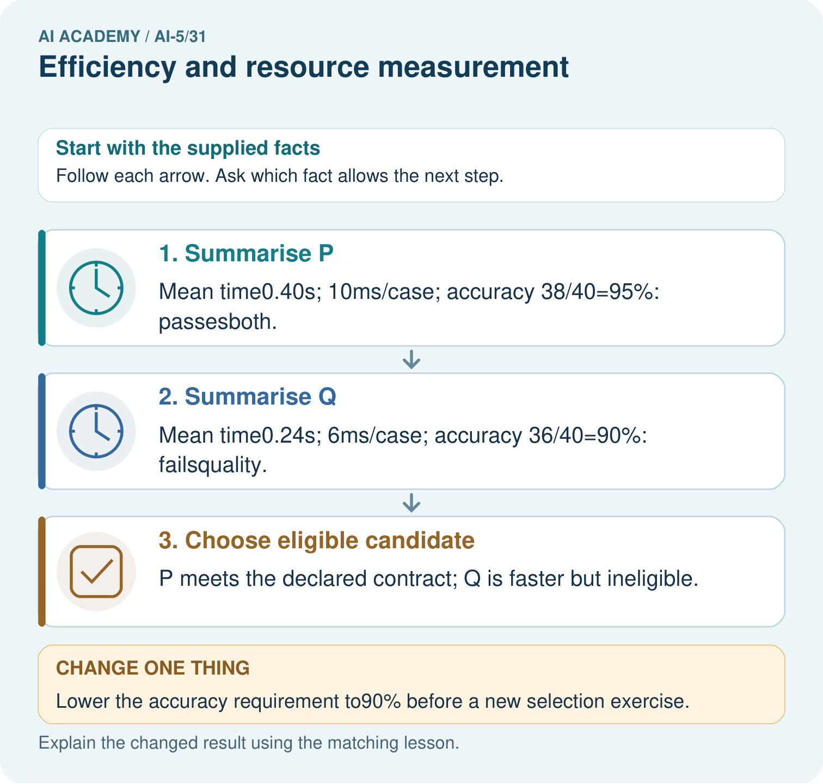
Why is 10ms/case not necessarily a single-request latency? Point to the relevant step in the picture, then write the changed result and the rule or evidence that supports it.

My picture-based explanation and changed-case prediction
________________________________________________________________
________________________________________________________________
________________________________________________________________
________________________________________________________________
________________________________________________________________
________________________________________________________________
Support used: alone / hint / worked example. This record is practice evidence.
Project connection: For your Image-pattern Network Investigation, save the input, procedure, observed result and limitation of this check. Label this worked example as practice; use a different, previously unreviewed case when checking independent understanding.

