AI ACADEMY · WORKBOOK · ai-5/32

Documenting a network experiment
Project: Image-pattern Network Investigation

01. Recall and choose your starting point
Try the recall before opening notes. Then use a different colour or a labelled second line to correct your explanation.

Efficiency and resource measurement
Without opening the old lesson, explain one key idea from Efficiency and resource measurement. Give an example and a mistake that the idea helps you avoid.

My remembered idea, example and correction
________________________________________________________________
________________________________________________________________
________________________________________________________________

Uncertainty and failure analysis
Without opening the old lesson, explain one key idea from Uncertainty and failure analysis. Give an example and a mistake that the idea helps you avoid.

My remembered idea, example and correction
________________________________________________________________
________________________________________________________________
________________________________________________________________

Embeddings and neighbourhoods
Without opening the old lesson, explain one key idea from Embeddings and neighbourhoods. Give an example and a mistake that the idea helps you avoid.

My remembered idea, example and correction
________________________________________________________________
________________________________________________________________
________________________________________________________________

02. Practise with fading help
Use W2: Trace the selected result for Documenting a network experiment. Record the answer once; the lesson and workbook refer to the same attempt.
Given inputs | Procedure I chose | Middle steps | Result and check

The step I completed without help, and the hint I needed
________________________________________________________________
________________________________________________________________
________________________________________________________________

03. Individual reasoning check
Use the worked case for Documenting a network experiment. Proposed explanation: “A smaller MSE is an accuracy percentage”. Decide whether this explanation is supported. Point to the step or supplied fact that decides; explain your repair if needed.

My explanation before partner discussion
________________________________________________________________
________________________________________________________________
________________________________________________________________
________________________________________________________________

04. Independent transfer case

Independent case: Audit a new record independently
A separate run R17 records baseline a = 1 and checkpoints a = 1.5 and a = 1.75. It uses prediction max(0, a*x) and one validation case V9 with x = 4, y = 8. Compute baseline and checkpoint predictions and squared errors, choose by lowest validation MSE, and write a bounded conclusion. Final evaluation and runtime have not been measured.

My independent explanation, trace and limits
________________________________________________________________
________________________________________________________________
________________________________________________________________
________________________________________________________________
________________________________________________________________
________________________________________________________________
________________________________________________________________
Attempt this case before feedback. Record any help. Earlier examples below are further practice; a case already practised with feedback cannot establish fresh transfer.

05. W1 Write the replay settings
For NN32-A, record the prediction rule, initial weight, bias policy, learning rate, update count, loss, training/validation IDs, data order or shuffling policy, and checkpoint selection rule. Name one environment field still to record when you run it.

My reasoning and evidence
________________________________________________________________
________________________________________________________________
________________________________________________________________
________________________________________________________________
________________________________________________________________
________________________________________________________________

06. W2 Trace the selected result
Calculate both weight updates and give each training and validation MSE. Name the selected checkpoint and baseline validation MSE. How many independent validation examples support the comparison?

My reasoning and evidence
________________________________________________________________
________________________________________________________________
________________________________________________________________
________________________________________________________________
________________________________________________________________
________________________________________________________________

07. W3 Audit the artifact record
A folder contains only best-model.json and a screenshot of 0.5625. Identify four missing artifacts or records and explain what a content hash can and cannot verify.

My reasoning and evidence
________________________________________________________________
________________________________________________________________
________________________________________________________________
________________________________________________________________
________________________________________________________________
________________________________________________________________

08. W4 Audit a new record independently
A separate run R17 records baseline a = 1 and checkpoints a = 1.5 and a = 1.75. It uses prediction max(0, a*x) and one validation case V9 with x = 4, y = 8. Compute baseline and checkpoint predictions and squared errors, choose by lowest validation MSE, and write a bounded conclusion. Final evaluation and runtime have not been measured.

My reasoning and evidence
________________________________________________________________
________________________________________________________________
________________________________________________________________
________________________________________________________________
________________________________________________________________
________________________________________________________________
________________________________________________________________
________________________________________________________________

09. W5 Investigate a replay mismatch
A partner gets different results after changing preprocessing and replacing the validation file. They keep the old run ID and overwrite the old score. Explain what should be preserved and how the revised work should be recorded.

My reasoning and evidence
________________________________________________________________
________________________________________________________________
________________________________________________________________
________________________________________________________________
________________________________________________________________
________________________________________________________________

10. Project checkpoint and reflection
Add a labelled documenting a network experiment evidence sheet to Image-pattern Network Investigation. Show how you can record a network experiment with enough detail to replay its calculations. Use the supplied fictional case and keep its inputs, intermediate steps, calculation or prediction, and limitation. Connect this record to last week’s record; a matching answer without a trace is insufficient.

My project change, supporting evidence and remaining limit
________________________________________________________________
________________________________________________________________
________________________________________________________________
________________________________________________________________
________________________________________________________________
________________________________________________________________

11. Feedback, return check and learning record
Evidence | My record
Worked alone / hint / model
First step I repaired and why
New case checked later; date and result
What I can now explain without notes
One remaining question
Revisit this idea with your teacher after a delay. Familiarity is different from explaining and using it on a changed case.

12. Pictorial case practice: Documenting a network experiment
Document checkpoint selection so another team can reconstruct every reported number.
Run R8 predicts ReLU(a×x). Validation V4 has x = 2, target 3. Baseline a = 0.5; checkpoints a = 1 and 1.25; choose minimum validation squared error.
All inputs and outcomes in this worked example are invented classroom data; no real model run is claimed.
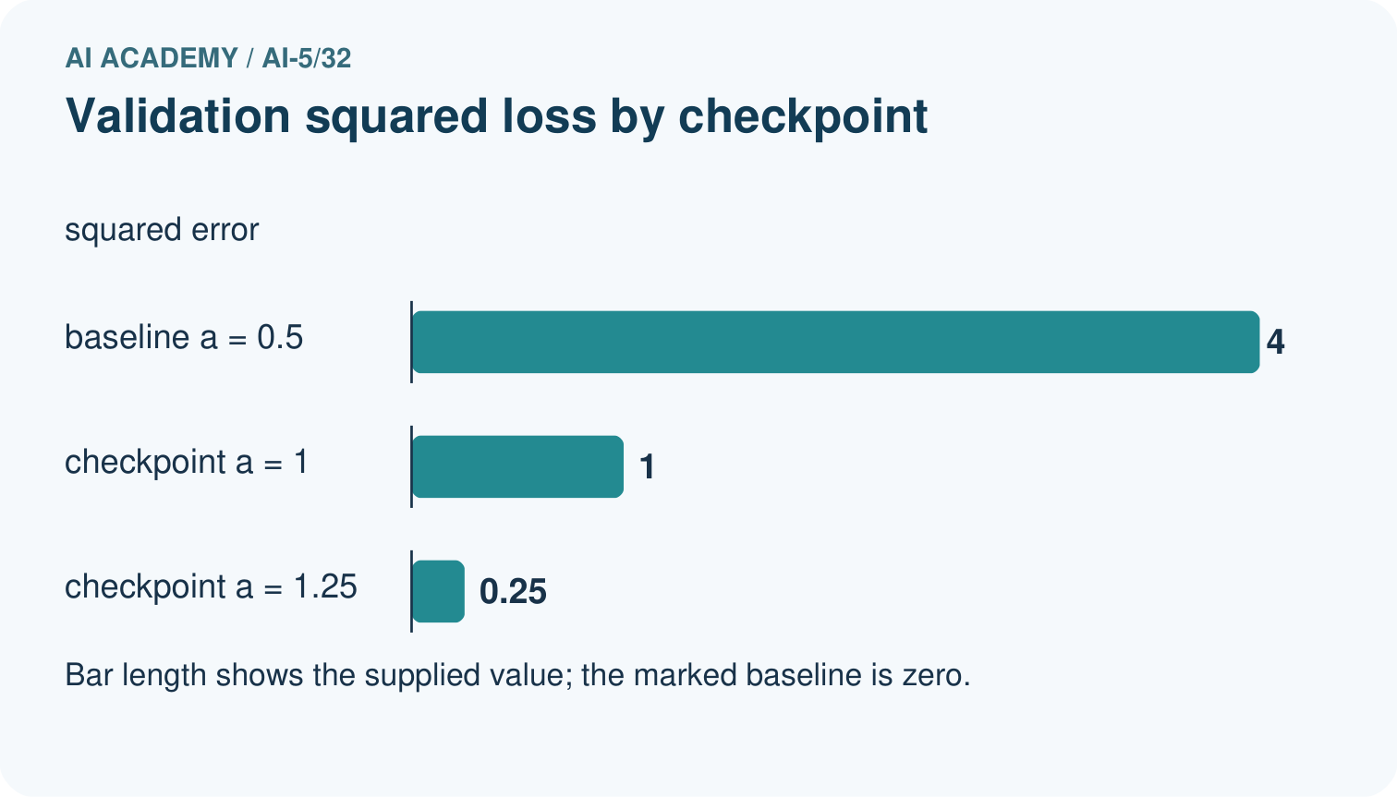
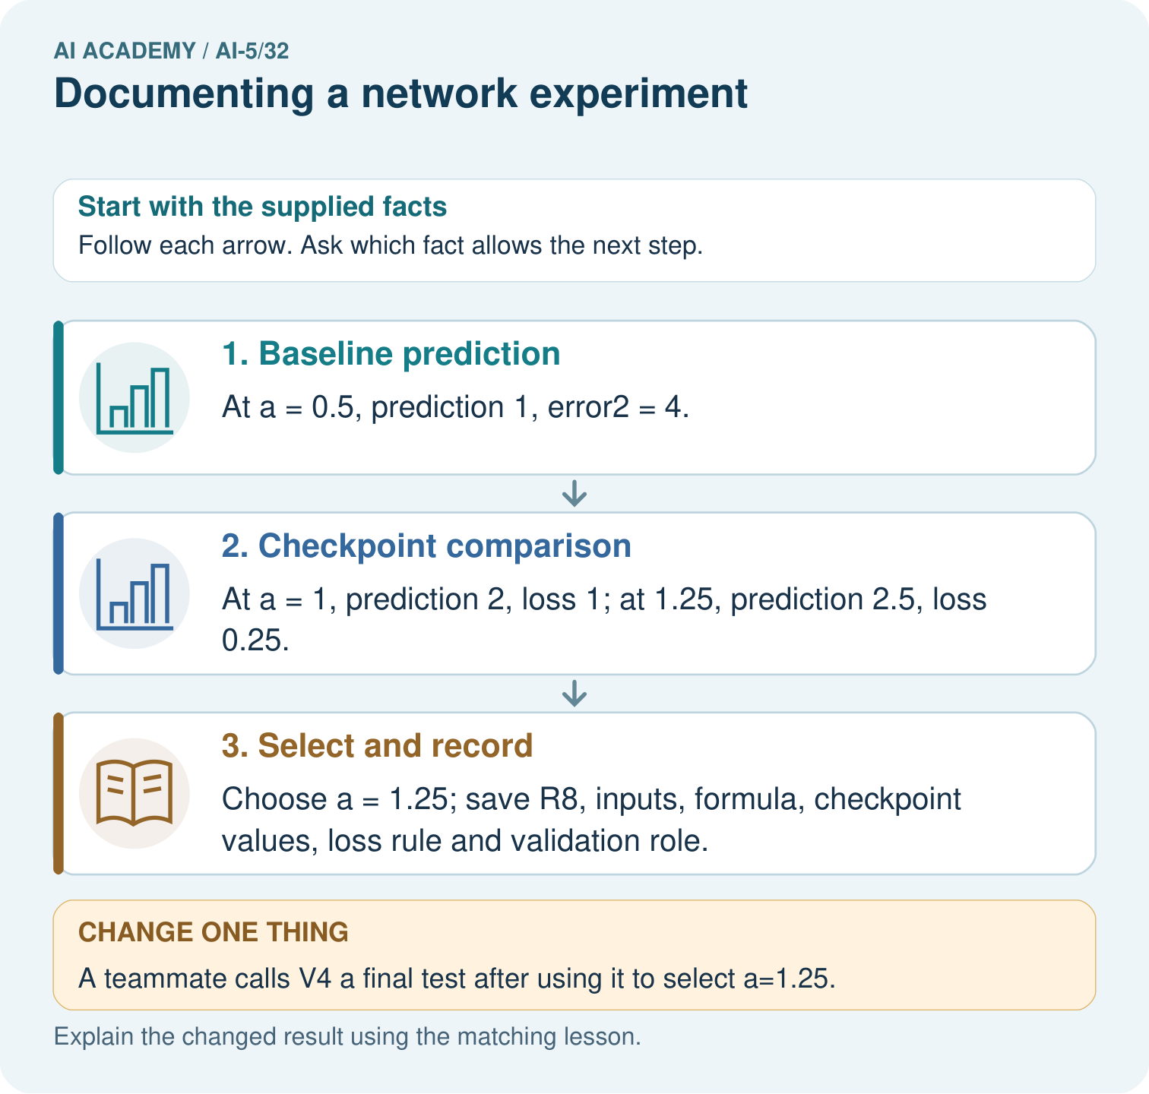
What additional evidence is needed for a final performance claim? Point to the relevant step in the picture, then write the changed result and the rule or evidence that supports it.

My picture-based explanation and changed-case prediction
________________________________________________________________
________________________________________________________________
________________________________________________________________
________________________________________________________________
________________________________________________________________
________________________________________________________________
Support used: alone / hint / worked example. This record is practice evidence.
Project connection: For your Image-pattern Network Investigation, save the input, procedure, observed result and limitation of this check. Label this worked example as practice; use a different, previously unreviewed case when checking independent understanding.

