AI ACADEMY · WORKBOOK · ai-5/35

Capstone limitations and revision
Project: Image-pattern Network Investigation

01. Recall and choose your starting point
Try the recall before opening notes. Then use a different colour or a labelled second line to correct your explanation.

Capstone controlled experiments
Without opening the old lesson, explain one key idea from Capstone controlled experiments. Give an example and a mistake that the idea helps you avoid.

My remembered idea, example and correction
________________________________________________________________
________________________________________________________________
________________________________________________________________

Documenting a network experiment
Without opening the old lesson, explain one key idea from Documenting a network experiment. Give an example and a mistake that the idea helps you avoid.

My remembered idea, example and correction
________________________________________________________________
________________________________________________________________
________________________________________________________________

Uncertainty and failure analysis
Without opening the old lesson, explain one key idea from Uncertainty and failure analysis. Give an example and a mistake that the idea helps you avoid.

My remembered idea, example and correction
________________________________________________________________
________________________________________________________________
________________________________________________________________

02. Practise with fading help
Use W2: Compare with the baseline for Capstone limitations and revision. Record the answer once; the lesson and workbook refer to the same attempt.
Given inputs | Procedure I chose | Middle steps | Result and check

The step I completed without help, and the hint I needed
________________________________________________________________
________________________________________________________________
________________________________________________________________

03. Individual reasoning check
Use the worked case for Capstone limitations and revision. Proposed explanation: “Passing a criterion means no failures remain”. Decide whether this explanation is supported. Point to the step or supplied fact that decides; explain your repair if needed.

My explanation before partner discussion
________________________________________________________________
________________________________________________________________
________________________________________________________________
________________________________________________________________

04. Independent transfer case

Independent case: Evaluate new evidence independently
A frozen ReLU candidate with a = 3 is compared with baseline a = 1 on final rows (2,6),(4,12),(-1,-3),(-2,-6). Compute both MSE values and candidate MSE on negative inputs. Write a bounded conclusion.

My independent explanation, trace and limits
________________________________________________________________
________________________________________________________________
________________________________________________________________
________________________________________________________________
________________________________________________________________
________________________________________________________________
________________________________________________________________
Attempt this case before feedback. Record any help. Earlier examples below are further practice; a case already practised with feedback cannot establish fresh transfer.

05. W1 Trace final predictions
For F1–F4 calculate candidate residuals and squared errors.

My reasoning and evidence
________________________________________________________________
________________________________________________________________
________________________________________________________________
________________________________________________________________
________________________________________________________________
________________________________________________________________

06. W2 Compare with the baseline
Compute both overall MSE values and the candidate negative-input MSE. Apply the strict final criterion.

My reasoning and evidence
________________________________________________________________
________________________________________________________________
________________________________________________________________
________________________________________________________________
________________________________________________________________
________________________________________________________________

07. W3 Explain the architecture limit
Why cannot extra training alone make this ReLU output negative? Name a proposed change and the evidence it would require.

My reasoning and evidence
________________________________________________________________
________________________________________________________________
________________________________________________________________
________________________________________________________________
________________________________________________________________
________________________________________________________________

08. W4 Evaluate new evidence independently
A frozen ReLU candidate with a = 3 is compared with baseline a = 1 on final rows (2,6),(4,12),(-1,-3),(-2,-6). Compute both MSE values and candidate MSE on negative inputs. Write a bounded conclusion.

My reasoning and evidence
________________________________________________________________
________________________________________________________________
________________________________________________________________
________________________________________________________________
________________________________________________________________
________________________________________________________________
________________________________________________________________
________________________________________________________________

09. W5 Label a revision honestly
After inspecting F1–F4, a student changes to prediction 2*x and reports “new final MSE 0”. Explain the accurate label and the next evaluation step.

My reasoning and evidence
________________________________________________________________
________________________________________________________________
________________________________________________________________
________________________________________________________________
________________________________________________________________
________________________________________________________________

10. Project checkpoint and reflection
For Image-pattern Network Investigation, use this week’s independent task as a rehearsal for the final evidence pack: A frozen ReLU candidate with a = 3 is compared with baseline a = 1 on final rows (2,6),(4,12),(-1,-3),(-2,-6). Compute both MSE values and candidate MSE on negative inputs. Write a bounded conclusion. Keep actual observations separate from expected results, preserve failures, compare a baseline and explain the limits.

My project change, supporting evidence and remaining limit
________________________________________________________________
________________________________________________________________
________________________________________________________________
________________________________________________________________
________________________________________________________________
________________________________________________________________

11. Feedback, return check and learning record
Evidence | My record
Worked alone / hint / model
First step I repaired and why
New case checked later; date and result
What I can now explain without notes
One remaining question
Revisit this idea with your teacher after a delay. Familiarity is different from explaining and using it on a changed case.

12. Pictorial case practice: Capstone limitations and revision
Revise a limited claim after a slice failure. A toy network works better on centred patterns than on shifted patterns, so the team narrows its initial claim.
Centred slice: 7/8 correct. Shifted slice: 3/8 correct. The network and label rubric are frozen.
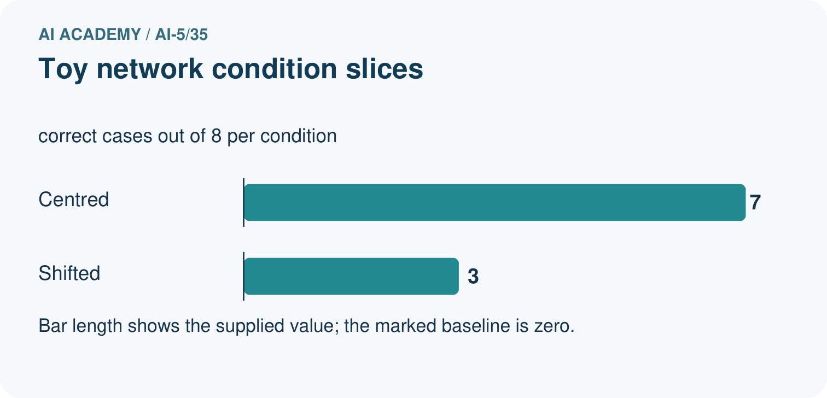
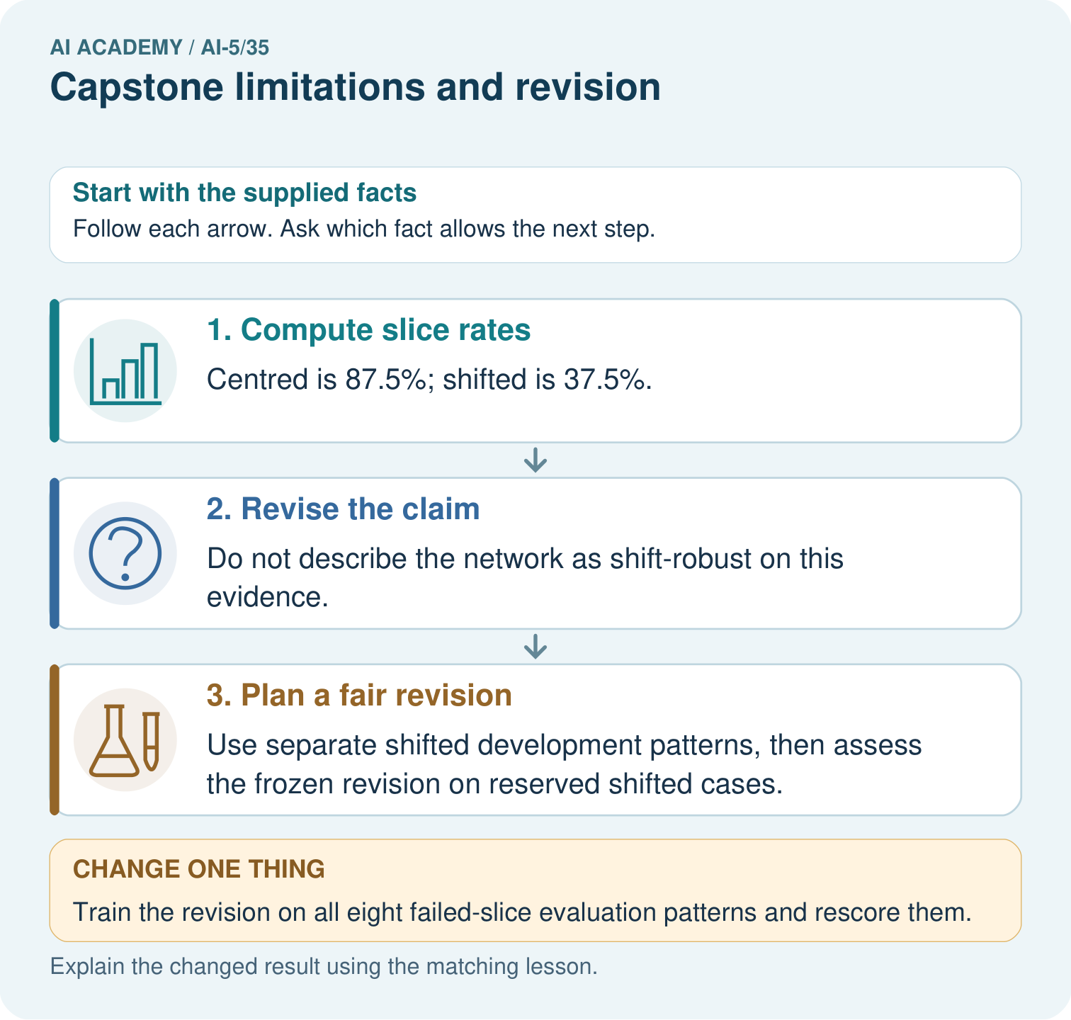
Calculate the slice rates and explain the claim revision. If the team trains on the shifted evaluation patterns, what kind of evidence does their rerun provide?

My picture-based explanation and changed-case prediction
________________________________________________________________
________________________________________________________________
________________________________________________________________
________________________________________________________________
________________________________________________________________
________________________________________________________________
Support used: alone / hint / worked example. This record is practice evidence.
Project connection: For the Image-pattern Network Investigation, save the labelled trace and the changed-case explanation beside the experiment record. State exactly what this example supports before linking it to the wider capstone claim.

