AI ACADEMY · WORKBOOK · ai-6/10

Evaluation pipelines
Project: Grounded Learning Service

01. Recall and choose your starting point
Try the recall before opening notes. Then use a different colour or a labelled second line to correct your explanation.

Integration tests and fixtures
Without opening the old lesson, explain one key idea from Integration tests and fixtures. Give an example and a mistake that the idea helps you avoid.

My remembered idea, example and correction
________________________________________________________________
________________________________________________________________
________________________________________________________________

Testing pure components
Without opening the old lesson, explain one key idea from Testing pure components. Give an example and a mistake that the idea helps you avoid.

My remembered idea, example and correction
________________________________________________________________
________________________________________________________________
________________________________________________________________

Configuration and secrets
Without opening the old lesson, explain one key idea from Configuration and secrets. Give an example and a mistake that the idea helps you avoid.

My remembered idea, example and correction
________________________________________________________________
________________________________________________________________
________________________________________________________________

02. Practise with fading help
Use W2: Trace the worked case for Evaluation pipelines. Record the answer once; the lesson and workbook refer to the same attempt.
Given inputs | Procedure I chose | Middle steps | Result and check

The step I completed without help, and the hint I needed
________________________________________________________________
________________________________________________________________
________________________________________________________________

03. Individual reasoning check
Use the worked case for Evaluation pipelines. Proposed explanation: “The worked result establishes every future case”. Decide whether this explanation is supported. Point to the step or supplied fact that decides; explain your repair if needed.

My explanation before partner discussion
________________________________________________________________
________________________________________________________________
________________________________________________________________
________________________________________________________________

04. Independent transfer case

Independent case: Apply a new case independently
Eight planned cases, six complete, five pass, one fail. Give observed pass rate and coverage.

My independent explanation, trace and limits
________________________________________________________________
________________________________________________________________
________________________________________________________________
________________________________________________________________
________________________________________________________________
________________________________________________________________
________________________________________________________________
Attempt this case before feedback. Record any help. Earlier examples below are further practice; a case already practised with feedback cannot establish fresh transfer.

05. W1 Explain the mechanism
Explain the weekly mechanism in your own words. Use the worked scenario to name its input, decision rule and output.

My reasoning and evidence
________________________________________________________________
________________________________________________________________
________________________________________________________________
________________________________________________________________
________________________________________________________________
________________________________________________________________

06. W2 Trace the worked case
Six cases are planned; five run, four pass and one fails. One is skipped. Show the intermediate steps and give the conclusion with its scope.

My reasoning and evidence
________________________________________________________________
________________________________________________________________
________________________________________________________________
________________________________________________________________
________________________________________________________________
________________________________________________________________
________________________________________________________________

07. W3 Audit the limit
A report omits this qualification: Missing evaluations can bias results; neither completion rate nor pass rate should hide the other. Explain how omitting it could change a reader's interpretation, and write an accurate replacement.

My reasoning and evidence
________________________________________________________________
________________________________________________________________
________________________________________________________________
________________________________________________________________
________________________________________________________________
________________________________________________________________

08. W4 Apply a new case independently
Eight planned cases, six complete, five pass, one fail. Give observed pass rate and coverage.

My reasoning and evidence
________________________________________________________________
________________________________________________________________
________________________________________________________________
________________________________________________________________
________________________________________________________________
________________________________________________________________
________________________________________________________________
________________________________________________________________

09. W5 Design a revealing follow-up
For the worked scenario, propose one additional case that could reveal a failure, describe its expected outcome before running it, and explain what would need to remain fixed for a fair comparison. Do not reuse W4 as a new final test after receiving feedback.

My reasoning and evidence
________________________________________________________________
________________________________________________________________
________________________________________________________________
________________________________________________________________
________________________________________________________________
________________________________________________________________
________________________________________________________________

10. Project checkpoint and reflection
Add a labelled evaluation pipelines evidence sheet to Grounded Learning Service. Show how you can explain the mechanism and terminology of evaluation pipelines. Use the supplied fictional case and keep its inputs, intermediate steps, calculation or prediction, and limitation. Connect this record to last week’s record; a matching answer without a trace is insufficient.

My project change, supporting evidence and remaining limit
________________________________________________________________
________________________________________________________________
________________________________________________________________
________________________________________________________________
________________________________________________________________
________________________________________________________________

11. Feedback, return check and learning record
Evidence | My record
Worked alone / hint / model
First step I repaired and why
New case checked later; date and result
What I can now explain without notes
One remaining question
Revisit this idea with your teacher after a delay. Familiarity is different from explaining and using it on a changed case.

12. Pictorial case practice: Evaluation pipelines
Four cases through a scoring pipeline. Two fixed versions answer the same four questions with frozen correct-or-incorrect labels.
A scores [1,1,0,1]; B scores [1,0,0,1]. Each 1 means agreement with the reference answer.
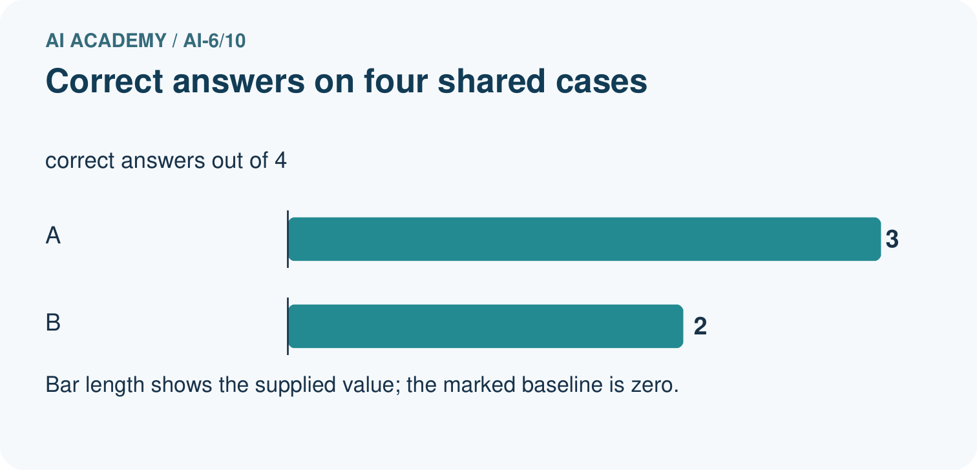
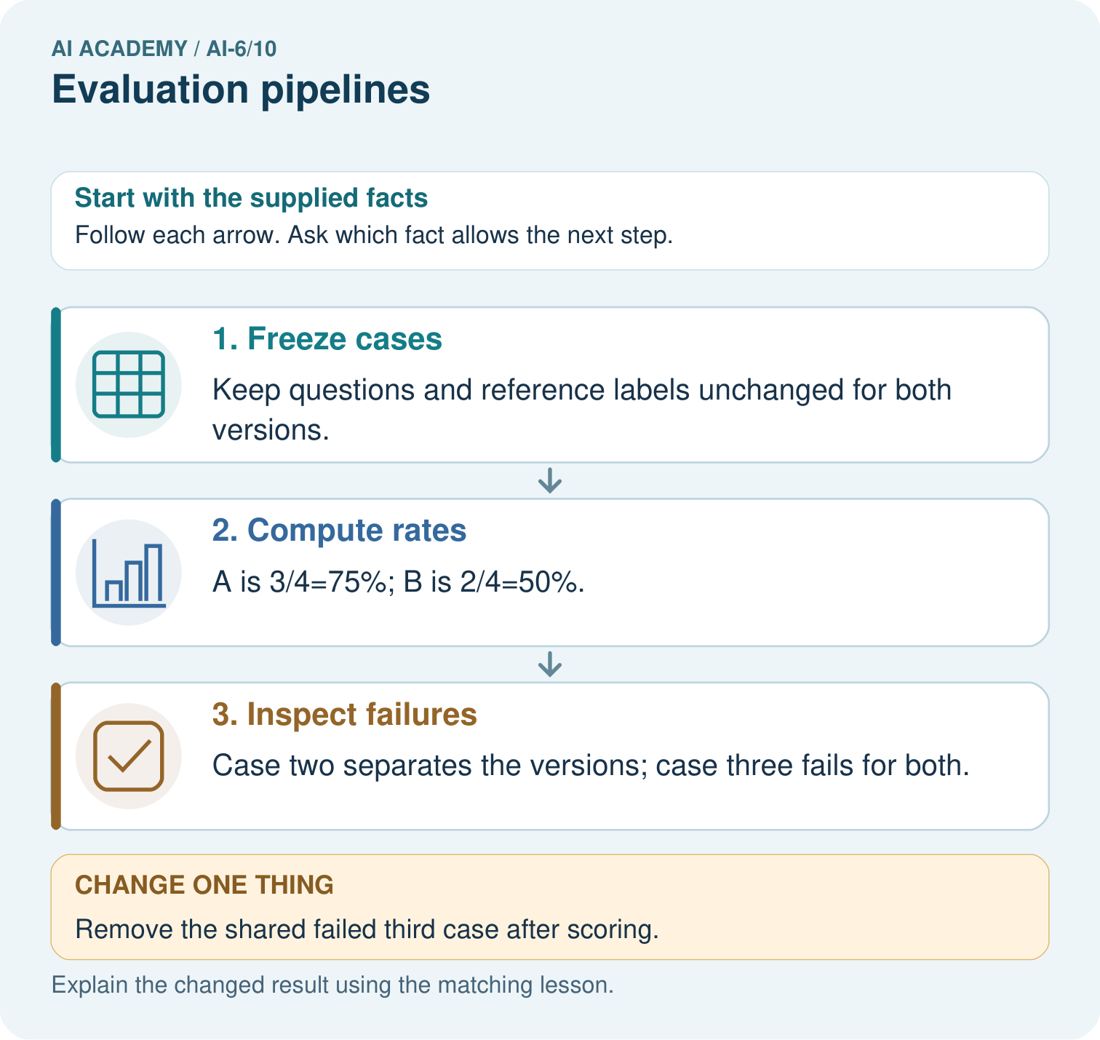
Calculate A’s and B’s correct rates on all four cases. Identify their shared failure and explain why removing that case after scoring changes the honesty of the comparison.

My picture-based explanation and changed-case prediction
________________________________________________________________
________________________________________________________________
________________________________________________________________
________________________________________________________________
________________________________________________________________
________________________________________________________________
Support used: alone / hint / worked example. This record is practice evidence.
Project connection: For the Grounded Learning Service, retain an annotated trace and the changed-case result. Name the contract or evidence that makes the deciding step valid, so another team can review it.

