AI ACADEMY · WORKBOOK · ai-6/11

Failure budgets and service objectives
Project: Grounded Learning Service

01. Recall and choose your starting point
Try the recall before opening notes. Then use a different colour or a labelled second line to correct your explanation.

Evaluation pipelines
Without opening the old lesson, explain one key idea from Evaluation pipelines. Give an example and a mistake that the idea helps you avoid.

My remembered idea, example and correction
________________________________________________________________
________________________________________________________________
________________________________________________________________

Testing model-dependent behaviour
Without opening the old lesson, explain one key idea from Testing model-dependent behaviour. Give an example and a mistake that the idea helps you avoid.

My remembered idea, example and correction
________________________________________________________________
________________________________________________________________
________________________________________________________________

Authentication and authorisation
Without opening the old lesson, explain one key idea from Authentication and authorisation. Give an example and a mistake that the idea helps you avoid.

My remembered idea, example and correction
________________________________________________________________
________________________________________________________________
________________________________________________________________

02. Practise with fading help
Use W2: Trace the worked case for Failure budgets and service objectives. Record the answer once; the lesson and workbook refer to the same attempt.
Given inputs | Procedure I chose | Middle steps | Result and check

The step I completed without help, and the hint I needed
________________________________________________________________
________________________________________________________________
________________________________________________________________

03. Individual reasoning check
Use the worked case for Failure budgets and service objectives. Proposed explanation: “The worked result establishes every future case”. Decide whether this explanation is supported. Point to the step or supplied fact that decides; explain your repair if needed.

My explanation before partner discussion
________________________________________________________________
________________________________________________________________
________________________________________________________________
________________________________________________________________

04. Independent transfer case

Independent case: Apply a new case independently
Objective 95% over 80 eligible requests. Five fail. Compute allowed failures and observed success.

My independent explanation, trace and limits
________________________________________________________________
________________________________________________________________
________________________________________________________________
________________________________________________________________
________________________________________________________________
________________________________________________________________
________________________________________________________________
Attempt this case before feedback. Record any help. Earlier examples below are further practice; a case already practised with feedback cannot establish fresh transfer.

05. W1 Explain the mechanism
Explain the weekly mechanism in your own words. Use the worked scenario to name its input, decision rule and output.

My reasoning and evidence
________________________________________________________________
________________________________________________________________
________________________________________________________________
________________________________________________________________
________________________________________________________________
________________________________________________________________

06. W2 Trace the worked case
In the interval 200 requests are eligible and 5 fail. Show the intermediate steps and give the conclusion with its scope.

My reasoning and evidence
________________________________________________________________
________________________________________________________________
________________________________________________________________
________________________________________________________________
________________________________________________________________
________________________________________________________________
________________________________________________________________

07. W3 Audit the limit
A report omits this qualification: Meeting one interval objective does not establish every future interval or zero critical failures. Explain how omitting it could change a reader's interpretation, and write an accurate replacement.

My reasoning and evidence
________________________________________________________________
________________________________________________________________
________________________________________________________________
________________________________________________________________
________________________________________________________________
________________________________________________________________

08. W4 Apply a new case independently
Objective 95% over 80 eligible requests. Five fail. Compute allowed failures and observed success.

My reasoning and evidence
________________________________________________________________
________________________________________________________________
________________________________________________________________
________________________________________________________________
________________________________________________________________
________________________________________________________________
________________________________________________________________
________________________________________________________________

09. W5 Design a revealing follow-up
For the worked scenario, propose one additional case that could reveal a failure, describe its expected outcome before running it, and explain what would need to remain fixed for a fair comparison. Do not reuse W4 as a new final test after receiving feedback.

My reasoning and evidence
________________________________________________________________
________________________________________________________________
________________________________________________________________
________________________________________________________________
________________________________________________________________
________________________________________________________________
________________________________________________________________

10. Project checkpoint and reflection
Add a labelled failure budgets and service objectives evidence sheet to Grounded Learning Service. Show how you can explain the mechanism and terminology of failure budgets and service objectives. Use the supplied fictional case and keep its inputs, intermediate steps, calculation or prediction, and limitation. Connect this record to last week’s record; a matching answer without a trace is insufficient.

My project change, supporting evidence and remaining limit
________________________________________________________________
________________________________________________________________
________________________________________________________________
________________________________________________________________
________________________________________________________________
________________________________________________________________

11. Feedback, return check and learning record
Evidence | My record
Worked alone / hint / model
First step I repaired and why
New case checked later; date and result
What I can now explain without notes
One remaining question
Revisit this idea with your teacher after a delay. Familiarity is different from explaining and using it on a changed case.

12. Pictorial case practice: Failure budgets and service objectives
A reliability allowance. A practice service requires at least 98 successes in each window of 100 eligible requests.
Current window has 97 successes and 3 failures. Success includes a correct refusal within the agreed time limit.
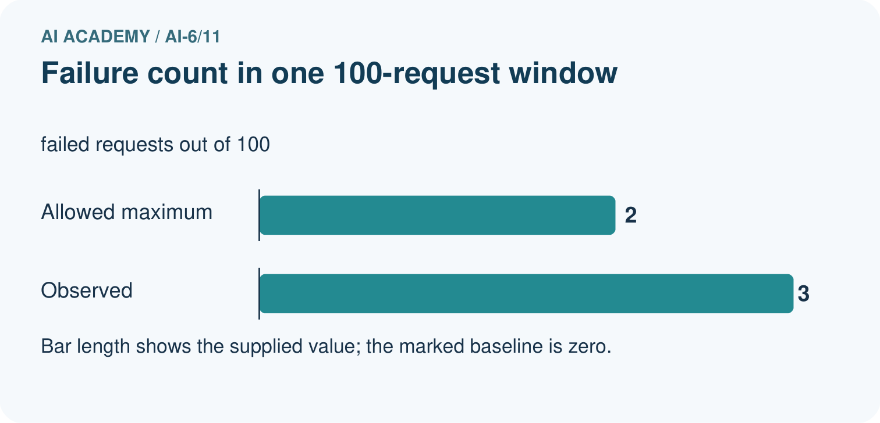
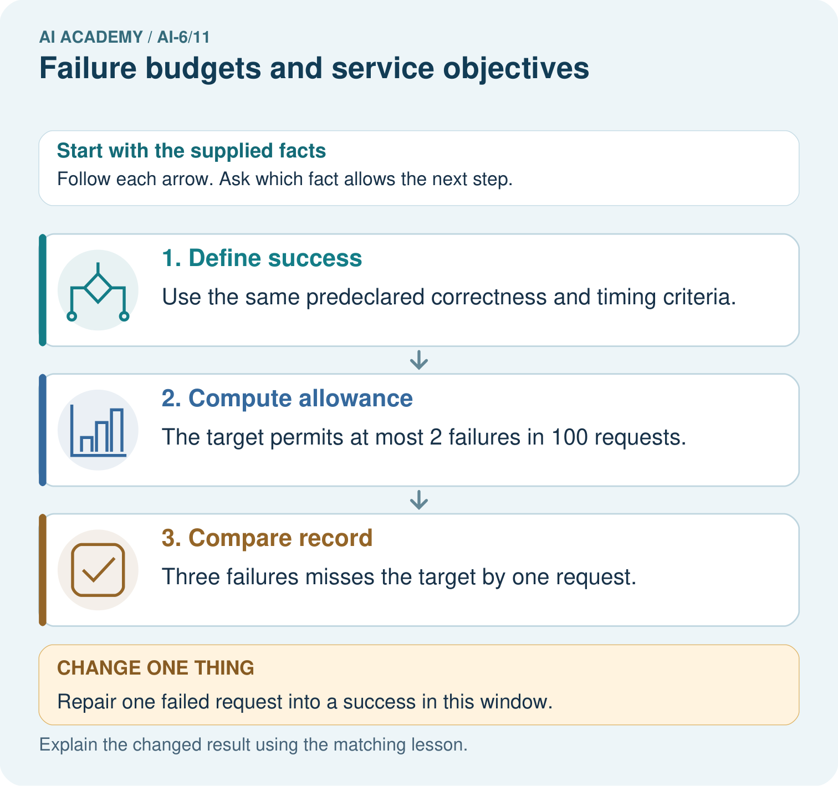
Calculate the maximum allowed failures among 100 requests. Does 97 successes and 3 failures meet the target, and what changes after one failure becomes a success?

My picture-based explanation and changed-case prediction
________________________________________________________________
________________________________________________________________
________________________________________________________________
________________________________________________________________
________________________________________________________________
________________________________________________________________
Support used: alone / hint / worked example. This record is practice evidence.
Project connection: For the Grounded Learning Service, retain an annotated trace and the changed-case result. Name the contract or evidence that makes the deciding step valid, so another team can review it.

