AI ACADEMY · WORKBOOK · ai-6/15

Approval gates and idempotency
Project: Grounded Learning Service

01. Recall and choose your starting point
Try the recall before opening notes. Then use a different colour or a labelled second line to correct your explanation.

Planning and action selection
Without opening the old lesson, explain one key idea from Planning and action selection. Give an example and a mistake that the idea helps you avoid.

My remembered idea, example and correction
________________________________________________________________
________________________________________________________________
________________________________________________________________

Logs traces and privacy
Without opening the old lesson, explain one key idea from Logs traces and privacy. Give an example and a mistake that the idea helps you avoid.

My remembered idea, example and correction
________________________________________________________________
________________________________________________________________
________________________________________________________________

Integration tests and fixtures
Without opening the old lesson, explain one key idea from Integration tests and fixtures. Give an example and a mistake that the idea helps you avoid.

My remembered idea, example and correction
________________________________________________________________
________________________________________________________________
________________________________________________________________

02. Practise with fading help
Use W2: Trace the worked case for Approval gates and idempotency. Record the answer once; the lesson and workbook refer to the same attempt.
Given inputs | Procedure I chose | Middle steps | Result and check

The step I completed without help, and the hint I needed
________________________________________________________________
________________________________________________________________
________________________________________________________________

03. Individual reasoning check
Use the worked case for Approval gates and idempotency. Proposed explanation: “The worked result establishes every future case”. Decide whether this explanation is supported. Point to the step or supplied fact that decides; explain your repair if needed.

My explanation before partner discussion
________________________________________________________________
________________________________________________________________
________________________________________________________________
________________________________________________________________

04. Independent transfer case

Independent case: Apply a new case independently
Key J already committed room A. A retry uses key J but room B. What should happen?

My independent explanation, trace and limits
________________________________________________________________
________________________________________________________________
________________________________________________________________
________________________________________________________________
________________________________________________________________
________________________________________________________________
________________________________________________________________
Attempt this case before feedback. Record any help. Earlier examples below are further practice; a case already practised with feedback cannot establish fresh transfer.

05. W1 Explain the mechanism
Explain the weekly mechanism in your own words. Use the worked scenario to name its input, decision rule and output.

My reasoning and evidence
________________________________________________________________
________________________________________________________________
________________________________________________________________
________________________________________________________________
________________________________________________________________
________________________________________________________________

06. W2 Trace the worked case
Approved send v1 to D uses key K, commits once, then caller retries K with the identical payload. Show the intermediate steps and give the conclusion with its scope.

My reasoning and evidence
________________________________________________________________
________________________________________________________________
________________________________________________________________
________________________________________________________________
________________________________________________________________
________________________________________________________________
________________________________________________________________

07. W3 Audit the limit
A report omits this qualification: A key prevents duplicate application effects only within the implemented persistence and downstream guarantees; it is not universal exactly-once delivery. Explain how omitting it could change a reader's interpretation, and write an accurate replacement.

My reasoning and evidence
________________________________________________________________
________________________________________________________________
________________________________________________________________
________________________________________________________________
________________________________________________________________
________________________________________________________________

08. W4 Apply a new case independently
Key J already committed room A. A retry uses key J but room B. What should happen?

My reasoning and evidence
________________________________________________________________
________________________________________________________________
________________________________________________________________
________________________________________________________________
________________________________________________________________
________________________________________________________________
________________________________________________________________
________________________________________________________________

09. W5 Design a revealing follow-up
For the worked scenario, propose one additional case that could reveal a failure, describe its expected outcome before running it, and explain what would need to remain fixed for a fair comparison. Do not reuse W4 as a new final test after receiving feedback.

My reasoning and evidence
________________________________________________________________
________________________________________________________________
________________________________________________________________
________________________________________________________________
________________________________________________________________
________________________________________________________________
________________________________________________________________

10. Project checkpoint and reflection
Add a labelled approval gates and idempotency evidence sheet to Grounded Learning Service. Show how you can explain the mechanism and terminology of approval gates and idempotency. Use the supplied fictional case and keep its inputs, intermediate steps, calculation or prediction, and limitation. Connect this record to last week’s record; a matching answer without a trace is insufficient.

My project change, supporting evidence and remaining limit
________________________________________________________________
________________________________________________________________
________________________________________________________________
________________________________________________________________
________________________________________________________________
________________________________________________________________

11. Feedback, return check and learning record
Evidence | My record
Worked alone / hint / model
First step I repaired and why
New case checked later; date and result
What I can now explain without notes
One remaining question
Revisit this idea with your teacher after a delay. Familiarity is different from explaining and using it on a changed case.

12. Pictorial case practice: Approval gates and idempotency
One approval, one reservation. A desk tool needs approval for the exact request and deduplicates repeated request keys.
K9 reserves desk 4 and is approved once. Two copies of K9 arrive.
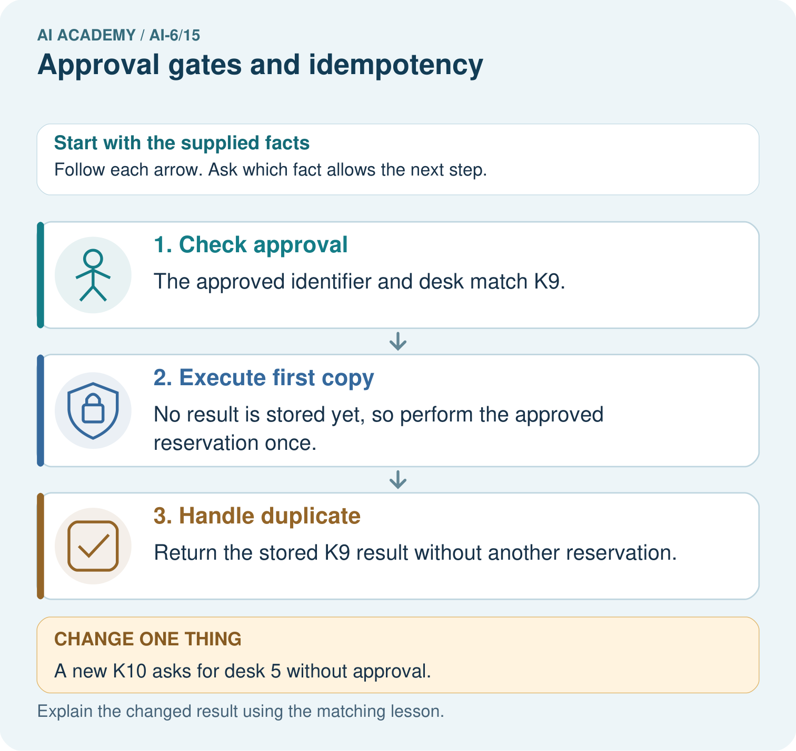
Trace the two deliveries of approved K9. How many reservations should occur, and why can a new K10 for desk 5 not borrow K9’s approval?

My picture-based explanation and changed-case prediction
________________________________________________________________
________________________________________________________________
________________________________________________________________
________________________________________________________________
________________________________________________________________
________________________________________________________________
Support used: alone / hint / worked example. This record is practice evidence.
Project connection: For the Grounded Learning Service, retain an annotated trace and the changed-case result. Name the contract or evidence that makes the deciding step valid, so another team can review it.

